Speaking Lesson Plan

House chores

Instructor:
Youngshin Woo
Level:
Upper-Intermediate
Students:
16
Length:
45 minutes

Materials:
- House chores crossword (16 copies for students and 2 extra copies)
- House chores flashcards
- Role-play strips
- Role-play cloze worksheet
- Board and board marker

Aims:
- Main aim: to develop students’ speaking ability by talking about house chores and what they think about it
- Secondary aim: to improve students’ ability to discuss by sharing ideas and negotiating
- Personal aim: I would like to improve my voice control

Language Skills:
- Speaking: students will talk about their ideas on sharing house chores and give presentations as well as role-play
- Reading: students will read the crossword worksheet and role-play strips
- Listening: students will listen to the teacher’s instructions and r students’ ideas and presentations.
- Writing: students will write in answers on crossword and cloze worksheets

Language Systems:
- Grammar: general observations
- Lexis : lexical items relevant to house chores
- Phonology: mouthing words in warm-up activity
- Function: discuss in groups and interview one another
- Discourse: talk about specific topics and come to conclusions

Assumptions:
- Students are able to communicate and exchange their ideas fluently in English
- Students understand sharing house chores can cause trouble
- Students knows how people think/feel about house chores
- Most students are willing to make the lesson as active as possible

Anticipated Problems and Solutions:
- Some students may be sensible with ‘divorce’
Do not place too much focus on it; just mention it only when it is necessary
- If warm up time is short
Skip the flashcards prepared for further vocabulary
- Students might be shy to volunteer for role-play presentation
Have the last student to come to school and her group do it
- If students finish all the activity sooner
Make use of the SOS activity

References:
- Breaking News English. http://www.breakingnewsenglish.com/1211/121123-household_chores.html
- ESL Tower. http://www.esltower.com/VOCABSHEETS/chores/chorescw.pdf
- Mes-English. http://www.mes-english.com/flashcards/files/chores_flash.pdf
- ESL Galaxy. http://www.esl-galaxy.com/crosswords/chorescw.pdf

Lead-In
Materials: Flashcards, Board
Time  3 min | Set Up  Whole Class | Procedure:  Greetings and show some of the flashcards. Elicit the word “House chores/work.”  Ask students 1) whether they like to do it, and 2) why or why not.  Introduce the topic and the following activity (crossword).

Pre-Activity
Materials: 18 Crossword Worksheets, Board
Time  10 min | Set Up  In Groups | Procedure:  I. Crossword  Instruction  Students work in groups. Ask them to answer in the worksheet. Give 3 minutes.  (Distribute the worksheet)  Monitor discreetly. Answer students if they ask questions.  (Give more time if necessary. If some students find the task hard, ask those who already finished the task to help others.)  Meanwhile, draw four columns on the board and write numbers (1~10) in each of them.  2. Answer checking:  Instruction  Ask two students in each group come out. One student mouths the answers and the other writes the words on the board. Make sure that they do not make noise.  Check the answers. Show the flashcards.
Main Activity
Materials: Role-play strips, Cloze Worksheets,
Time  7 min  15 min | Set Up  In Groups  In Groups | Procedure:  1. Discussion A  Instructions  Get students to talk about how they/their parents share(d) house chores. Give 3 minutes. Then each group gives a short presentation about what they talked about.  2. Discussion on the Given Role  Instructions  Each group picks a role-play strip. Groups do not share with other groups what their roles are. Give 3 minutes.  Two students from each group come up to the front; one student reads out their role strip, and other groups fill the blanks. The other student presents their answer to the strip.  Do the same with the other three groups.

Post-Activity
Materials: N/A
Time  10 min | Set Up  In Groups  Whole Class | Procedure:  I. Role-play  Instructions  Give a number (1~4) to students in each group. Get students of the same number to sit together. Role play partner A, partner B, counselor, and partner A’s mother.  Students share how they felt/though about it afterwards.

S.O.S activity
Materials: N/A
Time  10 min | Set Up  In pairs | Interview  Instructions  Students interview each other.  1) What’s your most hated chore and why?  2) What’s your most preferred chore and why?  3) What’s the best way to split up the housework?  Students volunteer to give mini presentations about their partners.
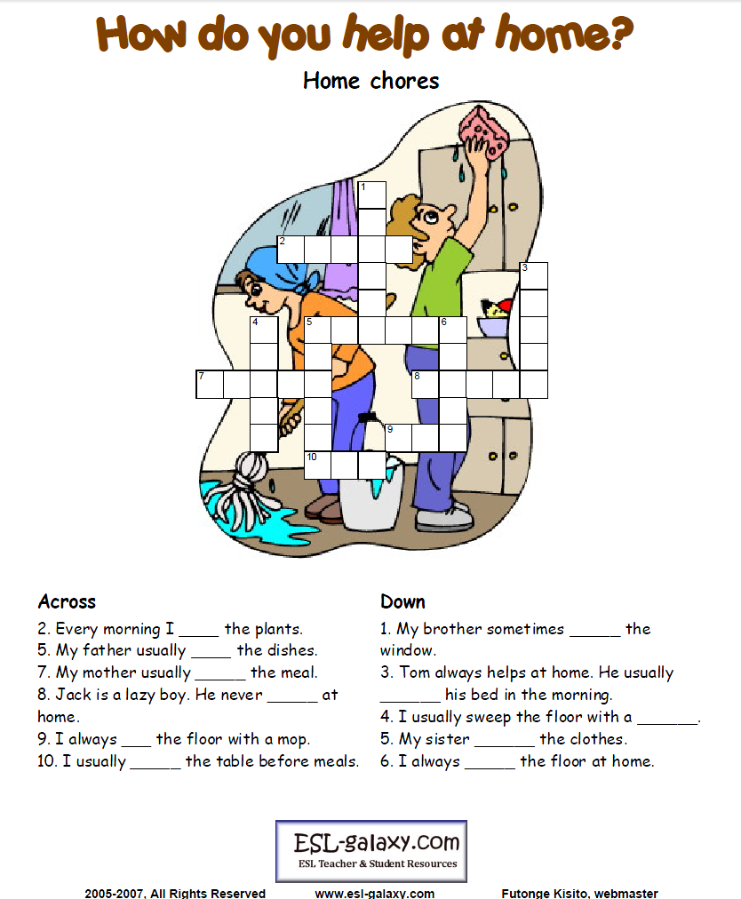
House Chores Flashcards

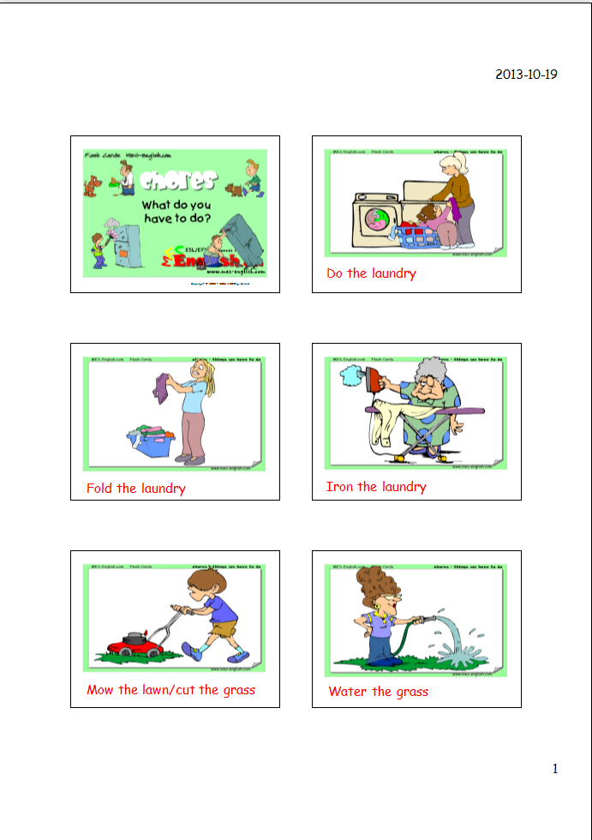
Role-Play Strips

Role A – Partner A
You spend 40 hours a week at work and come home and do most of the housework. You think this is unfair. Tell your partner three reasons why. You have a bad back and find it difficult to bend down. You think you should do the cooking, washing and ironing only. You want a divorce.
Role B – Partner B
You spend 50 hours at work and earn double the money your partner gets. You think you should do little housework. Tell your partner 3 reasons why. You have no time for housework, what with work, training for and running marathons and going out regularly with friends. You love cooking.
Role C – Counselor
You believe modern marriages are a 50-50 relationship. All household chores must be shared. Tell the others 3 reasons why. Anyone who does not do their share does not love their partner. Tell Partner B this. Solution – Partner B does the cooking, cleaning and dusting. Partner A does the rest.
Role D – Partner A's mother
You are shocked at how much work your son / daughter has to do. A full-time job and 99% of the housework. Marriage is forever, so divorce is not an option. Tell Partner A three reasons why. Tell Partner B not to be so lazy. Marriage and togetherness is more important than friends and running.

Role-Play Cloze

Role A – Partner A
You spend ___________ a week at work and come home and do most of the housework. You think this is _________. Tell your partner three reasons why. You have a ____________ and find it difficult to bend down. You think you should do the ___________, washing and ironing only. You want a divorce.
Role B – Partner B
You spend 50 hours at work and earn ____________ the money your partner gets. You think you should do ________ housework. Tell your partner 3 reasons why. You have no time for housework, but you enjoy training for and running _____________ and going out regularly with friends. You love cooking.
Role C – Counsellor
You believe ___________ marriages are a 50-50 relationship. All household chores must be shared. Tell the others 3 reasons why. Anyone who does not do their ____________ does not love their partner. Tell Partner B this. Solution – Partner B does the cooking, cleaning and ____________. Partner A does the rest.
Role D – Partner A's mother
You are __________ at how much work your son / daughter has to do. A full-time job and 99% of the housework. Marriage is forever, so divorce is not an option. Tell Partner A three reasons why. Tell Partner B not to be so _________. Marriage and ___________________ is more important than friends and running.

