Grammar Lesson Plan
Topic : Imperative sentence

Instructor:  Yujin | Level:  Intermediate  For Adults | Students:  16 | Length:  45 Minutes

Materials:
- Board and markers
- Picture 1, Picture 2, Picture 3 (17 copies each)
- Charade card
- Worksheet 1 (Reason and example of imperative sentence) (17 copies)
- Worksheet 2 (17 copies)
- Blank papers (4 for ‘to do list’ and 4 for s.o.s activity)

Aims:
Main aim
-At the end of this lesson, students should have improved their grammar skills about imperative sentence
Secondary aim
At the end of this lesson, students should have
-learned how to use imperative sentences properly and would be able to use them in their real life by practicing it a lot.
- improved speaking and writing skills by discussing and doing activities.
Personal aim
-I would like to improve my time management.
-I would like to improve eliciting.

Language Skills:
Reading : Students will read the worksheet.
Listening : Students will listen to other students’ presentation and students will listen to each other while they make “to do list”
Speaking : Students will practice speaking skills while they give the presentation and while they make “to do list” with their partner.
Writing : Students will practice writing skills while they write “to do list” on the paper and while they do worksheet.

Language Systems
-Grammar – imperative sentences.
-Functional – giving commands, ordering and requesting.
-Discourse – general use of commanding, ordering and requesting in everyday life.
-Phonology - Sounds of the words such as “imperative”
-Lexis – vocabularies.

Assumptions
Students already know
-how the class usually runs and teacher’s style of teaching and the pace of the course
-the basic structure of sentences.

Anticipated Errors and Solutions
Students may not easily understand the meanings of new vocabularies.
-Teacher will explain with simple and easy words and give examples if necessary.
Students might have troubles in activities.
-Monitor students and give some demonstrations.
If some of the students are too shy to participate during the group discussion.
-Encourage students to participate and give positive feedback
If activity finishes too soon
- Go to S.O.S activity.

References
http://www.k12reader.com/learn-about-imperative-sentences-now/
http://www.lessonsnips.com/docs/pdf/imperativesentencemore.pdf
http://www.englishexercises.org/makeagame/viewgame.asp?id=4594#a

Lead-In
Materials: Board and marker,

Time | Set Up | Procedure
5 min | Whole  class | -Greetings.  -Tell students about my experience and ask them about their feelings when they got too many commands.  -Show students pictures and elicit the word ‘emperor’ and tell them today’s topic ‘Imperative sentence’. Also, explain them that the word ‘imperative’ is derived from the word ‘emperor’.  CCQ  - Does emperor give a lot of command? (Y)

Pre-activity
Materials: Board and marker, Charades cards.

Time | Set up | Procedure
7 min | Groups  (2 groups with 8) | Instruction  ‘Warm up activity’  -Tell the students that we are going to do the ‘Charade’ game and explain the rules of the activity.  -Divide the class into 2 groups.  -There are 16 slips of paper and imperative sentences are written on each paper.  -Each student must choose a paper and act out what is written on the paper without speaking and the others in groups have to guess the answer.  -Each group has 2 minutes to do it and the team who got more right answers is the winner.

Main-activity
Materials Board and marker, Worksheet 1, Worksheet 2

Time | Set up | Procedure
5 min  5 min  3 min | Whole  Individual  Whole | Instruction  -Hand out Worksheet 1 and read the sentences together.  -Ask students if they can find rules for imperative sentences.  -Elicit some ideas.  -Go through followings.  (Subjects and verbs of imperative sentences, often used in ads etc)  -Hand out Worksheet 2 and tell them to do it individually for 5 minutes. Monitoring  -Monitor discreetly and answer if students ask questions.  -Give time warning. Be flexible with time. Give students 1 more minute if they need it.  Error correction  -Go through Worksheet 2 with students and check the answers.

Post-activity
Materials: Blank papers to make ‘to do list’.

Time | Set up | Procedure
3 min  8 min  8 min  1 min | Whole  Group  Whole | Instruction  -Tell students that they have to imagine a situation.  (You are married and you have 2 kids and a dog. You are going on a business trip for 1 week.)  -Ask them to write a ‘to do list’ for their husband, 10 do’s and 10 don’ts.  (Demonstrate my own to do list.)  -Inform them that they are going to do this in groups of 4 for 8 minutes and are going to present it.  Presentation  -Let 1 student in each group come out and present their list.  Conclude lesson

S.O.S Activity
Materials: Blank sheet.

Time | Set up | Procedure
10 min | Group | Instruction  -Inform students that they can see imperative sentences in recipe.  -Tell students to work in groups of 4 and write a recipe for their favorite food.  -Ask them to write a recipe using imperative verbs.  -They have 5 minutes to do it and they will share their ideas by presenting it.  -Students can look up the words in the dictionary.

Picture 1

Picture 2
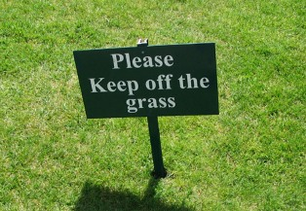

Picture 3

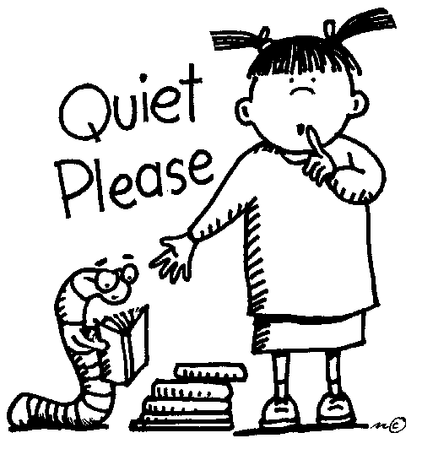

Charade card

Do the limbo. | Mop the floor | Jump | Lick an ice cream
Read a book. | Wash your hands. | Play hide and sick. | Laugh out loud
Clap your hands. | Brush your teeth. | Comb your hair. | Eat spaghetti.
Dance Kangnam style. | Make funny face. | Do the stretching. | Row the boat.
Worksheet no 1 Imperative sentences

REASON | EXAMPLE
to give advice or suggestions | - Exercise four times a week.  - Don’t eat too much chocolate.
to give directions | - Turn right at the bank and walk three blocks.
to give instructions | - Cut the onions into small pieces and fry in oil.  - Save your document and put it in a new folder.
to give orders or commands | - (Please) be quiet!  - Do your homework.
to give warnings | - Watch out!  - Don’t drive after drinking.
to make a polite request | - Please turn off the light, Mary.  - Close the window please, Janice.
to offer an informal invitation | - Bring a friend to the party if you like.  - Join us for dessert, Cathy!

Worksheet no 2
A.Choose the best imperative for each sentences.
- Teacher: Jerry, __________ please. I'm ready to begin teaching.
a. you sit down
b. sit down
- 2. Doctor: __________ this medicine before you go to bed, okay?
Patient: All right, doctor. Thanks.
a. You take
b. Take
- 3. __________ after you eat a big meal. It's not a good idea.
a. Exercise
b. Don't exercise
- 4. __________ careful! You almost spilled your coffee.
a. Don't be
b. Be
c. You be
- 5. A: Could you tell me how to find the bookstore?
B: Sure. __________ two blocks and __________ left at the corner. It's right there!
a. Walk / turn
b. Walks / turns
c. Don't walk / turn
- 6. Wife: __________ me when I am speaking.
Husband: Sorry, honey.
a. Please don't interrupt
b. You don't interrupt
c. Interrupt

B. Turn the affirmative sentences in negative sentences and the negative in affirmative sentences.
1, Turn down the radio.

2. Go straight.

3. Practice with the exercises.

4. Don’t come back later.

5. Don’t drink your coffee.

C. Fill in the gaps with the correct verb from the line below
turn off turn on lock go bring drinks be open watch see
Hello Anna, I have to go now, here are the keys for the house, do not the door to anybody please, you can TV until late if you wish but remember to all the lights and the alarm before you to bed. Make sure my son Todd is asleep before you to bed, and the doors, we will back by two in the morning. Ahh, and I forgot, Todd's milk is inside the refrigerator in a small bottle, he always it before falling asleep, a good girl and don't any people in the house.

