Listening Speaking Reading Grammar Writing

Topic: Gift-Giving Etiquette

Instructor:  Kim, Hyo Jin  (Christina) | Level:  Intermediate | Students:  16 | Length:  45 Minutes

Materials:
- Visual aid _ pictures related with present
- White board, board markers
- Computer,projector,screen
- Vocabulary worksheet #1 (17 copies+1copy for extra)
- Quiz worksheet #2 (17 copies+1copy for extra)
- Reading worksheet #3 (17 copies+1copy for extra)
- Vocabulary reinforcement sheet #4 (17 copies+1copy for extra)
- SOS activity : Discussion sheet (1 copy for teacher)

Aims: At the end of class,
- Students have learnt new vocabulary &idiom
- Students have improved reading skills
- Students have informed about etiquette for different culture
- Students have practiced speaking through pair/group work

Language Skills:
Reading: Reading on worksheet
Listening: Teacher’s instruction, discussion
Speaking: Speaking in pairs / in groups , Answering
Writing: Taking notes, Answering on the worksheet

Language Systems:
Phonology: Vocabularies, Idioms
Lexis: expressions used in describing of etiquette
Function: Have information about gift-giving etiquette
Grammar: Passive sentences
Discourse: Discussion and share ideas

Assumptions:
- Students understand every culture has different etiquette
- Students have experienced to give and get present well
- Students already know teacher’s teaching style and pace of the course

Anticipated Errors and Solutions:
- Students may not be able to understand the vocabulary properly
Repeat the word and make example sentence using that words
- Students may not be able to understand what is subject for
Tell them my story that I didn’t keep etiquette properly
- Students may need more time to work
Give students a little more time to work
- If students can’t compelet the gap fill task
Make other groups help them to fill task
- If there is much time remained
Use SOS activity : Prepare discussion topic and make them discussion in groups or in pairs

References:
- English definition : “Nate Dictionary”
- Article :Reading Advantage
- Worksheet #1 [quiz] : http://www.kiplinger.com

Lead-In
Materials: Board, Computer, Projector, Screen , Board Markers

Time | Set Up | Description of activities
5 min | Whole class | Greeting  Ask students their feeling when they receive gift from somebody else.  Show students 2 different pictures  Elicit what’s the situation and how the feeling of receiver’s  Introduce topic  Explain some present make people happy and some present don’t.  Introduce of topic and next activity.

Pre-Activity
Materials: Computer, Projector, Screen, Quiz worksheet (#1)
Vocabulary worksheet (#2)

Time | Set Up | Description of activities
8min  7min | Whole Class  Individually  Whole Class  Whole Class  In pairs  Whole Class | 1.Prediction(Quiz) (warming - up)  Instruction  Work individually  Notice that the quiz to test knowledge of gifting etiquette.  Check right answer. Give 2 min.  Distribute work sheet #1  CCQ  Do you check wrong answer?  Are you working individually?  Teacher monitors discreetly. Answer students if they ask questions.  Give time warning : 30 seconds left.  Go through answers and short explanation one by one  3.Vocabulary  Distribute the worksheet #2  Instruction  Explain how to match the words on the worksheet. Students put letter on the right from box as below.  Get students work in pair [ Indicating pairs ]  Give 3minites to students.  CCQ  -Are you working individually?  -How much time do you have?  Teacher monitors discreetly. Answer students if they ask questions.  Give time warning : 30 seconds left.  Give 1 more minute if they need  Check answers  Check answer together.  Go through each definition one by one and give example of the word if necessary and teach pronunciation

Main Activity
Materials: Reading worksheet (#3) ,Board

Time |  | Set Up |  | Description of activities
5 min  8 min |  | Whole class  Individually  Whole Class |  | 1.Reading  Instruction  Ask students to read the passage carefully and check some questions after read it  Give 5 min. to read.  CCQ  “Do you read briefly?”  “How much time do you have to read it?”  Distribute the worksheet #3.  Give time warning : 30 seconds left.  2.Reading comprehension  Instruction  Teacher ask some questions orally and students can reply their passage understanding  Check reading comprehension  1) Which color would probably be most suitable for wrapping a present in both China and Japan? White? Red? Black? Blue?  2) Can business traveler give chocolate, vodka or beer as gifts?  3) Can business traveler give gift originating from the host country?  4) What should you do when giving a gift to an Asian person? Is it to wait for the receiver to open it?  Use two hands to hand it over?  5) What should be best title for this passage?  3.Idiom  Write down 3 sentences on the board using idiom and let students read after teacher.  Explain what the meaning of idioms is and check idioms in the story.  - As a good rule of thumb, you should spend no more than a half of your salary on rent.  - That’s a good point; I’ll bear it in mind when I make my decision.  - They offered me the job, but, in the end, I turned them down.
Post Activity
Materials: Reading worksheet (#4)

Time | Set Up |  | Description of activities
7min  5min | Whole Class  Groups  Whole Class  Whole Class |  | 1.Free activity  Instruction  Indicting groups as “A” “B” “C” “D” . Get students work as group.  Ask students complete the passage with the correct form of items from the box.  Give 3 minutes. Distribute the worksheet #4  CCQ  -Do you work individually?  Monitor actively and participate within each group  Give time warning : 1 min left.  Feedback  Elicit and get answers one by one and summarize the story  2.Conclude lesson  Wrap up the class and give homework.  Homework :Search the internet regarding of [gift –giving etiquette] and make list 5 things

Visual aid (2 pictures)
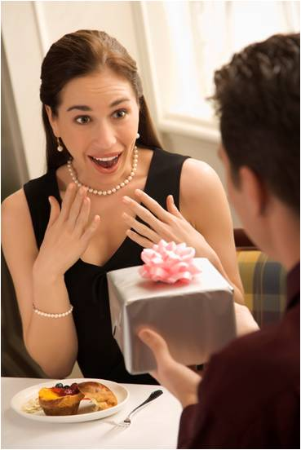

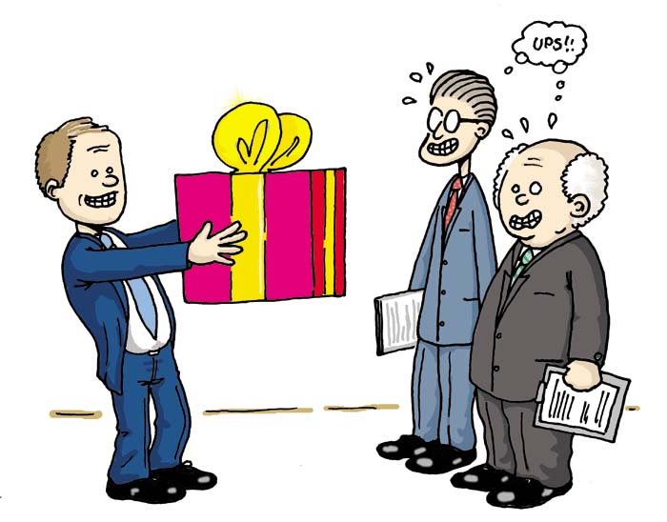

Word Worksheet

• Match the words below with their definitions. Good luck.

1. A difference or comparison between two things: _______________
2. Usually done in a particular situation: _______________
3. Noticeable, but in a bad way; showing off: _______________
4. Correct or suitable: _______________
5. To make (someone) feel disappointed: _______________
6. Expected and correct way of behaving: _______________
7. quiet ; not light ; not loud: _______________
8. Not suitable for a polite situation: _______________

subdued | vulgar
etiquette | customary
appropriate | contrast
flashy | frustrating

Worksheet_Quiz 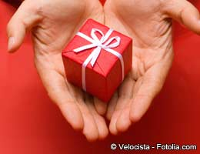

You can check right answer. Good luck!

- Gift cards are popular, but are they rude?
- Yes, you’ll be breaking etiquette rules.
- Not necessarily. They’re acceptable now.

- When you choosing gift wrapping paper for Japanese friend, what color do you avoid?
- White
- Green
- Pink
- Blue

- Is it okay to re-gift?
- Yes, as long as you know the receiver won't find out it's a recycled gift.
- Yes, as long as the item is in its original packaging.
- No, it's dishonest.

- If invited to a house for dinner in Turkey (Country) , which of these would you take?
- Money
- Pastries
- Whiskey

“Giving-Gift Etiquette”
In the early part of the twentieth century, an American woman named Emily Post wrote a book on etiquette. This book explained the proper behavior Americans should follow in many different social situations, from birthday parties to funerals. This book, The Emily Post book of Etiquette, continues to sell well today, although some of the rules Ms. Post gave needed to be updated by the publishers over the years. But, in modern society, it is not enough to simply know the proper rules for behavior in your own country. International travel for work and pleasure now makes it necessary for people to understand the rules of etiquette in other cultures as well.
Take, for example, the etiquette required in giving and receiving gifts. As a business traveler, it might be necessary from time to time to give a gift to a client or co-worker from another culture. Or, as a visitor in another country, a person might receive a gift of welcome or of thanks from members of the host culture. In both giving and receiving gifts, one should not assume that the rules of etiquette are the same or even similar to the rules in one’s own culture.
Cultural differences may appear even in such simple processes as giving or receiving a gift. In Western cultures, a gift can be handed over to the receiver with relatively little ceremony. When a gift is offered, the receiver typically takes the gift while expressing his or her thanks. However, in some Asia cultures, the act of giving is an important aspect of gift-giving, and this process may appear confusing or frustrating to Westerners.
In Chinese culture, a receiver will typically refuse to accept the gift at first, with the understanding between the giver and receiver that after being turned down several times, the gift will finally be accepted. In addition, to show respect for the receiver, it is customary in several Asian cultures to use two hands when offering a gift to another person.
After receiving a gift, tradition may demand that the person open the gift right away or, alternatively, wait before opening the gift. In many Western cultures, etiquette requires the receiver to open the gift immediately and show appreciation for the thoughtfulness of the giver. In Asian cultures, on the other hand, the gift may be accepted with appreciation and then set aside to be opened later. The gift will then be opened in private to avoid appearing greedy or impatient.
Another tip for cross-cultural gift-giving relates to wrapping presents, especially in choosing the color of paper used to wrap a gift. In Japan, for example, white or very bright colors are traditionally not good choices for wrapping a gift. In Japanese culture, white is the color associated with mourning and bright colors may be considered by some people to be vulgar because they are too flashy. Plain white and black are also to be avoided when wrapping presents in China, because of the relation of these colors to funerals. Joyful colors such as red, yellow and pink are preferred in Chinese culture.
In contrast, Europeans seem to prefer more subdued colors for wrapping presents. A good rule of thumb for wrapping gifts, especially for business travelers, is to travel with unwrapped gifts, and then wrap the gift with paper bought in the country where the gift will be given.
Finally, when choosing the appropriate gift to give, a good rule to bear in mind is the following “Never give vodka to Russians, chocolate to Belgians, or beer to Germans.” It is better to travel with quality gifts from one’s own region or culture. These are much more likely to be appreciated in other cultures because of their unique nature.
(622 words)

Worksheet #4

Complete the passage with the correct form of items from the box. One item is extra.

appropriate bear in mind contrast customary etiquette frustrate turn it down

When people from different cultures meet, problems may occur because their cultures follow different rules of (1) . What may be normal behavior in one culture may seem (2) or even rude in another. Take, for example, the (3)
between Western and Asian cultures regarding correct ways of giving and receiving gifts.
In some Asian cultures, it is (4) to refuse a gift several times before accepting it.
Westerners may find it (5) when they offer a gift to someone and the receiver
(6) .

SOS activity

Making a group and discussion “ What do you think”

- Have you ever acted inappropriately when dealing with someone of another culture? Has anyone from another culture ever acted inappropriately with you? If so, what happened?

- Are there any important cultural rules that a visitor to Korea should know?

