Listening Speaking Reading Grammar Writing

Topic: An Ice Place to Stay

Instructor:  Kim, Hyo Jin  (Christina) | Level:  Upper-Intermediate | Students:  16 | Length:  50 Minutes

Materials:
- Visual aid (picture, video) of ice hotel to stay
- Vocabulary & idiom worksheet #1 (17 copies+1copy for extra)
- Listening CD & CD player
- True/False worksheet #2 (17 copies+1copy for extra)
- Information sheet – listening worksheet #3 (17 copies+1copy for extra)
- White board, board markers
- SOS activity : Background of Sweden (1 copy for teacher)

Aims:
- Students have learnt new vocabulary &idiom for the main idea by doing a prediction check list
- Students have practiced conversation skills through the discussion
- Students have practiced reading and writing by doing definition worksheet, gap fill and true/false activities
- Students have predicted about the article through video
- Students will be able to pick up the specific word from the whole article by answering the worksheet.
- Personal aims : Improve time management skill

Language Skills:
Reading: Reading on worksheet and script.
Listening: Listening to the article, teacher’s instruction, discussion
Speaking: Speaking in pairs / in groups
Writing: Taking notes

Language Systems:
Phonology: Vocabularies, Idioms
Lexis: Vocabulary used in the article
Function: Have information about ICE HOTEL
Grammar: Using simple past
Discourse: Dialogue, Discussion

Assumptions:
- Students have lots of information of other countries
- Students will know the teacher’s teaching style
- Students will know the pace of course

Anticipated Errors and Solutions:
- Students may not be able to understand the article properly
Before listening, students will learn new vocabularies via worksheet
- Students may not be able to understand what is subject for
Show short file that introduced of ice hotel
- Students may need more time to work
Give students a little more time to work
- If students can’t compelet the gap fill task at first time
Students will listen to the article again
- If media file doesn’t work well
Use SOS activity : Prepare background information of Sweden that is ICE HOTEL located.

References:
- Visual aid: http://www.youtube.com
- Picture : http://blog.naver.com/nolantokki/60033733429
- English definition from “Nate Dictionary”
- North Star 2 book

Lead-In
Materials: Board, Picture

Time | Set Up | Description of activities
3 min | Whole class | Greeting  Ask students about weekend  Ask students enjoy travelling on weekend or not  Show students the two pictures of ice hotel and elicit from students  Feeling of pictures  Where the picture has been taken  Introduce topic  Write key word [ICE HOTEL] on the board  Introduce of topic and next activity.

Pre-Activity
Materials: Board, Visual Aid (Film), Vocabulary and Idiom worksheet, True or False worksheet

Time | Set Up | Description of activities
4 min  10min  8 min | Whole class  Whole Class  Individually  Whole Class  Whole Class  In Pair  Whole Class | 1.Show short film  Explain the reason of showing the film and show short film to students.  -If film has problem, go to SOS activity instead  After showing film, ask student what ICE HOTEL is and explain next activity.  2.Vocabulary and Idiom  Instruction  Explain how to match the words on the worksheet. Students put letter on the left with the definition on the right.  Get students work individually  Give 3minites to students.  (Distribute the worksheet #1)  CCQ  -Are you working individually?  -How much time do you have?  -Do you write all sentences on the left?  Teacher monitors discreetly. Answer students if they ask questions. Give time warming. Give 1 more minute if they need  Check answers  Check answer together by demonstrate of #1.  [Reindeer is a species of large deer, that is found in arctic and subarctic regions of Europe and Asia. So put the letter ‘e’ left side of #1]  Go through each definition one by one and give example of the word/ idiom if necessary and teach pronunciation)  3.Prediction  Write the headline of the article on the board and get students name of article.  [An Ice Place to Stay]  Instruction  Prediction about the article.  Get students looking at the headline and guess whether the sentences are true or false.  Get students do in pairs  Give 5min.  (Distribute the worksheet #2)  CCQ  -Are you working individually?  -Do you do this worksheet before or after listening?  Teacher monitors discreetly. Answer students if they ask questions  Everyone should have different answers for the true/false questions because students have not listened yet.  Students just predicted about the hotel.  Ask students how they predict briefly.

Main Activity
Materials: CD & CD player, listening worksheet, Board

Time |  | Set Up |  | Description of activities
5 min  10min |  | Whole class  Whole Class  Individually  Whole Class |  | 1.Listen for the main idea (general understanding)  Instruction  Note taking is not allowed and listen first.  Make sure try to remember worksheet question (True/False)  CCQ  “Do you take a note while listening?”  (play file without pausing or stopping)  Ask students to listen again  If Yes : Have them listen one more time  No : Have them share their thoughts  Check answers  Get students check True/False worksheet after listening and change if there is different with predict. Students fold and keep True/ False worksheet before notice.  2.Listen for details  Instruction  Listening one more time and students fill the blanks.  Get work individually.  (Distribute the worksheet #3)  CCQ  “Do you do with your partner?”  Teacher plays the article once again. Students fill the gaps as they listen  Ask students to listen again  If yes : Play the article once again  If no : Give them to check article  Check answers  Check answer together. Students go through the answers of each sentence one by one  Notice to check True/False worksheet  Give an answer of each True or False one by one  (If there is time, explain why it is True or False)
Post Activity
Materials: N/A

Time | Set Up |  | Description of activities
10min | Whole Class  Groups  Whole Class |  | 1.Free activity  Instruction  Indicting groups as “A” “B” “C” “D” . Get students work as group.  Ask students discuss about  - What things are important to you when you choose a place to visit? And why?.  I demonstrate of my case. [Lodging]  CCQ  -What do you discuss?  -For how long?  Monitor actively and participate within each group  Feedback  Elicit and get answers from students  Write on the board what things are important for visit.  2.Conclude lesson  Wrap up the class and give homework.  Homework : Make a speech note that unusual place that students ever been to. (2min speech note)

Visual aid (2 pictures)
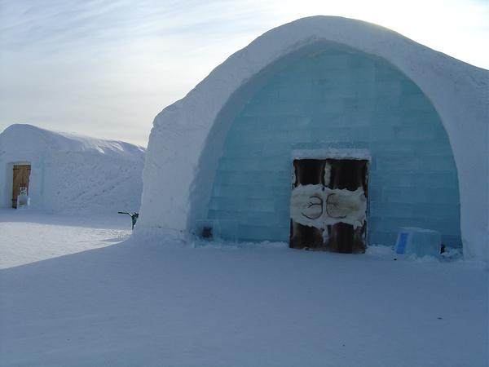
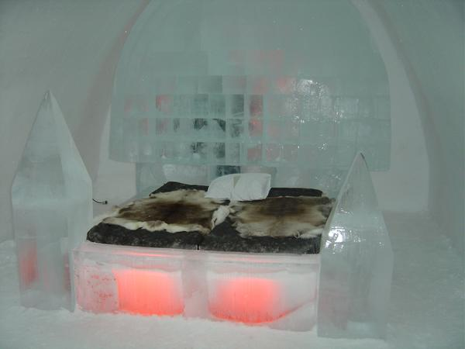

Worksheet #1
Vocabulary Worksheet

Please match the words on the left with the definitions on the right. Good luck!

 | 1.reindeer | a. something that completes or perfects
 | 2. surreal | b. very friendly and warm in manner
 | 3. Immaculately | c. an individual belonging to a group of peoples of the Arctic and sub-Arctic regions of Canada, Greenland and Alaska.
 | 4. grouse | d. ground-living game birds with a plump body, feathered legs
 | 5. complement | e. species of large deer, that is found in arctic and subarctic regions of Europe and Asia
 | 6. hearty | f. immoral
 | 7. wicked | g. very odd or bizarre
 | 8. Inuit | h. perfectly clean and neat

Worksheet #2
True/ False Worksheet
1. ICE HOTEL is designs by artists from France only (T/F)
2. It is built to a new design each winter (T/F)
3. Two years before the ICE HOTEL opened its rabbit-skin doors to its first clients (T/F)
4. Around ICE HOTEL, there is no restaurant nearby. (T/F)
5. There is a Champagne bar in the restaurant (T/F)

Worksheet #3
Gap fill in the blank
The ICEHOTEL in Swedish Lapland remains famous the world over as the original, and simply the best, hotel made purely from ice and snow. Located in Jukkasjarvi, 200km north of the Arctic Circle, the ICEHOTEL remains one of the most 1 hotels in the world and certainly the coolest! It is built to a new design each winter, melting back into the River Torne in spring after it has captured the hearts of those who have visited or stayed within its beautifully crafted walls.
Discover The World has been operating holidays to Swedish Lapland for 25 years, two years before the ICEHOTEL opened its reindeer-skin doors to its first clients. The 2013-14 season will be the 24th 2 and promises to be more special than ever before. It will 3 designs by artists from 15 countries and alongside the 20 ice rooms and 8 snow rooms will be 16 Art Suites, 1 Deluxe Suite and Northern Light suites. Accommodation at the ICEHOTEL»
The ICEHOTEL complex includes the surreal ICEBAR as well as a fine restaurant in a cozy wooden building. Immaculately presented meals often feature reindeer, elk, grouse and Arctic char and the desserts are truly wicked! Complemented by an excellent wine list, the ICEHOTEL Restaurant offers fine dining in a very fine setting. There is also a Champagne bar in the restaurant. Further to this, around a 10-minute walk from the ICEHOTEL is the Homestead restaurant, open in the evenings for hearty a la carte meals. This large log 4 , with wooden tables and tablecloths has a very welcoming and rustic 5 .
An ingenious hotel design, a host of thrilling winter activities and spectacular Swedish cuisine - the ICEHOTEL is the only place to be this winter!
Back in the Autumn of 1990, friends Par Granlund and Yngve Bergqvist had a vision to build an igloo, in the Inuit style but bigger than ever created before. But it was to be much more than a building made out of ice and snow. It was to be a work of 6 and 7 design, a meeting place which would cross cultural boundaries and symbolize local traditions, nature, history and the environment. The first igloo, a simple art gallery had just 50 square meters of floor space, visited mainly by 8 locals. Growing in size annually in a never-to-be-repeated design, ice rooms were included in the late nineties for those wishing to stay longer, seek inspiration and to admire the 9 and its stunning location. The little town of Jukkasjarvi, which actually means 'meeting place by the lake', has been a centre for trade and commerce amongst the native Sami for around 400 years - now it attracts ice artists and visitors from all around the globe as Par and Yngve’s vision is brought to 10 year after year.

SOS activity

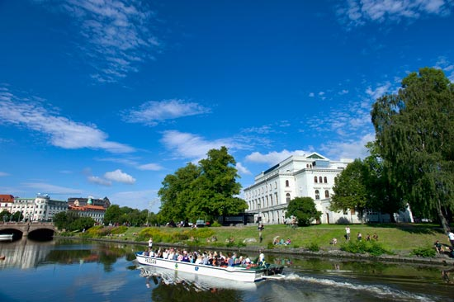

Sweden is a very large country in northern Europe. Every year tourists come from all over the world to visit Sweden’s cities, see the interesting sights, and enjoy the outdoors.
Tourists planning a trip to Sweden can choose different things to do.
Look at the picture and flag of Sweden. Map is on the wall.

Forests cover 50 percent of the land and are hoe to may wild animals, such as bears, elk, foxes. There are 96,000 lakes in Sweden, and in the north there is a long range of tall mountains. Adventurous travelers will want to explore the beautiful wilderness that Sweden has offer.

Original Listening Script (appendix)
The ICEHOTEL in Swedish Lapland remains famous the world over as the original, and simply the best, hotel made purely from ice and snow. Located in Jukkasjarvi, 200km north of the Arctic Circle, the ICEHOTEL remains one of the most stylish hotels in the world and certainly the coolest! It is built to a new design each winter, melting back into the River Torne in spring after it has captured the hearts of those who have visited or stayed within its beautifully crafted walls.
Discover The World has been operating holidays to Swedish Lapland for 25 years, two years before the ICEHOTEL opened its reindeer-skin doors to its first clients. The 2013-14 season will be the 24th construction and promises to be more special than ever before. It will feature designs by artists from 15 countries and alongside the 20 ice rooms and 8 snow rooms will be 16 Art Suites, 1 Deluxe Suite and Northern Light suites. Accommodation at the ICEHOTEL»
The ICEHOTEL complex includes the surreal ICEBAR as well as a fine restaurant in a cozy wooden building. Immaculately presented meals often feature reindeer, elk, grouse and Arctic char and the desserts are truly wicked! Complemented by an excellent wine list, the ICEHOTEL Restaurant offers fine dining in a very fine setting. There is also a Champagne bar in the restaurant. Further to this, around a 10-minute walk from the ICEHOTEL is the Homestead restaurant, open in the evenings for hearty a la carte meals. This large log cabin, with wooden tables and tablecloths has a very welcoming and rustic feel.
An ingenious hotel design, a host of thrilling winter activities and spectacular Swedish cuisine - the ICEHOTEL is the only place to be this winter!
Back in the Autumn of 1990, friends Par Granlund and Yngve Bergqvist had a vision to build an igloo, in the Inuit style but bigger than ever created before. But it was to be much more than a building made out of ice and snow. It was to be a work of art and creative design, a meeting place which would cross cultural boundaries and symbolize local traditions, nature, history and the environment. The first igloo, a simple art gallery had just 50 square meters of floor space, visited mainly by curious locals. Growing in size annually in a never-to-be-repeated design, ice rooms were included in the late nineties for those wishing to stay longer, seek inspiration and to admire the building and its stunning location. The little town of Jukkasjarvi, which actually means 'meeting place by the lake', has been a centre for trade and commerce amongst the native Sami for around 400 years - now it attracts ice artists and visitors from all around the globe as Par and Yngve’s vision is brought to life year after year.

