Listening Speaking Reading Grammar Writing

Topic: Breakfast

Instructor:  Kim, Hyo Jin  (Christina) | Level:  Upper-Intermediate | Students:  16 | Length:  45 Minutes

Materials:
- Visual aid _ Video & pictures related with breakfast
- White board, board markers , paper
- Computer, projector, screen
- Cooking Vocabulary #1 , Reading sentence #2 (17 copies+1copy for extra)
- Making a breakfast worksheet #3 (Different 4 copies )
- SOS activity : Making a story sheet (17 copies + 1copy for extra)
- Desk, Some food , bowl etc.,

Aims: At the end of class,
- Students have improved speaking skills
- Students have informed about importance of breakfast and how to make it
- Students have practiced speaking through pair/group work

Language Skills:
Reading: Reading on worksheet
Listening: Teacher’s instruction, discussion, other student’s presentation
Speaking: Speaking in groups , Answering , Presentation
Writing: Taking notes, Answering on the worksheet

Language Systems:
Phonology: Vocabularies
Lexis: expressions used in describing of cooking
Function: Making a sentence
Grammar: Present simple tense
Discourse: Discussion and share ideas

Assumptions:
- Students understand breakfast is important but hard to eat on time
- Students have experienced to cook
- Students already know teacher’s teaching style and pace of the course

Anticipated Errors and Solutions:
- Students may not be able to understand vocabulary related with cooking properly
Give vocabulary sheet and check together
- Students may not be able to understand what is subject for
Show them short video
- Students may need more time to work
Give students a little more time to work
- If students can’t compelet the cooking recipte note task
Make other groups help them to fill task
- If there is much time remained
Use SOS activity : Making a story

References:
- Cooking Video : http://goo.gl/iA05G
- Worksheet #2 : http://www.realsimple.com
- Worksheet #4 : http://esldiscussions.com/b/breakfast.html

Lead-In
Materials: Board, Picture, Paper

Time | Set Up | Description of activities
6 min | Whole class  Individually | Greeting  Show 3pictures to students and ask question which breakfast looks the best and why  Introduce topic  Explain today’s topic  Ask students why breakfast is important  Discuss in group (1min)  Write importance of breakfast on the board  Bing-Go Game  Do Bing-Go game using breakfast words

Pre-Activity
Materials: Computer, Screen, Projector, Worksheet #1 , #2

Time | Set Up | Description of activities
7min | Whole Class | 1.Show video  Show video how to make breakfast  [from YouTube]  2.Read worksheet  Distribute work sheet #1 (Vocabulary) and learn cooking words Read sentences on work sheet #2

Main Activity
Materials: Worksheet (#3) ,Board, Desk , Ingredients (Fruit, bowl, apron etc.,)

Time |  | Set Up |  | Description of activities
7 min  15min |  | Whole class  Whole Class |  | 1. Making cooking recipe  Distribute work sheet #3  Making cooking recipe note and drawing breakfast and prepare presentation for 6min  CCQ  -Are you going to make cooking dialogue, OK?  Demonstration  Demonstrate how to make dialogue with one student  Teacher monitors discreetly. Answer students if they ask questions.  Give time warning: 1 minute left.  Give 1 more minute if they need  2. Presentation of cooking recipe & asking question  For 2 minutes, each presenter presents their cooking recipe and show how to make their food  Explain own breakfast detail.  -Prepare some ingredients to make actually  From each group members ask 1 question to presented team if they have.  3.Vote most delicious breakfast  Vote most delicious breakfast and give present to members
Post Activity
Materials: Worksheet #4

Time | Set Up |  | Description of activities
8min  2min | Whole Class  In pair  Whole class  Whole Class |  | 1.Free Discussion  Discuss about breakfast.  Distribute work sheet #4  Give 5 minutes. Write partner’s answer on the sheet  CCQ  -Do you work individually?  Monitor actively and participate within each group  Give time warning : 1 min left.  2.Free Discussion-answering  Ask students what is partner’s answer. Not ask all, pick 3~4 questions  3.Conclude lesson  Wrap up the class and give homework.  Homework: If SOS activity is not finished, finish it.  Or, describe an ideal meal. Discuss the food, the person(s) you would eat with, the place, and so on. Why is this ideal for you?
Warm Up – Bing go game
Mix breakfast menu and put into student’s own worksheet. Do Bingo Game for breakfast.
(2min)
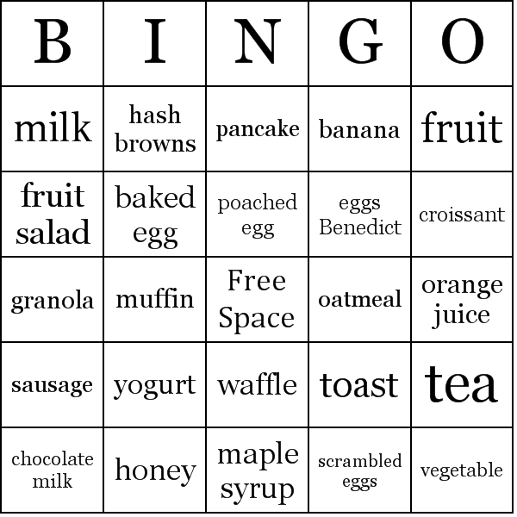

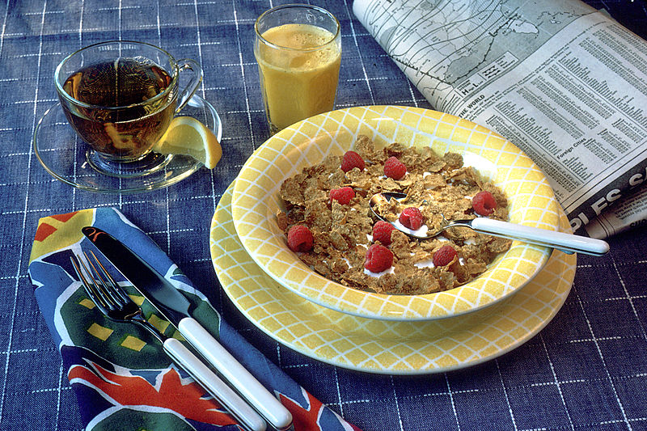

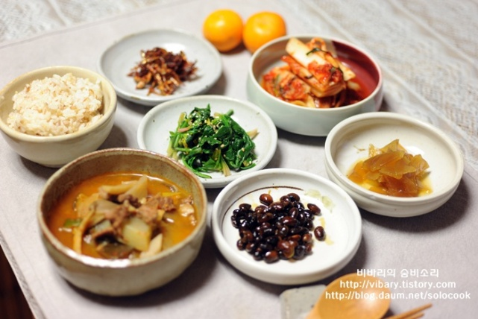

Worksheet #1 Learn cooking verb as below.

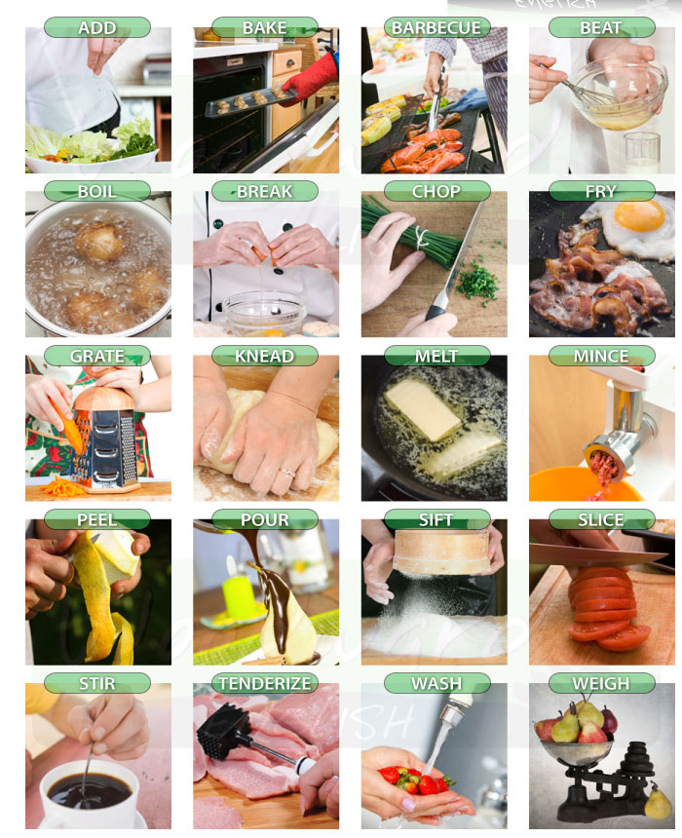

Worksheet #2 _Read a sentence

English- Muffin Egg Pizzas 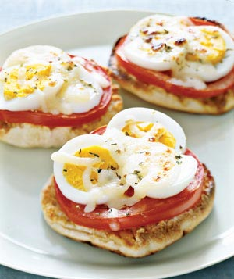
- Ingredients
4 English muffins
Olive oil
Tomato slices
2 hard-cooked eggs, sliced
Grated mozzarella
Oregano
Kosher salt
- How to cook
- Make Hard-Cooked Eggs.
- Toast 8 English-muffin halves and place on a cookie sheet.
- Drizzle each with olive oil, then layer on tomato slices, hard-cooked egg slices (1/2 an egg each), and a little grated mozzarella. Sprinkle with oregano and kosher salt.
- Broil 5 minutes or until the cheese melts

Worksheet #3 _Making a breakfast (Group A)
Strawberry Smoothie 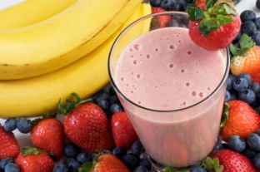
- Ingredients
10 Strawberries
1/2 Cup or 125ml of milk
5 Ice cubes
1 tablespoon of sugar (optional)

- How to cook (Presenter & Assistant) - 2 students

- Recommend another breakfast – 1 student

- Why smoothie is good as breakfast? - 1 student

Worksheet #3 _Making a breakfast (Group B)
Pan Cake 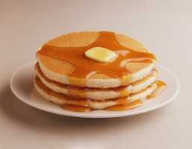
- Ingredients
1 cup flour
2 tablespoons sugar
2 teaspoons baking powder
1/2 teaspoon salt
1 cup milk
2 tablespoons unsalted butter, melted, or vegetable oil
1 large egg
1 tablespoon vegetable oil
Assorted toppings, such as butter, maple syrup, confectioners' sugar, honey, jams, preserves, sweetened whipped cream, or chocolate syrup

- How to cook (Presenter & Assistant) - 2 students

- Recommend another breakfast – 1 student

- Why pancake is good as breakfast? - 1 student

Worksheet #3 _Making a breakfast (Group C)
Fruit Salad 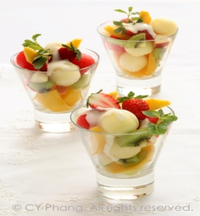
- Ingredients
1 apple
4 bananas
4 kiwis
1/2 pineapple
1/2 cup yogurt
1~2 tablespoons honey
Assorted toppings, such as nuts

- How to cook (Presenter & Assistant) - 2 students

- Recommend another breakfast – 1 student

- Why fruit salad is good as breakfast? - 1 student

Worksheet #3 _Making a breakfast (Group D)
Egg Sandwich 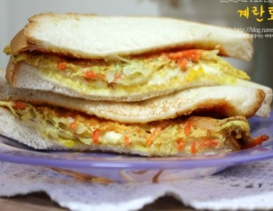
- Ingredients
2 pieces White bread
1 tablespoon butter
1 egg
2 tablespoons napa cabbage
1 tablespoon carrot
2 teaspoons brown sugar
2 teaspoons ketchup
2 teaspoons mayonnaise
Salt and pepper

- How to cook (Presenter & Assistant) - 2 students

- Recommend another breakfast – 1 student

- Why egg sandwich is good as breakfast? - 1 student

Draw breakfast on the plate
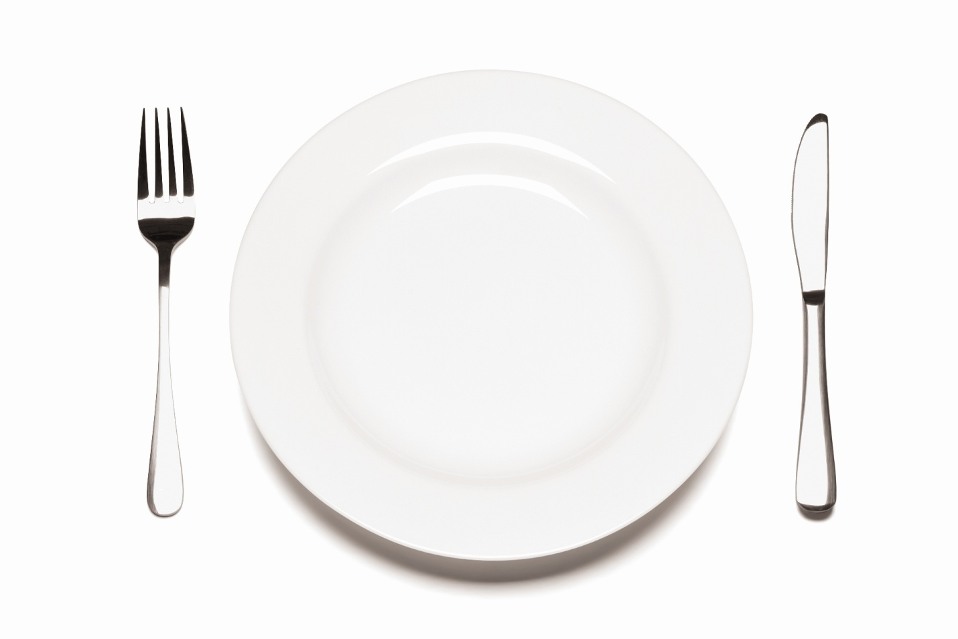

Worksheet #4 _Asking about breakfast (Discussion)

STUDENT A’s QUESTIONS (Do not show to Student B)
1) | What did you have for breakfast this morning?
2) | Has what you eat for breakfast changed over the years?
3) | What do you do while having breakfast?
4) | Do you prefer to eat breakfast alone or with other people?
5) | Do you ever eat breakfast in a restaurant or canteen etc?
6) | What do you think of breakfasts in other countries?
7) | Is the breakfast you usually eat very healthy?
8) | How often do you skip breakfast or have it on the go?
9) | Can you eat “lunch-style food” or “dinner-style food” for breakfast?
10) | What do you think of breakfasts at hotels?

STUDENT B’s QUESTIONS (Do not show to Student A)
1) | Do you always have time to eat what you want for breakfast?
2) | How important is having breakfast?
3) | Do you watch breakfast television?
4) | Do you make your own breakfast?
5) | What is a traditional breakfast in your country?
6) | Must breakfast be eaten in the morning?
7) | Do you ever eat breakfast at fast food restaurants?
8) | Do you like having breakfast in bed?
9) | What is the origin of the word breakfast?
10) | Do you prefer a cooked breakfast?

SOS Activity [Making a story]
Making a story filling in the speech bubble with partner.
