Listening Speaking Reading Grammar Writing

Topic: Comparative

Instructor:  Sarah | Level:  Intermediate | Students:  6 | Length:  30 minutes

Materials: Script worksheet (12 copies)
Eliciting picture that can compare with each other.
Pair worksheet for Post-Activity
Wall chart – comparative form
White board, board markers

Aims: -Main Aim: Students will be able to use comparative by drawing, role-play etc.
-Secondary Aim: Students will be able to learn comparative forms by doing activities.
-Personal Aim: I want to study how to let students know comparative easily.

Language Skills- Reading : Students will read the worksheets.
Listening : Students will listen to other students speaking.
Speaking : Students will speak by participating activities.
Writing : Students will write on their worksheets.

Language Systems:
Phonology : er, ir, or, ear
Lexis : Celsius, population, Pluto, Venus
Function: Announcement
Grammar: Comparative
Discourse: Monologue, Dialogue

Assumptions: Students already know:
-How the class is set up and run.
-the teacher’s style of teaching and the pace of the course.
All students know how announcers speak..

Anticipated Errors and Solutions:
-Students may not be able to understand how to make variety of script.
→Provide students some sources and give them 1~2 examples.
→Demonstration again briefly.
-If time is short
→Let 3~4 students draw for Pre-Activity.
→Cut third script for Main-Activity.
-If students finish their tasks earlier than anticipated.
→Give students to draw one more time.

References: Google image

Lead-In
Materials: Board
Time | Set Up | Student Activity | Teacher Talk
2 min | Whole Class | Answering teacher’s question | Hello everyone, how are you doing?  How was your weekdays?

Pre-Activity
Materials: Board, Marker, Eliciting picture, Wall chart
Time | Set Up | Student Activity | Teacher Talk
8 min | Whole  Class  Whole Class | Answer  questions and  elicit word today’s grammar | Elicit the word “Comparative”  (Show students the picture of two kids measuring their height)  -“What are they doing?”  “They’re comparing their height with each other”  “We will know about Comparative today”  Model the word “Comparative” on the board.  - Listen and Drawing Activity  Instruction  Now I’ll explain situations including comparative  Listen carefully and describe the situation on the board one by one.  Demonstration  I’ll show you first “There are a boy and a girl”  “The boy taller than the girl”  At the same time, draw on the board.  We have 7 minutes.  CCQ:  -Do they have the same height?  -Who is taller?  ICQ:  -Do you have to write sentences?  -Where do you have to draw on?  “Let’s begin in a clock wise”  Q#1 : The girl’s hair is much longer than the boy  Q#2 : The boy has bigger eyes than the girl’s.  Q#3 : The boy looks a little happier than the girl  Q#4 : The girl’s legs are much thicker than the boy’s  Q#5 : The boy’s arms are longer than his legs.  Q#6 : The boy has more expensive cellphone than the girl’s.  Involve in the activity discreetly and boost up students’ courage.  Give them clear and fun situations with clear pronunciation.  Answer students if they ask questions.  If the activity end earlier than expectation.  Do the activity one more time.  Show students the wallchart “Form of Comparative”  After look at the chart and talk about pronunciation /ir/, /er/, /or/(doctor), /ear/(earth,early)

Main Activity
Materials: Worksheets
Time | Set Up | Student Activity | Teacher Talk
10 min  2 min | Groups  Of two  Whole Class | Announce the scripts  Correct the worksheet by comparing with the other team’s worksheet verbally | - In the News Center (Announcing)  Instructions  I’ll divide into two groups.  One is the Times News Center and the other is  The Herald News Center.  You have to pretend to be announcers.  I’ll give 3 scripts to each team.  And you choose one script. Then you have to announce to us.  You have to explain by using only comparative. The examples are on the script.  The opposing team has to guess the contents and fill in the blanks during the announcing.  And vice versa.  (Distribute sample worksheets)  Demonstration  “Hello I’m Sarah, a announcer of ABC News Center. I have a scientific news. ~  CCQ  -Can you know the size of the planet without comparison target ?  -Do we have use comparative only?  ICQ  -How many students in each team?  (Distribute worksheets)  I’ll give you 30 second for choosing script and preparing.  “Go Times News Center first”  Monitor discreetly and boost up students’ courage.  Answer students if they ask questions  If students have difficulty in explaining.  →Give them hints.  Give time warning: 30 seconds left.  Be flexible with time. Give 1 more minute if they need it.  “Time’s up”  Error correction  -Correct the worksheets.

Post Activity
Materials: Worksheet
Time | Set Up | Student Activity | Teacher Talk
3 min  5 min | Pair work  Individually  In pair work | Search comparison factors with partner.  And write the worksheet  Students read their work. | - Writing Activity  “Comparing with My Partner”  Instructions  Now you’ll compare with your partner.  Search for the differences.  And write on your own worksheet on your perspective.  You can use comparative expressions only.  Demonstration  Compare with someone verbally.  CCQ:  -Do you have to search the same thing of your partners?  -How can we explain the differences?  ICQ: We have 5 minutes.  - How much time do you have?  (distribute worksheet)  Monitor discreetly. Answer students if they ask questions.  Give time warning: 30 seconds left.  - Presentation  Instructions  Now you can tell us the differences.  Let’s start in a clock wise.  We have 5 minutes.  ICQ: -How much time do you have?  “Now begin”  Monitor discreetly. Answer students if they ask questions.  Give time warning: 30 seconds left.  Be flexible with time.  “Time’s up  Error correction  -Correct the worksheets.  “Good job today, See you guys tomorrow”

SOS Activity
Materials: Worksheet
Time | Set Up | Student Activity | Teacher Talk
5 min | Individually |  | Categorizing Activity  Instructions  Today we learned many words in various fields.  Let’s review the words and categorize them.  We have 5 minutes.  Demonstration  Show students the worksheet.  CCQ:  -Are ‘father’ and ‘Venus’ in the same  category?  ICQ : -How much time do you have?  (distribute the worksheet)  “Now begin”  Monitor discreetly. Answer students if they ask questions.  Give time warning: 30 seconds left.  Be flexible with time.  If I have more time, let students compare the result with their friends.  “Time’s up  Error correction  “Good job today, See you guys tomorrow”  ”

Asia has population than Africa.
Africa has population than Europe.
South America has population than Africa.
North America has population than Africa
Europe has population than Africa.
North America has population than South America.
North America has population than Europe.
Europe has a little population than North America.
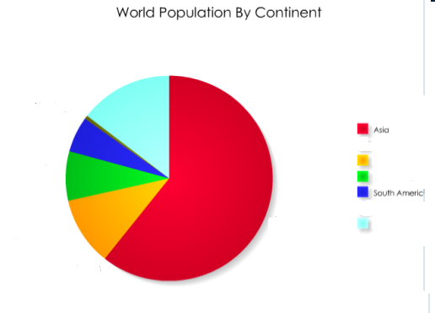
Hello, I’m an investigator from the Times.
Asia has population than Africa.
Africa has population than Europe.
South America has population than Africa.
North America has population than Africa
Europe has population than Africa.
North America has population than South America.
North America has population than Europe.
Europe has a little population than North America.
<Examples> bigger, smaller

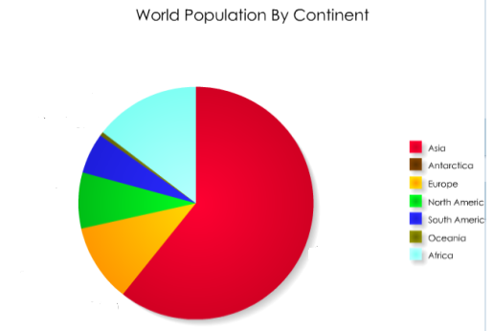

Guess the name of the Mountains
<Examples>
Mt. Seorak Mt. Geumgang Mt. Beakdu
Mt. Jiri Mt. Halla

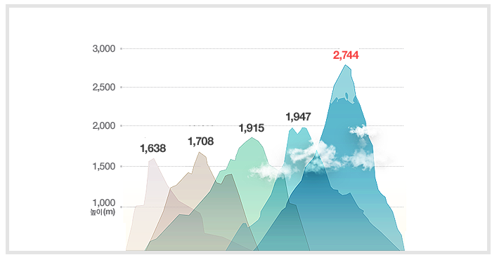

Jiri

Hello, I’m from Times.
According to research,
Mt. Seorak is than Mt. Geumgang.
Mt. Seorak is than Mt. Jiri.
Mt. Halla is than Mt. Beakdu.
Mt. Halla is than Mt. Jiri.
Geumgangg
Seorak
Jiri
Halla
Beakdu
<Examples> higher, lower

Hello, I’m the Herald Weather Forecaster
Friday is 31°c (degree Celsius).
Saturday is 5°c than Friday. etc.
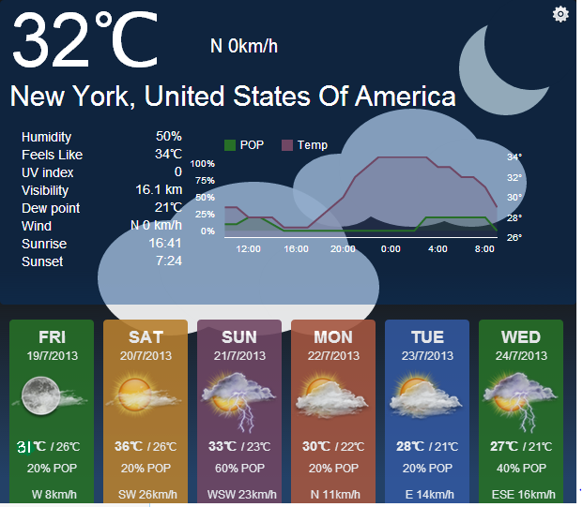
<Examples> hotter , cooler

Guess temperature

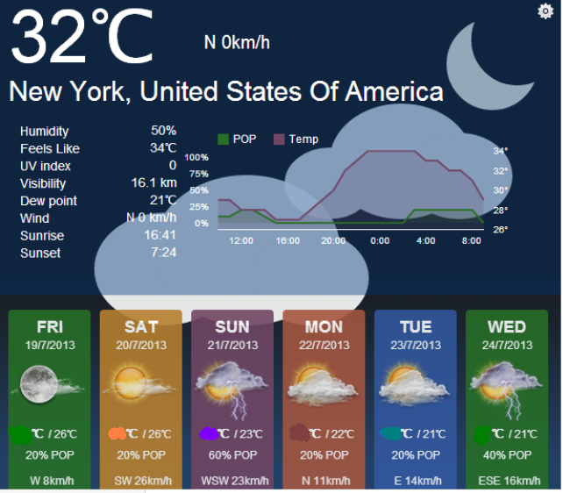

Welcome to Herald Sports News

<Examples> more, less

I will tell you the Olympic result.
U.S got 104 medals.
China got 17 medals than U.S
U.S got 22 medals than Russia.
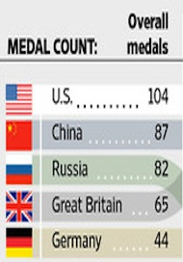
etc……
Guess Olympic Score

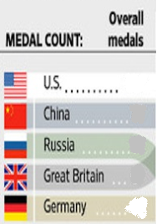

Hello, I’m a Science reporter.(sample)
According to the research,
The Venus is than earth.
The Pluto is than Mercury.
The Mars is than Pluto.
The Venus is than Mars.
The Mars is than Mercury.
<Examples> bigger, smaller

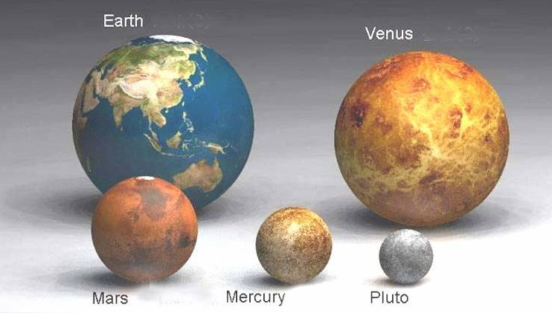

Let’s guess size of the planets.

Venus Pluto Mars

<Examples> bigger, smaller

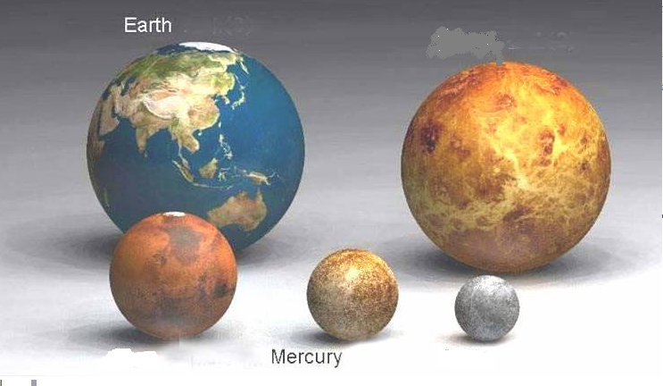

Here is the research for family members’ the hour of rising.

<Examples> earlier, later


Grandfather Grandmother Mother Father Son Daughter
5 AM 6 AM 8 AM 7 AM 9 AM 10 AM

Grandfather gets up at 5 AM.
Mother gets up 3 hour than Grandfather.
Father gets up 1 hour than Mother.
Keep Going~

Here is the research for family members’ the hour of rising.

Grandfather Grandmother Mother Father Son Daughter
AM
AM
AM
AM
AM
5 AM

Here is the research for family members’ age.

Grandfather Grandmother Mother Father Son Daughter

80

Here is the research for family members’ age.
<Examples> younger, older

Grandfather Grandmother Mother Father Son Daughter
80 75 45 40 10 5

Grandfather is 80 years old.
Father is 40 years than Grandfather.
Mother is 5 years than Father.
Keep Going~

Let’s Compare with My Partner

1 .

2 .

3 .

4 .

5 .


Connect up with the right category

Mars
Beakdu Family
Grandfather
Sports Planet
Daughter
Geumgang
Pluto Weather
Medals
Forecast
Seorak Olympic
Venus
Celsius Continent
Asia
Degree
Europe
Population

