Listening Speaking Reading Grammar Writing

Topic: COORDINATING CONJUNCTIONS

Instructor:  GINA&MISHA | Level:  intermediate | Students:  10 | Length:  30 Minutes

Materials:
- White board and board marker
- Wall-chart for FANBOYS acronym
- Pictures activity(3 copies)
- Example picture for Pictures activity (1 copy)
- Cloze activity worksheet(5 copies)
- Puzzle worksheet(10 copies)

Aims:
- Main aim: To enable students to improve their grammar skills by participating and practicing through activities.
- Secondary aim: Students will learn rules of conjunction on how to link words, phrases and clauses.
- Personal aim: I want to improve my confidence and time management

Language Skills:
- Reading: Student will read the work sheet before working out the sentences.
- Listening: Student will listen to other student’s presentations.
- Speaking: Student will talk by presenting their discussed work.
- Writing: Student will write their sentences.

Language Systems:
- Phonology: /θ/(Sounds for ‘toothache’)
- Lexis/Vocabulary: New word that learn, “acronym”
- Function: Promising expression (Ex. I will be…)
- Grammar: Coordinating Conjunctions
- Discourse: Dialogue

Assumptions:
- Students already know:
How the class is set up and run(There will be 10 students and will work in pairs or groups)
The teacher’s style of teaching and the pace of the course
- All the students are intermediate students(Age 12 and up)
- Students exchange ideas and opinions to complete tasks

Anticipated Errors and Solutions:
- Students may not able to follow the activities
- Demonstrate before they work on their worksheet.
- There may not be enough time to complete the lesson;
- Assign the post activity writing task as a homework assignment
- If students finish their tasks earlier than anticipate
- We can move forward to the SOS activity.
- If students cannot elicit the topic
- Play hangman starts with ‘C’

References:
- Visual aids from www.google.com
- http://www.really-learn-english.com/
- Pearson Longman; Fundamentals of English Grammar 4th Edition

Lead-In
Materials: None
Time | Set Up | Student Activity | Teacher Talk
1min | Whole class | Answering teacher’s question | Hello, everyone!  How are you today?  How well do you know your grammar?

Pre-Activity
Materials: Wall-chart, Board and board markers
Time | Set Up | Student Activity | Teacher Talk
4min  4min | Whole class  Indivi  dual | Answering teacher’s question  Listen to the teacher  Do the activity | Procedure:  Elicit the word ‘Conjunctions’  Write two sentences on the board  Sentence #1  It started to rain.  Sentence #2  I bought an umbrella.  How do we link these sentences together?  Students will answer: It started to rain so I bought an umbrella.  In grammar, what do we call for the “so”?  Yes. It’s “Conjunctions!”  Model  Write “Conjunctions” on the board.  What is Conjunction?  It’s use to link words, phrases and clauses.  CCQ  Why she bought an umbrella?  Is it raining now?  FANBOYS activity  Instruction  Please try to find the seven coordinating conjunctions through these acronym = FANBOYS  F=for  A=and  N=nor  B=but  O=or  Y=yet  S=so  Demonstration  For example, we just learned “so” as one of the seven coordinating conjunctions. (Teacher place the “so” card next to the “S”)  ICQ  What is the “F” stands for?  Ss will answer “for”  Then call out the students to place the card accordingly.  “Now begin”  Monitor  Monitor discreetly.  Each student put the card next to the picture.  Check the answers orally.

Main Activity
Materials: Pictures, board and markers.
Time | Set Up | Student Activity | Teacher Talk
2min  5min  3min | Whole class  Groups  Groups | Listen to the teacher  Do the activity  Group leader will present their sentences | Pictures activity  Instructions  Each group will come out with their own sentences based on the pictures given.  I will group you all into 3 groups. Each group will have to work out their own sentences according to the pictures. You have 5 minutes to work on it.  (Hand out the pictures)  Demonstration  For example, I will show a picture and get one of the students to create a short sentence.  Show student pictures of apple and banana.  “I can’t decide if I want an apple or a banana with my yogurt”  ICQ  Did you get your own pictures?  How much time do we have?  “Now begin”  Monitor  Monitor discreetly.  Give ideas or opinions if they get stuck.  Give time warning: 3minutes, 2minutes, 1 minute, 30 seconds left.  Be flexible with time.  Give students 1 more minute if they need it.  “Time’s up”  Each leader will write their sentences in front of the class.  Briefly review the error correction for the sentences  Answers will vary but examples are;  1. Jimmy and Jane are good friends  2. Jimmy would love to own a nice car, but he has got no money.  3. It started to rain, so we have to stay in the shed.  4. Jane went to a dentist for she was having a toothache.  5. I dislike neither the silkworms nor the snake wine.  6. The weather is sunny, but I am feeling cold.  7. I ate a lot, yet I am still hungry.  8. I cannot sleep well for the baby was crying the whole night  9. It is a holiday but I have to stay at work.

Post Activity
Materials: cloze activity worksheet, board and marker
Time | Set Up | Student Activity | Teacher Talk
2min  3min  3min  3min | Whole class  In pairs  Whole class | Listen to the teacher  Students will discuss  Listen to the teacher | Instruction  Now I will group all of you into pairs. You will discuss about what to fill in the blank in order to connect the sentence based on this worksheet.  You will have 3 minutes to do it.  Demonstration  Write the example on the board  Exp: I waved at my friend but she didn’t see me.  (hand out the worksheet)  ICQ  ----, who is your partner?  How much time do we have?  “Now begin”  Monitor  Monitor discreetly.  Give ideas or opinions if they get stuck.  Give time warning: 2minutes, 1minute.  Give time warning: 30 seconds left.  Be flexible with time.  Give students 1 more minute if they need it.  “Time’s up”  Now let’s check the answer from each pair for what have discussed.  Conclude lesson  Review and error correction  Do error correction if the usage of conjunction is incorrect.  And briefly discuss the Coordinating Conjunctions.  Correct the pronunciation  Especially /θ/(Sounds for ‘toothache’)  Good job today.  Go home to study the second conditional conjunction for tomorrow’s class.  Thank you for participating today.  See you tomorrow.

SOS Activity
Materials: Board and markers
Time | Set Up | Student Activity | Teacher Talk
2min  2min  1min | Whole class  Individual | Listen to the teacher | Instruction  Students will do word search puzzle.  I will give you 2minutes to do it.  (Hand out the puzzle worksheet)  Demonstration  Solve a puzzle on the puzzle worksheet  ICQ  Are you working individually?  Monitor  Monitor discreetly.  Give ideas or opinions if they get stuck.  Give time warning: 1minute, 30 seconds left.  Be flexible with time.  Give students 1 more minute if they need it.  “Time’s up”  Check the answer orally

Worksheet
Examples:
- I will be late to the party, I am working until seven.
- Tom likes to read write.
- Sally does not like the mountains, does she like the ocean.
- I wanted to ride my bike, the tire was flat.
- Fred wants peas or carrots supper.
- I love a chocolate, I do not eat a chocolate ice cream.
- She was late to work, her boss made her stay after five.
- I want to go see a movie, my sister has my car
- Mr. and Mrs. Smith didn’t have any children grandchildren
- The joke was very funny, everybody laughed

The CONJUNCTIONS for the blanks
FOR, AND, NOR, BUT, OR, YET, SO


Worksheet (answer for teacher)
Examples:
- I will be late to the party, for I am working until seven.
- Tom likes to read and write.
- Sally does not like the mountains, nor does she like the ocean.
- I wanted to ride my bike, but the tire was flat.
- Fred wants peas or carrots for supper.
- I love a chocolate, yet I do not eat a chocolate ice cream.
- She was late to work, so her boss made her stay after five.
- I want to go see a movie, but my sister has my car
- Mr. and Mrs. Smith didn’t have any children or grandchildren.
- The joke was very funny, so everybody laughed

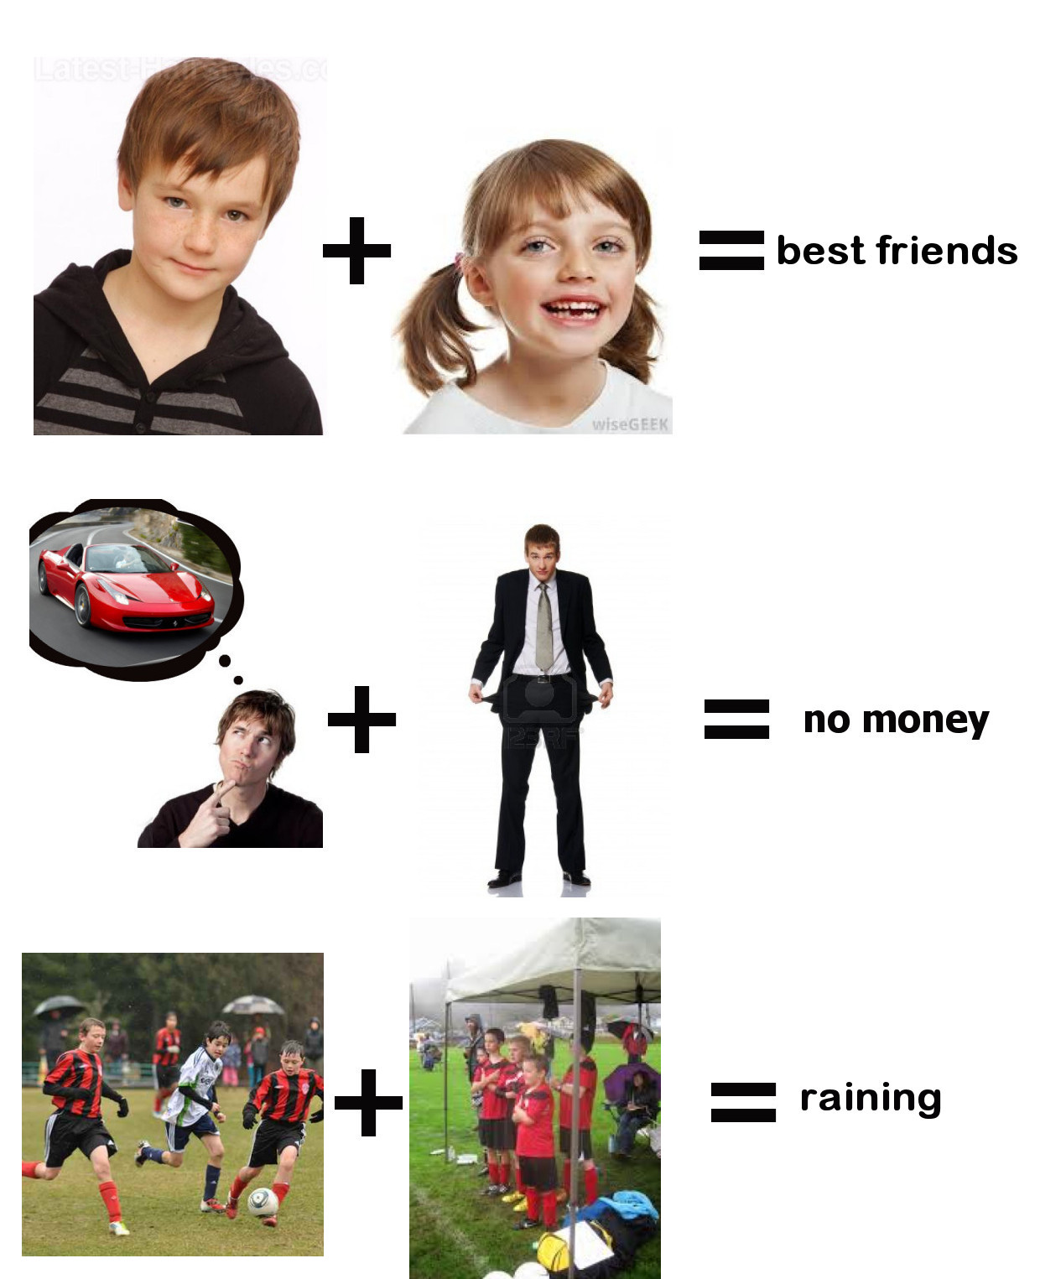Make sentences with this conjunction
FOR, AND, NOR, BUT, OR, YET, SO
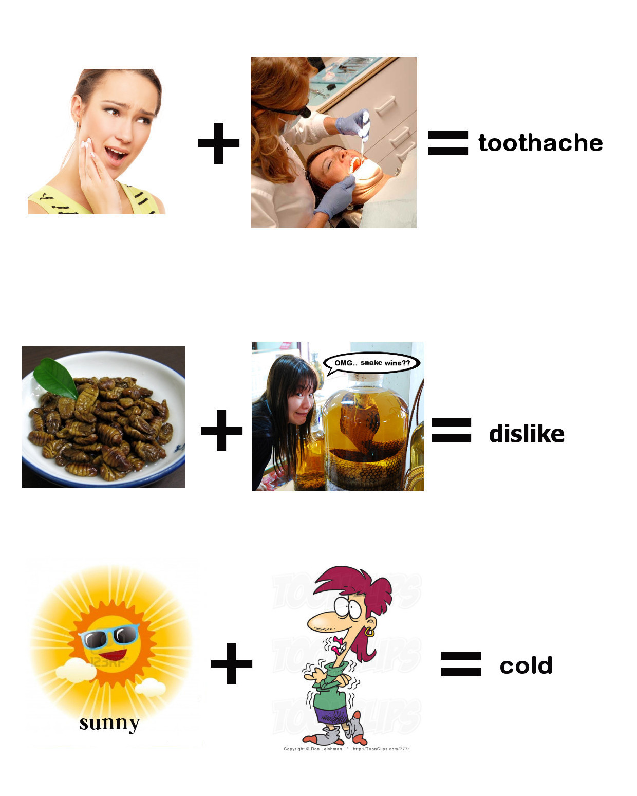
Make sentences with this conjunction
FOR, AND, NOR, BUT, OR, YET, SO
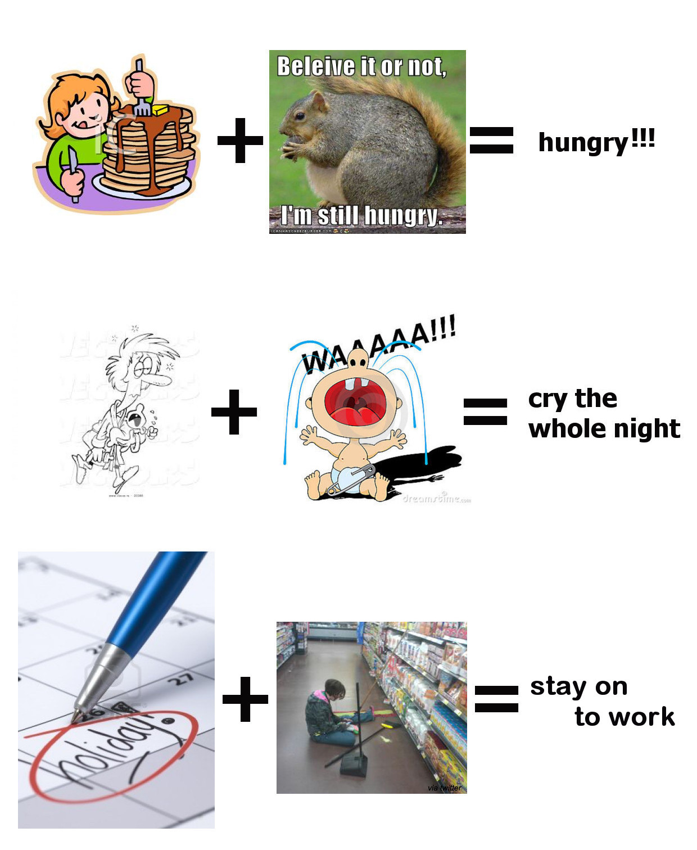
Make sentences with this conjunction
FOR, AND, NOR, BUT, OR, YET, SO
Word search puzzle.
Circle the connecting words from the puzzle. The words may be horizontal, vertical, or diagonal. The first letter of each word is highlighted in gray.

T | B | M | R | L | R | B | A
O | M | N | O | R | U | B | L
A | O | M | H | T | F | E | T
W | N | T | T | K | O | T | Y
R | I | D | I | P | R | E | O
E | J | T | E | F | T | U | P
M | R | O | N | T | W | X | G
T | B | V | S | O | J | E | H



