Should We Legalize Same-sex Marriage?

Instructor: Christine  (lee A Reum) | Level:  intermediate | Students:  6 | Length:  30 minutes

Materials:
-Reading Text(6 copies):Main Activity
-visual aid pictures
-Pros Cons examples of scripts
-White board, board maker & tape

Aims:
-Main Aim : Ss will express their opinion about same-sex marriage by debating and speaking
-Secondary Aim: Ss will understand the various words of today’s topic by drilling and doing activities
-Personal Aim : I want to improve my explanation skills and make it simple

Language Skills:
-Reading: Ss will read reading text
-Listening: Ss will listen to other student’s opinions and teacher’s explanation
-Speaking: Ss will speak their ideas and answers
-Writing: Ss will write the their answers on their worksheets

Language Systems:
-Phonology : None to discuss
-Lexis : words used in describing same-sex marriage
( assert, deprive, inheritance, inclination, refute, decline, stain)
-Grammar: None to discuss
-Function : Expressing opinion, discussing
-Discourse : Dialogue , Monologue

Assumptions:
Students already know:
-how the class is set up and run(there will be 2 student groups at each table)
-the teacher’s style of teaching and the pace of the course
-all the students are adults (Age 25 and up)
-all the students understand homosexuality

Anticipated Errors and Solutions:
-Students may not be able to follow the passage
→ Give them Explanation until they get the idea
- Students may need more time to debate
→ Give them 1~2 minute more

References:
-Scrivener, Jim. Learning Teaching. Macmillan, 2011.
- Visual aid: http://www.google.co.kr
- Article : www.theedutimes.com

Lead-In
Materials: Board (1min)
Time | Set Up | Student Activity | Teacher Talk
1 min | Whole class | Answering teacher’s questions | Hello everyone! How was your weekend?  Asking students their opinion about marriage.  ( ),Are you a single?  Do you have a someone who love you?

Pre-Activity
Materials : Visual Aids, Worksheet, Board and makers (7min)
Time | Set Up | Student Activity | Teacher Talk
1 min  2min  4min  1min | Whole class  Whole class  Work individually  Whole class | Answers elicited questions  Listen to teacher  Do activity  Read the text | Procedure  Eliciting  (Show the students visual aid-picture #1,#2, #3)  1. Eliciting today’s topic  Model  Write it on the board  -Warm up( Before You read)  Let them know vocabulary related to the topic.  Let them match the proper meaning words one by one  Reading the text.  (Distribute the worksheet)  Instructions  Let’s read the article  Think about your thought as you read this article taken from the newspaper.  I will give you 4min to read. Read individually and silently.  ICQ  Do you read with your partner?  How much time do you have?  ( Pass out the text and run the task)  Feedback  Do you need more time to read?  What do you think about this article?  Asking reading questionnaire based on comprehension  -What countries approve their same sex marriage?  -In Korea, Is same sex marriage legal?

Main Activity
Materials: 6copies of the text , Board and makers (13min)
Time | Set Up | Student Activity | Teacher Talk
1min  2min  10min | Whole  class  Groups  Groups | Listen to teacher  Share their opinion  Speech their opinion | Procedure:  Debating Activity  (Show them chart summarized)  Instructions  We will divide into 2 groups  One group will be for the Same-sex marriage,  The other will be against the Same-sex marriage.  Before starting debating, you should share your ideas and opinions first with your members.  While debating, I will make it a rule to take turns for each member. I will give you 2min to prepare your speech with your members.  ICQ  -What are you supposed to do?  - How much time do you have?  (Give Ss 2min to prepare their speech)  Let them debate freely ( for 10 min)  Let’s begin

Post Activity
Materials: None (6min)
Time | Set Up | Student Activity | Teacher Talk
1min  4min  1min | Whole class  Group  Whole  Class | Listen to teacher  Student do role play  Listen to teacher | Procedure:  Role Play  Instructions  We are going to pretend to be a woman who has same-sex preference and to be her mother.  The situation is the time when you get to know your sister is a gay.  If you know this, what would you like to say to her? Imagine this situation.  You will work in your partner.  A’s will be the woman and B’s will be her mother.  You have 4minutes.  When I say ‘begin’ you will ask questions freely and answer them.  ICQ  -Are you working in pairs?  -How much time do you have?  Monitor discreetly and participate within each student.  Give time warning: 1 minutes; 1 minute; 30 seconds left.  Be flexible with time. Give 1 more minute if they need it.  -Time’s up.  2.Conclude lesson  Today we learned about expressing our opinion about Same-sex marriage  Error correction  Elicit today’s words for Ss  Do any error correction.  If there is pronunciation correction let them correct the word  Good job today.  Thank you for your participation and see you!

SOS Activity
Materials: None(4min)
Time | Set Up | Student Activity | Teacher Talk
1min  3min | Whole  Class | Listen to teacher  Write and review | Instructions  Text Writing  We have talked a lot about today’s topic.  Now we will write what we learned or were heard when debating.  While thinking, make a list on the sheet.  I will give you 3 min to write.  (Give them workshhets)  Let them write on the sheet  ICQ  Are you working in pairs?  How much time do you have?  Monitor actively and participate within each student.  Good job today.  Thank you for your participation and see you!
Should We Legalize Same-sex Marriage?
Vocabulary) assert , deprive, inheritance , inclination, refute, decline, stain

In recent days, the number of people who support same-sex marriage has been increasing, especially among the young people. However, there is still severe criticism about the same issue among the older generations and religious people.

As of now, there are over ten countries, which allow same-sex marriage including the Netherlands, Belgium, Canada, and Spain. In Korea, a famous male film director got married to a person of the same sex and it has become a much-discussed issue. Same-sex marriage is not illegal, so it can’t be banned in Korea but there has been no case of a same-sex couple acknowledged as a legal couple.

Those who are in favor of same-sex marriage assert that homosexual deserve to be treated as ordinary people in the country, so they should receive legal benefits including health insurance and inheritance. Also, they say that it is unreasonable to deprive them of their right because of their sexual preference.

They maintain that sexual minorities can't change their natural inclination and it is also against constitutional law. Everyone has the right to pursue one’s own happiness. They say that Korea constitution clearly states equality before the law.
Moreover, it states that no one should be discriminated against because the right to marry is guaranteed based on one’s dignity and freedom.

They refute the fact that if we allow same-sex marriage, the birth rate declines.
Although they ban same-sex marriage, homosexual won’t marry someone of the opposite sex or give birth to a baby, so banning same-sex marriage has nothing to with the birth rate of the society, they say.

On the other hand, those who are against same-sex marriage point out that same-sex marriage stains our traditional values about marriage, which consist of a man and woman. In short, it is too early to discuss this issue in Korea.

Also, if they adopt a baby, the child may experience identity issues or suffer discrimination because of his or her parents.

Those who are against same-sex marriage claim that it will affect, not this generation’s birthrate but next. If the homosexual couple adopts a child, the child will likely support homosexuality, and therefore, he or she may not marry a person of the opposite sex. Consequently, it leads to a low birth rate.
Debate: Should We Legalize Same-Sex Marriage?

Same-Sex marriage is still controversial in many countries, including Korea.
Some say that homosexuality is abnormal and unnatural, so same-sex marriage should not be legalized. Other say that allowing same-sex marriage is protecting one’s freedom and dignity. What do you think about this issue?

Pros
1. Homosexuality should be treated equally since their human rights are important.
2. Allowing same-sex marriage may help to end our prejudices against sexual minorities.
3. Same-sex marriage has nothing to do with low birth rates.

Cons
1. Same-sex marriage ruins traditional values in Korea.
2. A child adopted by a same-sex marriage couple may be more likely to marry a person of the same sex.
3. Same-sex marriage actually affects birth rates.

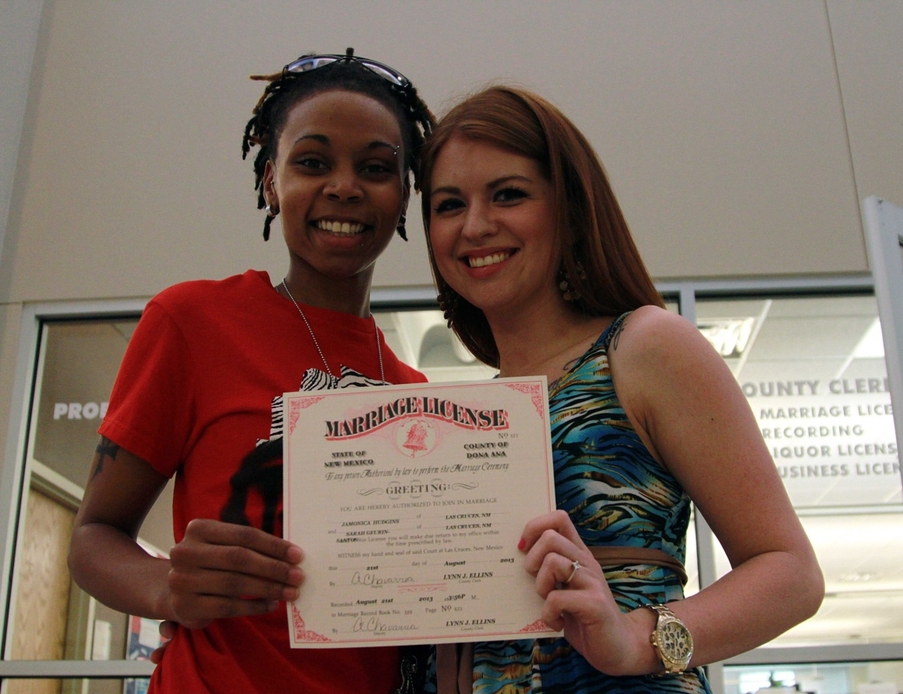

SOS Worksheet
Make a list and write the sentences used in debating.

Pros

1.

2.

3.

Cons

1.

2.

3.

