X Listening X Speaking Reading Grammar Writing

Topic: Transportation
Instructor:  June(Hyo Im Nam) | Students Age –  Pre-Intermediate(8~9 years old) | Number of students:  12 | Lesson Length: 50 min
Materials: Taxi Picture
Car Picture
Van Picture
Ship Picture
Motorbike Picture
Bus Picture
Train Picture
Subway Picture
Plane Picture
Truck Picture
Toys
Car
Truck
Helicopter
Ship
Transport Worksheets
Transport Survey Worksheets,
Transport Crossword Worksheets
Board, board marker
Computer , Portable speaker
Song “The Transportation” “How Long Does It Take?”
Transport Song Worksheet

Aims/Objectives:
Students will be able to use the expressions “How do you come to school?” and “How long does it take?” by listening songs.
Students will be able to use the preposition “by” in front of transportation modes practicing worksheets.
Students will be able to use transportation vocabulary in their everyday lives by practicing worksheets and singing songs.

Language Skills:
- Reading : Sharing the list, the worksheet, sentences
- Listening: Listening to the song, to the teacher, and to the presentation of other students
- Speaking: Sharing the favorite thing, answering, singing the song, and presenting
- Writing: Making the list of favorite things, making descriptive prepositional noun phrases of their favorite things

Assumptions:
- Students already know some words e.g. walk, taxi, bus, car, etc.
- Students are familiar with the models of transportation.
- Ss will enjoy and also have fun
- Ss will easily learn a pattern by practicing the pattern with T guidance

Anticipated Errors and Solutions:
Students may not have enough time to complete the activity. / Give them more time.( 1~2 minutes)
Students may not be able to match the words correctly. / Elicit target vocabulary or give some hints.
The computer doesn’t work. / Teacher will sing the song by self and help Ss learn the melody or use cell phone.
Activity takes too long. / The other activity may be shortened.
Ss might be shy. / Teacher gives encouragement.

References:
http://www.english-4kids.com/kidsvideos/elementaryvideos/transportation/transportation.html
http://www.englishexercises.org/makeagame/viewgame.asp?id=4503
http://www.timestesol.com/sbMn.php?pgNm=plans

Lead-In In (9)
Materials: Board, Board Marker
Toys:
Car
Helicopter
Truck
Etc.

Time: | Classroom Set Up: | Student Activity and Goals: | Teacher Procedure Instructions:
2 min  4 min  3 min | Whole class | Greet teacher  Ss look at transportation toys – become interested  Ss respond | Greet students  T shows transportation toys.  Ask Ss about those

Pre-Activity (14)
Materials: Pictures Of Transportations
Taxi Picture
Car Picture
Van Picture
Ship Picture
Motorbike Picture
Bus Picture
Train Picture
Subway Picture
Plane Picture
Truck Picture
Board, Board Marker.
Computer
MP3 The Transportation Song and “How Long Does It
Practicing the Pattern by using “The Transport Song” worksheet

Time: | Classroom Set Up: | Student Activity and Goals: | Teacher Procedure Instructions:
7 min  10 min | Whole class | Ss listen T’s explanation and song  Sing a song  Ss listen then Ss read sentences using the pattern | T play The Transportation Song And “How Long Does It Take?” song by Youtube.  Sing a song  T introduce “The Transportation” Song And “How Long Does It Take?” song by showing Youtube.  Handout, “The Transport Song” worksheet for practicing the pattern with sentences. T demonstrates first. Ask Ss to read the sentences using below patterns.  Examples  - You can drive a ~ .  - You can ride a ~ .

Main Activity (12)
Materials: Class Transport Survey
Board, Board Markers
Colored pencils, 12 papers
Time: | Classroom Set Up: | Student Activity and Goals: |  | Teacher Procedure Instructions:
15 min | groups of 2 | Transportation survey – mingle with classmates to ask and write down answers.  Draw a picture and present it |  | Ask Ss make 2 groups and provide survey forms to Ss.  Examples  - “How do you come to school?”  - “How long does it take?”  Draw my own transportation
Post Activity (12)
Materials: Transport Crossword
Board, Board Markers
Computer , Portable Speaker
The Transportation Song And “How Long Does It Take?” song by Youtube

Time: | Classroom Set Up: |  | Student Activity and Goals: | Teacher Procedure Instructions:
5 min  5 min  2 min | Whole class |  | Ss fill out the crossword with their partners.  Sing songs  Ss say goodbye | Provide crossword forms to Ss.  Sing songs again.  Congratulate and thank Ss for active participation

< SOS activity >
Talking about my interesting story related to the transport
“THE TRANSPORT SONG” worksheet

Listen and fill in the blanks:

You can drive a
you can drive a
you can ride on a
or in a bus
How do you get from A to B
over , through the , or in a ?
You can ride a
you can ride a
you can ride a
if you like
How do you get from A to B
over land, through the air, or on the sea?
You can sail a
if the wind is right
or inside a
if it’s watertight
you can fly a
way up in the sky
or a
if you want to try
How do you get from A to B
over land, through the air, or on the sea?
You can catch a
if you have the fare
or you can
from here to there
How do you get from A to B
over land, through the air, or on the sea?
You can fly a ship
if you have been taught
but first you have to train to be
an astronaut
How do you get from A to B
over land, through the air, or on the sea?
How do you get from A to B
over land, through the air, or on the sea?

What are these?

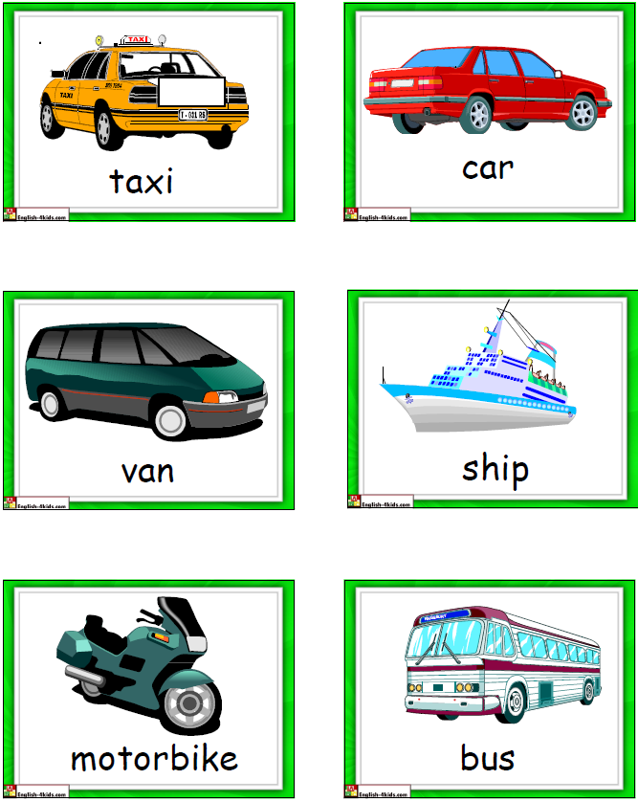

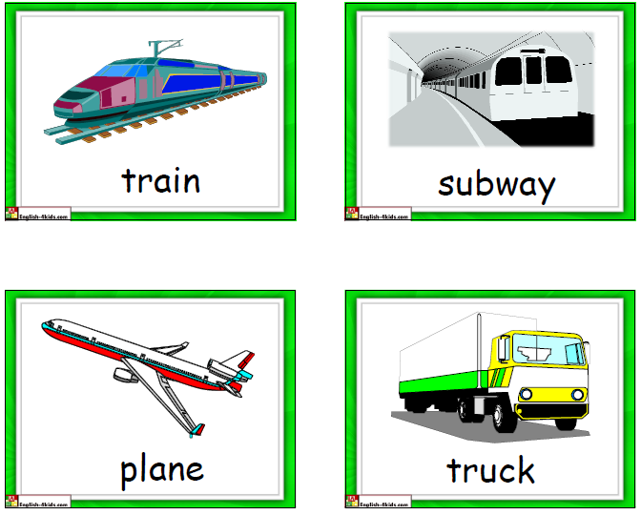

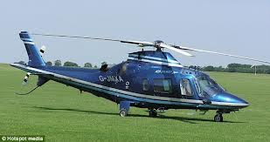

submarine helicopter

