Listening Speaking Reading Grammar Writing

Topic:
Chocolate

Instructor:  Gina&Misha | Level:  intermediate | Students:  10 | Length:  30 Minutes

Materials:
- White board and board marker
- Video clip about how to bake a chocolate cake (for 2.50min)
- Activity of arranging the making of the chocolate cake. (12 cards)
- Worksheet of article about “The Accidental Invention of the Chocolate Chip Cookie” (10 copies)
- Worksheet for making questions (2 copies)
- Jeopardy game
- Dessert Crossword puzzle(10 copies)

Aims:
- Main aim: To enable students to improve their reading skills by sequencing the chocolate cake order and reading article about the facts of chocolate.
- Secondary aim: Students will practice speaking through the activity and jeopardy game.
- Personal aim: I want to improve my confidence and time management

Language Skills:
- Reading: Student will read the worksheet about the chocolate cake recipe and “The Accidental Invention of the Chocolate Chip Cookie” article.
- Listening: Student will listen to how to bake an easy Chocolate Cake video clip and other student’s presentations.
- Speaking: Student will have a discussion in group during group activity and answer the question of jeopardy game based on the article.
- Writing: Student will try to make a question about article.

Language Systems:
- Phonology: Sounds for “flour”
- Lexis: “Necessity is the mother of invention.”
- Function: Explanation
- Grammar: Countable/Non-countable nouns
- Discourse: Dialogue, Monologue

Assumptions:
- Students already know:
How the class is set up and run(There will be 10 students and will work in pairs or groups)
How to play “Jeopardy game” and to solve “Crossword puzzle”
The teacher’s style of teaching and the pace of the course
- All the students are intermediate students(Age 15 and up)
- Students exchange ideas and opinions to complete tasks

Anticipated Errors and Solutions:
- Students may not able to follow the activities
- Demonstrate before they work on their worksheet.
- If students finish their tasks earlier than anticipate
- We can move forward to the SOS activity.
- If students cannot elicit the topic
- Ask some question related to the topic.

References:
- Visual aid: www.google.com
- Video clip: “Cake Recipes - How to Make Easy Chocolate Cake” http://www.youtube.com/watch?v=ZqMqTB7RSjo
- Article : http://www.todayifoundout.com/
- Crossword clue: http://www.crosswordsolver.org/

Lead-In
Materials: None
Time | Set Up | Student Activity | Teacher Talk
1min | Whole class | Answering teacher’s question | Hello, everyone!  How are you today?  What food actually makes you happy?  What do you do when you are feeling down?

Pre-Activity
Materials: White board and board marker, video clip about how to bake a chocolate cake, cards of making of the chocolate cake
Time | Set Up | Student Activity | Teacher Talk
2min  4min  1min  1min | Whole class  Group | Answering teacher’s question  Watch the video clip  Answering teacher’s question  Do the activity | Procedure:  Elicit the word ‘Chocolate’  Do you like candy?  (show students cacao bean picture)  Look at this picture  What is this?  - Ss will answer: Those are beans that come from the cacao tree, ("cocoa" is what the bean is called after it has been processed.)  (show them heart shaped box picture)  What do you want to fill in this box with?  - Ss will answer.  (In case they cannot elicit the topic)  What are the most popular sweets in the world?  What kind of present usually people give away for Valentine’s Day?  Model  Write “Chocolate” on the board.  CCQ  Is chocolate salty?  What kind of food can we make with chocolate?  Watch the video clip  Instruction  Show them the video clip about how to make an easy chocolate cake.  “Let’s watch the video clip!”  Once the video clip is finished, students have to arrange the cards of making Chocolate Cake in order.  I will put you into two groups, Group A and Group B. You will have 1minute to do it.  (Hand out the cards)  Demonstration  For Example, Please try to arrange the order for this.  Get one student to try.  ICQ  Are you working alone?  How much time do we have?  “Now begin”  Monitor  Monitor discreetly.  Give time warning: 30 seconds left.  Be flexible with time.  Give students 1 more minute if they need it.  “Time’s up”  Check the answer by showing the cards.

Main Activity
Materials: Worksheet of article, Worksheet for making questions
Time | Set Up | Student Activity | Teacher Talk
1min  1min  1min  2min  3min | Whole class  Individually  Whole class  Group  Individually | Answering teacher’s question  Read the article  Listen to teacher  Do the activity | - Article activity  Instructions  I will give you an article for you to read. Please try to understand the article.  Highlight the main points while reading.  I will give you 1 minute to do the reading.  Demonstration  Give an example, “It’s difficult to imagine that the chocolate chip cookie, one of the world’s most beloved sweet treats, was actually invented by accident.” This is one of main points.  ICQ  How much time do we have?  Are you working in a group?  “Now begin”  Monitor  Monitor discreetly.  Give ideas or opinions if they get stuck.  Give time warning: 1 minute, 30 seconds left.  Be flexible with time.  Give students 1 more minute if they need it.  “Time’s up”  - Article activity  Instructions  We will give you worksheet to make Literal, Interpretive, and Applied questions or answers. I will put you into groups. Group A and Group B. I will give you 2 minutes to do it.  Demonstration  Example for Applied question, If you were Ruth, what other ingredients you will put in the cookies?  (Hand out the worksheet)  ICQ  How much time do we have?  Are you working individually?  “Now begin”  Monitor  Monitor discreetly.  Give ideas or opinions if they get stuck.  Give time warning: 1 minute, 30 seconds left.  Be flexible with time.  Give students 1 more minute if they need it.  “Time’s up”  Teacher will call out the students to present their answers.

Post Activity
Materials: White board and board marker, Jeopardy game ppt
Time | Set Up | Student Activity | Teacher Talk
1min  10min  2min | Whole class  Group  Whole class | Answering teacher’s question  Play the game | Jeopardy game  Instructions  We are going to play a Jeopardy game.  The game is based on the article that you just read. I will put you into groups. Group A and Group B. The time limit of answering the question is only 30 seconds. For each an unanswered question, the next group can steal the question.  Demonstration  Choose the question by the number.  The points are subjected to the difficulty of the question.  ICQ  Are we working individually?  “Let’s start the game”  Monitor  Monitor discreetly.  Monitor the time for each question.  Announce the winner between group A and group B.  Briefly review the answers for the Jeopardy game.  Review and conclude the lesson  The actual meaning of “Necessity is the mother of invention” is "If someone really needs to do something, they will find a way of doing it”.  Do you enjoy the game?  The lesson is over.  See you tomorrow.

SOS Activity
Materials: White board and board marker, crossword worksheet
Time | Set Up | Student Activity | Teacher Talk
1min  3min | Whole class  Group | Answering teacher’s question  Doing activity | Crossword Puzzle  Instructions  We will do a crossword puzzle. I will put you into two groups, Group A and Group B. You will have 3 minutes to do it.  Demonstration  I will solve the question no.1 together.  (Hand out the worksheet)  ICQ  How much time do we have?  Are you working alone?  “Now begin”  Monitor  Monitor discreetly.  Give ideas or opinions if they get stuck.  Give time warning: 2minutes, 1 minute, 30 seconds left.  Be flexible with time.  Give students 1 more minute if they need it.  “Time’s up”  Check the answer orally.

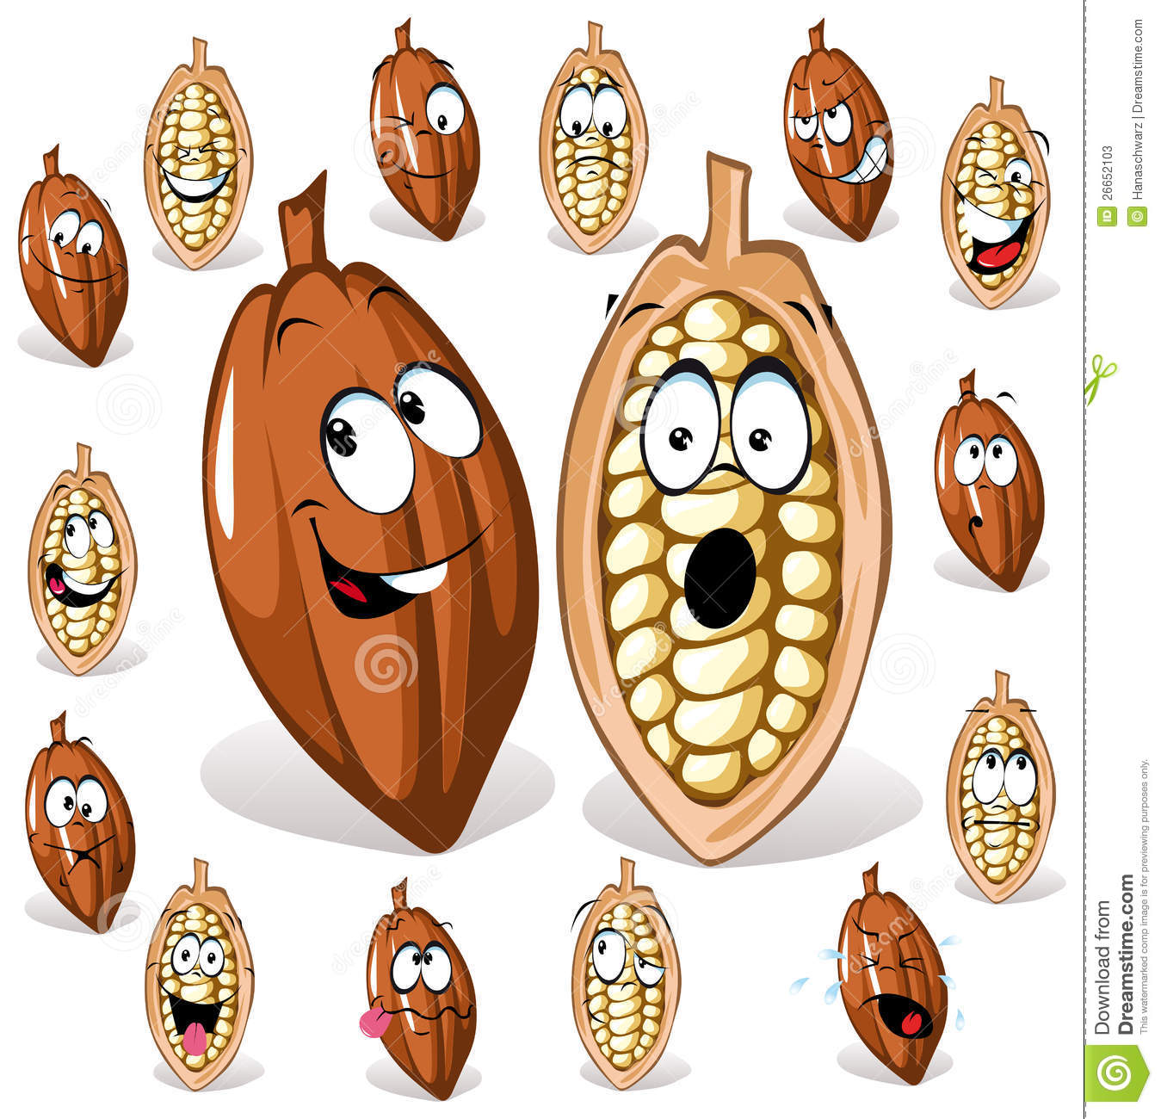

The recipe of Chocolate Cakes.

- Start by preheating your oven to 350c. Grease and flour two 9” round cake pans.

- Place 2 cups of sugar into a large bowl. And add 1 3/4cups of flour, 3/4 of a cup unsweetened cocoa powder, 1 1/2 teaspoon of baking powder, 1 1/2 teaspoon of baking soda and 1 teaspoon of salt. Stir all of the dry ingredients together.

- Next, add 2 eggs, 1 cup of milk, 1/2 a cup of vegetable oil and 2 teaspoons of vanilla extract. Mix the batter for 2 minutes with an electric mixer at medium speed. Slowly mix in one cup of boiling water into the batter.

- Divide the batter evenly between the prepared pans.

- Bake them in the preheated oven into a toothpick inserted into the center of the cake comes out clean for 30 to 35 minutes.

- Cool the cakes inside the pans for 10 minutes. Gently invert them and allow them to cool completely on the wire rack before topping them with your favorite frosting.

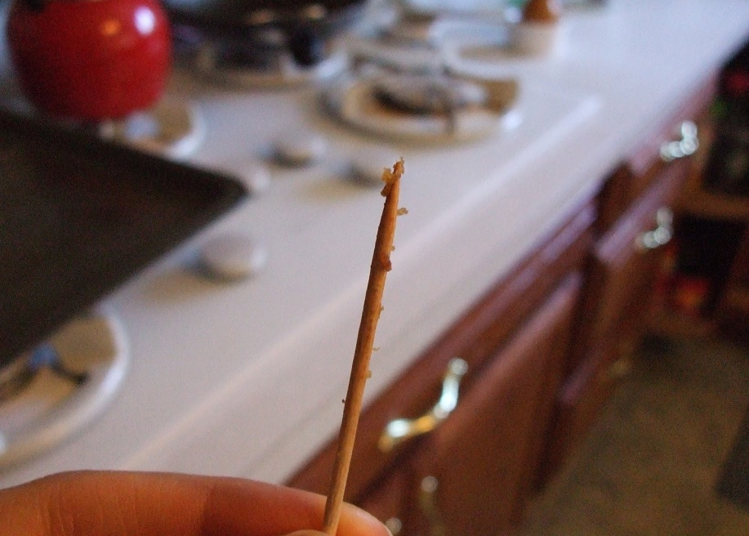

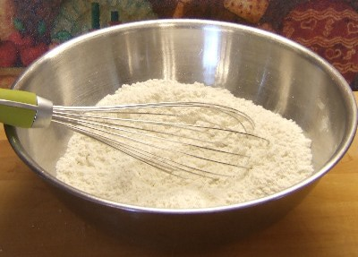

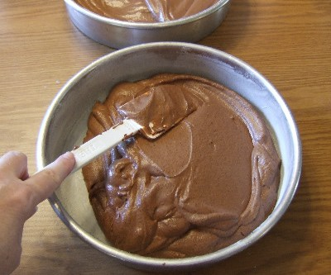

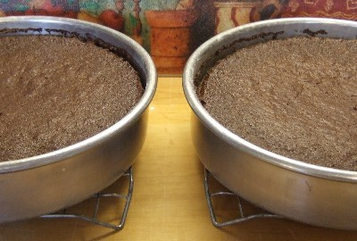

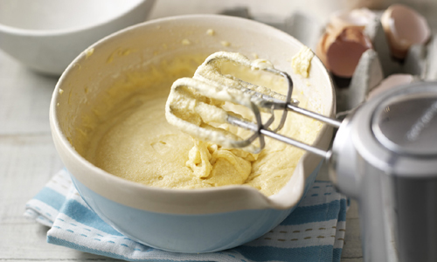

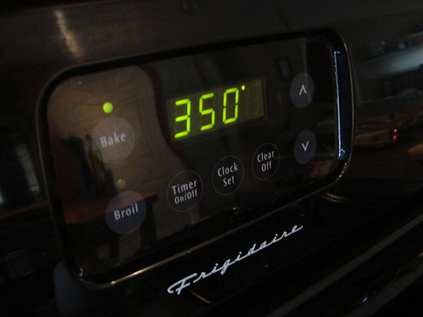

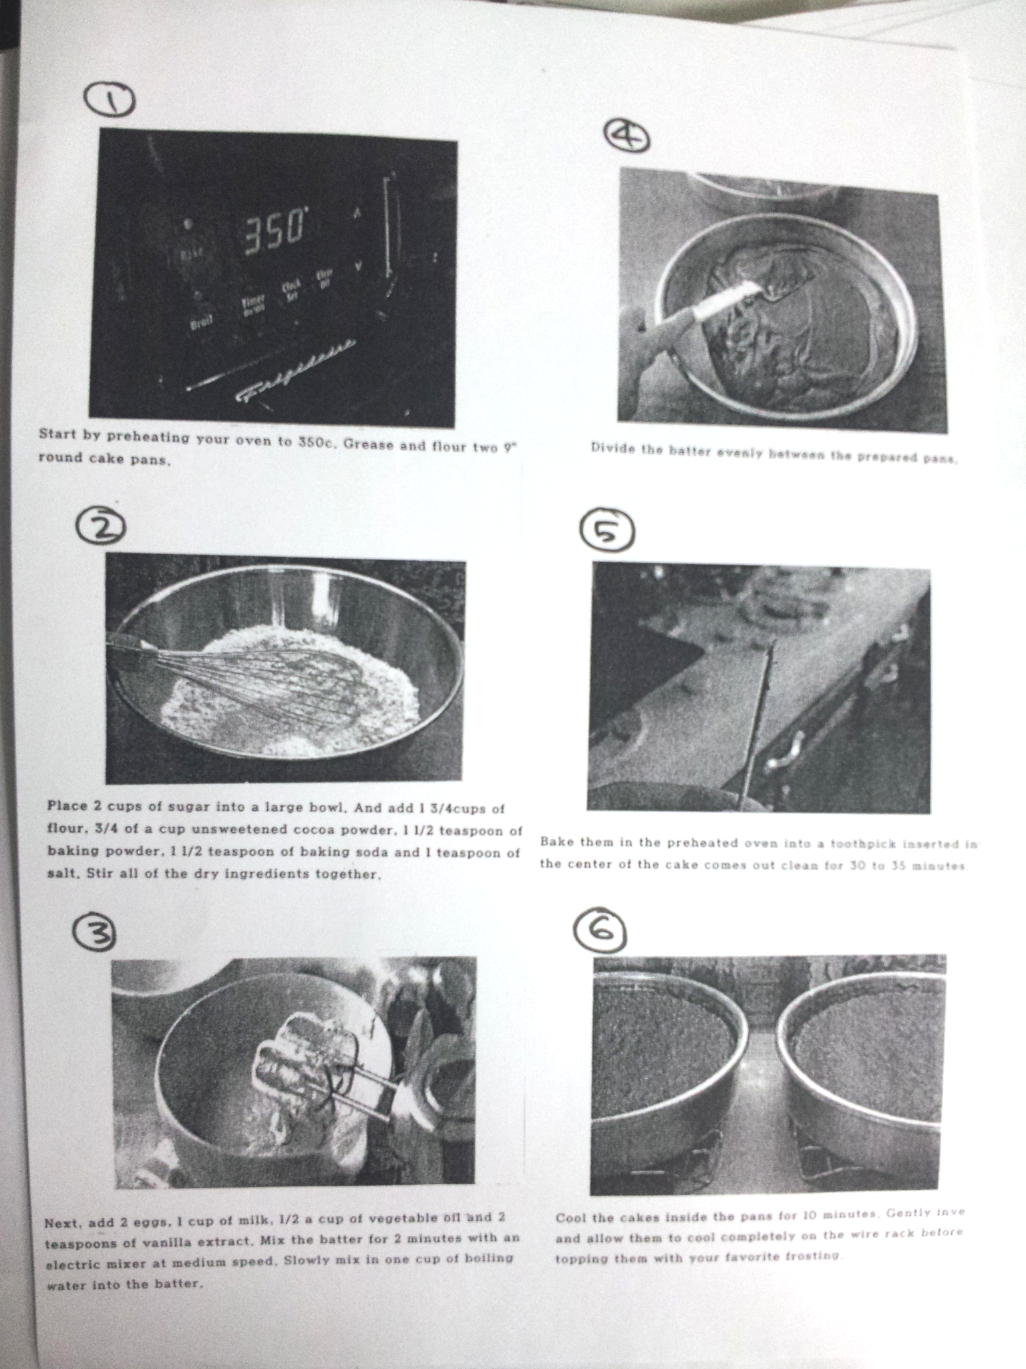
The Accidental Invention of the Chocolate Chip Cookie

It’s difficult to imagine that the chocolate chip cookie, one of the world’s most beloved sweet treats, was actually invented by accident. The invention of the chocolate chip cookie happened in 1930 when Ruth Graves Wakefield and her husband, Kenneth, were running the Toll House Inn on Route 18 near Whitman, Massachusetts. Mrs. Wakefield, a dietician and food lecturer, prepared all the food for the guests at the inn and had gained an enviable local reputation for her impressive range of desserts.
It’s often said that necessity is the mother of invention, and so too it was in this story. One night, Ruth decided to whip up a batch of Chocolate Butter Drop Do cookies, a popular old colonial recipe, to serve to her guests. But as she started to bake, Ruth discovered she was out of baker’s chocolate. Ruth then chopped up a block of Nestlé semi-sweet chocolate that had been given to her by Andrew Nestlé of the Nestlé Company. Ruth had expected the chocolate to melt and disperse through the cookie dough as regular baking chocolate would. Instead, the chocolate pieces retained their individual form, softening to a moist, gooey melt, and the world had its first known chocolate chip cookie.
These original chocolate chip cookies proved to be such a scrumptious success that Ruth had no choice but to repeat the recipe. She called her new invention the “Chocolate Crunch Cookie” and published the recipe in several Boston and New England newspapers. When Ruth’s Chocolate Crunch Cookie recipe was featured on an episode of The Betty Crocker Cooking School of the Air radio program, the popularity of the humble chocolate chip cookie exploded and the cookie soon became a favorite all across America. The popularity of the cookie further increased after Ruth published the still popular, Toll House Tried And True Recipes, featuring the “Toll House Chocolate Crunch Cookie”, in 1936.
Due to the enormous popularity of the cookie recipe, sales of Nestlé semi-sweet chocolate skyrocketed and Andrew Nestlé and the Wakefields struck a deal. In exchange for a lifetime supply of free chocolate, Nestlé printed Ruth’s recipe, by this stage called “Mrs. Wakefield’s Toll House Cookies”, on the chocolate labels and even started to score their chocolate bars and include a special chocolate chopper so people could easily make the chocolate chips for their cookies. This continued until 1939 when Nestlé introduced their own brand of conveniently pre-chopped chocolate- the small chocolate buttons still known today as “Nestlé’s Toll House Chocolate Morsels”.
Worksheet
Using the story The Accidental Invention of the Chocolate Chip Cookie, create 2 questions from each of the categories of comprehension levels.

Literal
1. .
2. .

Interpretive
1. .
2. .

Applied
1. .
2. .
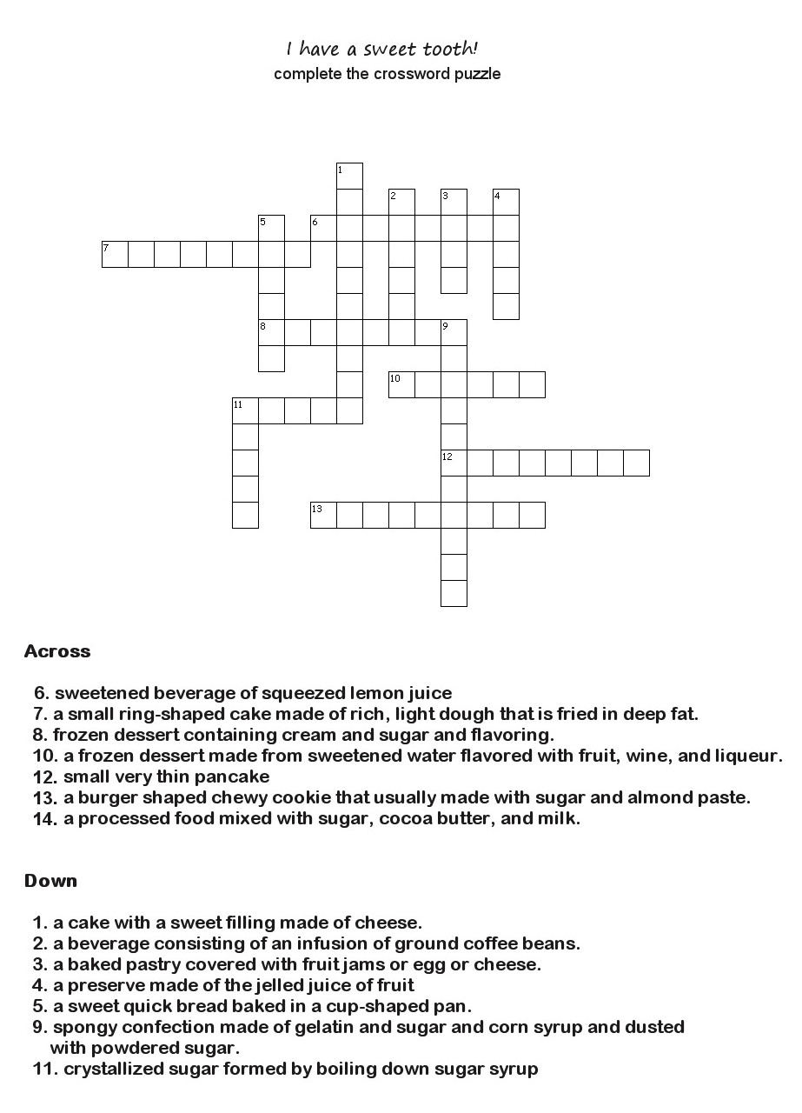
Worksheet
Worksheet(Answer)
- Cheesecake : a cake with a sweet filling made of cheese
- Coffee: a beverage consisting of an infusion of ground coffee beans.
- Tart : a baked pastry covered with fruit jams or egg or cheese
- Jelly : a preserve made of the jelled juice of fruit
- Muffin: a sweet quick bread baked in a cup-shaped pan.
- Lemonade : sweetened beverage of squeezed lemon juice
- Doughnut: a small ring-shaped cake made of rich, light dough that is fried in deep fat.
- Ice cream: frozen dessert containing cream and sugar and flavoring.
- Marshmallow: spongy confection made of gelatin and sugar and corn syrup and dusted with powdered sugar.
- Sorbet: a frozen dessert made from sweetened water flavored with fruit, wine, and liqueur.
- Crape: small very thin pancake
- Candy : crystallized sugar formed by boiling down sugar syrup
- Macaroon: a burger shaped chewy cookie that usually made with sugar and almond paste.
- Chocolate: a processed food mixed with sugar, cocoa butter, and milk.
..
.
.

