Listening Lesson Plan

American Holidays - Halloween
INSTRUCTOR | LEVEL | STUDENTS | LENGTH
Angie Kim | Intermediate | 12 | 50 mins

Materials:
- Video file: Learn English Holidays – Halloween.mp4
- Video file transcript and vocabulary definitions sheet (teacher use only)
- Laptop/Computer and a projector
- 12 copies of the Halloween fill in the blanks worksheet
- 12 copies of the Halloween vocabulary definitions sheet
- 4 Halloween pictures and tape to stick them onto the wall
- Whiteboard and markers

Aims:
By the end of this lesson students will -
- Develop their listening comprehension skills by completing activities related to the video.
- Expand their vocabulary and learn how to communicate with each other using the new words they have learnt.
- Become more familiarized with how Halloween is celebrated in American culture.

Language Skills:
Listening: Speaker in the video clip talking about Halloween and how it is celebrated in America.
Speaking: Class discussion about the subject of Halloween, group discussions, responding to the teacher’s questions, presenting to the class.
Reading: Halloween fill in the blanks and vocabulary worksheet, reading the guiding questions and vocab definitions written by the teacher.
Writing: Halloween fill in the blanks and vocabulary worksheet, writing their own sentences using the vocabulary given on the vocab sheet.

Language Systems:
Phonology: Practicing new vocabulary and their corresponding pronunciations.
Lexis: Understanding the way the speaker in the video describes Halloween and how it is celebrated.
Grammar: Fill in the blanks worksheet and letting students write their own sentences using the newly learned vocabulary.
Discourse: Group discussion about Halloween and what they know about it, figuring out the meanings of the new words.
Functions: Getting students to discuss in groups, questioning the students, getting the students to perform presentations to the class.

Assumptions:
- Students know what Halloween is but don’t know how it is celebrated in different countries.
- Students don’t know where Halloween originated or how it became popular in America.
- Students have seen many Halloween decorations and may have been exposed to the idea of Halloween through multimedia such as videogames or TV shows.

Anticipated Errors and Solutions:
- Students may not be able to follow the video clip easily
  - Let them listen to the video again until they get the general meaning. Play the video in chunks if the students are still having trouble by the end of the second play.
- Students may need more time to work on the fill in the blanks worksheet
  - If students take more than 4 minutes to complete the worksheet, cut answer-checking time by sharing the answers verbally instead of going over the answers together as a whole class.
- If time is running short
  - Cut down on the time given for the post activity and ask students to complete the task for homework.
- If students finish all their tasks earlier than anticipated
  - Get students to engage in discussion with each other about what kind of costume they would like to wear on Halloween and if they have any interesting Halloween experiences they would like to share.

References:
http://www.youtube.com/watch?v=GrdVgEOdxkU

Notes:
Plan B:
If you can’t get the video to work, then use the video transcript that has been provided and read it out clearly to the students manually at a normal pace. You may read the transcript again if students did not understand clearly the first time, but do not read out loud more than 3 times.
Proceed with other following activities according to the lesson plan.

Pre Task or Warmer
Do you know about Halloween? |  | Aims:  To let students become familiar with the main topic and pre teach vocabulary – carve, costume, haunted house, hayride | Materials:  4 Halloween pictures and tape  Whiteboard and markers
Time | Set Up | Students | Teacher
7 mins  4 mins | 4 Groups - 3 students per group  Whole Class | Students discuss with their group members about what they can identify in their picture.  1 student goes up to the whiteboard and writes a list of words that correspond to their group’s assigned picture  E.g. group 1 writes under picture 1, group 2 writes under picture 2 and so on.  All of the students participate in a class discussion about each of the pictures. | Attach the 4 pictures next to each other on the whiteboard.  Assign 1 picture to each group and get the group to discuss the picture for 3 minutes.  Ask a member from each group to write the words they have elicited from their picture on the whiteboard.  Ask all the groups about what they think about each other’s pictures.

Notes:

Task Preparation or Presentation
Halloween in America |  | Aims:  To get the students to focus on the vocabulary that is being used in the video. | Materials:  Video File: Learn English Holidays – Halloween  Video file transcript /Vocab definitions sheet  Laptop/Computer and projector
Time | Set Up | Students | Teacher
3 mins  5 mins  4 mins  2 mins | Whole Class  Whole Class  Individually  Whole Class | Students can read the guiding questions and think about the answers or discuss with other students what they think.  Students should be focusing on listening to the video while it is playing.  Students complete each of the sentences by filling in the blank spaces with the matching word.  Students read out the sentences on the fill in the blanks worksheet together as a whole class. | Before playing the video, write the following guiding questions on the whiteboard:  - What kinds of activities do people like to do on Halloween?  - How did Halloween become popular?  - Do you like to celebrate Halloween? If so, how?  Let the students have 2 minutes to think about the guiding questions.  Connect the laptop/computer to the projector and play the video file and get the students to watch/listen.  After the video has finished playing, hand out the fill in the blanks worksheet to students and ask them to complete it.  CCQ:  Ask one student what their assigned task is and go through the first fill in the blank together to make sure they understand.  If all students have completed the fill in the blanks worksheet, go over the worksheet together as a whole class to make sure all the answers are correct. Go at a pace that all the students can easily follow.

Notes:
If students did not appear to understand the video clearly the first time, you may play it for them again, but do not play it more than 3 times.
If you cannot get the video to work, then read out the video transcript to the students at a normal pace. Repeat and speak more slowly if necessary.

Task Realization or Practice
Halloween in America continued |  | Aims:  To assess and improve the student’s listening comprehension skills.  To let students become more comfortable with using new vocabulary. | Materials:  Halloween fill in the blanks worksheet  Video file transcript/Vocabulary sheet  Vocabulary definitions
Time | Set Up | Students | Teacher
6 mins  12 mins | Whole class  4 groups – 3 students per group | All of the students participate in a class discussion about the possible meaning of each word. Students can also answer questions the teacher may ask them to elicit the meanings.  Students write down the definitions of each word on the vocabulary sheet.  Students discuss with their group members which word to act out and how they will do it. After deciding, they can practice acting out the word as preparation for their presentation.  Each group makes their presentation to the class. All the group members should actively participate in the presentation. | Hand out the vocabulary sheet to students and get them to elicit the meaning of each word. Explain the meaning if necessary.  Use the vocabulary definitions sheet and write the proper definitions of each word on the whiteboard so that students can copy the meaning onto their own vocabulary sheets.  Get each group to act out one word from the vocab list. Give the groups around 6 minutes to prepare before they present to the class.  Monitor the class discreetly and provide more time if the groups need.  Assign the order of when each group will present by having the groups play paper scissors rock.

Notes:

Post Task or Production
What did we learn today? |  | Aims:  To teach students how to use newly learned vocabulary in their own context. | Materials:  Vocabulary sheet
Time | Set Up | Students | Teacher
7 mins | Individually | Students pick out 3 or 4 words from the vocabulary sheet and write each of the words in a sentence they come up with themselves.  The sentences can be about anything and don’t necessarily have to be about Halloween, as long as they use the words in the correct context. | Ask the students to pick 3 or 4 words out of the vocabulary sheet and use each of the words they have picked in a sentence.  Get the students to write each sentence provided in the space below the vocabulary sheet.  If needed, you can provide an example of how one of the words could be used in a sentence verbally.  Monitor the students and answer any questions they might ask.  CCQ:  Ask one of the students what they are supposed to write in the space below the vocab definitions sheet.

Notes:
Students who have finished this exercise early can read out loud the sentences they have written and provide feedback to each other.
Students who do not finish this task in time may complete it for homework.

Worksheets, hand-outs and lesson materials
Picture 1:
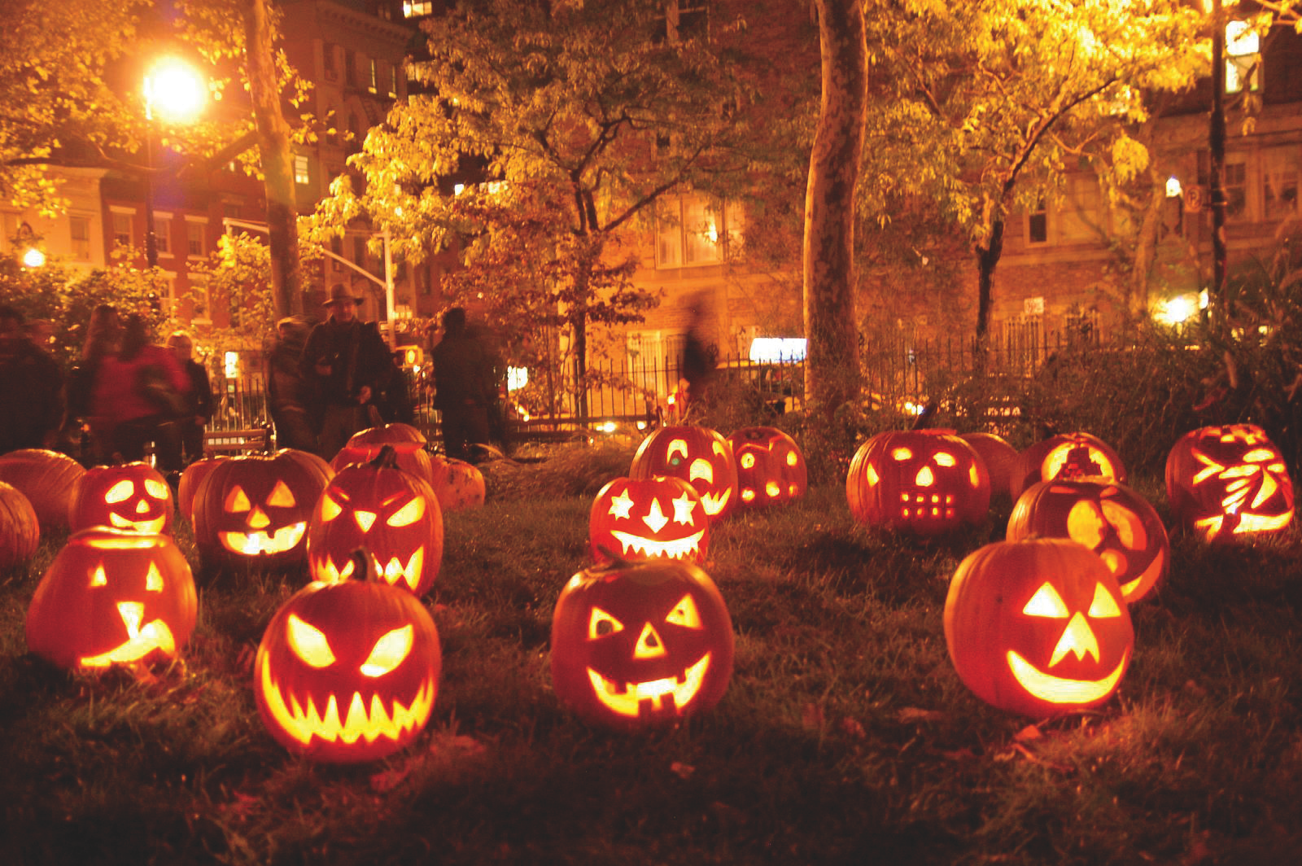
Picture 2:
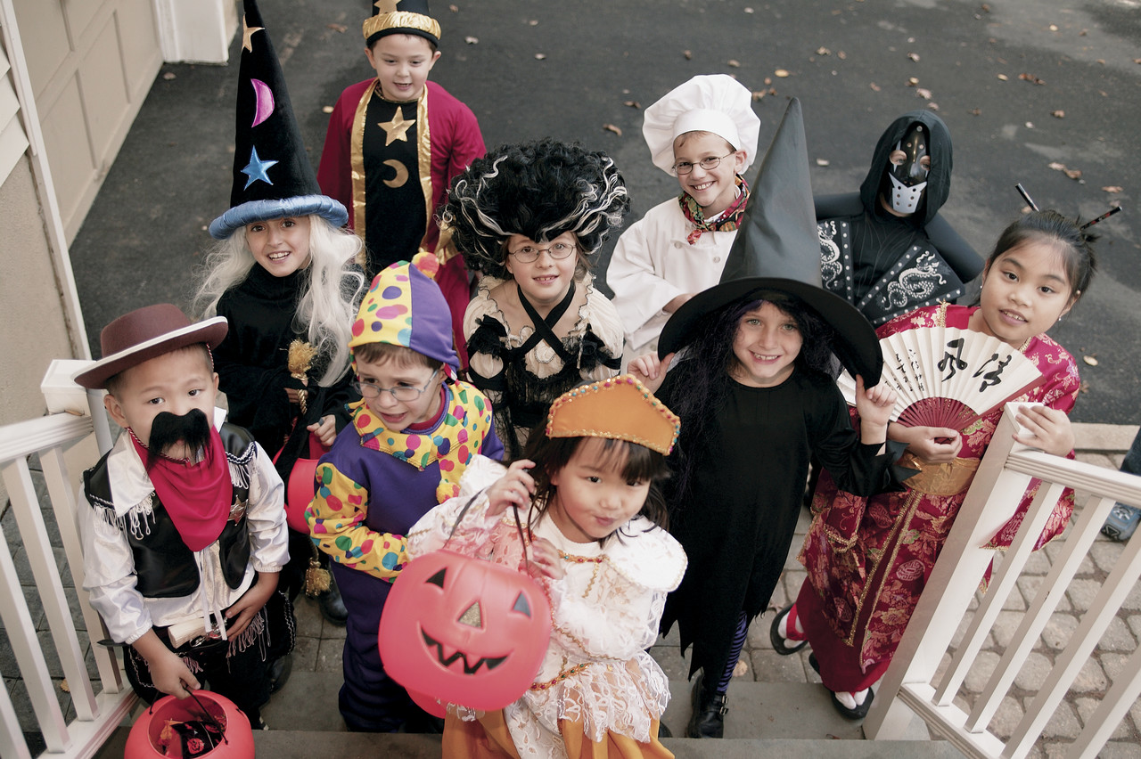
Picture 3:
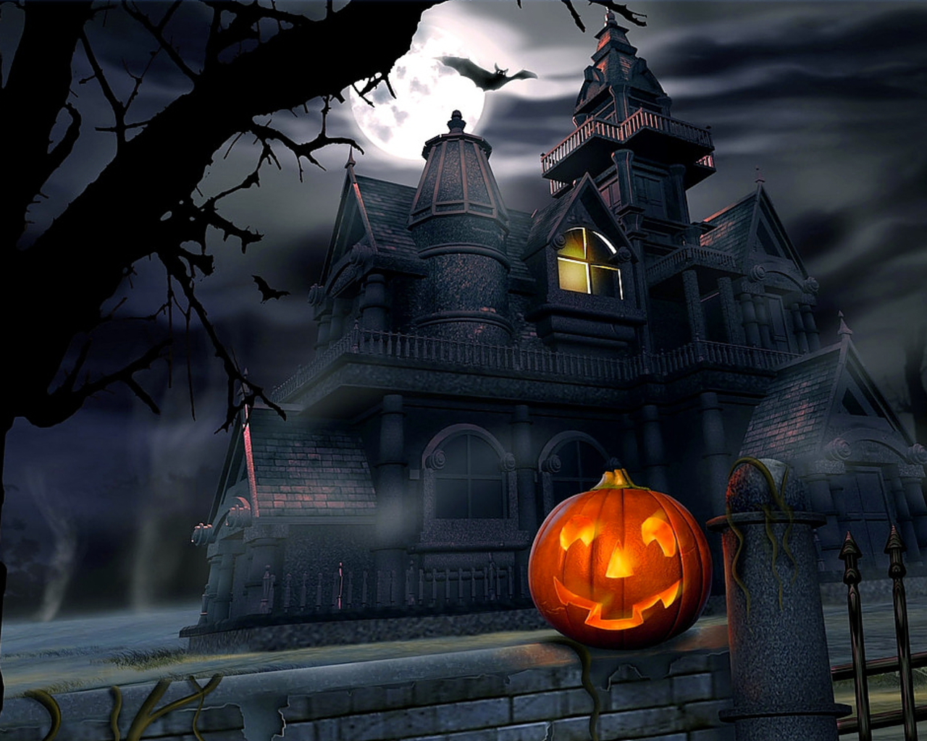
Picture 4:
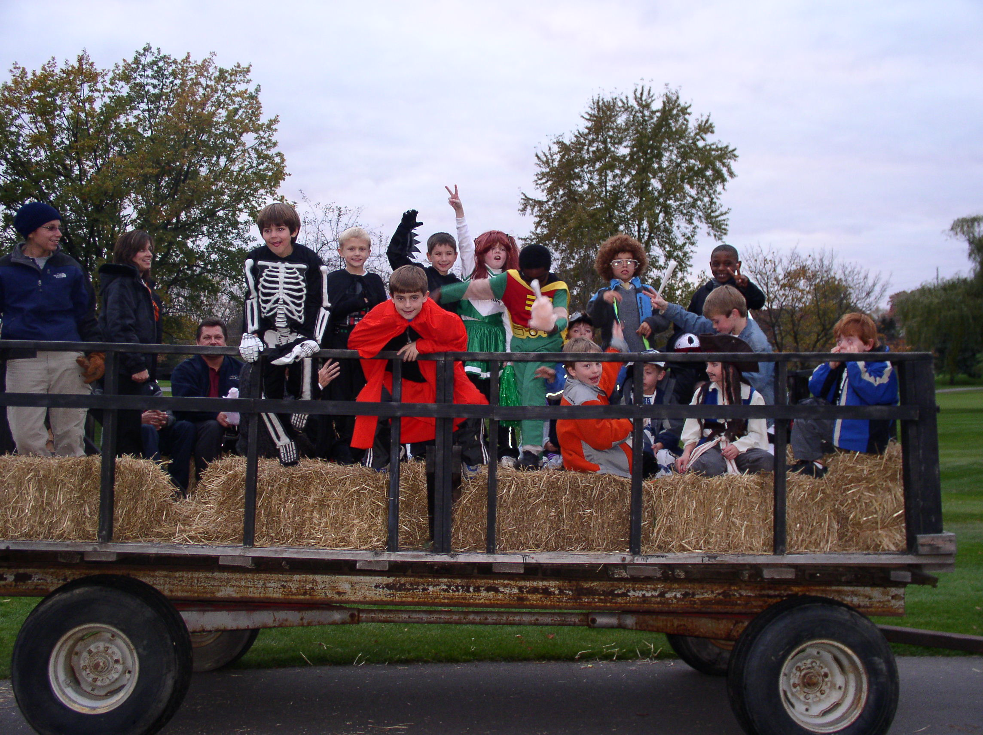
Teacher use only:
Video file: Learn English Holidays – Halloween Transcript

Halloween is a time for celebration in the USA. Its become the second most popular holiday in the nation over the years. Halloween is know for its often times scary costumes, elaborate parties and events, horror film festivals and its many Gothic trappings. This holiday was a latecomer to the US, not really becoming popular until the early twentieth century. Today, it's one of the most anticipated holidays in the USA!

People in the USA typically carve pumpkins into scary jack o' lanterns, decorate their houses to look as creepy as possible, and wear elaborate costumes to celebrate this holiday. These aspects of Halloween, according to some, have their roots in various Celtic and European myths, legends and cultural traditions. Today, popular horror films have also influenced the cultural traditions that surround Halloween. The monster movies of the early twentieth century are significant contributors to the look and feel of modern Halloween celebrations in the USA! Trick or treating started at the beginning of the twentieth century to curb the vandalism and destruction that once characterized this holiday in the USA. Today, Halloween is a night when the streets are full of families getting treats from their neighbors, and vandalism and other problems are rare. Some families and social groups set up elaborate haunted houses and invite people to go through for free or for a donation. Hayrides and other nighttime events are also very popular in rural areas. Check the local theaters and TV stations around Halloween and you'll find plenty of scary stuff to watch, too!

Vocabulary definitions:

- Gothic: Characterized by a gloomy setting and an atmosphere of decay
- Trappings: Articles of dress or ornament, especially accessories
- Latecomer: A person who arrives late
- Carve: To cut a solid material so as to form something
- Creepy: Having or causing uneasy feeling from horror or fear
- Vandalism: An action where one destroys or damages public or private property
- Haunted house: Houses in which ghosts are seen or heard
- Hayride: A fun ride, usually at night by a group in an open wagon or truck partly filled with hay

Fill in the blanks Exercise
Halloween is know for its often times scary costumes, elaborate _______ and events, horror film festivals and its many Gothic trappings.

People in the USA typically carve pumpkins into scary jack o' lanterns, decorate their houses to look as creepy as possible, and wear elaborate ________ to celebrate this holiday.

Today, popular ______ films have also influenced the cultural traditions that surround Halloween.

Trick or treating started at the _________ of the twentieth century to curb the vandalism and ___________ that once characterized this holiday in the USA.

Some ________ and social groups set up elaborate haunted houses and invite people to go through for free or for a donation. Hayrides and other nighttime events are also very popular in rural areas.

Check the local ________ and TV stations around Halloween and you'll find plenty of scary stuff to watch, too!
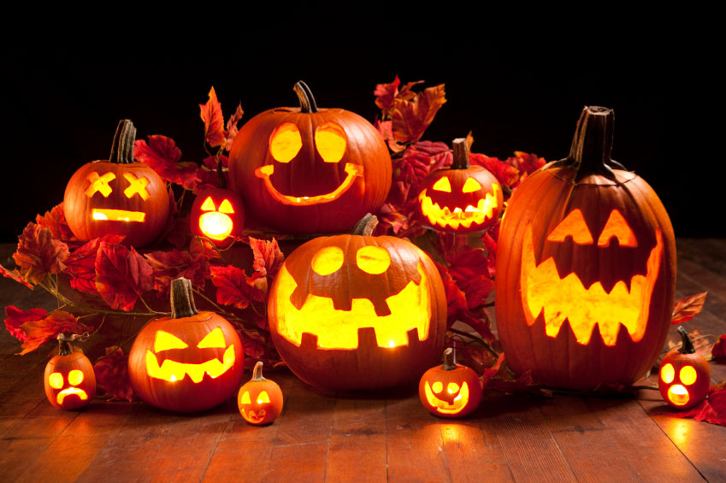
Choose from the following words below to fill in the blanks:
- Theaters
- Costumes
- Horror
- Beginning
- Families
- Destruction
- Parties
Vocabulary Sheet
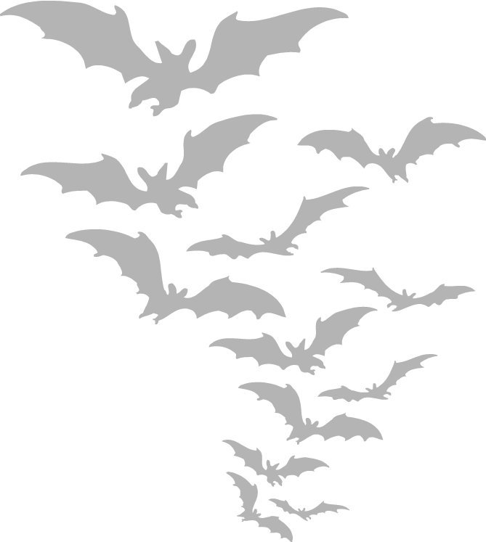
Do you know the definitions?

Gothic
Trappings
Latecomer
Carve
Creepy
Vandalism
Haunted
Hayride

Make your own sentences!
Choose 4 four words from the vocabulary list above and use them to make your own sentences.
1.
2.
3.
4.

