Listening Lesson Plan

I’m finally engaged.
INSTRUCTOR | LEVEL | STUDENTS | LENGTH
Julie | Intermediate | 13 adults | 50 mins

Materials:
○ Computer, Speaker, Mp3 file named “I’m finally engaged” (c:> Document> English material> 94WD TESOL)
○ White board and markers
○ Worksheet – 1, 2 (13 worksheets each)
○ Lesson material
○ Picture-#1

Aims:
○ The students learn 5 daily expressions and know its’ meaning and function.
○ The students can make sentences using 5 daily expressions.
○ The students learn vocabularies relevant to an engagement.

Language Skills:
Listening: The students listen to the dialogue and have a conversation with colleagues.
Speaking: The students express their opinion and have a conversation with colleagues.
Reading: The students read the worksheet.
Writing: The students fill in the blanks and make sentences using 5 key expressions.

Language Systems:
Phonology: They learn the right pronunciation of new vocabularies and key expressions
Lexis: They learn new vocabularies about engagement and 5 key expressions. (Refer to the Lesson materials #2, #3)
Grammar: They get used to various tenses.
Discourse: Two speakers are talking about engagement.
Functions: Asking and answering to surprising events.

Assumptions:
○ Most of the students are women and above 23 years. So they are familiar with this topic and it could be useful.
○ The students know the manner of learning in the class.

Anticipated Errors and Solutions:
○ There are many group activities. Some of the students cannot be active.
→ Encourage the student by asking for his opinion of what others are saying.
○ The students can take long time to carry out the tasks.
→ Monitoring them. If there’s a trouble, give them a hint to solve the problem indirectly.

References:
○ EBS Radio “Power English” 2013.11.11 Script.

Notes:

Pre Task
Title:  Introduce the topic |  | Aims:  To introduce the topic to the students. | Materials:  White board, Markers, Lesson materials, Picture-#1
Time | Set Up | Students | Teacher
3 mins | Whole class | ○ Greetings  ○ Look at the board with curiosity  ○ Short Response with words or short phrases like fiancé, before marrying etc.  ○ Short/longer Response with short phrases or sentences like happy, be in a good mood, pleased, glad, delighted etc.  ○ They can get a big picture of the content. | ○ Greetings :  Try to find out the students’ mood and wait for them to be ready  ○ Introduce the topic :  Write down the title (I’m finally engaged) on the board.  ○ Guiding Questions :  - Ask students if they know the meaning of the title. (Elicit related words. Show them a picture-#1)  - Ask students to imagine you are to be engaged or think about your experience.  ○ Introduce the content :  Give the students background information about dialogue.(Refer to the lesson material #1)

Task Preparation
Title:  Prepare for the listening |  | Aims:  To learn new vocabularies and guess the dialogues. | Materials:  White board, Markers, Worksheet -1 (13sheets), lesson materials.
Time | Set Up | Students | Teacher
5 mins  8 mins | In groups  In groups | ○ Have a little discussion and fill in the blanks with a suitable word.  ○ They learn new vocabularies relevant to the engagement.  ○ Have a little discussion and make a dialogue based on the vocabularies.  ○ Write down the words on the board. | ○ Pre-teach (vocabulary)  - Hand out worksheet-1 to each student  - Grouping (3 team 4/4/5 people each)  - Get the students to fill in the blanks with a discussion (3mins)  - Check the right answer  (Refer to the lesson materials #2)  ○ Group activity :  - Ask the students to imagine the speakers’ conversation based on the vocabularies learned just before and make a dialogue. (5mins)  - Get them to write down on the board. Compare each team’s answer. (3 mins)

Notes:

Task Realization
Title:  Listen to the dialogue |  | Aims:  Listen to the dialogue and understand new expressions. | Materials:  Computer, Speaker, Mp3 file, worksheet-2 (13sheets)
Time | Set Up | Students | Teacher
8 mins  7 mins  8 mins | Individually  Individually  In groups | ○ Listen to the dialogue and understand its main point.  In the second, third playing, catch the specific point.  ○ short/longer responses based on their understanding.  ○ fill in the blanks listening to the dialogue.  ○ They are thinking about new expressions and guessing these. Write down the ideas on the paper.  ○ They learn the exact meaning of the expressions. | ○ Play the recording  ○ CCQ  - How did the man notice her engagement?  - When the woman sets the date of the wedding?  - Where will the woman marry? Out? In?  - What does the man ask for?  (If the students ask for a repeat, play again)  ○ Individual activity : (7mins)  - Hand out a worksheet-2 to each student  - Ask the students to fill in the blanks listening to the dialogue again.  - Play and repeat the recording until they fill all the blanks.  ○ Group activity : (8mins)  - Check the blank together and ask the students to guess its’ meaning with a discussion.  - Share the ideas and let them know the exact meaning of the idioms.

Notes: Check the computer function beforehand.

Post Task
Title:  Use the expressions |  | Aims:  To remind the words and expressions and make sentences using them. | Materials:  Computer, Speaker, Mp3 file
Time | Set Up | Students | Teacher
7 mins  4 mins | In groups | ○ Make sentences based on the understanding of the expressions. Prepare for the presentation.  ○ Try to understand specifically during listening.  ○ Remind of todays’s new vocabularies and expressions. | ○ Group activity :  - Make sentences with the expressions.  - Share the answers by the presentation.  (Each group presents one sentence at least)  ○ wrap-up  - Listen to the dialogue once again.  - Remind them of 5 key expressions.

Notes: Check the computer function beforehand.
Lesson materials
#1. About dialogue
There are two speakers Amy and Paul.
They are friends.
Amy is telling him about her engagement.

#2. Vocabularies
Engagement ring, Bride and groom, get married, set the date, Bridemaids, Groom’s men.

#3. Key expressions
1. Something out of this world
2. Pop the question
3. Be on the pins and needles
4. It’s about time
5. You’re shoo in

#4. Script
Amy : Paul, you’re not going to believe what happened to me last night.
Paul : By the look on your face, I’m guessing it was something out of this world.
Amy : If you look at my left hand, you might notice something a little different. Something very shiny and beautiful.
Paul : Oh my gosh! Isn’t that an engagement ring? Did Rian finally pop the question?
Amy : Yes! I’m getting married. I’ve been pins and needles waiting for him to ask me
Paul : Yes, It’s about time. When are you going to get married?
Amy: We set the date for next march around the time cherry trees are in bloom. We want to have outdoor marry at the downtown.
Paul : That sounds like a beautiful setting for a wedding. I hope I’m invited or maybe even a groom’s man if he needs me.
Amy : That’s traditionally the groom’s choice but I know Rian really likes you. So you’re a shoo in for the job.
Paul : Well, I was the person who introduced you to love buzz, so I guess I should have a part to play.
Amy : That’s the time! If I were Rian, I’ll make you the best man.

Picture-1

Worksheets -1
Vocabularies check
◈ Fill in the blanks with a suitable word. (noun or verb)

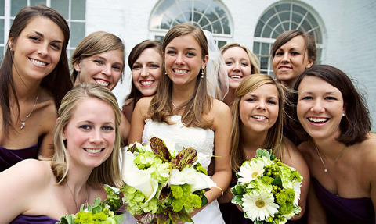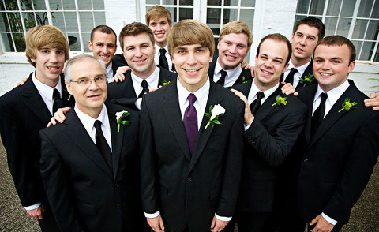

1. ____________ring 2. _______ and _________ 3._______married 4. ________ the date 5. _______________ 6. ________________
(noun) (noun) (noun) (verb) (verb) (noun) (noun)

Worksheets -2
Script
◈ Fill in the blanks with a suitable word.

Amy : Paul, you’re not going to believe what happened to me last night.
Paul : By the look on your face, I’m guessing it was______________________ .
Amy : If you look at my left hand, you might notice something a little different. Something very shiny and beautiful.
Paul : Oh my gosh! Isn’t that an engagement ring? Did Rian finally _____________________?
Amy : Yes! I’m getting married. I’ve been ___________________ waiting for him to ask me
Paul : Yes, ______________. When are you going to get married?
Amy: We set the date for next march. We want to have an outdoor wedding at the downtown.
Paul : That sounds like a beautiful setting for a wedding. I hope I’m invited or maybe a groom’s man if he need me.
Amy : That’s traditionally the groom’s choice but I know Rian really likes you so much, ____________ for the job.
Paul : Well, I was the person who introduced you to love buzz, so I guess I should have a part to play.
Amy : That’s the time! If I were Rian, I’ll make you the best man.

