Speaking Lesson Plan

Title: Tourism and Holidays.
INSTRUCTOR | LEVEL | STUDENTS | LENGTH
Jin Joo, Chu | Intermediate | 12 students | 50 mins

Materials:
- “Tourism and Holidays” worksheet (13 copies/2 pages per copy)
- Board, board marker

Aims:
• To give students practice with developing their speaking and listening skills.
• To get students familiar summarize in an essay of what they discussed in class.

Language Skills:
Speaking: Interviewing Ss, answering interview questions, discussing
Listening: Ss response to questions/discussions, T’s explanation of vocabularies.
Reading: Passage about tourism and holidays in Europe.
Writing: Essay for homework based on this lesson, writing down information from discussions about tourism.

Language Systems:
Discourse: Discussion about tour routes and topics about travelling.
Phonology: Correct pronunciation of nationalities (Belgian, Luxembourgish)
Lexis: Tourism, Luxembourg, Foot-and-mouth disease.
Grammar: If clauses answering questions in ‘activity 1’
Functions: Interviewing others, discussing with group, answering questions.

Assumptions:
Students are familiar with the topic of informal and formal introductions, questions tags, making offers, and keeping a conversation going on varied topics such as likes and dislikes, description of locations, travel and holidays. They are also familiar and fluent with all tenses.

Anticipated Errors and Solutions:
-If time is short, skip questions #3,5,6 in ‘activity 1’
-When there’s time left, talk more about the post activity or keep on with the SOS activity.
-Students may not pick up the answer for the questions in ‘activity 2’ in the passage. Give a hint by telling in which paragraph the answer is.

References:
“Tourism and Holidays”-Liz Regan 2004
(http://www.englishclub.com/esl-forums/viewtopic.php?f=192&t=23893&p=197016&hilit=tourism+and+holiday#p197016)

Notes:
SOS activity
A foreign VIP client of your company will visit from this Thursday to next Monday. Your boss has given you an unlimited budget to show your country to the client. Design the best itinerary you can for the visit.

Pre Task or Warmer
Title:  Introduce to topic:  Tour and Holiday |  | Aims:  Introducing the topic of tourism. | Materials:  Board, board marker
Time | Set Up | Students | Teacher
3mins | Whole class | I. Introduce topic  Answer guide questions  Guide question  Do you like to travel?  Why do you think people travel? | I. Introduce topic  Write the topic on the board.  Ask guide questions to whole class and get them involved with the topic tour and holiday.  Guide question  Do you like to travel?  Why do you think people travel?

Notes:

Task Preparation or Presentation
Title:  How do Europeans spend their holidays? |  | Aims:  Brainstorming and learning vocabulary related to tourism: country names, locations, etc. after a reading activity | Materials:  “Tourism and Holiday” worksheet (2 pages)  Board, board marker.
Time | Set Up | Students | Teacher
16mins | Whole Class | 1. READING  Read the passage out loud to listen to the pronunciation of themselves and their partners. Highlight unfamiliar vocabularies as reading along.  2. VOCABULARY  Ask highlighted vocabularies and learn it from other Ss and T.  3. ACTIVITY  Answer the questions in Activity 2 and compare them with their partners. Check if they have any errors. | 1. READING  Distribute worksheets.  Instructions  Read the passage in “Tourism and Holiday (activity 2)”, one paragraph each out loud taking turns while the rest follow along. Highlight any vocabulary that you don’t know.  2. VOCABULARY  Ask for any unfamiliar vocabularies. Write them on the board and elicit the answer from Ss. Some vocabularies and definitions are written in ‘Notes’.  3. ACTIVITY  Instructions  Answer the questions in “Tourism and Holiday” below activity 2. Share your answers with your partners. 3 mins.  Check answers and ask where in the passage the answers are.

Notes:
Vocabulary:
-Affair: issue, matters of public interest
-Foot & Mouth outbreak: An outbreak of foot and mouth disease in the United kingdom 3 times. Caused crisis in British agriculture and tourism
-Foot and mouth: a highly contagious viral disease of sheep, cattle, pigs and goats, characterized by the development of blisters in the mouth.

Answers:
1. b
2. Airplane, because England is an island
3. Luxembourg
4.Quick quiz
1- island (Paragraph 7 ‘British Tourists’)
2- Portuguese (Paragraph 1)
3- holidaymaker (Paragraph 2)
4- culture, geography (Paragraph 5 ‘Home or Away’)

Task Realization or Practice
Title:  Tourism experiences |  | Aims:  Talk about personal experiences and ideas of travelling with questions on the worksheet. Speaking and listening skills (discussing in groups). | Materials:  “Tourism and Holiday” worksheet
Time | Set Up | Students | Teacher
26mins | In pairs  In group | Activity 1  Interview partner with questions 1 to 4 below ‘activity 1’ and write down any interesting answers.  After the interview share things written down and tell the class about their partners.  Then discuss questions 5 to 8 within the group and write down any important information.  Share their own or group’s idea with the whole class about questions #7 and 8.  Ss listening others speaking should write down any additional information that they didn’t catch. | Lead into the second worksheet.  Instructions  Ask and answer questions 1 to 4 below ‘Activity 1’ in pairs and write down any interesting answers. 6 mins.  After the conversation talk about any interesting answers that they got from their partners.  Instructions  Discuss the questions from 5-8 in your group (4 people). Write down your and your group’s ideas. 14 mins.  Talk about questions #7 and 8 with the whole class.

Notes:

Post Task or Production
Title:  Tourism in Korea |  | Aims:  Speaking about tour in Korea (discussion) | Materials:  Board, board marker.
Time | Set Up | Students | Teacher
5mins | Whole Class | Apply the answers of questions #7 and 8 to Korea. Share ideas with the class. | 1. Apply  Instruction  Apply answers from questions #7 and 8 to tourism in Korea.  Elicit from Ss. Some examples in ‘Notes’.  2. Homework  Write an essay about your opinion of the phrase in Activity 3.

Notes:
#7: Rise in prices in main tour locations such as Myungdong, many foreigners smoking on streets even though it’s illegal.
#8: Creates jobs, brings in money to the local economy and government.

Worksheets, handouts and lesson materials

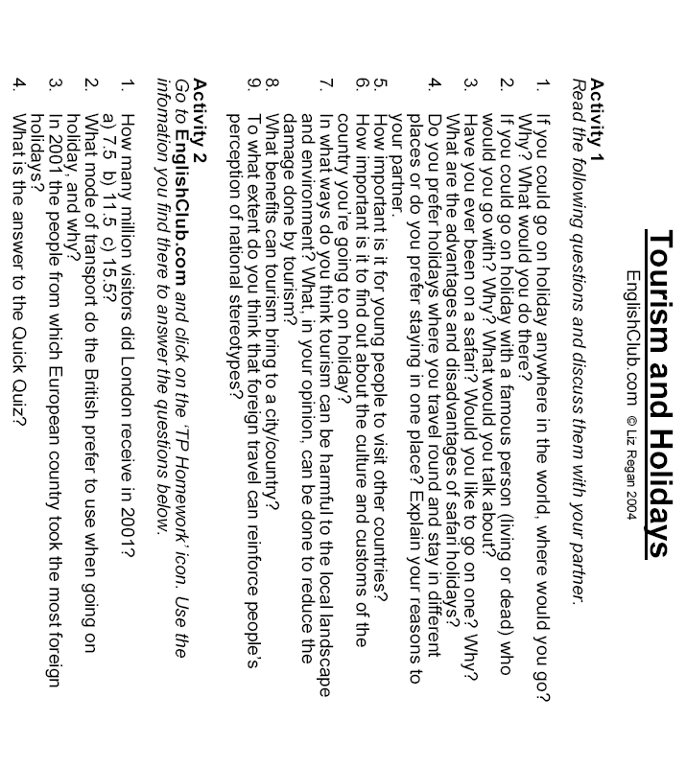

Tourism and Holidays (activity 2)
Instructions: Read the text below to find the answers to the questions on your worksheet.
European Tourists
Do you prefer to go on holiday in your own country or abroad? According to recent European Union statistics the people who take the most holidays are the Germans. More than 4 out of 5 Germans went on holiday in 2001 as opposed to the Portuguese where only one in three people took a holiday.
Most European tourists (holidaymakers who come from countries within the European Union) tend to take holidays in Europe with Spain, France and Italy. These preferred destinations account for between 48 and 86% of all foreign holidays taken by EU nationals.
The Spanish, French, Italians, Portuguese and Finnish often prefer not to go abroad at all. They tend to take their holidays in their own countries, unlike the Belgians, Germans, Luxembourgish and Dutch who prefer to go to other EU countries.
In 2001, however, all EU holidaymakers preferred to go to other EU countries rather than their own, apart from the French. People from Luxembourg showed the highest rate of going abroad at 81% of the population.
Home or Away?
Why is it that some people prefer to have a foreign holiday while others prefer to stay in their own country? There are many reasons: economic factors such as the cost of the holiday play a part along with current affairs (such as the Foot & Mouth outbreak in the UK, terrorist attacks such as September 11 etc). Culture and geography of the countries involved have an important role, as does the variety of services and attractions offered to tourists. In addition, the reason for the holiday (to relax, to see the sights, to visit relatives/friends etc) is an important consideration, and, last but not least, the success of tour operators' marketing campaigns can help some holidaymakers decide where to go.
Next-door Neighbours
One of the major trends continues to be holidaying in neighbouring countries: the Belgians go to France, the Germans go to Austria, the Spanish go to Portugal and the Portuguese go to Spain.
British Tourists
In 1996 62% of British people holidayed in Britain. By 2000 this had fallen to 47%. In 2001 all EU holidaymakers preferred to travel by car rather than train, plane etc., except the British who prefer to fly. The fact that the country is an island no doubt influences this.
London
London is still one of the most popular tourist destinations in Europe and, indeed, the world. This is borne out by the fact that in 2001 London received 11.5 million visitors.

Quick Quiz
Read the clues below and write the solutions on a piece of paper. Then take the first letter of each answer and rearrange them to find the hidden word connected with this Talking Point.
1. The fact that Britain is an __________ means that many British tourists prefer to travel by plane.
2. In 2001 only one in three __________ people took a holiday.
3. Another word for tourists is __________.
4. There are many factors which influence where people might choose to go on holiday. The __________ and __________ of the destination countries have an important role.

Talking Point Homework, EnglishClub.com © Liz Regan 2004

