Language Based Lesson Plan

Title – What color/animal is this/that?
INSTRUCTOR | AGE | STUDENTS | LENGTH
Brian Hong | 5-6 | 7 | 40 min

Materials: Worksheet #1 & #2, SOS Activity, Children's Glue, Crayons, Visual Aid A~R, Animal Twister Mat, Spinner Board, White Board, White Board Marker, Appendix A~D, Scotch Tape.

Aims:
- Students should start to understand the concept of “this” and “that” by observing the model and participating in the activity.
- Students will learn how to use simple substitution by using “What color/animal is this/that?” type of questioning from the usage model.
- Students will learn the spelling for the colors and animals covered in the lesson by repetitive visual exposure.

Language Skills:
Listening: to listen to “What color/animal is this/that?” question model. Following directions.
Speaking: to express their opinion during the activities.
Reading: to read the words on the visual aid and worksheet #2.
Writing: to fill-in the missing letters during worksheet #2.

Language Systems:
Grammar: Students inductively learn how to substitute words for basic grammar. (What color/animal is this/that?)
Lexis: Students learn the spelling of the words covered and use it in the activity. (Worksheet #2)
Discourse: Their understanding can be evaluated during the activities by observing their response to directions.
Functions: Students learn how to use and substitute the appropriate words following the teacher's model.
Phonology: Students mimic the pronunciation of the words learned.

Assumptions:
Students already know/have an understanding of:
- How to associate words together using simple sentences.
- A-Z letters of the English alphabet.
- The names for the colors and animals covered in the lesson plan, and have been exposed to the spelling of the words yesterday.

Anticipated Errors and Solutions:
- Will make a few errors when participating in the activities. (Repetitive modelling)
- Will have difficulty paying attention during the lesson. (Mix up the modelling activities while keeping them active)

References:
- None

Notes: Their understanding and knowledge, of the spelling learned, can be evaluated during the Worksheet #2 activity.

Pre Task or Warmer (7 min)
Title:  Visual Modelling |  | Aims:  Students learn the spelling for the colors and animals covered in the lesson through repetitive exposure. | Materials:  Visual Aid A~R, White Board, White Board Marker, Scotch Tape.
Time | Set Up | Students | Teacher
7 min | Whole class  Whole class  Whole class  Whole class | Say hi to the teacher.  Give a response  Take turns asking “what color is this/that?”  Give a response | Greet the children.  Step 1  Show the 6 different color visual aids while eliciting.  What color is this?  Good this color is _______. The spelling is ________.  Step 2  Place some of the visual aids far away and go back and forth using the “What color is this, and what color is that that?” questioning sequence.  Step 3  Use objects in the room and get the students to lead.  CCQ: What color is this/that? Good, who wants try?  Step 4  Repeat step 1 for animal visual aids, and then associate it with animal with color visual aids.

Notes: Make sure that the children are paying attention to the spelling of the colors and animals covered throughout the lesson through repetitive exposure.

Task Preparation or Presentation (10 min)
Title:  Worksheet #1: Matching |  | Aims:  To teach children the spelling of the colors and animals learned, while being exposed to basic grammar. | Materials:  Worksheet #1, Scissors, Children's Glue, Crayons, Pre-cut Cut-outs.
Time | Set Up | Students | Teacher
10 min | Whole class  Whole class  Whole class | Receive worksheet #1  Observe the activity modelling.  Give a response and follow the modelling.  Give a response. | Hand out worksheet #1, glue, and crayons.  Show the students how to do the activity by modelling.  Point to the word pink.  What is this word? Pink! Good. P-I-N-K.  - Read “this color is pink,” and trace over the words with a crayon while reading it. (Use a larger copy)  - After tracing over the words, put some glue on the pink word cut-out and stick it on top of the word pink.  - Repeat this process until they do it through learned behaviour.  After this activity ask the students CCQ questions.  CCQ: How do you spell pink?  - Get all the student involved.  - If a student cannot answer, tell the student the spelling and have the student repeat the spelling.  Y-E-L-L-O-W. Ok now everyone. Y-E-L-L-O-W.

Notes: Demonstrate how to do the activity for Worksheet #1. Guide the students throughout the activity using positive reinforcement. Give non-toxic children’s glue and pre-prepared animal cut-outs to the students.

Task Realization or Practice (20 min)
Title:  Worksheet #2: Following directions. |  | Aims:  To evaluate the children's understanding of the spelling learned through monitoring. | Materials:  Worksheet #2, Crayons
Time | Set Up | Students | Teacher
20 min | Whole class  Whole class  Individual | Receive worksheet #2.  Give a response.  Follow the modelling and color-in the pink cow.  Give a response and do the activity. | Hand out worksheet #2.  Show the students how to do the activity by modelling.  Step 1  CCQ: What animal is this? Cow. C-O-W.  - What color is the cow? Pink. P-I-N-K. Good.  - Get a crayon and color-in the pink cow.  Demonstrate the activity for the students by modelling.  Repeat step one while getting all the students involved  - If the students have trouble following the directions, model it again.  Active monitoring throughout the activity.

Notes: Demonstrate how to do the activity for Worksheet #2. This activity can be used as an observation point to evaluate how much information the students have learned. In case that the students are struggling during this activity, use modelling and positive reinforcement to guide the students in the right direction.

Post Task or Production (3 min)
Title:  Repeated Exposure |  | Aims:  Review what the children learned throughout the lesson by modelling through repeated exposure. | Materials:  Visual Aid M~R.
Time | Set Up | Students | Teacher
3 min | individual  Whole class  Whole class  Whole class | Give a response.  Give a response.  Finish the lesson. | Repeat what was done during the warmer.  Step 1  Use objects in the room to review what they learned.  CCQ: What color is this/that? Red. R-E-D. Good  What color is this/that? Blue. B-L-U-E. Good.  Step 2  Use the color visual aids and elicit a response.  - What animal is this/that? Cow, C-O-W. Good  - What color is the cow? Brown. B-R-O-W-N. Good.  End the lesson.

Notes: Go over what the students have learned throughout the lesson by repeating parts of the pre-task/warmer. (Repetitive exposure) Use positive reinforcement to encourage participation.

SOS Activity - Animal Twister (10 min)
Title:  Animal Twister |  | Aims:  Back up activity for the children in case they finish the lesson earlier than expected. | Materials:  Animal Twister Mat, Spinner Board.
Time | Set Up | Students | Teacher
10 min | Whole class  Whole class  Whole class  Whole class | Sit down around the mat.  Watch demonstration.  Stand up.  Play the game  Finish the lesson | Get the students to sit down around the mat. (TPR)  Demonstrate how to play through modelling.  Get the students to stand up. (TPR)  Start the game.  Have the students take turns leading. (Spinning)  Active monitoring.  End the lesson.

Notes: This activity will be useful as the students are exposed to the topic already learned while having fun.

Make sure to actively monitor while ensuring the safety of the children.

Appendix A: Colors (Visual Aid A~F)

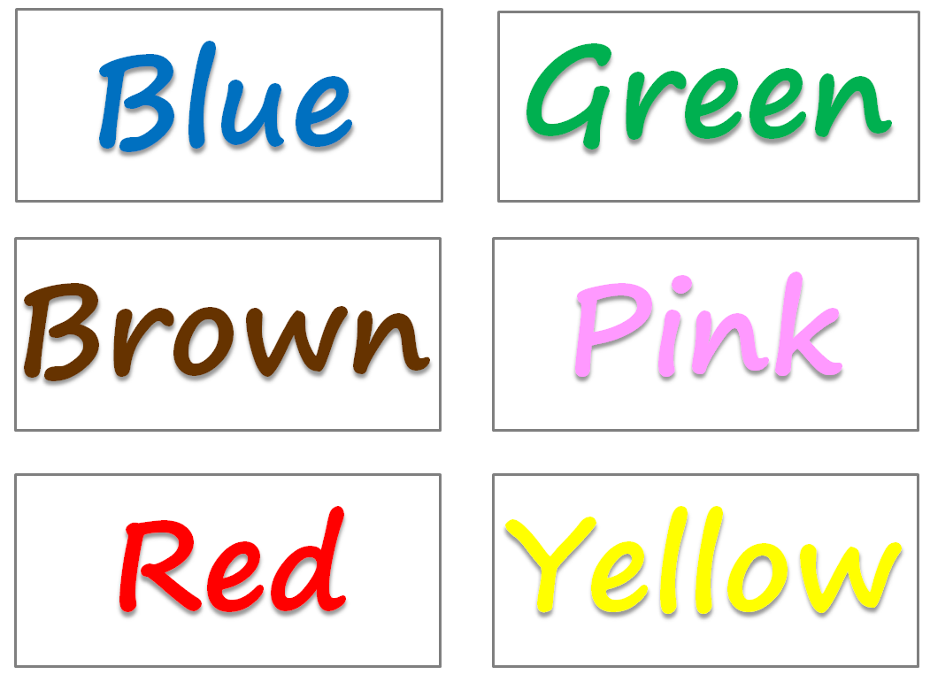

Appendix B: Animals Print (Visual Aid G~L)

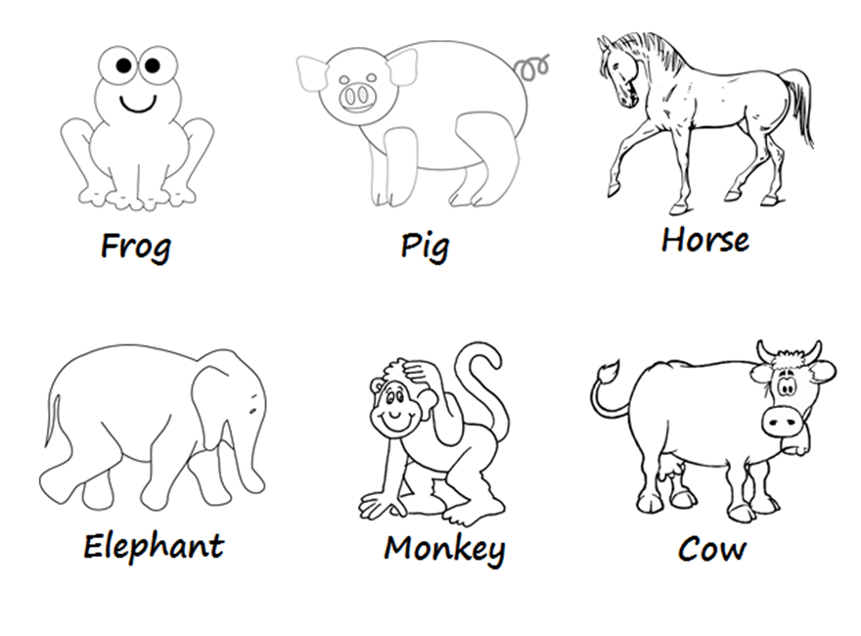

Appendix C: Animal Print with Color (Visual Aid M~R)

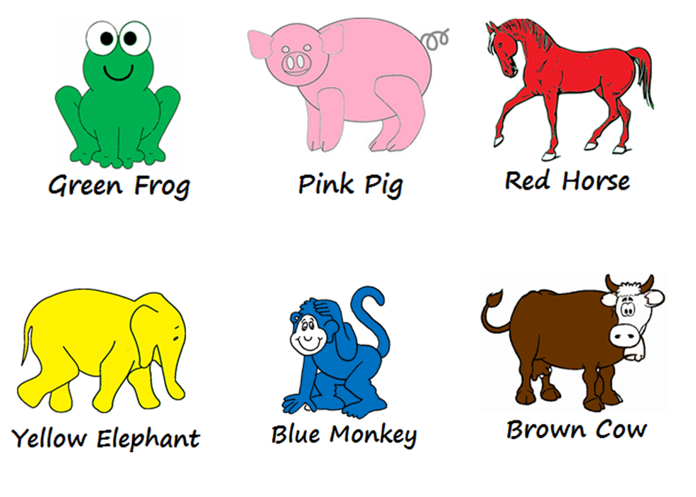

Appendix D: Animal Twister
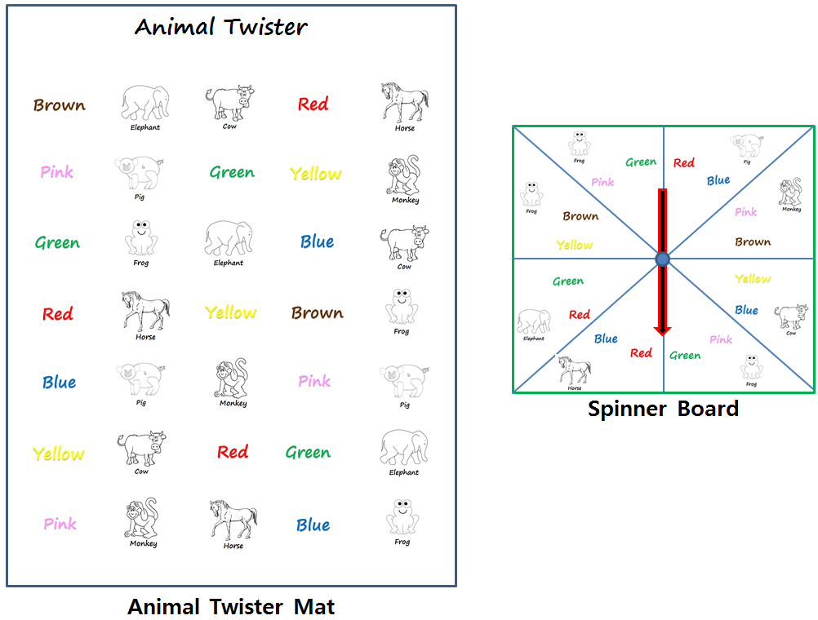

Worksheet #1: Matching
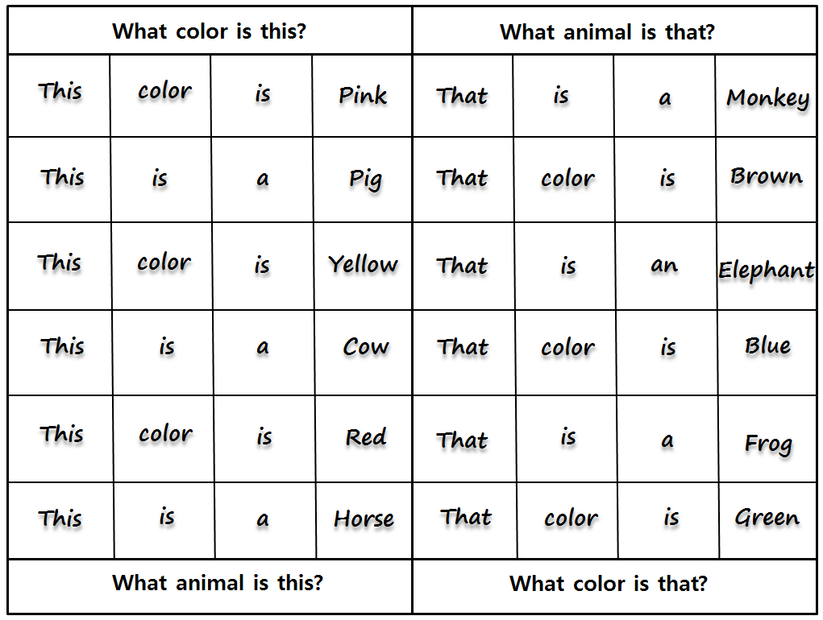

Worksheet #1: Cut-out
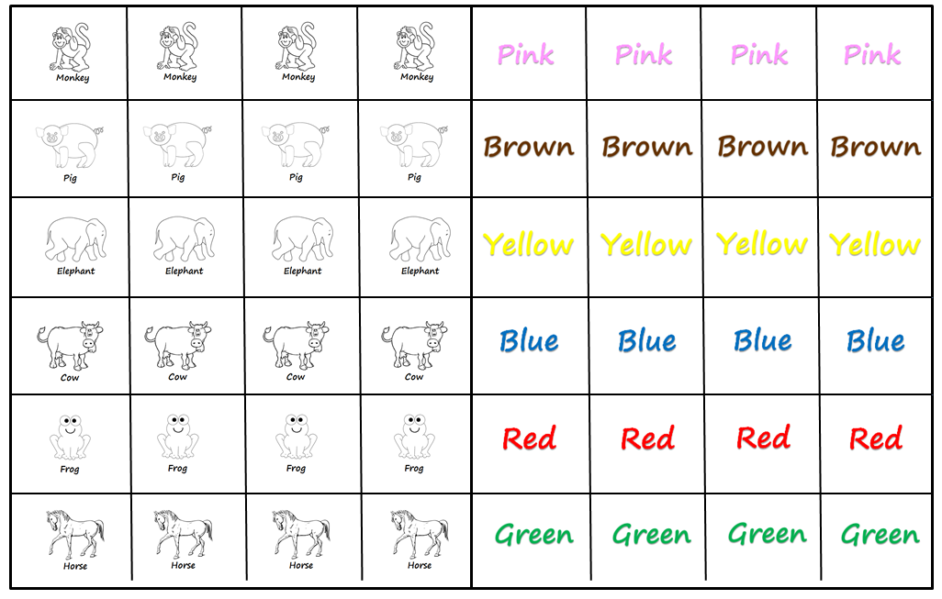

Worksheet #2: Following directions.
