Reading Lesson Plan

Title: Divorce
INSTRUCTOR | LEVEL | STUDENTS | LENGTH
Jenny | Intermediate | 12 | 4

Materials:
- pictures 1~3
- White board & board makers in the classroom
- Hand out sheets for guessing (3 copies)
- Hand out sheets for reading(12 copies)
- Hand out sheets for comprehension(6 copies)
- Story pictures(6 copies)
- SOS plan hand out sheets(3 copies)

Aims:
- Ss will improve their reading skills through reading hand out and written words and expressions on the board
- Ss will learn new words and phrases through studying new expressions
- Ss will learn new pronunciation and expression by asking and answering questions
- Ss will improve listening attitude by listening teacher’s instructions and other students’ expression
- Ss will improve their communicative skills by talking and expressing their thoughts

Language Skills:
Reading: written things on the board, hand out sheets
Listening: Ts’ instructions, other students’ expressions
Speaking: discussing about worksheets, answering questions, making their own story with pictures
Writing: answering on the board, making their own story with pictures

Language Systems:
Phonology: correction of pronunciation during speaking, practicing new vocabulary
Lexis: new vocabulary words and phrases through guessing the meanings with hand out
Grammar: through other students’ expression, correction of grammar during communication, reading written things
Discourse: express their ideas, answer and asking questions, discussing their own story with their partners
Functions: asking and answering, discussing, expressing

Assumptions:
- All students are adults and now about divorce
- Most students are interested in thinking about divorce

Anticipated Errors and Solutions:
- Ss may not be able to understand an instruction easily
: demonstrate an instruction rather than explain again until they get the purpose
- Some students may do something unrelated to the topic
: let them know the purpose of the activity again and give them an example
- Ss may need more time to finish their activity
: ask other group members to look or talk again what they did
-Some students finish their activity earlier than anticipated
: ask them to look or talk again what they did

References:
Article: http://www.breakingnewsenglish.com/1211/121123-household_chores.html:
Picture1: http://imagesearch.naver.com/search.naver?sm=ext&viewloc=1&where=idetail&rev=17&query
Picture2: http://19anjanspeaks.blogspot.kr/
Picture3: https://www.google.co.kr/search?q=grounds&newwindow=1&source=lnms&tbm
Story picture1~2: https://www.google.co.kr/search?q=lazy+husband&newwindow=1&tbm=isch&tbo
Story picture3: https://www.google.co.kr/search?q=lazy+husband&newwindow=1&tbm=isch&tbo#newwindow
SOS Plan: http://www.angelfire.com/hi/EnchantedGoddess/test11.html

Pre Task
Title:  Introduction of topic |  | Aims:  - To draw out ideas, vocabulary from the students by asking  - To increase students interest to the topic by let them think  - To connect the topic with students by let them think  - Build rapport each other by communication | Materials:  White board & board makers
Time | Set Up | Students | Teacher
7mins | Groups of 4 | - Listen T’s instructions  - Come up with their ideas with their group members  - Write down their ideas on the board  - Share their thoughts together | Instructions  - Greeting  - Elicit thoughts by asking guiding questions  - Ask them to write the questions on the board  - Let them share their ideas together  - Ask a CCQ questions  Guiding Question  - What kind of problems married couples could have?  - What solutions are there to handle marriage problems?  CCQ  - Can you guess why I ask you?

Notes

Task Preparation
Title:  Pre vocabulary |  | Aims:  - Let Ss know new words by guessing meanings by themselves  - Practice some words by listening& talking together | Materials:  White board & makers, Picture 1~4,  Hand out sheets for guessing
Time | Set Up | Students | Teacher
8mins  7mins | Groups of 4  Whole class | - Show picture A & B  - Think about a guiding question  - Think about and talk about expressions together  - Write down on their notes if they need  - Think about a concept checking question  - Share their opinions together  - Think about the reasons for divorce  - Share their ideas together | Instruction  - Give students Hand out sheets for guessing the words on the board  - Give them time to guess the meaning on the board  - Ask them to match words and meanings on the boards  - Then, ask them about the reasons for divorce  - Share their ideas together  Demonstration  - Demonstrate students how to match words and meanings on the boards  Guiding Questions  - How can you guess the meanings, when you have unknown words in some contents?  -What could be the reasons for divorce?  Comprehension Questions  - Do you know the meaning of these words?  CCQ  - Do you know why I ask you to guess the meanings?

Notes:

Task Realization
Title:  Read and Share |  | Aims:  To understand meanings by reading hand out  To share students thinking by talking  To build rapport by talking | Materials:  Hand out sheets for reading,  Hand out sheets for comprehension,  White board & makers
Time | Set Up | Students | Teacher
14mins | Individually  Pairs | - Read an article in hand out  - Answer questions with their partners | Instruction  - Ask them read the article in hand out  - Give them questions in hand out  - Ask them talk about that with pairs  Demonstration  - Show them how to share their opinions  Comprehension Questions  - Both of you should share your opinions?  CCQ  - Why we talk to each other with questions I gave you?

Notes:

Post Task
Title:  Create their own story |  | Aims:  To think freely with their partners  To use vocabulary by creating their own story  To be familiar with new words by communication | Materials:  Story pictures
Time | Set Up | Students | Teacher
14mins | Pairs | - Listen teachers instructions  - Start to create their own story  - Write down their story on their note  - After finishing, change it with another pairs in their table  - Read another pairs’ story | Instruction  - Give them pictures  - Ask them to create their own story with their partners  - Let them set pictures’ order  - Ask them to create negative or positive conclusion  - Ask them write down their story  - After finishing, let them change it with another pairs in their table  - Ask them to read another pairs’ story  Demonstration  -Show students how to create their own story  CCQ  -Why do we do this activity?  Comprehension Questions  - Will you create a charming story?

Notes: SOS plan

- Read hand-out sheets together in their group
- Talk about it together in their group

Picture 1~3

Hand out sheets for guessing
1) We have no grounds for believing that we can skip the microteaching.
2) She didn’t notice her husband’s infidelity until she saw him kiss another woman.
3) Alcohol has an adverse effect on family life.
4) Korean soap operas always have discord in relationship among people especially between the mother-in-law and daughter-in-law.

Hand out sheets for reading
Most people believe that the biggest grounds for divorce are either infidelity or arguments over money. However, a new report from British law firm Gateley suggests otherwise. According to its analysis of 350 divorce cases, seven out of ten divorces occur because of disputes over who does what household chores. Twenty percent of divorces are due to unfaithfulness. Gateley says the days are gone when the wife did all the cooking and cleaning. Dual income marriages now mean split responsibilities for vacuuming, doing the dishes and tidying. Gateley advised couples to discuss who does what before walking down the aisle. A spokeswoman said that, "going into a marriage blind could be a recipe for disaster".
Conversely, a study in Norway suggests that couples who share household chores are more likely to split up. Thomas Hansen, co-author of the report 'Equality in the Home,' said the divorce rate among couples who shared housework equally was 50 per cent higher than for those where women did all the work. Mr Hansen said that in Norway women did most of the housework in 70 per cent of marriages, and were "largely happy" to do so. An adverse side effect of marital discord is that many families are now "too poor to split up". The U.K. charity Relate said that in many middle-income families, couples stay together because they can't afford to divorce. Relate says this results in a "toxic" home environment.

Hand out sheets for comprehension
1) Most people believe that the biggest grounds for divorce are either boredom or having nothing in common.
True/ False/ We don’t know
2) A law firm says the age of women doing all the housework is over.
True/ False/ We don’t know
3) The Norway study said most women weren't happy to do housework.
True/ False/ We don’t know

4) Do you think women should do most of the house chores?

5) If you had a problem of dividing up household chores, what would you do?

6) What could be the biggest grounds for divorce in South Korea?

7) What kind of problems can we think in a "toxic" home?

8) What is less favourite household chores?

Story picture1~4
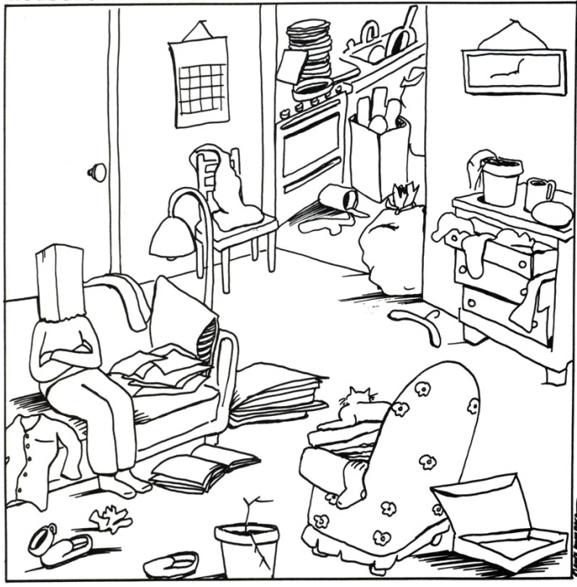
A young man and woman fell in love at first sight.
So they decided to get married.
On the wedding day, the young man promised her that
he would do anything for her. But, ....

SOS plan hand out sheet
1. Place in order, the following colors you like:

1) Red 2) Blue 3) Green 4) White 5) Black

2. Place in order, the following animals you like the most

- Tiger 2) Sheep 3) Horse 4) Sheep 5) Monkey

3. You are able to go into a space ship and explore the universe, what would you like to do or look for?
- View the Earth Planet.
- Explore all stars in the space.
- Start working on the Earth conservation.
- Look for a spaceman.
- Try to find a new planet to live in.
-----------------------------------------------------------------------------------------------------------------------------------------------------
Answer)
1. The order of the color represents the importance of certain aspects of your life
Red is passion/ Blue is family and friends/ White is marriage/ Black is death/ Green is Career
2. The order of the animals represents your view on certain aspects of life.
Tiger = pride/ Sheep = love/ Monkey = money/ Horse = family/ Cow = career
3. This test deals with how you perceive your present situation.
1) You may not be so happy with your present situation. However, you think it is still okay for you to live on.
2) You are happy with your current situation, but you want to change
3) You are happy with your current situation, and want to keep it that way.
4) You want to leave your current situation, no matter what it takes
5) You want to escape to find something new, you aren't happy with yourself

