Grammar Lesson Plan

Title: Preposition of Place _ How does my rook look like?
INSTRUCTOR | LEVEL | STUDENTS | LENGTH
MINO | intermediate | 12 (adults) | 50 mins

Materials:
Worksheet A (three sentences for correcting order for pre-task from busyteacher.org)
Worksheet B (1 to 4 slides from GLP_mino_GLP_ppt for task-preparation from busyteacher.org)
Worksheet C (descriptive text for task realization from www.slideshare.net)
Worksheet D (5 slide from GLP_mino_GLP_ppt for task-realization from slideshare.net)

Aims:
To raise awareness of the positioning of prepositions and their application through activities of correcting the order of words and creating sentences
To provide Ss with the chance to apply prepositions through the place-depicting activity
To offer Ss with the opportunity of imagining a place based on a text

Language Skills:
Reading: Ss read a descriptive text and imagine the place.
Writing: Ss create descriptive sentences using prepositions.
Listening: Ss listen to what others say through several sessions of group discussion.
Speaking: Ss speak what they think through several sessions of group discussion and present their own sentences in front of other Ss.

Language Systems:
Phonology: listen to what others say and try to listen to what I am saying.
Lexis: try to learn new words and expressions, especially focusing on prepositions
Grammar: Unknowingly Ss try to focus on preposition and understand their application.
Discourse: Discussing with other students during given time for several times
Functions: discussing, depicting, describing, exchanging, presenting

Assumptions:
Most of the Ss are women, so Ss might feel interesting when they are given the chance to draw a picture from a text.
Even though teacher don’t mention about the word “preposition, Ss might get to better know the application of preposition through several related activities.

Anticipated Errors and Solutions:
Ss might need more time to place words in the right order
- Let Ss create just one sentence, rather than two.
Ss feel difficult to draw a picture based on the description of the given text.
- Give them one or more hints about the positioning of described items.

References:
www.slideshare.net
busyteacher.org
www.britishcouncil.org

Notes:

Warmer
Title: correcting order of three sentences with prepositions |  | Aims:  To provide Ss with the chance of understanding the structure of sentences, especially focusing on preposition through the practice of correcting the order of words | Materials:  Worksheet A
Time | Set Up | Students | Teacher
6  Mins  4 mins | Group of 4  Whole class | Ss are given small cards with each word written on, and instructions to put them in order to make two complete sentences.  Each student from a group comes out to write down two sentences | Distribute Ss small cards (worksheet A), each card part of two complete sentences.  ICQ: How many sentences are you supposed to create with these small cards?  Compare two sentences from each group and correct the order, if necessary.

Notes:

Task Preparation
Title: Description practice |  | Aims:  To offer Ss the chance to think about the use of proposition through the practice of describing several photos | Materials:  Worksheet B
Time | Set Up | Students | Teacher
6  mins | Whole class | Ss try to use exact prepositions to describe the pictures shown to them through ppt. | Encourage Ss to create sentences to describe the given pictures without mentioning about the word “preposition”.  Elicit Ss’ competition by making the activity a group competition. Give a point from a concerned group when a student gives a correct answer.

Notes:

Task Realization
Title: Draw a picture following the description of a text |  | Aims:  To provide Ss with the chance of deeply thinking about preposition through a drawing activity based on a descriptive text. | Materials:  Worksheet C
Time | Set Up | Students | Teacher
13  Mins  9 mins | Group of 4  Whole class | Based on what they did through task preparation activity, Ss draw a picture that well describes the given text through a group discussion.  Given the chance to share the results of other groups and figure out what they mistakenly understood, especially the use of prepositions. | Distribute Worksheet C  Encourage Ss to read the text carefully and to actively involve themselves in group discussion in order to draw a picture as exact as possible.  Let Ss competitive by telling them to give points for the best drawing.  Let Ss paste pictures they drew on the board. Compare the results together, correcting the different points if necessary.

Notes:

Post Task or Production
Title: Creating descriptive sentences |  | Aims:  To offer Ss the chance to properly use prepositions to depict a scene | Materials:  Worksheet D
Time | Set Up | Students | Teacher
10  Mins  2 mins | Whole class | Actively involved in the sentence-creating activity using prepositions. They will get more points by giving right answers.  Get to the chance to revisit what they were doing through several activities today. They finally get to know that all of them are related to preposition. | Show Ss a picture that shows someone’s room.  Elicit Ss to create descriptive sentences that depict the picture, which will naturally let Ss use prepositions.  CCQ: 1. Where is the computer?  2. Is there a desk in the room? Where?  3. Is the flower vase located right next to chair?  4. Where is the picture frame?  Wrap up the class after giving short explanations about preposition.

Notes:

Worksheets, handouts and lesson materials
Worksheet A
Let’s meet at the west door of the cathedral to speak privately.
They have many beautiful pictures of his girlfriend on the wall.

Worksheet B
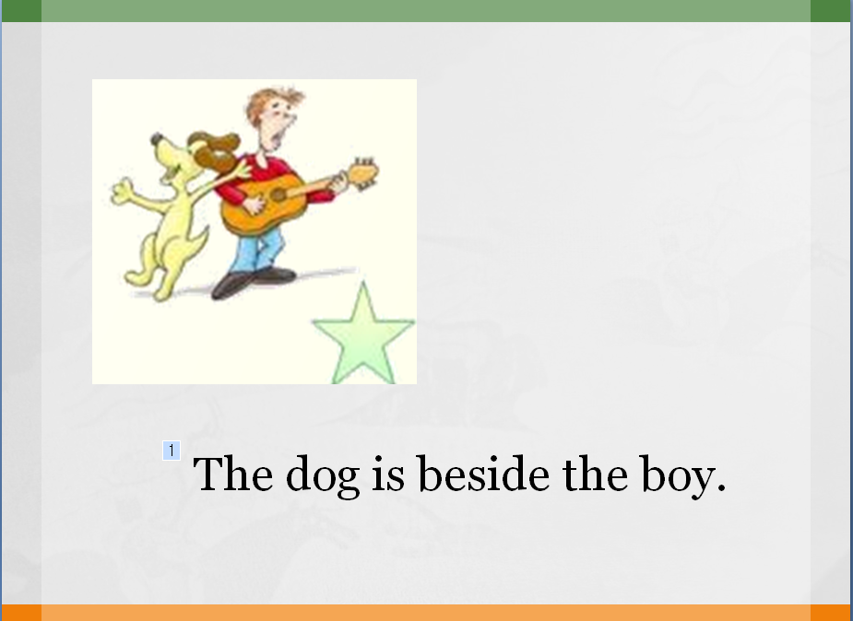

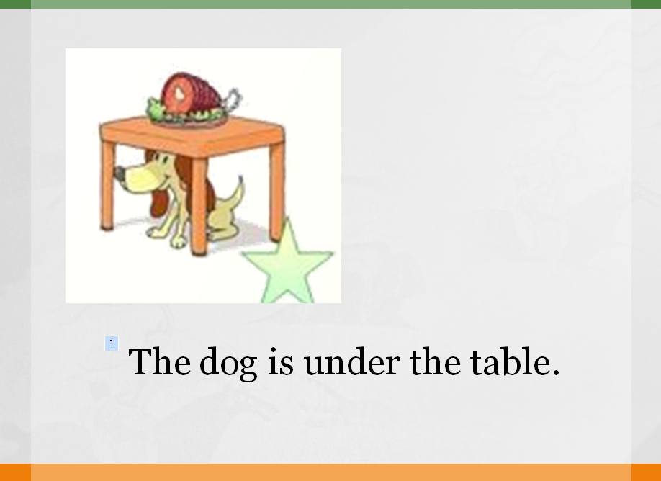
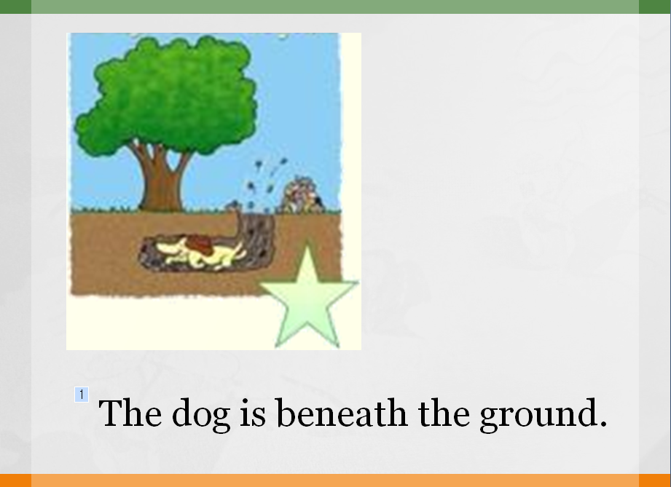

Worksheet C
My room is on the second floor of the house, between the room of my parents and my brother’s room. My room is very small, but in the room I have everything I need. In my room the bed is right by the door. On the bed are two pillows and a red blanket. It is also a large white teddy bear, who often sleeps with me. Above the bed hands a large clock, and on the bedside table is a small alarm clock. Clock is always accurate. Opposite the bed is large window with white curtains. Under the window stands a desk and chair. On the table are a laptop, and several books. On the left side of the desk is closet with my clothes. In the room is also the red carpet. Carpet is a stylish and very convenient. On the walls are handing a lot of photos with my family and friends. In the corner stands a trash can.
Worksheet D

