Listening Lesson Plan

Title: If the world were a village.
INSTRUCTOR | LEVEL | STUDENTS | LENGTH
Stephanie | Intermediate | 12 (adults) | 50 mins

Materials:
- worksheet (12)
- board game sheet(3)
- ppt file( with video clip) –usb
- dice (3)
- counters for board game(12)

Aims: At the end of the lesson;
Students have learned the 2nd conditional sentence through the video clip, worksheet and board game.
Students have learned the vocabulary in worksheet by pictures or examples.(ppt file)
Students have practiced reading through worksheet.
Students have practiced speaking by group work.

Language Skills:
Writing: students can make sentences using the pattern and write down.
Reading: students can read the worksheet .
Listening: students can listen to the students’ speech and teacher’s speech.
Speaking: students can speak when they work in group.

Language Systems:
Grammar: 2nd conditional If s+v-ed ~, s+would+v~/ If s+were~, S+would+v
Phonology: pronounce the vocabulary
Lexis: vocabulary in worksheet
Discourse: group work
Functions: dialogue, information

Assumptions:

Students are familiar with and are interested in psychology test.
Nowadays, most of the students don’t think they are happy.
Students are familiar with the board game.

Anticipated Errors and Solutions:
Students may need more time to finish the board game.
teacher can give about 3-5mins more .
Students may have the difficulty making the sentences when they do the board game.
->teacher will help them and correct the error if they mistake.(with indirect way)
Students may finish their work earlier than expected.
->teacher will review the vocabulary or let them make more 2nd conditional sentences .
**SOS plan
--if there is more than 15min left, teacher will give the worksheet related to the 2nd conditional (included at the end of the file)

References:
http://www.familycare.org/special-interest/if-the-world-were-a-village-of-100-people
http://www.youtube.com/watch?v=r6eTr4ldDYg
http://busyteacher.org/7323-if-wish-board-game.html
http://busyteacher.org/18083-conditionals-revision-worksheet.html
http://www.mimint.co.kr/love_n/board_view.asp?bbstype

Notes: for SOS plan
, teacher will give the worksheet related to the 2nd conditional (included at the end of the file)
http://busyteacher.org/18083-conditionals-revision-worksheet.html
for plan B(ppt is not available),
teacher can skip the video clip (because content of video clip is almost same as the worksheet) and use the white board and maker to teach the vocabulary.

Pre Task or Warmer
Title:  Psychology test |  | Aims:  Students will have learned today’s topic through psychology test. | Materials:  Ppt file
Time | Set Up | Students | Teacher
5mins | Whole class | Students can choose one item among 4 items.  Students will listen to the explaination.  Students will answer the today’s topic. | Let them know we’ll do the psychology test for fun.  Teacher will explain the situation.  (today is your friend’s wedding day.  You’re wearing a black simple dress and you want to add one accessory . what will you choose?)  Let them choose one among 4 items.  Explain interpreted meaning one by one.  -----------------------------------------------------------------------  **Heart-shaped necklace  Degree of happiness 40%- you feel happy but you don’t think you are happy. You’d better have more confident with happiness.  **flower brooch  Degree of happiness65%-you’re satisfied with your life and you feel quiet happy.  ** purple shawl  Degree of happiness 10%-you don’t feel happy but you feel anxiety. What do you worry?  ** fancy nail art  Degree of happiness 90%- your life is filled with happiness.  ----------------------------------------------------------------------  Teacher will elicit the today’s topic.

Notes: plan B
If the ppt file is not available, teacher can introduce the topic without ppt file. Teacher can explain the test by speaking.

Task Preparation or Presentation
Title:  vocabulary |  | Aims:  Students will have learned today’s vocabulary in worksheet . | Materials:  ppt
Time | Set Up | Students | Teacher
7  mins | In group | Students will discuss the meaning of the vocabulary referring to the examples in the ppt. | Teacher will introduce the vocabulary.  INSTRUCTION  -Let them discuss the meaning of vocabulary referring to the examples in the ppt.  -let them work in group.  -Teacher will give 3mins to discuss.  After 3mins, teacher will ask about the meanings .

Notes:

Task Realization or Practice
Title: if the world were a village,.. |  | Aims:  Students will have learned the 2nd conditional by seeing the video clip, reading the text, and doing the board game. | Materials:  Ppt file (check if the video clip is included)  Worksheet(text)(12)  Board game sheet(3)  Dice(3), counters for board game(12)
Time | Set Up | Students | Teacher
7mins  4mins  10mins  10mins | In group | Student will make 3 sentences using this pattern.  Students will answer the questions.  Students will see the video clip. They might feel something happy.  Students will answer the question related to the today’s topic.  Students will read the text and discuss in group. | Teacher will introduce the sentence; if the world were a village of 100people,____would___________)  INSTRUCTION  -Teacher will make sure the group.  -Teacher let them make 3 sentences using this pattern in group.  -Teacher will show them an example sentence.  (if the world were a village of 100 people, 61 would be Asians.)  -Teacher will give 3mins to make sentences.  After 3mins, let them share the ideas.  *Concept checking  -Is there any possibility that the world become a village in real?  -Are only 61 Asians in the real world?  Before reading the text, teacher will show them the video clip.  CCQ  -why did I show you the video clip?  (teacher will elicit the ideas related to the today’s topic “happiness”)  Teacher will distribute the worksheet(text)  INSTRUCTION  -Let them read and choose 3 memorable sentences in the text .  -let them work in group.  -Teacher will give 10mins to read and discuss .  -After 10mins, students will share the ideas using whole sentence(today’s pattern).  Distribute the board sheet and dice to each group.  INSTRUCTION  -give the direction how to do it.  (throw the dice . depending on the square you land on ,you have to say something using the sentence on the square. If the answer is correct , they can stay on the square. If not, they have to go back to the square they were before.)  -let them do it in group.  -give them 10mins to do it.

Notes:

Post Task or Production
Title: substitution tables |  | Aims:  Students will have practiced the 2nd conditional using substitution tables. | Materials:  Ppt file
Time | Set Up | Students | Teacher
7 mins | Whole class | Group members will speak out the sentences they made. | INSTRUCTION  -Teacher will point the 2-3words.  -Using those words , let the group members make sentences .  -Let them speak out .  -group by group  After that, review today’s pattern and vocabulary.
Notes: **SOS plan

--if there is more than 15min left, teacher will give the worksheet related to the 2nd conditional (included at the end of the file)

Worksheets, handouts and lesson materials
Worksheet 1
If the world were a village of 100people....
When you woke this morning
did you look forward joyously to the day?
When you go to bed tonight,
do you think you will be filled with satisfaction and happiness?
Do you think the place where you live is precious?
If you read this, the things around you might start to look a little different.
In the world today, 6 billion 300 million people live.
If this world were shrunk to the size of a village.
If the world were a village of 100people,
The village would have 61 Asians, 13 Africans, 12 Europeans, 9 Latin Americans, and 5 from the USA and Canada.
50 would be male, 50 would be female.
75 would be non-white; 25 white.
67 would be non-Christian; 33 would be Christian.
80 would live in substandard housing.
16 would be unable to read or write.
50 would be malnourished and 1 dying of starvation.
33 would be without access to a safe water supply.
39 would lack access to improved sanitation.
24 would not have any electricity (And of the 76 that do have electricity, most would only use it for light at night.)
8 people would have access to the Internet.
1 would have a college education.
1 would have HIV.
2 would be near birth; 1 near death.
5 would control 32% of the entire world's wealth; all 5 would be US citizens.
48 would live on less than US$ 2 a day.
20 would live on less than US$ 1 a day.

Board game sheet
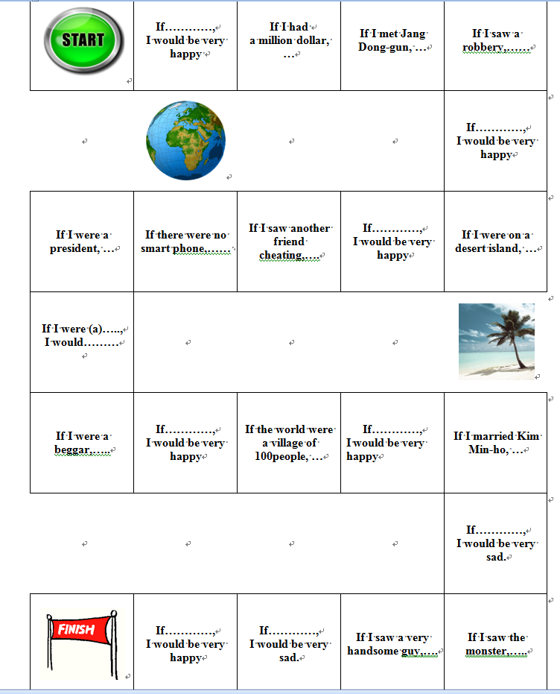
Ppt file page 1,2,3,4,5
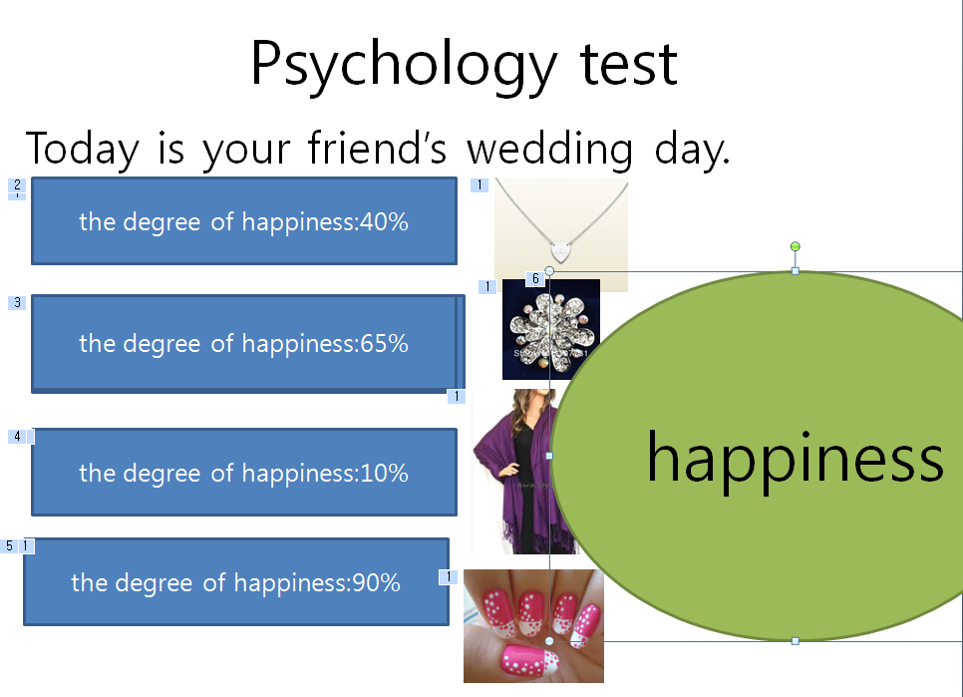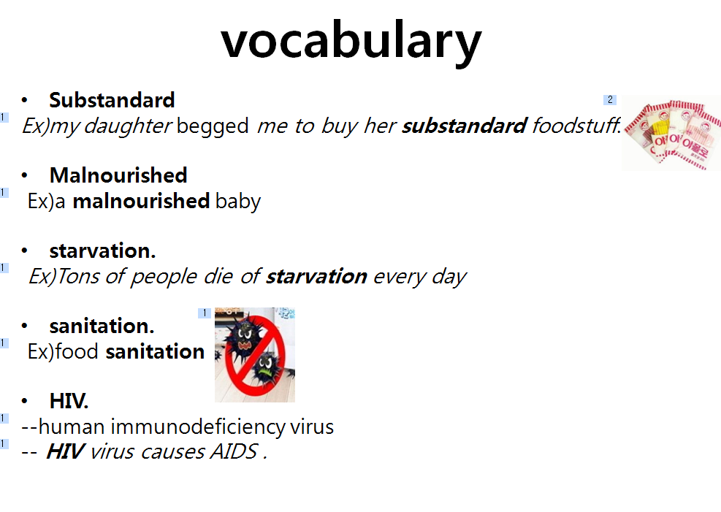

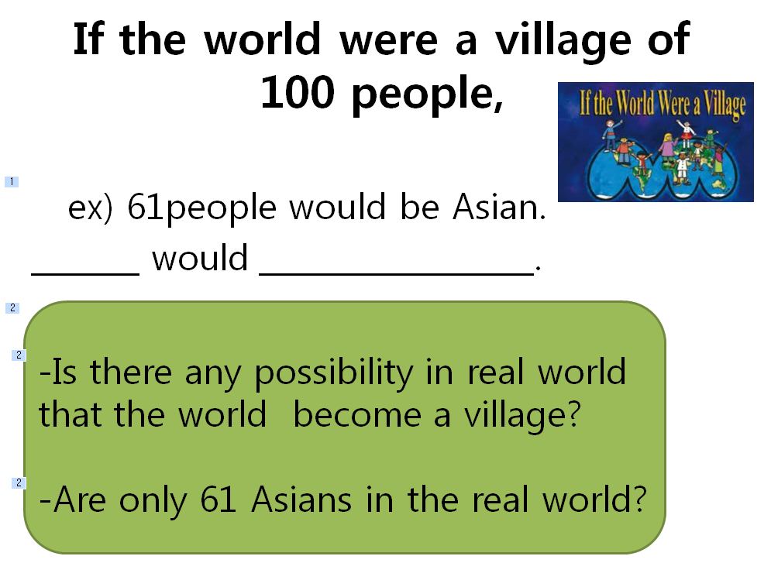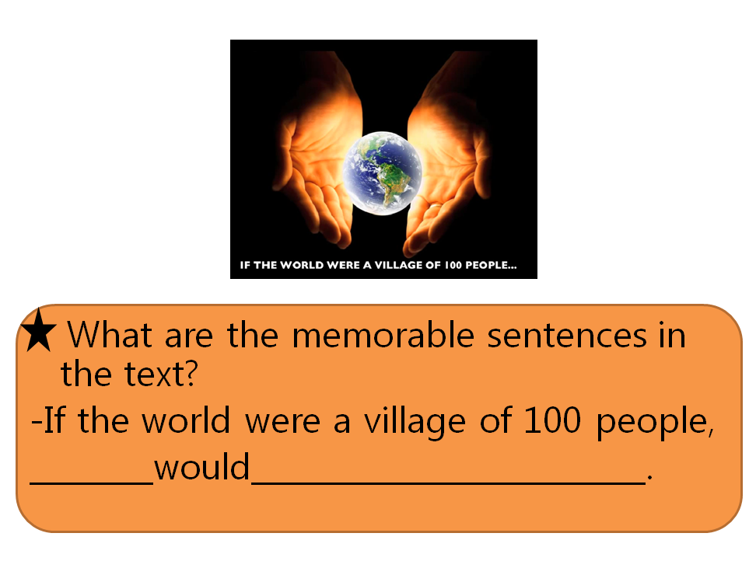

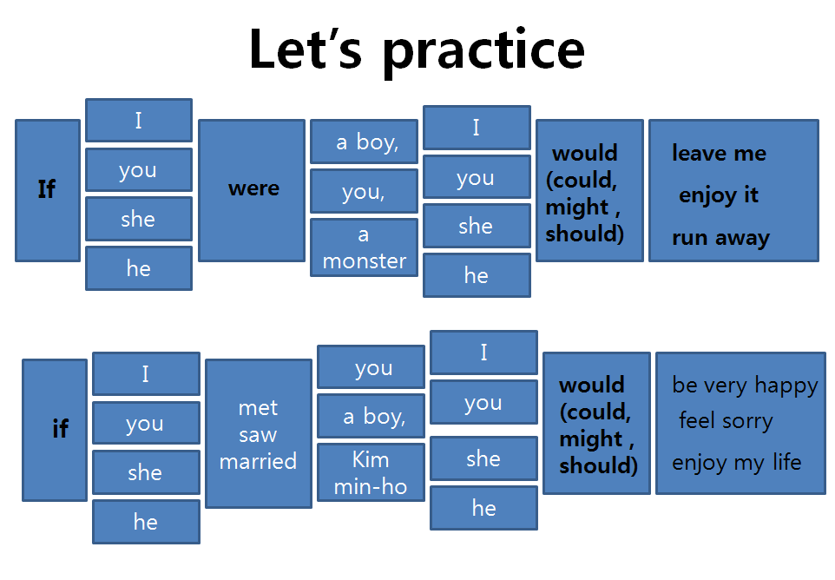

SOS plan
