Grammar Lesson Plan

Lets Be Creative!
INSTRUCTOR | LEVEL | STUDENTS | LENGTH
Angie Kim | Intermediate | 12 | 50 mins

Materials:
Whiteboard and markers
Tic Tac Toe Game Sheet x 6
Tic Tac Toe Game Cards x 10
Fill in the Blanks worksheet x 12
Make Your Own Story worksheet 1 x 6
Make Your Own Story worksheet 2 x 6

Aims:
By the end of this lesson students -
- Have practiced forming sentences with verbs followed by either a gerund or infinitive by completing the lesson activities.
- Become more confident in making their own sentences using the verb followed by gerund/infinitive structure by getting used to how the sentences sound in real life.
- Develop their English fluency skills and pronunciation by actively participating in the pair activities and the teacher’s eliciting.

Language Skills:
Speaking: Responding to the teacher’s questions, participating in class and pair discussions.
Listening: Listening to the teacher’s questions, instructions and examples. Listening to their partners and the class’ ideas.
Reading: Various activity worksheets, reading the vocabulary written on the whiteboard.
Writing: Completing the Make your own story worksheets 1 & 2, by making up their own sentences.

Language Systems:
Grammar: Allowing the students to form their own sentences based on the new vocabulary and words related to the topic.
Phonology: Practicing new vocabulary and their pronunciations
Lexis: Understanding the way new words are used in sentences and how to apply them freely in their own conversations.
Discourse: Group and class discussions about the worksheet answers, figuring out the meanings of new words, group Q&A.
Functions: Getting the students to discuss in pairs, questioning the students about the words and their meanings.

Assumptions:
- Students cannot confidently use verbs that are followed by a gerund or an infinitive.
- Students may have some previous experience listening to sentences that do use verbs that are followed by a gerund or infinitive, so they may be familiar with how the sentences are meant to sound.

Anticipated Errors and Solutions:
- Students might have some difficulty forming their own sentences and using the correct grammatical structure.
  - Let the students have a clear understanding of new words by pre-teaching. It is okay for students to make errors as long as they correct them by the end of the lesson.
  - Encourage the students to read out loud to one another so that they can get a feel of the sentences and if they sound correct or not.
- If time is running short
  - Cut down the time of the post activity.
- If students finish their activities earlier than anticipated
  - Use the SOS plan (in post activity).

References:

Notes:

Pre Task or Warmer
Tic Tac Toe |  | Aims:  To lead the students into the main topic and to get them to use verbs which are followed by gerunds or infinitives. | Materials:  Tic Tac Toe game sheet and game cards
Time | Set Up | Students | Teacher
8 mins | Pairs | Students get into pairs and play the Tic Tac Toe game with each other.  This game should get students actively thinking about the types of verbs that they can use in sentences. Specifically verbs that are followed either by a gerund or an infinitive. | Before handing out the game materials to the students, make sure they know how to play they game. Let the students know the rules of the game if they are not familiar.  Hand each pair a Tic Tac Toe board sheet and game cards.  Tic Tac Toe Game Instructions:  Students decide who is Player 1 & Player 2.  Player 1 – pick one square on the board and provide the correct verb to the sentence provided inside the square.  If both students can agree that Player 1’s sentence makes sense, Player 1 can place their “X” or “O” card over the board square and ends their turn.  Player 2 does the same as Player 1 for their turn. They can pick any square on the board and form a strategy that opposes Player 1’s moves.  Monitor the students while they play.  ICQ:  How can you win at this game?  CCQ:  What do you think this activity is about?

Notes:
If one group has 3 players, get 2 students to be Player 1 or Player 2 and alternate taking turns against the other player.

Task Preparation or Presentation
What’s the verb? |  | Aims:  To pre-teach new vocabulary related to the main topic as well as eliciting the correct use of verbs. | Materials:  White board and markers  Fill in the Blanks worksheet
Time | Set Up | Students | Teacher
5 mins  4 mins  2 mins | Whole class  Individually  Whole class | Students should be actively engaging and responding to the teacher’s elicitations.  Students complete the Fill in the Blanks worksheet and can discuss with other students about the answers.  Students read out loud the sentences together. | Elicit the following vocabulary from the students:  Recommend (Syn – endorse, commend)  Postpone (Syn – delay, reschedule)  Consent (Syn – agree, accept, approval)  Demand (Syn – request, call, dictate)  Make sure that students can also correctly pronounce the vocabulary.  Once the students have a clearer understanding of how to use the new vocabulary, hand out the Fill in the Blanks worksheet to each student.  Students are allowed to discuss with others about what they think the blank words could be.  If students appear they have finished the worksheet after a couple of minutes, go over the answers together as a whole class and read the sentences together out loud.  CCQ:  What did you all learn from doing this activity?

Notes:

Task Realization or Practice
Make your own story! |  | Aims:  To let the students practice forming grammatically correct sentences in English and to also practice English speaking fluency | Materials:  Make your story worksheet 1
Time | Set Up | Students | Teacher
19 mins | Pairs | Students work together and think of interesting words to use to complete the Make your own story worksheet.  Students read their stories out loud to the class. | Hand out a worksheet to each pair.  Ask the students to come up with their own words and take turns filling out each blank in the worksheet.  Encourage the students to be creative and use interesting words. Give an example using one sentence in the Make your own story worksheet.  Monitor each pair while they are doing the worksheet activity.  After students complete the activity, ask them to read out their stories to the rest of the class.

Notes:

Post Task or Production
Title |  | Aims:  To let students improve their fluency in speaking English. Allow students to freely form and practice their own sentences. | Materials:  Make you own story worksheet 2
Time | Set Up | Students | Teacher
12 mins | Pairs | Students work together to make up their own stories by using the words on the vocabulary list. | Ask the students to come up with their own interesting stories by incorporating the words used on the vocabulary list.  Students are working in pairs so you can get the students to write one sentence each until their story is completed.  If all the students finish this activity early and some time is left over, get the students to read their stories out loud to the rest of the class.

SOS: Get the students to look up “Mad Libs” on the Internet and fill them out.

He _ _ _ _ _ _ _ watching movies | He _ _ _ _ _ to go swimming everyday | She _ _ _ _ _ _ _ _ _ playing the piano everyday
She really _ _ _ _ _ _ to go the party | He _ _ _ _ _ _ letting her go to the party because she was too young | He _ _ _ _ _ _ _ _ _ _ to brush his teeth that night
She quit _ _ _ _ _ _ _ 5 years ago | He _ _ _ _ _ _ _ _ to her with his grandmother’s ring | He resumed  _ _ _ _-ing after she left

X | X | X | X | X
O | O | O | O | O

Fill in the Blanks Worksheet

Fill in the blanks by using the correct words provided in the Word List:

1. Jenny ___________ watching the movie.
WORD LIST:
- To Do
- Speaking
- Consented
- Meeting
- Managed
- Denied
- To Stay
- Demanded
- Recommended
2. Alain _______ to finish the class.

3. Stephanie hesitated __ __ her homework.

4. Julie postponed _______ her friend until next week.

5. Hannah continued ________ to her classmates.

6. Mino struggled __ ____ awake during class.
7. Min ______ eating the cookies.

8. Serin ________ to know who ate the cookies.

9. Jenna finally _________ to marry him.
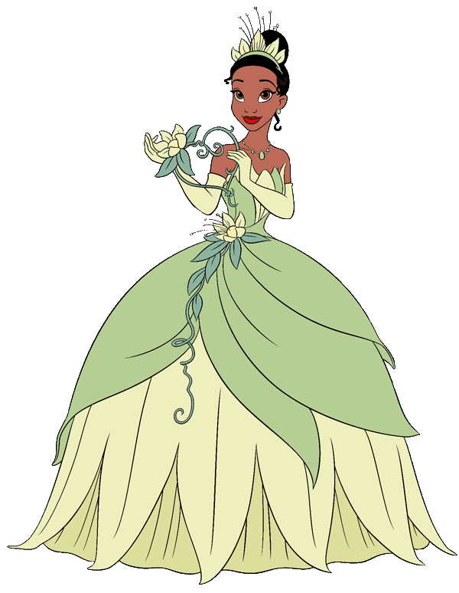
Make you own story!

Create your own interesting story in pairs by filling the blanks in with interesting verbs/adj/nouns/etc.

Once upon a time there was a handsome Prince. He was __________(verb) quietly in the castle.

There also lived a beautiful Princess who loved to go __________(verb) everyday.

One day she saw the Prince's photo and decided that she wanted to ______(verb) him.

The Prince received a ________(noun) from the Princess and agreed to go ____________(action verb) with her.

The next day the Prince went walking ____________(adverb) in the woods.

In the woods the Prince met an evil _______(noun).

The evil _______(same noun) turned the Prince into a ______(adj) _______(noun).

The Princess found the Prince in the woods and gave him a ________(noun).

The Prince and Princess…. (Make your own conclusion!) __________________________________________________________________________________________________________________________________________________________________.
Make your own story again!
Use all the words in the Vocab List to make your own stories in pairs:
Vocab LIST:
1. Hesitate
2. Continue
3. Consent
4. Postpone
5. Manage
6. Deny
7. Struggle
8. Demand
9. Recommend

