Listening Speaking Reading Grammar Writing

Topic: A Car Accident

Instructor:  Joy, Stella | Level:  Intermediate | Students:  9 | Length:  30 Minutes

Materials:
Pictures: a person wearing seatbelt, policeman
traffic light, scene of a car crash
Worksheet: vocabulary (9 copies)
Drawing of car parts (3 copies)
Three sets of roll cards (driver 1, driver 2, policeman)
White board and markers

Aims:
- Ss will have improved overall speaking skills through role play.
- Ss will have learned new vocabulary related to car accident.
- Ss will have practiced logical and persuasive communication.
Ts’ personal aim: to improve lesson planning and to gain self-confidence in teaching.

Language Skills:
Speaking: Ss will play roles and present to class.
Listening: Ss will listen to T’s instructions and to description of accident scene.
Reading: Ss will read vocabulary in worksheet and role cards.
Writing: SS will re-write roles and prepare presentation.

Language Systems:
Phonology: /p+l/ in whiplash, /f/ /b/ in fender-bender
Lexis: vocabulary related to car accident
Grammar: various grammars in the situation
Function: arguing, persuading, debating, calling help, directing
Discourse: description, dialogue, debate

Assumptions:
Ss already know how the class is set up and run.
Ss are used to T’s teaching style and pace of the course.
Most Ss can drive.
Ss know important traffic rules.

Anticipated Difficulties and Solutions:
- Emergency numbers 119/999/911
>>> to explain difference by country.
- Ss may not know the specific words of car parts/injuries.
>>> to give explanation without spending too much time on each word.
- Ss may need more preparation time (most likely).
>>> to allow more time by cutting off post activity.
- Some Ss may stay passive.
>>> to encourage them to participate.
- Ss may finish main activity early.
>>> to let them work on/find out more new words related to car/injury.

References:
Pictures of policeman, people with/without seatbelt, traffic light, car crash:
https://www.google.co.kr/imghp?hl=ko&tab=wi
Worksheet : definitions from http://dic.daum.net/index.do?dic=ee
pictures from https://www.google.co.kr/imghp?hl=en&tab=wi
Drawing of car parts: http://f1espn.tistory.com/67

Lead-In
Materials: none

Time | Set Up | Student Activity | Teacher Talk
1 min | Whole class | To feed in their experience | Do you have driver’s license?  Can you drive a car?  Anybody who just keeps the license in the closet and cannot drive at all?  Do you wear a seatbelt when driving?

Pre-Activity
Materials:
Pictures of a person wearing seatbelt, policeman, traffic light, car crash
Worksheet, Board and marker

Time | Set Up | Student Activity | Teacher Talk
8 min  (2)  (4)  (2) | Whole class  Indiv.  Whole class | To listen to T and answer to questions  To brainstorm  To match words-meanings | Elicit  (To show pictures of a person wearing seatbelt, policeman, traffic light and car crash)  What do you see here?  Have you ever been injured while driving a car?  What about anybody in your family or friends?  What do these pictures make you think of?  Modeling  “A car accident”  Brainstorming  (to elicit words related to car accident and draw “cloud” on board)  CCQ  Is a car accident something that happens suddenly and unexpectedly?  Who or what do you call when you have a car accident?  Can a car accident cause traffic congestion?  Instruction  I will give you a handout. You will work on vocabulary that is related to car accident. You work individually and later we will check together.  (to hand out worksheet)  You may look up in dictionary and have 3 minutes.  Demo  (to do one matching in the worksheet as demo)  ICQ  Do you work in group?  How much time do you have?  Execute & monitor  (Close monitoring not necessary  To give timing, 1min-30sec)  Check  (to let Ss match, taking turns; let others help; explain if needed; discuss different emergency numbers, eg. 119/999/991)  Error correction  whiplash /p+l/  fender-bender /f/ /b/  “Good job, everyone!”

Main Activity
Materials:
3 sets of role cards,
Drawing of car parts, Board and marker

Time | Set Up | Student Activity | Teacher Talk
17 min  (3)  (7)  (6)  (1) | Group of 3  Group of 3  Group  Whole class | To read role cards  To organize a role play and present | Instruction  Let’s sit in a group of three.  (to group Ss considering balance in competency)  Imagine you had a car accident. I will give each group a set of 3 role cards. Your group will assign each person a role and organise a role play. You will see what the situation is like from role cards, but you can change it. For instance you may like to set a different situation where a driver caused an accident on purpose. Or you give different characters to drivers. Or just a minor accident.  Demo  Can Amy stand up please?  (To let her pick a role card from one set; Joy and Stella pick one each too)  What is your role, Amy? Joy is policeman and I am driver 2.  (To handout role cards)  (To hand out the drawing of car parts)  Here is a drawing of car parts which may help you setting up the scene. You have 7 minutes to plan. Then each group will present 2-min role play to class.  ICQ  Do you work individually?  What do you do with role cards?  Do you have to follow the roles exactly as described on cards?  How much time do you have to plan?  Execute and monitor  (To monitor discreetly  Not to intervene unless procedure goes absolutely wrong  To help when asked  To take notes of difficulties or errors  To give timing, 3min-1min-30sec)  OK, time is up.  Are you ready?  (To let each group present)  Correction/feedback  (To correct and feedback from the notes taken while monitoring  To get feedback from other groups)  All right, everyone. Did you enjoy the activity? Good… and well done!

Post Activity
Materials: none

Time | Set Up | Student Activity | Teacher Talk
4 min  (3)  (1) | Group  Whole class | To describe situation and speak to class | Instruction  It was interesting to see the different situations three groups created. Now let’s check whether we understood each other correctly. You will stay in the same group and will re-write the accident scene of another group. Group-a will talk about Group-b’s play, G-b will about G-c’s, and G-c about G-a’s. Give a short and clear description as you understood. Let one person in your group speak to class later. You have 2 minutes.  Demo  Pointing groups and in gesture  ICQ  Group-a, which group will you talk about? And you Group-b?  How much time do you have?  Do you need one person in your group to present to class?  Execute & monitor  (Close monitoring not needed  To give timing, 1min-30sec)  Check  (To let one or two groups give a talk depending on time left.)  Correction/feedback  (To correct misunderstands if any)  Wrap-up  How was it? Was the vocabulary new to you? What did you find difficult?  You worked hard today and did an excellent job!

Worksheet – matching

- Read the definitions and write appropriate word from the box.
Amount spent for diagnosis, treatment or prevention of medical problems
A conclusive resolution of a matter
Promise of reimbursement in case of loss
Policeman who has the power to close roads and direct traffic
A collision between motor vehicles that produces minor damage

insurance fender-bender
settlement medical expense traffic officer

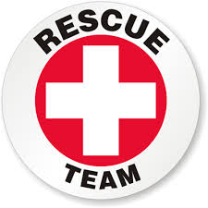
- Match each picture with appropriate word from the box.
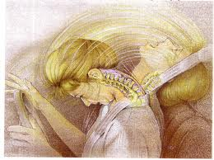
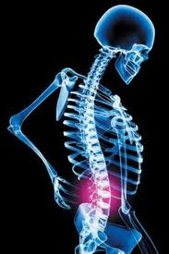

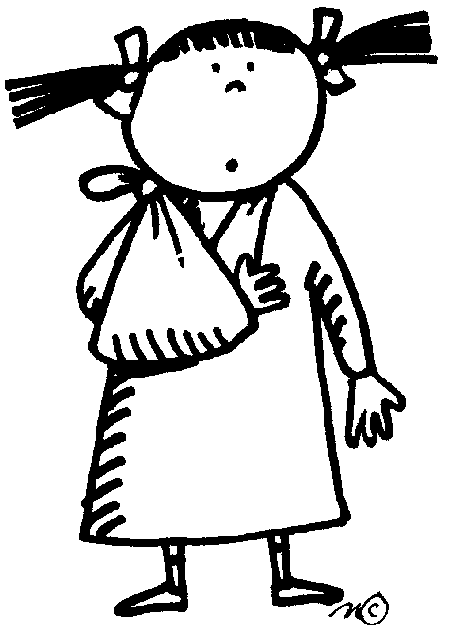
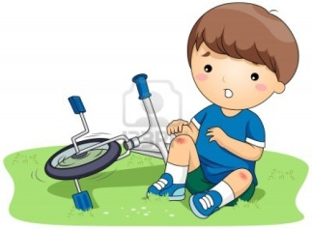

119 broken bruised whiplash slipped disc

Roll cards

Driver 1
I was turning left at green light and the light changed to orange when I drove half way through. That moment, the other car appeared suddenly and hit me. He must have started his car before the light turned green as the street was quite empty. Oh, my back hurts!

Drive 2 (Group-a)
No, I started my car at green light. I saw him driving at full speed when I reached the middle of intersection. I managed to stop but it was too late. Oh my gosh, I think I have a whiplash! And I must tell I could smell alcohol when he came out of the car to talk to me.

Driver 2 (Group-b)
No, I started my car at green light. I saw him driving at full speed when I reached the middle of intersection. I had my pregnant wife in the back seat and we were on the way to hospital. I couldn’t possibly drive so carelessly! I only hope she and my baby are safe.

Driver 2 (Group-c)
I am sorry… I am a beginner and maybe I shouldn’t have driven at night. But I am sure I started my car at green light. I saw him only when I reached the middle of intersection. It’s my mom’s car and I don’t know whether I am covered by insurance. What do I have to do?

Traffic officer
I came to the site of car accident at 9pm. Two drivers were having an argument with their cars stopped in the middle of the road. One car (1) had a bash on the front door on driver’s side. The other one (2) had the bumper smashed. Both drivers seemed to have some injuries. I need to listen to what they say and do something!

