Listening Speaking Reading Grammar Writing

Topic:
Countable noun VS Uncountable noun

Instructor:  Alice & Julia& Eddie | Level:  Intermediate(Adult) | Students:  8 | Length:  30 Minutes

Materials:
- White board and board marker
- Wall chart for filling the blank activity
- Wall chart for filling pictures and making full sentences.
- Visual aid realia
- Worksheet(A/B)

Aims:
Main aim: Ss will be able to improve their grammar skills by filling the blank activity and making full sentences and selling food.
Secondary aim: Ss will be able to learn new grammar and vocabulary by completing activities.
Personal aim: We want to reduce commentaries and give more STT and improve
eliciting.

Language Skills:
Reading: Ss will read sentences after filling the blank activity.
Listening: Ss will listen to other student’s shopping list and some sentences.
Speaking: Ss will talk to each other when they prepare for filling the blank activity and sell their special food to other student.
Writing: Ss will write their own list for grocery shopping.

Language Systems:
Phonology: / Refrigerator / (sounds for /R/,/F/)
Lexis: New vocabulary (Ex. refrigerator)
Grammar: Countable and Uncountable noun
Function: Distinguish
Discourse: Question and Answer

Assumptions:
- Students already know = How the set up and run.
- Students had an experience for grocery shopping
- Students exchange idea to complete tasks.

Anticipated Errors and Solutions:
Students may not be able to follow the passage easily
- Provide them with the worksheet for the idea of content.
Students may need time on their presentation
- Give students extra time to work and Demonstrate before they work on their own dialogue.
Students may not be active in the activity
- Give some example about the topic.
- Find out volunteer or pick some students to talk.

References:
- Pictures for wall poster:www.google.com

Lead-In
Materials: None
Time | Set Up | Student Activity | Teacher Talk
1min | Whole class | Answering teacher’s question | Hello, everyone!  How are you doing today?  What did you eat for breakfast?  What kind of fruit do you like?

Pre-Activity
Materials:
Wall-chart, Board and Board markers, Realia
Time | Set Up | Student Activity | Teacher Talk
2min  1min  3min | Whole class  Indivi  -dually | Answering teacher’s question  Listen to teacher  Do activity | Procedure:  Showing visual aid realia  Eliciting  -What is this?  -Have you ever eaten this?  -Do you like to drink milk?  -What is different between A and B?  Modeling  “Countable noun VS Uncountable noun  (write it on the board)  CCQ  -Can you count milk?  -Can you count apples?  -Does Liquid, solid, gas have a shape?  Filling the pictures and words activity  Instruction  I want you to find pictures and words to fill gaps in the sentences.  Demonstrations  For example, If this is apples and put ‘apples’ card here in this sentence.  “Let’s begin, --- please come out one by one and do it”  ICQ  Do you work in a group or individually?  What will you put on the poster?  “Now begin”  Monitor  Monitor discreetly.  Each student puts the card on the poster.  Check answers orally

Main Activity
Materials: Wall-chart, Board and Board markers
Time | Set Up | Student Activity | Teacher Talk
3min  7min  3min | Whole class  In groups | Listen to teacher  Student do activity | Instructions  I want you to make two groups.each group has 4 people.  First , I want you to find pictures to fill this refrigerator in right position.  Second, make complete questions and answers under the refrigerator by using word cards  I will give you 3 minutes to prepare it.  When you are ready, come out and complete on this poster for 4 minutes.  Demonstration  (showing demo. live)  ICQ  Are we working individually?  How much time do you have?  “now begin”  Monitor  Monitor discreetly.  Give ideas or opinions if they get stuck.  “Time’s up”  Each student puts the pictures and word cards on the poster.  Check answers orally

Post Activity
Materials: Board and a board marker, Worksheet
Time | Set Up | Student Activity | Teacher Talk
1min  3min  3min  3min | Whole class  Individu-ally  Whole class | Listen to the teacher  Do activity  Students share their opinions  Listen to the teacher | Instructions  You will order some foods. make your own list for grocery shopping  You will choose three things from word box. There are two different worksheets. Worksheet(A) will be covered only countable noun and worksheet (B) will be covered only uncountable noun. You will work individually and I will give you 3 minutes.  Demonstration  (Showing live demo.)  ICQ  Are you working individually?  How much time do you have?  “Now begin”  Monitor  Monitor discreetly.  Give ideas or opinions if they get stuck.  Give time warning: 3minutes  2minutes, 1minute.  Give time warning: 30 seconds left.  Be flexible with time.  Give students 1 more minute if they need it.  “Time’s up”  Check the answer / 1st presentation  Now let’s hear from each person for what they will buy.  (write what they say on the board)  Review and error correction  Correct pronunciation  refrigerator  /R/ ,/F/  Good job today.  Thank you for participating today.  See you tomorrow.

SOS Activity
Materials: Board and a board marker, Realia
Time | Set Up | Student Activity | Teacher Talk
1min  3min  3min | Whole class  Groups | Listen to teacher  Do activity | Instruction  You will sell these food by giving special abilities.  You need to create special abilities for your food given.  You will work in pair. I will give you 3 minutes to prepare it. and after that you will start to sell your food in front of the people.  Demonstration  Showing live demo.  ICQ  Are we working individually?  How much time do we have?  Does this food have a special ability?  “Now begin”  Monitor  Monitor discreetly.  Give ideas or opinions if they get stuck.  Give time warning: 3minutes  2minutes, 1minute.  Give time warning: 30 seconds left.  Be flexible with time.  Give students 1 more minute if they need it.  “Time’s up”  Each group will come in front of the class to sell their food.

Work Sheet(A)

you will make your own list for grocery shopping
Choose Only 3 countable food.

1.

2

3.

--------------------------------------------------
Word box:
Apple, orange, cookie, tomato, carrot, milk, water, bread
Work Sheet(B)

you will make your own list for grocery shopping
Choose Only 3 uncountable food.

1.

2

3.

----------------------------------------------------------------------
Word box:
Apple, orange, cookie, rice, salt, milk, water, bread

Wall poster

1.

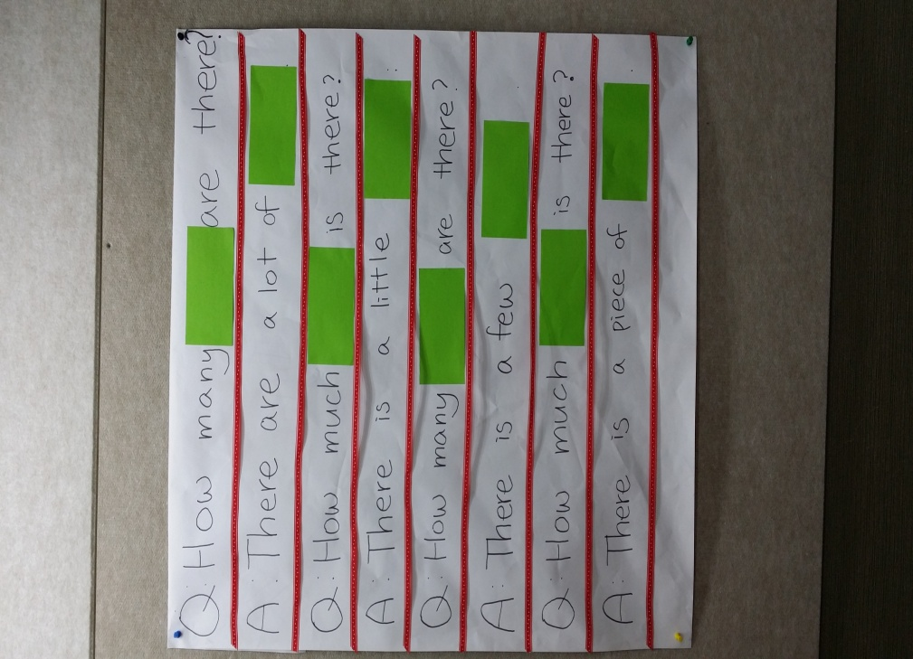

2.
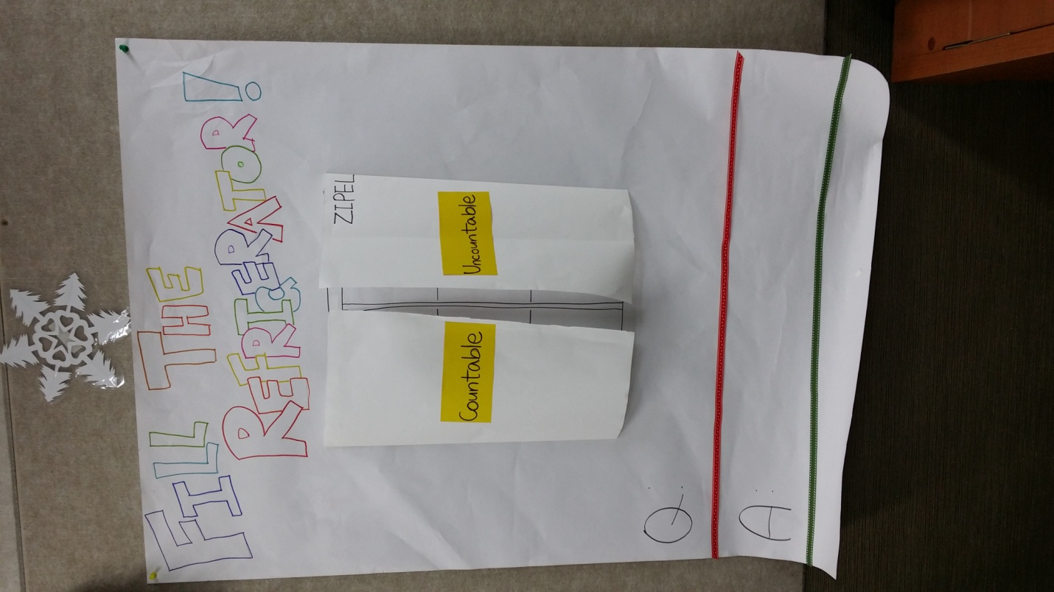

Pictures and words for wall poster
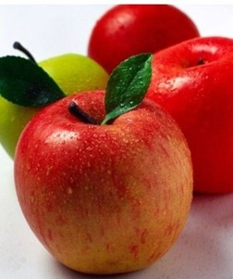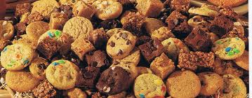
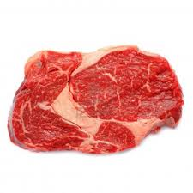

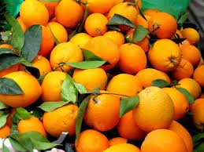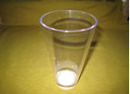

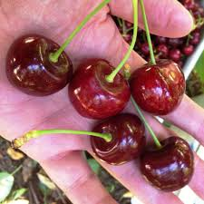

Apples
Meat
Cookies
Salt
Oranges
Milk
Cherries
Cake

How many
How much
How many
How much
are
are
is
is
In the refrigerator.
In the refrigerator.
There are
There is
a little
a lot of
a little
a lot of

