Listening Speaking Reading Grammar Writing

Topic: Tomorrow(OST of Annie)

Instructor:  Amy | Level:  Intermediate | Students:  8 Students | Length:  30 Minutes

Materials:
- Vocabulary & Idiom worksheet (8copies)
- Pictures of Annie
- Gap file worksheet (8copies)
- White board and board markers
- DVD of Annie, DVD player, Overhead projector, Screen

Aims:
- Main aim : Ss will be able to improve their listening skills by listening and understanding conversation in the song.
- Secondary aim : Ss will be able to learn key sentences and vocabularies.
- Personal aim : I want that Ss learn useful expressions.

Language Skills:
- Reading : Ss will read vocabularies & idiom worksheet.
- Listening : Ss will listen to conversation in the song.
- Speaking : Ss will sing a song
- Writing : Ss will fill in the blanks while listening.

Language Systems:
- Phonology : Silent syllable, intonation in the conversations
- Lexis : Vocabularies and idioms
- Function : Learning colloquialism
- Grammar : Tense, idiom
- Discourse : Making up a song.

Assumptions:
Students already knows :
- The set of the class and the pace of the course
- The teacher’s teaching skill and type
- How relatively to speak fluently and write accurately

Anticipated Errors and Solutions:
If students can’t complete Fill in the blanks at the first time.
- Students will listen to a song for twice again.
If students need more time to finish work on the worksheet.
- Teacher will provide more time to finish working on the worksheet.
If students speak with loud voice when they discuss.
- Teacher asks politely students keep your voice down.

References:
- Visual aid (Pictures) : Picture from Google image.
- English vocabulary from : http://endic.naver.com/?sLn=kr
- Movie : DVD of Annie

Lead-In
Materials: None
Time | Set Up | Student Activity | Teacher Talk
1min | Whole  Class | Answering teacher’s questions | Hello everyone!  How are you today?  Have you ever seen Musical?  What musical be made into a movie?

Pre-Activity
Materials: Board & Board makers, Visual aid, Worksheet#1
Time | Set Up | Student Activity | Teacher Talk
2min  5min  2min | Whole  Class | Answers elicited questions  Do matching activity  write answers  check answers and learn the vocabulary and idioms | Procedure :  - Brainstorming  Elicit  (show visual aid-pictures(the characters of Annie)  Have you seen these characters?  Do you know what her name is?  Model  Write the tile ‘Annie’ on the board  CCQ  Is Annie rich?  Does Annie have parents?  - Idioms & vocabularies  Instruction  I’ll give you a worksheet of vocabularies and idioms. Match the items  I’ll give you 5 minutes to finish.  (Distribute the worksheet#1)  Demonstration  Do you have the worksheet?  Let’s look at the No.1…  ICQ  Are you working in groups?  How much time do you have?  “Let’s start.”  Monitoring  Monitor observantly.  If Ss ask questions, answer it.  “3 minutes left”  “1 minutes left”  Give 1 or 2 minutes if they need it.  “Time’s up”  Check answers  Do you finish it? Good!  Let’s check it together.  Go through the idioms one by one  Elicit the meaning from students  Teach pronunciation  “You did good job!”

Main Activity
Materials: DVD of Annie, DVD player, Overhead projector, Screen, Worksheet #2
Time | Set Up | Student Activity | Teacher Talk
9 min  3 min | Whole Class and group | Watch and Fill in the blanks  Check answers | Instruction  I will show you the scene of the movie Annie. (The part of Tomorrow)  After watching, fill in the blanks.  I’ll play 2 times  (Distribute the worksheet#2)  ICQ  Are you working in group?  Do you fill in the blanks while watching?  How was the movie?  Do you want to watch one more time?  (If they want to watch one more time, play it)  Check answers  Time’s up.  Let’s check the answers together.

Post Activity
Materials: Papers and pens
Time | Set Up | Student Activity | Teacher Talk
3 min  2 min  3 min | Whole Class and in pairs  In pairs  Whole  Class | Write short conversation section each other through Sentences of Worksheet#1  Presentation  Answers elicited questions of today’s lesson  Error correction | - Production(writing and speaking)  Instruction  You are going to have discussion in pairs.  You write short conversation about your “tomorrow(want to be)”  I’ll give you 3 minutes to discuss.  ICQ  What will you discuss?  Do you choose sentences with your partner?  Do you write short conversation section?  Please start.  Monitoring  Monitor discreetly.  If the Ss ask questions, answer it.  Discussion  Please listen “A” team’s prepared conversation, and then B, C, D team will present conversation.  - Conclude Lesson  Elicit today’s vocabularies and idioms for students.  You all did great today.  Please try to remember the sentence, and usually use it.  Thank you all for your great participation and great work.  Have a good day and see you tomorrow!

SOS Activity
Materials: Papers and pens
Time | Set Up | Student Activity | Teacher Talk
10min | In pairs | Discuss | Instruction  Let’s talk about your favorite  song(OST).  Tell the story of the movie and  explain why you like it to your partner.  ICQ  Did you talk in pairs?  What will you discuss?  Monitoring  Monitor discreetly.  If the Ss ask questions, answer it.  Discussion  Please listen “A” team’s prepared conversation, and then B, C, D team will present conversation.

※Visual aid
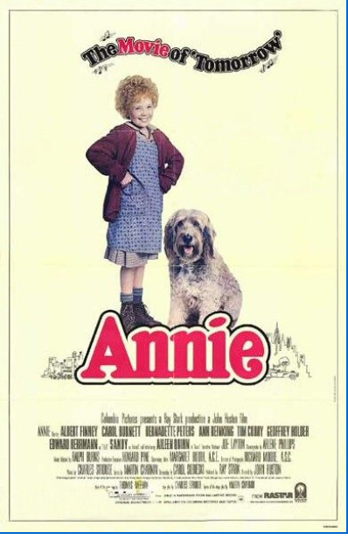
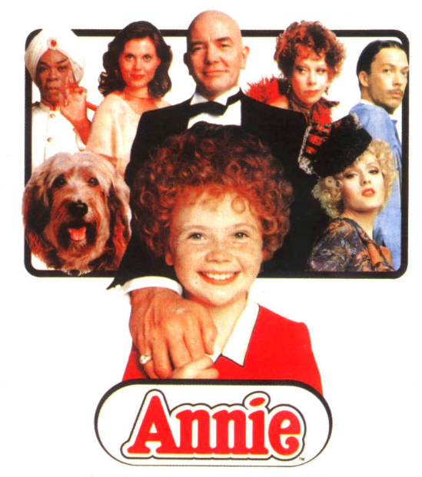
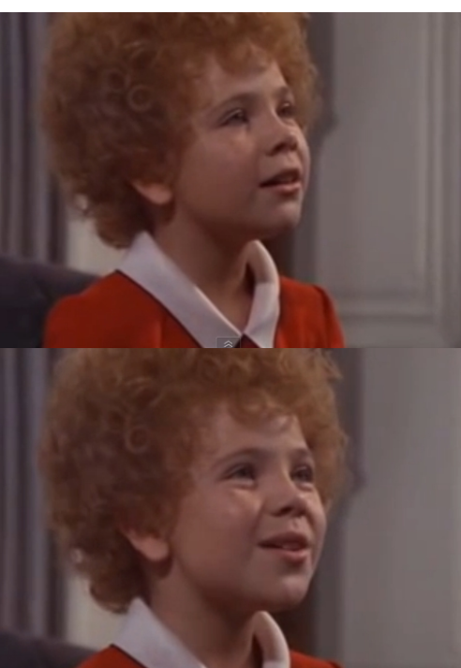


※Worksheet #1

Matching & Text Completion Exercise
Guessing words | Correct answer(find from under)

If you say that it is a good bet or a safe bet that something is true or will happen, you are saying that it is extremely likely to be true or to happen.

to remove things that you have been using and no longer need in order to leave a clear space

If you describe someone or something like this, not happy

Someone is unhappy because they are alone or do not have anyone they can talk to.

You put it there in a rather casual way.

Bet Clear away Gray _ Lonely Stick

※Worksheet #2(Gap fill)
Fill in the blanks while you watch the movie.

Tomorrow
The sun'll come out tomorrow
___ your _____ dollar that tomorrow
There'll be sun
Just thinking about tomorrow
_____ ____ the cobwebs and the sorrow
___ there's none
When I'm ____ with a day That's ____ and ____
I just ____ ___ my chin and grin and say, ohh
The sun'll come out tomorrow
So you _____ hang on ____ tomorrow
Come what may
Tomorrow! Tomorrow! I love yah, tomorrow
You're always a ____ _____

※Worksheet #2(Gap fill) - SCRIPTS

Tomorrow
The sun'll come out tomorrow
Bet your bottom dollar that tomorrow
There'll be sun
Just thinking about tomorrow
Clears away the cobwebs and the sorrow
Till there's none
When I'm stuck with a day That's gray and lonely
I just stick out my chin and grin and say, ohh
The sun'll come out tomorrow
So you gotta hang on till tomorrow
Come what may
Tomorrow! Tomorrow! I love yah, tomorrow
You're always a day away

