Listening Speaking Reading Grammar Writing

Topic: Subject-Verb Agreement

Instructor:  Surin | Level:  Intermediate | Students:  8 students | Length:  30 Minutes

Materials:
- Worksheets (8 copies)
Worksheet#1 singular and plural
Worksheet#2 subject-verb agreement
Worksheet#3 activities (sentence maze)
- A piece of paper and a pen (for each person)
- White board and Board markers

Aims:
- Main aim: Ss are able to understand what is the subject-verb agreement is.
- Secondary aim: Ss are able to make sentences correctly with subject-verb agreement..
- Personal aim: Increase STT in this class, and make them to be clear with the concept of empty subject.

Language Skills:
- Reading: Ss are able to read sentences through the worksheets..
- Listening: Ss are able to listen to what teacher and other students are saying during the drills.
- Speaking: Ss are able to tell their answers to teacher, and repeat the sentences during the drills.
- Writing: Ss are able to write the answers through the worksheets..

Language Systems:
- Phonology: -s
- Lexis: New vocabulary
- Grammar: subject-verb agreement
- Function: Leaning about the usage of subject-verb agreement, eliciting the topic.
- Discourse: Sharing ideas

Assumptions:
Students already know:
- Teacher's style of teaching.
- How the class is set up and run.
- Basic grammar usage.
- They can express what they think well in English..

Anticipated Errors and Solutions:
- Students may not be able to understand the grammar rule.
Set an example(demonstration) to let them understand.
- Students may finish their working on worksheets early or late.
Try to encourage students to match the time well.
- Students may need more time to find the answers.
Give students extra time to work.

References:
- English vocabulary from : http://dic.naver.com/
- English translation from : http://translate.google.com/
- Searching for the concepts : http://www.docstoc.com/docs/21626943/
- https://www.google.co.kr/search?q=Subject-Verb+Agreement+realia&newwindow=1&source=lnms&tbm=isch&sa=X&ei=YkzZUoOYKMrllAW7j4HIAg&ved=0CAcQ_AUoAQ&biw=1366&bih=667#newwindow=1&q=subject-verb+agreement+worksheets&tbm=isch&facrc=_&imgdii=_&imgrc=Fad01oXbWnm_0M%253A%3BmELsYqfmQLWScM%3Bhttp%253A%252F%252Fimg.docstoccdn.com%252Fthumb%252Forig%252F21626943.png%3Bhttp%253A%252F%252Fwww.docstoc.com%252Fdocs%252F21626943%252FSubject-Verb-Agreement-Worksheet-2%3B1275%3B1650

Lead-In
Materials: None
Time | Set Up | Student Activity | Teacher Talk
1min | Whole  Class | Answering teacher’s questions | Good morning, everyone! How are you today?  Did you eat your breakfast? What did you eat?  I ate a sweet potato, and some apples..

Pre-Activity
Materials: Board, Board markers, Worksheet #1 ,visual aids
Time | Set Up | Student Activity | Teacher Talk
5min  5min | Whole  Class | Answers elicited questions  Students go through the worksheet  and learn the vocabulary and idioms | Procedure:  - Brainstorming  Elicit  (Show pictures)  What is this? (SS answer)  How many things in this picture? (SS answer)  Yes, as you know we call the things considering about things' number, the singular and plural.  Model  (Write “subject-verb agreement” on the board.)  Today, we are going to learn about "subject-verb agreement". The subject and verb must agree in number. Both to be singular or both must be plural.  CCQ  Are we saying 2 apple?  Are we saying 4 pencils?  - Vocabulary & Idioms  Instruction  (Distribute the worksheet #1)  Before we start, we should check the vocabulary, and work on quiz.  Work individually for 3 minutes. Are you ready?  Then let's get start.  Demonstration  Look at #1...The word '~' means.  ICQ  Are you working in groups?  How much time do you have?  "Let's see."  Monitoring  Monitor discreetly. Answer students if they ask questions  Notice when 1minute left. Be flexible with time. Give 1 more minute if they need it.  “Time’s up”  Check answers  Let’s check the answers together.  -Ask students and let the students tell what they wrote.  -Go through the answers one by one  -Elicit the meanings from students  -Explain the meaning if necessary  Phonology : how to pronounce -s to be put at the end of the words.  Well done!

Main Activity
Materials: worksheet #2, #3, pen and paper, smart phones
Time | Set Up | Student Activity | Teacher Talk
3min  6min | Whole Class  Group | Work on the worksheets | Instruction  Let's go through today's topic, “subject-verb agreement”. In English, singular subjects need singular verbs, and plural subjects need plural verbs.  In present tense, one must add an -s or -es at the end of the verb when the subjects performing the action is a singular third person: he, she, it.  For example,  The student sings, or He/she sings in singular form, but in plural, it would be The students sing.  In additional, He has 2 apples, 4 tomatoes, and a pear. Susie is a teacher. or They are teachers, like this.  Then let's do it by yourselves.  CCQ  Are we put -s at the end of singular nouns?  Are we put -es at the end of the word 'paper'?  (Distribute the worksheet#2)  You should match the verbs to subjects' form in worksheet#2. Work with your partner, solve the questions one by one in turn. I will give you 3 minutes for this activity.  ICQ  Are you working in group?  How much time I gave you?  Let's start.  Monitor discreetly.  Check answers  Let’s check the answers together  - let the students tell the correct answers  - wrap up and error correction  Phonology : notice the pronunciation /self/, /selves/.  Grammar : subject-verb agreement.

Post Activity
Materials: None
Time | Set Up | Student Activity | Teacher Talk
6min  5min | Group  Group | Work on worksheet#3.  Do quiz | - Production( speaking & writing )  Instruction  (Distribute worksheet#3)  From now on, we will do a game, the sentence maze!  Let's do the activity in groups. Connect the words in each sentence and find the way. I will give you 5 minutes.  ICQ  Are we doing a sentence maze?  Are we working alone?  How much time do you have?  Let's begin!  Monitoring  Monitor discreetly. Help Sts when they need helps.  - Conclude lesson  Elicit today’s vocabulary and idioms for students and Wrap up the grammar.  Grammar: Subject and verb agreement.  Error correction : Check the pronunciation of -s, -es  Feedback  You guys all did a good job today. please try to understand how to use the form in subject-verb agreement. See you tomorrow!  Homework  No homework.

SOS Activity
Materials: A piece of paper and a pen, smart phones
Time | Set Up | Student Activity | Teacher Talk
5min | Group | Explaining what they've leant. | - Production( speaking & writing)  Instruction  Now, we will get feedback about what we've leant today with each other. Let's make 2 groups and get discuss about the topic. Remind what you've leant and get ideas with each other, and explain the concept to other group's friends. I will give you 5 minutes to discuss and 5minutes to give a presentation..  ICQ  How much time do we have in discussion?  How much time do we have in presentation?  What was our topic?  Monitoring  Monitor discreetly. Help students when they need helps.

★ Pictures

★ Worksheet #1 Vocabulary
Match the words !
Singular is the form that is used when referring to one person or thing.
Plural is the form that is used when referring to more than one person or thing.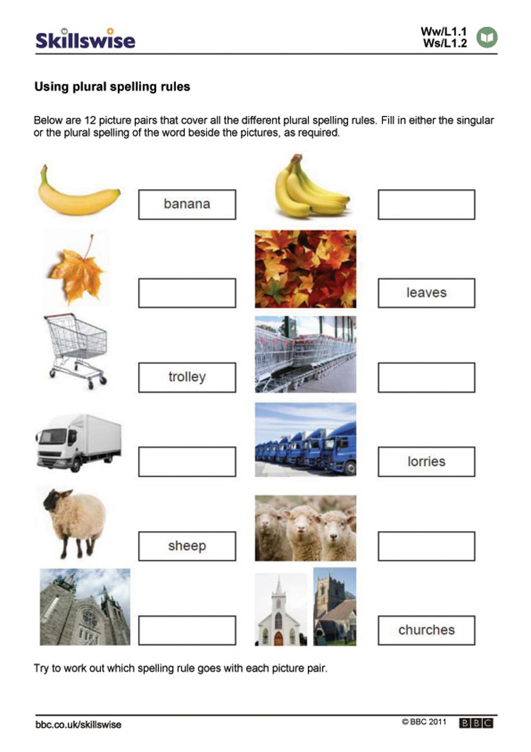

★ Worksheet #2

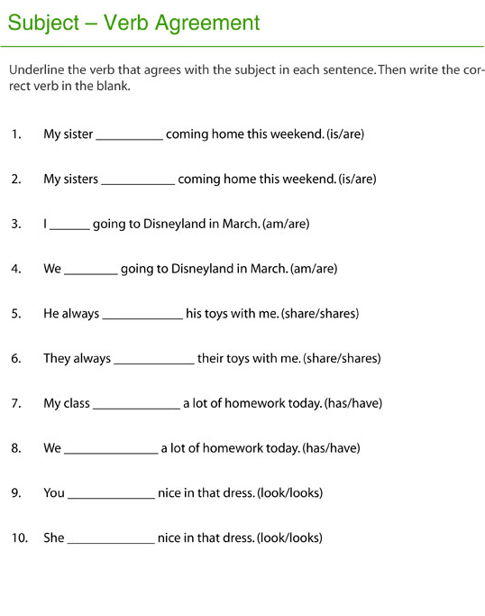

★ Worksheet #3

Connect the words in each sentence.
Find your way from the beginning of the maze to the end.

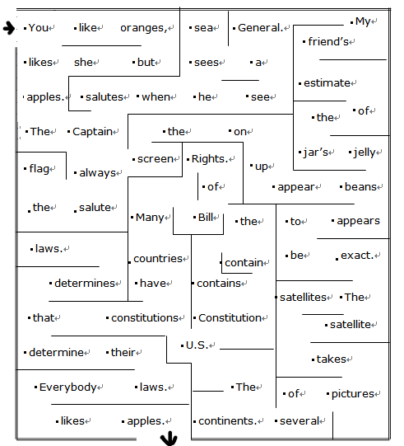

Write the full sentence you made.
[ ]

