Jane Austen Festival, Bath, England
The Jane Austen festival takes place each year in Bath, an elegant Georgian city with strong Austen connections. It’s a grand, costumed affair, and you’ll see so many fancy gowns, top hats and bonnets that you’ll almost believe you’re back in Regency England.
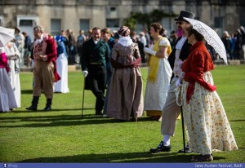
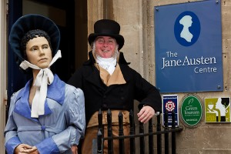
Attend lunches, fairs, promenades, theatrical performances, lectures and workshops all related to Austen’s era, and be inundated with Austen-esque facts and experiences. Many of these are ticketed, so be sure to book in advance.

2014 Bath Jane Austen Festival dates – 12th to 21st September 2014
There will be lots of events spread over 9 days for Austen enthusiasts to enjoy in Bath. Hope to see you soon.
Date of the Promenade is Saturday 13th September 2014.

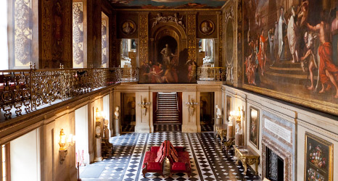
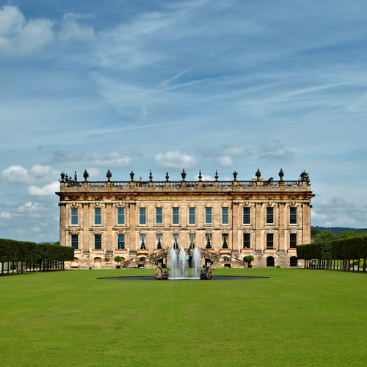
Chatsworth, Derbyshire, England
Austen’s books feature a number of grand country houses. One of these is Chatsworth, which Elizabeth Bennet actually visits in ‘Pride and Prejudice’. It was also the inspiration for Mr Darcy’s home estate of Pemberley.
Surrounded by the dramatic countryside of the Peak District, and home to a vast collection of historical artworks, it’s just the place to get a sense of life in Austen’s era.
House and display | Explore over 30 rooms in the ancestral home of the Cavendish family. | Open every day 16 March - 23 December 2014
Farmyard and playground | Our working farm and adventure playground is fun and educational for all ages. | Open every day 16 March - 23 December 2014
Garden | Having evolved over more than 450 years, the garden continues to change today | Open every day 16 March - 23 December 2014
Jane Austen’s House Museum, Hampshire, England
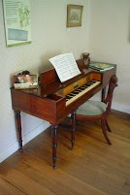
Jane Austen spent the last eight years of her life in Chawton, a Hampshire village between Winchester and London. This is where she did much of her mature writing, including ‘Persuasion’ and ‘Emma’, and revised several of her earlier works.
It’s practically hallowed-ground for her fans, and even if you’re not familiar with her writing, it’s a fascinating 17th-century home in an idyllic village which will tell you the story of her life. After her death, Jane Austen was buried in nearby Winchester Cathedral, a towering gothic building that’s also well worth a visit.
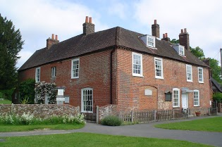

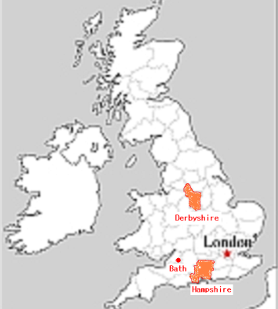

Main works of Jane Austen
- Sense and Sensibility (1811)
- Pride and Prejudice (1813)
- Mansfield Park (1814)
- Emma (1815)
- Northanger Abbey (1818)
- Persuasion (1818)

Experience the Pride and Prejudice lifestyle

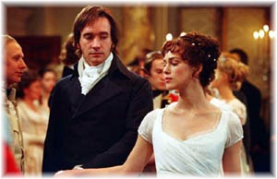

2013 marked 200 years since the publication of Jane Austen’s classic novel, ‘Pride and Prejudice’. See fabulous costumes, grand country houses and discover why this book inspired film adaptations, drama series and won an army of devoted fans.

