Listening Speaking Reading Grammar Writing

Topic: Edison the Wizard (science hero)

Instructor:  Kelly (Kim) | Level:  Intermediate | Students:  8 students | Length:  30 Minutes

Materials:
• White board and board markers
- Pre-activity Worksheet (8 copies)
- Reading text(8 copies)
- Main-activity (Sentences order 2sets)
- Post-activity Worksheet(8copies)
- Realia – Some pictures about Edison

Aims:
- Main aim : Ss will be able to read and comprehend an article.
- Secondary aim : Ss will be able to have the main/detailed ideas of the article while play sentence order game.
- Personal aim : I want to give clear instruction and time control.

Language Skills:
- Speaking : Ss will speak while Sentence order game.
- Listening : Ss will listen each other while they play the games.
- Reading : Ss will read an article and questions on the worksheets.
- Writing : Ss will write the answer on the worksheets.

Language Systems:
- Phonology : /bulb/, /wizard/
- Lexis : inventor, wizard, carbon, burn, bulb, improve
- Grammar : Past tense
- Function : Sentence order
- Discourse : Group discussion

Assumptions:
Ss already know :
- The set of class and the pace of course.
- The teacher’s teaching skills and type and the atmosphere in the class.
- Ss are familiar with the sentences order game.
- Ss will enjoy the activities but will find it challenging

Anticipated Errors and Solutions:
Students may not be able to finish the worksheets in time
- Give them one more minute. But if they need more time, make them stop.
- Check the answers together.
Some students do not participate in the group activities
- Encourage them to answer the questions
If students finish their task earlier than anticipated
- Do SOS activity

References:
- Visual aid (Pictures of Edison, bulb on the website ‘Google’)
- English definition form ‘Dictionary.com’ mobile application
- Text Book – Reading for vocabulary (Level B)

Lead-In
Materials: None
Time | Set Up | Student Activity | Teacher Talk
1 min | Whole | Answer teacher’s questions | Hello everyone!  How are you doing today? Good  Have you used the light bulb?

Pre-Activity
Materials: Board and Board markers, Worksheet#1
Time | Set Up | Student Activity | Teacher Talk
3 min  5 min  3min | Whole  Individually  Whole  class | Answer elicited questions.  Work on the worksheet  Students and teacher will  Check answers together | Procedure :  - Brainstorming  Elicit  (Show the students visual aid pictures without telling the names)  What do you see in the picture?  Where can I get light bulb?  Do you know who made light bulb?  Very good.  Today, we’re going to read the article about “ Edison the Wizard”  Model  (Write the “ Edison the Wizard”  on the board)  He is the greatest a science hero.  CCQ  Do we use light bulb in our house?(Yes)  Can I get light bulb in supermarket?  - Vocabularies  Instruction  I’ll give you a worksheet #1.  Match the words with the correct definitions. Work individually.  I’ll give you 5 minutes to finish.  (Distribute the worksheet#1)  Demonstration  Does everyone have the worksheet?  Let’s look at No.1…  ICQ  Are you working in pairs? (No)  How much time do you have? (5min.)  “Now, please begin”  Monitoring  Monitoring discreetly. If Ss ask questions, answer it.  Time warning  2 minutes left.  1 minute left.  Time’s up.  Check Answers  Does everyone finish it? Good.  Let’s check it all together.  Go through the answers one by one.  (Call student’s name and ask them to say the answers)  Everyone did good job.

Main Activity
Materials: Reading text, Sentence order 2sets
Time | Set Up | Student Activity | Teacher Talk
3min  6min | Whole  class  Group | Read the text  Sentence order game | 1. Reading Text  Instruction  I’ll give you the reading text.  Please read and carefully.  First time, Let’s read it all together.  You have 3 minutes to read it.  (Distribute the reading text)  Demonstration  (Reading one sentences aloud)  Today, we turn on the light if it’s dark.  ICQ  Are you working in pairs?(No)  How much time you have?(3min.)  “Let’s begin”  Monitoring  Monitoring discreetly. If Ss ask questions, answer it.  Time warning  1 minute left.  Time’s up.  Now you need to turn it upside down.  2. Sentence order game  Instruction  We’re going to play “sentence order game”  Read each sentence on the strips and place them in the correct order.  Once you’re done, read them aloud.  I’ll give 6 minutes.  (please do not mark the numbers on the strips)  Let’s make groups of 4.  Please choose team leader.  (Give sentences stripes to each team)  When I say “Go” each team’s leader shuffle sentences and give each two.  Demonstration  For example, Jin has the first sentence reads her sentence aloud.  Then, 2nd student sentence follow jin.  It would be connect sentence.  ICQ  Are you working in pairs? (No)  How many strips give each them?(two)  How much time do you have?(6min.)  Monitoring  Monitoring discreetly. Help the Ss play the game properly.  Time warning  3 minute left. 1minute left.  Time’s up.  Ok, Good job.  Thank you for your effort.

Post Activity
Materials: Worksheet#2
Time | Set Up | Student Activity | Teacher Talk
5min  3min  1min. | Individually  Whole  class  Whole  class | Answer the questions  Check the answers together.  Listening to the teacher | 1. Reading comprehension  Instruction  I will give 2 worksheets.  Firstly, Reading comprehension.  Please choose the best answer.  And then, please write the summary on your title. Work individually.  I will give 5minutes.  Demonstration  Does everyone have the worksheet?  Let’s look at No.1…  ICQ  Do you work in pairs?(No)  How much time do you have? (8min)  (Distribute the worksheet #2, #3)  O.K You may begin.  Monitoring  Monitor discreetly.  Answer students if they ask questions.  Time Warning  “3mintues left”, “1min. left”  Be flexible with time.  Give 1 more time if students need it.  “ Let’s stop, Time’s up”  Check Answers  Okay, let’s check the answers together.  (Call student’s name and ask them to say the answers)  “Very good”  - Conclude Lesson  Error correction  (Point out some errors in their speaking)  Let’s say pronunciation.  “Wizard, bulb”  All right!  Everyone, you all did great job.  That’s all for today.  It’s time to finish.  “Good bye, See you next time

SOS Activity
Materials: Dice, Emotional template
Time | Set Up | Student Activity | Teacher Talk
5min | Group | Listen to the teacher giving  instructions | 1. emotional reading  Instruction  You’re going to roll a dice and read this  Text. Look at this table first.  After you roll the dice, you can show the emotions and actions.  You are going to work in groups.  I’ll give you 5minutes.  Demonstration  For example, if the number three is rolled, you should look angry and put your hands on your waist like this?  Can you try? Show me your angry face! Everybody has one chance to roll.  You can roll the dice one by one each sentence.  ICQ  How much time do you have?(5min.)  Are you working individually?(No)  You may begin.  Monitoring  Monitoring discreetly. If the Ss ask questions, answer it.  2 minutes left.  1 minutes left  Time’s up.  Feedback  It was so funny. Good job everyone

※Reading Text
Edison the Wizard

Science hero
Today, we turn on the light if it’s dark. But long ago it wasn’t that simple. people used candles to see at night. What would they say if they saw a lamp? They might call it a magic light. That’s what they called Thomas Edison’s light bulb. Thomas Edison was an inventor. He made many of the things we use every day. He is most famous for how he improved the light bulb. Before Edison, light bulbs did not work very well. They gave off light for just a short time.
These light bulbs also cost a lot of money to make. Edison wanted to make a light bulb people could use at home. Light bulbs back then burned out too quickly. He needed something that burned much more slowly. Edison tried using many different things. Finally, he found something that worked. It was carbon! Edison’s carbon light bulb gave off light for forty hours! Everyone was very surprised. Now people’s homes were bright even at night! Edison was called a wizard. They said his light bulb was made with magic. It wasn’t magic, it was carbon.

※Worksheet #1
1. Match the words with the correct definitions.
inventor wizard carbon light bulb candle lamp improve

1) to make something better _____________________
2) someone who can do magic _____________________
3) something that gives light _____________________
4) an element found in all living things _____________________
5) the glass part of a lamp _____________________
6) a stick that burns to give us light _____________________
7) someone who makes new things _____________________

2. Complete each sentence with a word from the box.
candles improved inventor carbon lamp wizard burned

1. It is dark. we need to turn on the _________________
2. An _________________ makes new things.
3. A _________________ can do magic.
4. Long ago people used _________________ to see in the dark.
5. Thomas Edison _________________ the light bulb.
6. Edison made his light bulb with _________________
7. Before Edison, light bulbs ____________________ too quickly.

※Worksheet #2
1. Reading Comprehension Choose the best answer.
1) This story is about _________________
a. an inventor b. a better candle
c. carbon d. magic
2) Edison found that _______________ burned much more slowly.
a. magic b. tungsten
c. carbon d. candles
3) Before Edison light bulbs __________________.
a. lasted for 40 hours b. always burned slowly
c. were bigger d. gave off light for just a short time
4) Edison’s light bulb __________________.
a. was made with carbon b. was made with magic
c. burned for 40 minutes d. burned out very quickly

2. General Understanding Circle T for true of F for false.
1. Edison invented the light bulb. T F
2. Edison’s light bulb burned much more
Slowly than old light bulbs. T F
3. Edison’s light bulb burned forever. T F
4. Before Edison light bulbs were very T F
expensive.

※ Worksheet #1 ( Answer Key)
1. Match the words with the correct definitions.
inventor wizard carbon light bulb candle lamp improve

1) to make something better ___improve____________
2) someone who can do magic ______wizard____________
3) something that gives light ________lamp___________
4) an element found in all living things _____carbon__________
5) the glass part of a lamp ________light bulb_______
6) a stick that burns to give us light ________candle________
7) someone who makes new things _______inventor________

2. Complete each sentence with a word from the box.
candles improved inventor carbon lamp wizard burned

1. It is dark. we need to turn on the _____lamp_______
2. An ___inventor_______ makes new things.
3. A _____wizard_____ can do magic.
4. Long ago people used ____candles____to see in the dark.
5. Thomas Edison ___improved______ the light bulb.
6. Edison made his light bulb with ____carbon______
7. Before Edison, light bulbs ____burned__ too quickly.

※ Worksheet #2 ( Answer Key)
1. Reading Comprehension Choose the best answer.
1) This story is about _________________
a. an inventor b. a better candle
c. carbon d. magic
2) Edison found that _______________ burned much more slowly.
a. magic b. tungsten
c. carbon d. candles
3) Before Edison light bulbs __________________.
a. lasted for 40 hours b. always burned slowly
c. were bigger d. gave off light for just a short time
4) Edison’s light bulb __________________.
a. was made with carbon b. was made with magic
c. burned for 40 minutes d. burned out very quickly

2. General Understanding Circle T for true of F for false.
1. Edison invented the light bulb. T F
2. Edison’s light bulb burned much more
Slowly than old light bulbs. T F
3. Edison’s light bulb burned forever. T F
4. Before Edison light bulbs were very T F
expensive.

※Sentence order
Today, we turn on the light if it’s dark.
People used candles to see at night.
Thomas Edison was an inventor.
He is most famous for how he improved the light bulb.
These light bulbs also cost a lot of money to make.
Light bulbs back then burned out too quickly.
Edison’s carbon light bulb gave off light for forty hours!
They said his light bulb was made with magic.

※ Worksheet #3
1. Please write and retell the summary on your title.
_____________________
____________________________________________
____________________________________________
____________________________________________
____________________________________________
____________________________________________
____________________________________________
____________________________________________

2. Make a sentence using the given word.
1) ______________________________________ (lamp)
2) ______________________________________ (improve)
3) ______________________________________ (burn)

※Visual aid
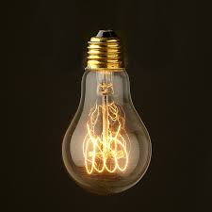

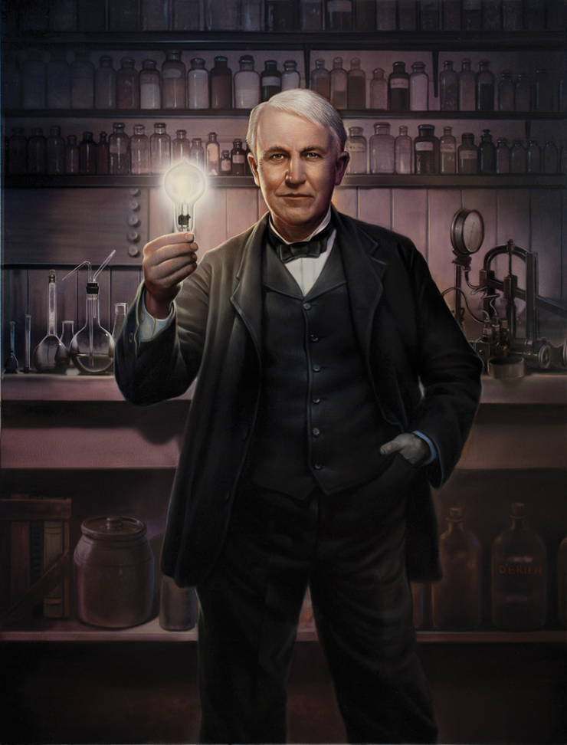
(SOS Activity)
<Emotional Reading>
Number | Emotion | Action
 | Happy | Smile
 | Tired | Whisper
 | Angry | Put hands on your  waist
 | Sleepy | Rest your chin in  your hands.
 | Annoyed | Make a face
 | Bored | Stare blankly.

