Listening Lesson Plan

Title: What do you want learn? (Accepted or reject)
INSTRUCTOR | LEVEL | STUDENTS | LENGTH
Jessica 2 | Pre-Intermediate | 12 | 50 Minutes

Materials:
- Picture1&2
- Vocabulary & Fill in the blank worksheet 1 (12copies), (extra 3copies)
- Listening activity work sheet 2(12copies), (extra 3copies)
- White board and board markers, pen, paper
- Computer, internet, Screen, speaker

Aims:
Students can improve their listening comprehension.
Students will practice express their thoughts.
Students will practice prediction by finding out the meaning of key word.
Students can make their relationship through the activity.

Language Skills:
Listening: Listen media file, teacher’s talk.
Speaking: Sharing ideas in discussion.
Reading: Worksheet A.
Writing: Fill in the blanks while listening.

Language Systems:
Phonology: correction of pronunciation during speaking.
Lexis: New vocabulary used in the song.
Discourse: discussion, question and answer
Functions: group discussion, whole class activity, individual thinking and questioning
Grammar: Present tense

Assumptions:
- All students are adults and know about Music(I believe I can fly)
- Most students think about learn motto and creative of their lives
- Most students are interested in Movie(accepted)

Anticipated Errors and Solutions:
If Students feel hard listening, play one more
Please check if they understand properly to discuss about Music & Movie story.
Explain well about vocabularies. If they don’t understand well, show the exact sentence from the video.

References:
- Visual aid (Pictures) : Picture from Google image.
- Visual aid (music file) : www.youtube.com
- Visual aid (video file) : http://www.youtube.com/watch?v=KZtF_gT3Sgg&list=PL2BDDD9B7613550B8
- worksheet : http://blog.naver.com/rmator1?Redirect=Log&logNo=30178065231
- http://blog.naver.com/rmator1?Redirect=Log&logNo=30178065231

Notes: SOS Plan
The Lesson finishes early : Do SOS plan.
If we need another thing to do, talk about getting wrong information and any mistakes or fun stories because of that.

Pre Task or Warmer
Title:  Learn is.. |  | Aims:  - To draw out ideas from the students by asking  - To increase students interest to the topic by pictures  - To connect the topic with students by pictures | Materials:  Picture1&2,  White board and board markers
Time | Set Up | Students | Teacher
8min | Whole class | - Answer the questions given by teacher  - Think about their own learn motto and meaning of motto | <Procedure>  Post picture 1,2 on the board  <Instruction>  - Greeting  - Elicit thoughts about Learn.  - Introduce about Steve Jobs by showing picture1  - Introduce about Andy Warhol by showing picture2  - Introduce Steve Jobs Challenge & innovation  - Introduce about Andy Warhol Creativity & Confidence  - Pre-teach vocabulary  Guiding Question  - What is this picture?  - What words can you come to mind when you think about - Steve Jobs? CEO? The Apple? Computer?  - What words can you come to mind when you think about Andy Warhol? Artist? Free? Mad? Creative?  - Could you tell me about your personality?

Notes:

Task Preparation or Presentation
Title:  ‘I think do..’ |  | Aims:  - Help students understand general meaning by listening  - Practice for improving language skills by listening& talking | Materials:  board, marker, board eraser, computer, internet, speaker, music file
Time | Set Up | Students | Teacher
1min  4min  5min | Individually  Whole class | - Answer the questions given by teacher  - Think about their own learn motto and meaning of motto  - Written on the board to consider the meaning of the word.  - Listening and Speaking  -Prepared to listen to music.  -Listen carefully to the music. ‘I Believe i can fly’ | <Procedure>  - Write the word ‘the importance’ on the board.  - Write the word ‘Yes or No’ ,’accepted or reject’  on the board.  -Write the words: ‘awful, believe, spread, soar, open door, breaking down, silence, achieve’ on the board.  <Instructions>  -“What is the most important thing in learning?”  -“Why do you think so?”  - Check before play the music if students could understand background information properly.  - Please check if everything works properly.  (Computer, internet, sound)  .  1. You will listen to ‘I Believe i can fly’  2. Think about what is important of learn.  “Let’s think of the meaning and listen to music”  -Turn on the music.

Notes:

Task Realization or Practice
Title:  ‘Real learning is..?’ |  | Aims:  To learn new words and phrases by worksheets  To share students wisdoms by talking  Listening comprehension, speaking | Materials:  - Computer, internet, speaker, music file& video file, overhead projector, screen, fill in the blank worksheet, board, marker, board eraser
Time | Set Up | Students | Teacher
1min  5min  7min  10min | Whole class  Whole class  Whole class  Whole class | - Listen teachers instructions  - Think about the meanings during listening to music.  - Fill the blank while listening to music.  -Listening to the music  -Listen carefully  -Speaking  -Answer the questions  - Listen one more time  - Fill one word in the blanks  -Think about the meanings during listening to music.  <Vocabulary>  -Study with worksheet.  -Read through and guess the meaning.  - Listen & Watching  - Watch the video about Accepted  - Answering & questions | After listen to the music  1.Activity (music)  <Procedure>  Hand out worksheet A  <Instruction>  1. You will listen to the song.  2. Fill in the gaps as you listen.  <Demonstration>  - Play the Music file ( I believe i can fly)  - Pause at 3.30 sec  Elicit the first answer on the board.  ICQ:  “What are we doing?”  “How many times will you listen?”  CCQ:  “How was the music?”  “How do you feel when you first heard this music?”  “Do you understand the meaning of this song?”  “What will you focus on the meaning of this song?”  (Check if they have correct meaning of them)  “What will you do with your worksheet?”  Now, Here we go.  Play the music again  Write down blanks while Ss are listening.  Check answers  Let's check the answer together.  <Transition>  Have Ss rotate and write their answers on the board all the missing words.  check the correct answers on the board together.  2.Activitiy(movie)  <Procedure>  - Check before play the movie if students could understand background information properly.  - Please check if everything works properly.  (Computer, internet, video clip etc..)  <Instruction>  - Please let them note what students hear and all information that they can get from it.  - I’m going to show student the scene of the video  <Questions and answers>  ICQ  - What are we doing?  - Where Is the background of a movie?  CCQ  - How was this movie?  - What is the difference between acceptance and rejection?  - Can you think of us change the future? How?  -Before the discussion, we should know if they could get all information correctly and understand fully.  -Please check everybody is in discussion and if they have any difficulty for that.

Notes:

Post Task or Production
Title:  ‘Real learning is..!’ |  | Aims:  Discussion, speaking | Materials:  Listening activity work sheet, Board, marker
Time | Set Up | Students | Teacher
10mins | Whole Class  Or  Group of 4  / Individual | <Discussion>  - After watching the movie, what felt Did you?  - While the school life, acceptance and rejection that you have experienced?  - The good thing? And want to do, What you want to learn it?  - What is real learning?  - Let students make their own note for the discussion and information. | <Procedure>  Hand out worksheet B to Ss  <Instruction>  1. Write down on worksheet B.  2. Discuss about your brain map with each group  <Demonstration>  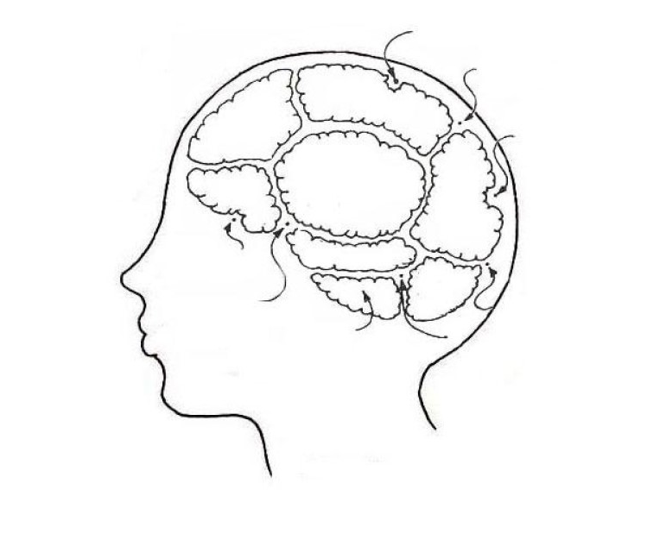  School, Friends, facility, curriculum, faculty, Technology, traditional, creativity, passion, different..  CCQs plus expected As  1. What do you have to do?  - Discuss and write  How to break a fixed frame?  Accepted or reject.  What is the real learning does this mean?  What is the real learning?  Teaching methods and personalized way.  2. Who are you going to discuss with?  3. How much time do you need?  <Transition>  Share their ideas and opinions with classmates.  <Instruction>  1. One brave volunteer needed.  2. Let Student come out.  3. Show Student the sentence related word.  4. Not speaking, only gesture.  5. The other Ss can guess what it is.  <Demonstration>  1. Describing the behavior without speaking.  2. Ss know the answer, raise their hand.  3. Teacher give a chance to speak.  4. If it’s right, Ss get the point.  5. The highest score S will be a winner.  6. Each Ss have a chance to roll-player.  7. All answer is related movie (accepted).  CCQ plus expected As  1. Can volunteer, can speaking?  2. If you know the answer, what to do?  3. The answer is related what?  <Transition>  Share answer with classmates.  <Monitor>  If the Ss ask question, answer it.  Thank you for your big help!  You did good jab day!!  Thank you Ss

Notes:

SOS activities
Title:“our school” |  | Aims: Discussion, speaking | Materials: Pen, empty paper
Time | Set Up | Students | Teacher
10min | Group of 4 | -Discussion with partner.  -Talking with partner.  -Make a poster with partner. | <Procedure>  Hand out empty paper  <Instructions>  Make a poster with partner.  The title of poster is “School to learn just what we want”  1. Discuss Ss ideas with partner.  2. Drawing.  3. Write down what it is.  <Demonstration>  1. Let's make our school with a partner.  (School to learn only what we love)  2. Discuss with your partner.  3. Draw with my partners on the paper.  4. I will announce in front of classmates.  (Between 2-3 minutes)  CCQs plus expected As  1. Is it possible at school in the reality?  2. What is interesting would happen, if possible, in reality?  <Transition>  Share answer with classmates.

Notes:

Worksheet 1 (Answer)
I used to think that I could not go on
And life was nothing but an awful song
But now I know the meaning of true love
I′m leaning on the everlasting arms
If I can see it, then I can do it
If I just believe it, there′s nothing to it
(Chorus)
I believe I can fly
I believe I can touch the sky
I think about it every night and day
Spread my wings and fly away
I believe I can soar
I see me running through that open door
I believe I can fly
I believe I can fly
I believe I can fly
See I was on the verge of breaking down
Sometimes silence can seem so loud
There are miracles in life I must achieve
But first I know it starts inside of me
If I can see it, then I can be it
If I just believe it, there′s nothing to it
(Chorus)
I believe I can fly
I believe I can touch the sky
I think about it every night and day
spread my wings and fly away
I believe I can soar
I see me running through that open door
I believe I can fly
I believe I can fly
I believe I can fly
hey′Cos I believe in you
oh..............
If I can see it, then I can do it
If I just believe it, there′s nothing to it
(Chorus)
I believe I can fly
I believe I can touch the sky
I think about it every night and day
spread my wings and fly away
I believe i can soar
I see me running through that open door
I believe(I believe)
I believe I can fly (I can fly)
I believe I can fly (I can fly)
I believe I can fly (I can fly)
If I just spread my wings (I can fly)
I can fly (I can fly)
I can fly (I can fly)
I can fly (I can fly)
If I just spread my wings (I can fly)
I can fly...
woo... i can fly
hmmmmm...fly, fly, fly

Vocabulary
Awful :
Believe :
Spread :
Soar :
Open door :
breaking down :
silence :
achieve :

Matching & Text Completion Exercise

Awful : The weather last summer was _________
Believe : _____ up into the sky
Spread : The Internet is the worldwide __________to meeting people
Soar : Many people ________ in emocracy
Open door : There's no easy way to _________ one's aim
breaking down : to _____________ resistance / opposition
silence : the _________ of new thoughts
achieve : To ________ one, is to _________ all

Worksheet 1 (Answer)
I used to think that I could not go on
And life was nothing but an awful song
But now I know the meaning of true love
I′m leaning on the everlasting arms
If I can see it, then I can do it
If I just believe it, there′s nothing to it
(Chorus)
I believe I can fly
I believe I can touch the sky
I think about it every night and day
Spread my wings and fly away
I believe I can soar
I see me running through that open door
I believe I can fly
I believe I can fly
I believe I can fly
See I was on the verge of breaking down
Sometimes silence can seem so loud
There are miracles in life I must achieve
But first I know it starts inside of me
If I can see it, then I can be it
If I just believe it, there′s nothing to it
(Chorus)
I believe I can fly
I believe I can touch the sky
I think about it every night and day
spread my wings and fly away
I believe I can soar
I see me running through that open door
I believe I can fly
I believe I can fly
I believe I can fly
hey′Cos I believe in you
oh..............
If I can see it, then I can do it
If I just believe it, there′s nothing to it
(Chorus)
I believe I can fly
I believe I can touch the sky
I think about it every night and day
spread my wings and fly away
I believe i can soar
I see me running through that open door
I believe(I believe)
I believe I can fly (I can fly)
I believe I can fly (I can fly)
I believe I can fly (I can fly)
If I just spread my wings (I can fly)
I can fly (I can fly)
I can fly (I can fly)
I can fly (I can fly)
If I just spread my wings (I can fly)
I can fly...(i can fly,i can fly)
woo... i can fly
hmmmmm...fly, fly, fly

Matching & Text Completion Exercise

Awful : The weather last summer was awful
Believe : soar up into the sky
Spread : The Internet is the worldwide open door to meeting people
Soar : Many people believe in emocracy
Open door : There's no easy way to achieve one's aim
breaking down : to breaking down resistance / opposition
silence : the Spread of new thoughts
achieve : To silence one, is to silence all

Awful : The weather last summer was awful
Believe : Many people believe in emocracy
Spread : the propagation of new thoughts
Soar : soar up into the sky
Open door : The Internet is the worldwide open door to meeting people
breaking down : to break down resistance / opposition
silence : To silence one, is to silence all
achieve : There's no easy way to achieve one's aim

Worksheet 2
ㅌㅊㅇ

