Listening Lesson Plan

Title: Museum Guided Tour
Teacher | Student Level & Age | No of Students | Length
Kelly Nayoung Kang | Intermediate & Adult(who set up psychological barriers to learning) | 12 | 50 mins

Materials:
-Microsoft’s PowerPoint, Notebook, Beam projector, Speaker and Board & Markers
-Vocabulary worksheet(16 copies)
-Realia (aprons, cloth caps, ears, arm warmer)
-Listening Audio File (mp3 file, classical music)
-Camera
-Digital file (jpg file)
- A4 paper(14) and pens

Aims: To help students
-Eliminate the feeling that they cannot be successful and/or the negative association they may have toward studying and thus to help them overcome the barriers to learning
-Understand the culture typical farm village on 18th century, France.
-Improve listening skill and Stimulate their achievement motivation through integration of the fine art (music and art)
-Overcome their negative feelings and turn them into positive energy to further their learning by listening to classical music
-Active with group activity

Language Skills:
Listening: the teacher’s and a curator of museum explanation
Speaking: group discussion for inferring the painting
Reading: read an idiom for warm up
Writing: writing some key words for inferring the painting

Language Systems:
Phonology: pronunciation of the curator (some related words on painting and farming)
Lexis: new vocabulary used in painting and farming
Grammar: can use ‘present progressive tense’ to infer for the painting.
Discourse: teacher-student interaction and student-student interaction through the activities
Functions: describing the paint

Assumptions:
Some students might know the painting.

Anticipated Errors and Solutions:
-If the notebook doesn’t work so can’t open the presentation file and audio file
: bring copy files in USB memory
-Students may not be able to listen the curator’s voice with classical music
: first, turn down the volume if it doesn’t help then listen the audio file without background classical music
-If the work takes long time or finish earlier than anticipated
: play the audio file as part of the group activities in lesson.
-Camera battery might be dead
: prepare an extra battery

References:
Dictionary- Naver(dic.naver.com), Longman(ldoceonline.com), The free dictionary(thefreedictionary.com)
Painting- The Gleaners, Jean-François Millet (http://firefliesblog.com/wp-content/uploads/2013/04/Gleaners.jpg)
Albert Einstein (http://goo.gl/y5RS0u, http://goo.gl/ZNlQbF)
Guide script- Musée d’Orsay(musee-orsay.fr), Nate(http://goo.gl/KVdNDW)
Music- Moon River - London FILMharmonic Orchestra (http://www.youtube.com/watch?v=28f9bqklFeo)
Mozart (1. Eine Kleine Nachtmusik Movt 1| http://www.youtube.com/watch?v=Rb0UmrCXxVA)

Notes:

Pre Task or Warmer
Title:  Greeting & lead-in |  | Aims:  To greet the students, make them relax and get them ready for the new lesson | Materials:  Audio file: Moon River  Albert Einstein’s photo and his idiom (Windows Power point)
Time | Set Up | Students | Teacher
7 mins | Whole class | Students close their eyes and listen to the music  Imagine some scenes of music then talk to whole students  Read the idioms | Greet the students  Play the song and ask them what they feel about the music  Explain they are about to begin a new and exciting experience in Listening and that imagination is important

Notes:

Task Preparation or Presentation
Title:  Listening to the curator’s explanation for ‘The Gleaners’ |  | Aims:  To make the students imagine where they are, what kind of art they’re appreciating  Introduce new vocabularies used in painting and farming to them | Materials:  Vocabulary worksheet (Realia)  Questions (Windows power point)  Listening Audio File (The curator’s audio mp3 file, classical music)
Time | Set Up | Students | Teacher
17  mins | Whole class | Listen to the audio file and imagine  Learn new vocabularies | Give instructions about the what things they should listen  Play the audio file and classical music at the same time  Monitor the students

Notes:

Task Realization or Practice
Title:  Group discussion for inferring the painting |  | Aims:  To be active with group activity | Materials:  Realia (aprons, cloth caps, ears, arm warmer)  Listening Audio File (mp3 file, classical music)
Time | Set Up | Students | Teacher
13 mins | Groups of 4 students | Group discussion for inferring the painting and come to the front to describing vividly it with realia. | Divide the class into groups of 4  Give a clear instructions of the activity  Ask ICQs and monitor what the students  Give them the time to discuss and then call them to the front then make them describing the picture.  Take a photo to compare students inferring to the painting  Praise their work

Notes:

Post Task or Production
Title:  Compare their imagination to the painting |  | Aims:  Listen again the audio file as  To compare their imagination to the painting with a photo | Materials:  A photo that student’s work
Time | Set Up | Students | Teacher
13mins | Whole class | Compare their work to the painting with a photo and the painting  Listen to the audio file again and appreciate the painting | Play the audio file and classical music at the same time  Compare their work to the painting  Emphasize the imagination

Notes:

Worksheets, handouts and lesson materials
Worksheets

- Vocabulary
Ear[íər] n.
peasant [|peznt]: n.
glean [gli:n]: v.
gleaner [ˈɡliːnə] n.
heart-breaking [hɑ:rt-brèikiŋ] a.
portray[pɔ:r|treɪ] / depicts[dɪ|pɪkt] /
noble [noʊbl] a.
rake [reɪk] v.
straw [strɔ] n.
onlooker [|ɑ:nlʊkə(r);|ɔ:n-] n.
tagrag [tǽɡræ̀ɡ] n. & a.
juxtapose [|dƷʌkstə|poʊz] v.
kernel [|k3:rnl] n.
elaborately [ilǽbərətli] adv.
stubby [stʌbi] a.
chapped [tʃӕpt] a.
paddy[pӕdi]

- lesson materials

  - Microsoft Power point
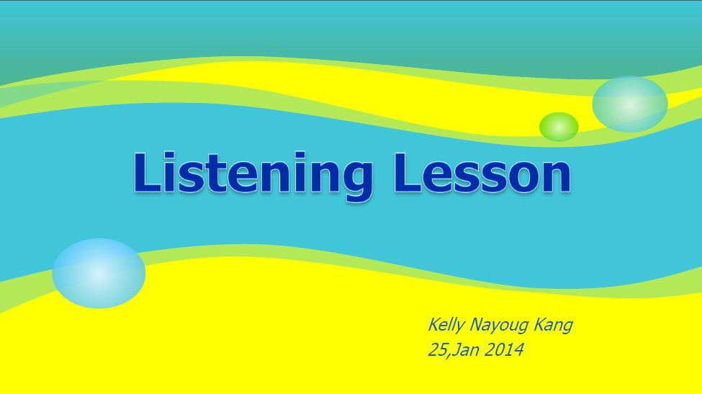
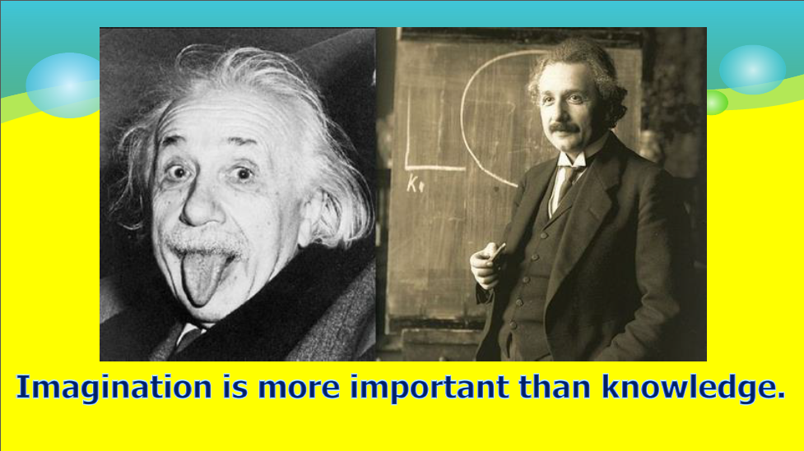
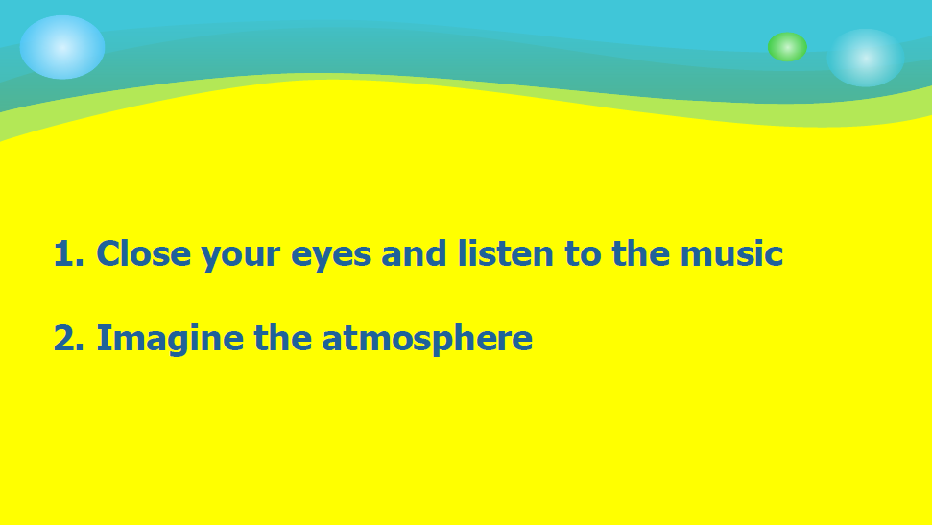
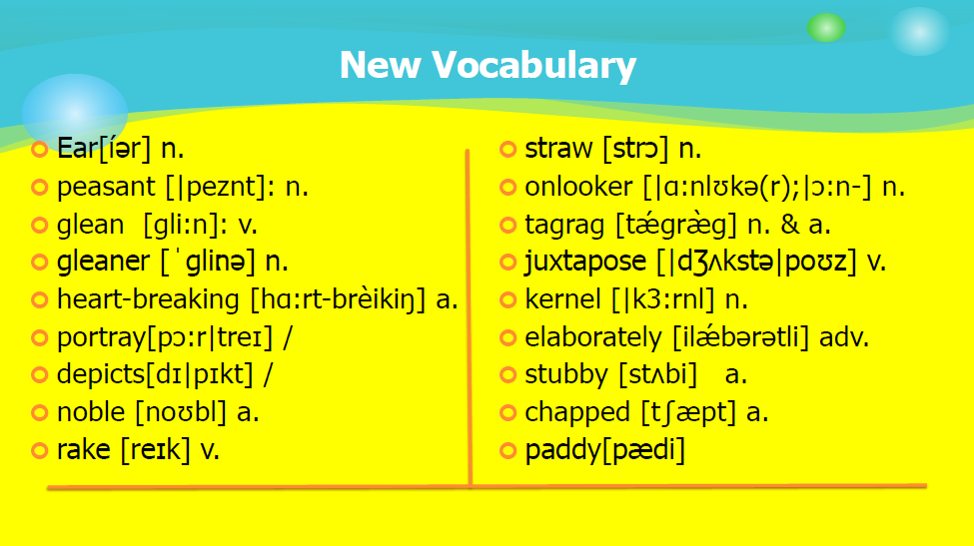
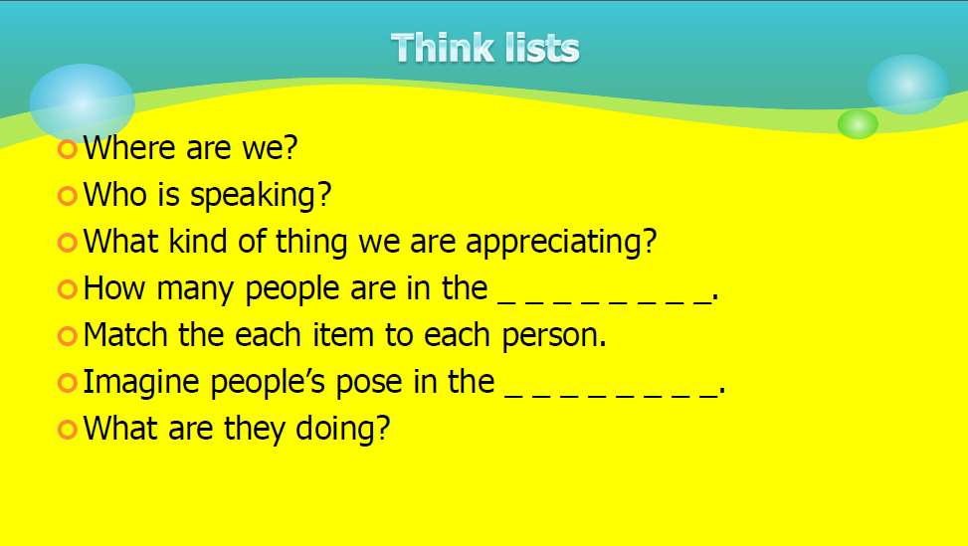
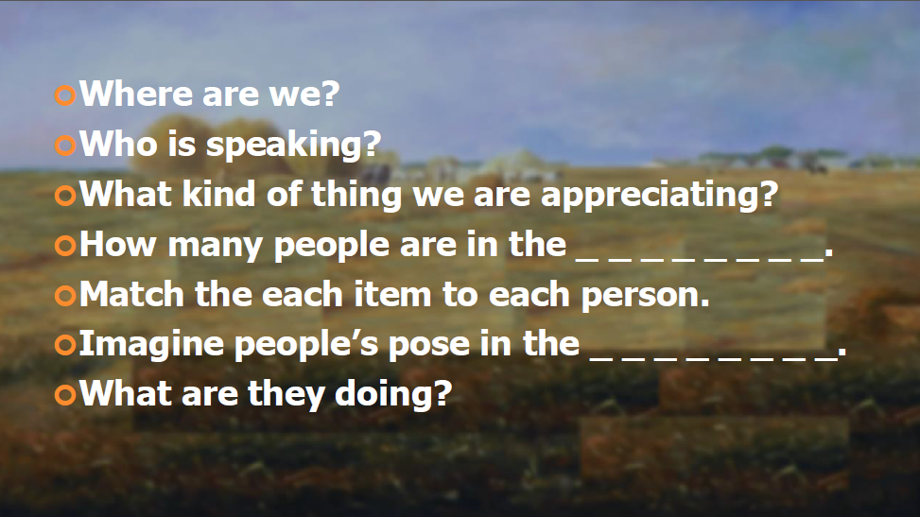
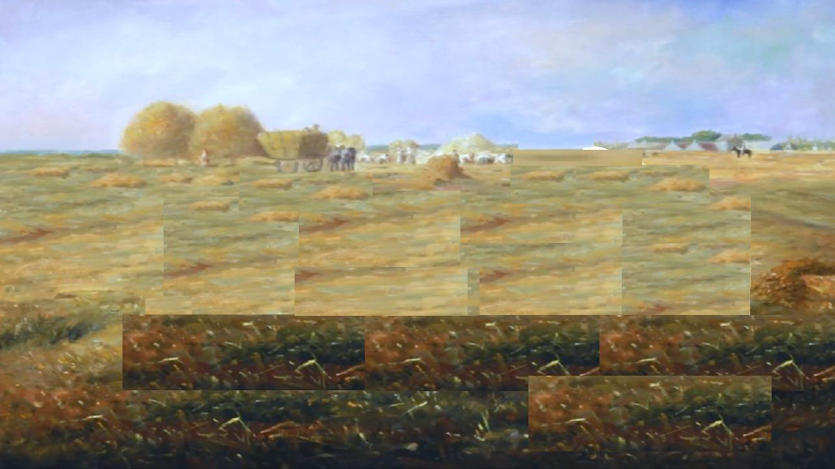
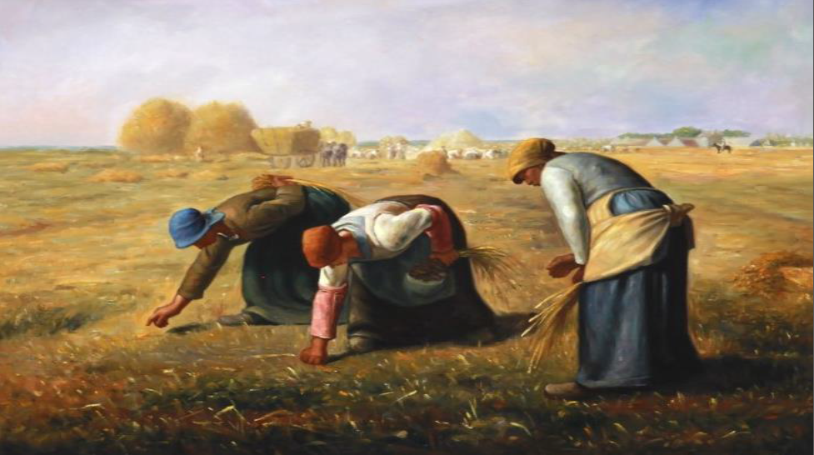

  - Reailia (aprons, cloth caps, ears, arm warmer)
  - Audio File (mp3 file, classical music)

