Listening Lesson Plan

Title : All You Need Is Love- Pop song
Teacher | Student Level & Age | No of Students | Length
Sally | Low Intermediate & 20~25 | 12 | 50 mins

Materials:
Listening CD and CD player
Music Video Clip
Picture
Board & Marker

Aims:
To improve Ss intensive listening skill
To acquire repeated vocabulary pop song
To encourage speaking with group members
To practice and sing to learn the pop song

Language Skills:
Listening : Listen to the pop song several time
Speaking : Talk to member about related experience pop song and practice pronunciation.
Reading : Acquire vocabularies and do worksheet
Writing : Writer a letter to your lover

Language Systems:
Phonology : Can & Can't
Lexis : Vocabulary used in pop song
Grammar : Learn to second form sentence(be verb.)
Discourse : Talking about experience.
Functions : Improve listening skill through familiar pop song and discuss personal opinion

References:

http://blog.naver.com/dustnr777?Redirect=Log&logNo=130177039261
http://wendy3.blog.me/100201997105
http://www.youtube.com/watch?v=8hEog14P_yo

Notes: N/A

Pre Task or Warmer
Title:  Guess topic |  | Aims:  To interest Ss to understand lesson topic | Materials:  Related to Pictures(poster)
Time | Set Up | Students | Teacher
5  mins | Whole class  Use 4 groups | Ss will anticipate topic  Ss talk to the picture each other | Teacher post the picture on the board  Teacher ask student s to feeling about picture  Teacher make student to discuss members theirs  opinion and feelings.

Notes: Arranging the seating to Ss can face to each other

Task Preparation or Presentation
Title:  Listen to pop song |  | Aims:  To fill in the blanks by listen to music | Materials:  CD player  Music Video Clip of movie scene in LOVE ACTUALLY  Worksheet paper(lyrics)
Time | Set Up | Students | Teacher
15  mins | Whole class  In pairs | Listen to pop song  Feeling to comfortable and cozy  Fill in the blank to listen carefully  Compare to mate with the blanks | Turn on the CD player(only music) several times  Make Ss to fill the blank  Turn on same pop song with movie clip  Ask to Ss -What is topic pop song

Notes: N/A

Task Realization or Practice
Title:  My special love |  | Aims:  To discuss Ss talk to topic LOVE personal love experience | Materials:  CD player  Board
Time | Set Up | Students | Teacher
20 mins | Whole class  In pairs | Ss conversate mate their special experience with listen to pop song  Ss can ask their mate any questions | Before Ss's talking time, Teacher can say that she's love story.  Teacher can monitor Ss's conversation by go around classroom.

Notes:
Teacher should turn on pop song continuously , for Ss talk to topic to more comfortable moods

Post Task or Production
Title:  Write a love letter to my darling |  | Aims:  To remind Ss what listen pop song and write letter their  Feelings(Thanks, forgive, propose etc.) | Materials:  Worksheet (letter paper of 14 copies )
Time | Set Up | Students | Teacher
10 mins | Whole class | Ss can sing freely regardless of pop lyrics order  Ss receive letter paper and write down their lovely mood  Ss can introduce else pop song  Ss will present voluntarily their letter and other Ss listen to  letter | Give Ss letter paper to writer love letter their lover  Ask Ss how to feelings about pop song  -What are you most like pop song & singer?  -Do you remember the lyrics?  -Who is going to presentation?  Make student understand pop song clearly

Notes
Ss can use dictionary

Pictures
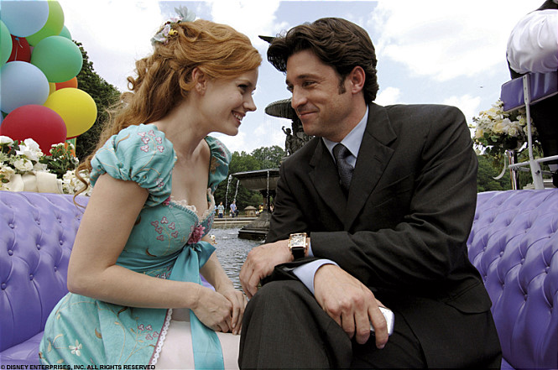

Lyrics

Love, love, love, love, love, love, love, love, love.
There’s nothing you can do that ( ) be ( ).
Nothing you can sing that can’t be sung.
Nothing you can say but you ( ) learn how to play the game
It’s easy.
There’s nothing you can make that can’t be made.
No one you can ( ) that can’t be saved.
Nothing you can do but you can learn how to be in time
It’s easy.
All you need is love, all you need is love,
All you need is love, love, love is all you need.
Love, love, love, love, love, love, love, love, love.
All you ( ) is love, all you need is love,
All you need is love, love, love is all you need.
There’s nothing you can know that isn’t known.
Nothing you can( ) that isn’t shown.
Nowhere you can be that isn’t where you’re meant to be.
It’s easy.
All you need is love, all you need is love,
All you need is love, love, love is all you need.
All you need is love (all together now)
All you need is love (everybody)
All you need is love, love, love is all you need.

Love, love, love, love, love, love, love, love, love.
There’s nothing you can do that can’t be done.
Nothing you can sing that can’t be sung.
Nothing you can say but you can learn how to play the game
It’s easy.
There’s nothing you can make that can’t be made.
No one you can save that can’t be saved.
Nothing you can do but you can learn how to be in time
It’s easy.
All you need is love, all you need is love,
All you need is love, love, love is all you need.
Love, love, love, love, love, love, love, love, love.
All you need is love, all you need is love,
All you need is love, love, love is all you need.
There’s nothing you can know that isn’t known.
Nothing you can see that isn’t shown.
Nowhere you can be that isn’t where you’re meant to be.
It’s easy.
All you need is love, all you need is love,
All you need is love, love, love is all you need.
All you need is love (all together now)
All you need is love (everybody)
All you need is love, love, love is all you need.

Worksheet( letter paper)

