Speaking Lesson Plan

Title : Drinking
Teacher |  |  | Student Level & Age | No of Students |  | Length
Sue |  |  | Intermediate | 20 Students |  | 50 mins

Materials:
White board, markers, pictures, worksheets(23 copies)

Aims:
Ss will improve their speaking skills to talk about topic
Ss will share their experiences and opinions by talking

Language Skills:
Listening : Ss will listen to other students’ opinions
Speaking : Ss will talk about their experiences and improve their skills
Reading : Ss will read the article before they do a discussion
Writing : Ss will write their own thinking

Language Systems:
Phonology : None to discuss
Lexis : Establishment, acceptable, rude, proper, bingle
Grammar : Present tense
Discourse : Dialogue, conversation
Functions : Expression opinions

Assumptions:
Students already know how to set up and run
Students already know about topic
Students understand the culture of drinking in KOREA

Anticipated Errors and Solutions:
Ss may not be able to pronounce some words
- Let Ss do repetition and drill
Ss may not be able to understand some vocabulary or instruction
- I will explain the instruction again
Ss may not use correct word
- I will give them correct expression

References:
http://www.visitseoul.net/en/article/article.do?_method=view&art_id=41402&lang=en&m=0004007001003&p=07

Notes:

Pre Task or Warmer
Title:  Description : Winter |  | Aims:  To understand about topic easily |  |  | Materials:  Pictures, white board, board markers
Time | Set Up | Students |  |  | Teacher
10 mins | Whole class | Answering to teacher’s questioning |  |  | Hello! Everyone! How are you today?  The weather is cold. How is your condition?  <Show the pictures>  <Eliciting>  What do you usually do when you meet with your friends?  What can you see in these pictures?  Do you feel when you see the pictures?  Do you like drinking?  <Model>  Write on the board “drinking”  <CCQ>  Do you usually go to drink with your friends?  How many times a week do you go drinking?  Do you like drinking?  Let Ss talk about drinking culture

Notes:

Task Preparation or Presentation
Title:  Description |  | Aims:  To understand of instruction | Materials:  Worksheet#1,
Time | Set Up | Students | Teacher
15 mins | Whole class |  | <Instruction>  Before talking, let Ss read an article.  And then do a next step  Now you will have an activity. I’ll divide 4 groups. You have to talk what we can think about good and bad factors of drinking.  And then you have to write down 5 things on the paper of good and bad factors.  I’ll give you worksheet #1  <Distribute worksheet>  <ICQ>  What are we doing?  Are you working in groups?  <Monitoring>  Monitor discreetly. Answer Ss if they needed.  “Times up”

Notes:

Task Realization or Practice
Title:  Description |  | Aims:  To listen carefully and talk together | Materials:  Worksheet #2
Time | Set Up | Students | Teacher
15  mins | Whole class |  | <Instruction>  After talking together. And then let them choose one reporter to present their opinions.  I’ll give you 12 minutes to write the paper through talking.  < ICQ>  What are you doing?  Are you working in groups?  Let’s start!  <Monitoring>  Watch discreetly. Answer Ss if they ask questions.  If they need more time, I’ll give more.  “Times up”  Each team will choose reporter to present their opinion.

Notes:

Post Task or Production
Title:  Description |  | Aims:  To listen other Ss’ opinions.. | Materials: worksheet #2
Time | Set Up | Students | Teacher
10 mins | Whole class | Ss listen the word of each reporter  Ss share their written paper | <Instruction>  So now we are going to listen what each reporter says. They will speak about good and bad factor of drinking.  Come out from A  <ICQ>  What are you doing?  Are you working individually?  <Monitoring>  Watch discreetly. Answer Ss when they ask questions.  “Times up”  You guys did a good job.

Notes:

Worksheets, handouts and lesson materials

Worksheet #1
If you enjoy having a drink or two, you'll have no problem feeling right at home in Korea. The consumption of alcohol is highly accepted here and is considered the ultimate way to create a friendly social setting, so the best way to understand true Korean culture is by learning the social rules and etiquette that accompanies Korean drinking culture.
Why Koreans go for a drink
● To form close relationships
Korean love to take part in "hoesik", outings where co-workers dine and drink together after work. Comparable to the western concept of "happy hour", many drinks are poured all around during hoesik, creating a relaxing environment. Koreans believe that you must dine together or drink together in order to create friendships and get to know one another. For that reason, they will organize groups together and arrange for events to go drinking together. Whenever there's a new student or colleague, a guests needs to be entertained, or a person is visiting from another country, it's safe to say that alcohol always makes an appearance.
● End-of-year parties
Although bars and pubs have a steady flow of customers throughout the year, the busiest time is always towards the end of the year. In Korea, the end of a year holds a special meaning; it's a time of the year where co-workers, clubs and organizations, classmates, and any other organized groups will all get together to look back at the year they've spent together and toast to another year together.
Where to go for a drink
● Minsokjujum (traditional Korean bars)
Korean minsokjujum are very similar to the Japanese izakaya. These places typically serve Korean "anju" with their Korean alcohol, snacks that are eaten while consuming alcohol. Koreans always snack on food while drinking, and as such, anju is a very important part of Korean drinking culture. Anju is comparable to pub food, but instead of burgers and fries, Koreans will snack on pajeon (a savory Korean pancake), spicy stews and stir-fried dishes. Typical alcoholic beverages will include Korean rice wines like makgeolli or dongdongju, soju and beer. Prices are relatively low at these places, making them popular with students and young professionals. The biggest problem you'll come across at one of these places is trying to finish off all of the anju, as the serving sizes are usually very generous.
● Pojangmacha (street carts or stalls)
Anyone who visits Korea needs to have at least one drink at a pojangmacha. A pojangmacha is a street cart or stall that sells food and/or beverages. You'll find pojangmacha all over Korea, but the ones you see on the street only sell snacks, not any alcohol. The pojangmacha bars are more like a giant version of these small food carts, but with more variety on the menu in terms of alcohol and anju, and tables for you to enjoy your evening. Korean seafood dishes, chicken dishes, and barbeque pork dishes are just some of the things you'll find on the anju menu here, and beer and soju are the beverages of choice to go along with them. Although a pojangmacha bar may not look like it's expensive, anju dishes here can cost just about as much as any other Korean bar, sometimes even more. Make sure you know how much the dishes are before you order to avoid any unwanted hassle.
● HOF
A HOF is the Korean version of a german beer hall, and is what is considered to be a typical Korean bar. Beer is the drink of choice here, although the selection of beer is usually limited to Korean brands. Fried chicken and french fries are the most common items on the anju menu and prices are relatively inexpensive, with a 500cc mug of beer costing only about 4,000 to 6,000 won and anju ranging from around 12,000 to 20,000 won.
● Makgeolli Bar
If you want some grade A makgeolli, you go to a makgeolli bar. Other traditional Korean bars will serve makgeolli as well, but for the best makgeolli a makgeolli bar is where you want to go. And every makgeolli bar will serve their own unique recipe of makgeolli, depending on the area, region or province you're in. Anju menus at makgeolli bars generally tend to offer a lot of variety, making them popular with people of any age.
● And More...
If you want to drink wine, you go to a wine bar. If you want to drink sake, you go to a Japanese isakaya. There are plenty of drinking places in downtown Seoul to choose from, each with their own speciality of alcoholic beverages.
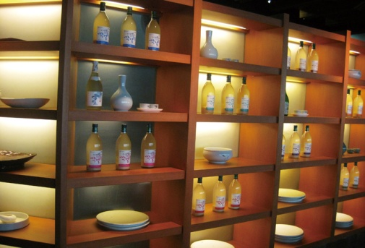 | 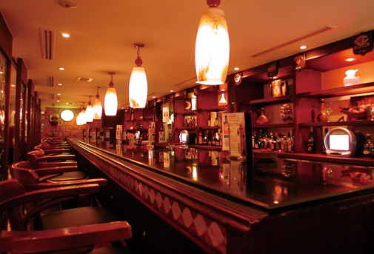 | 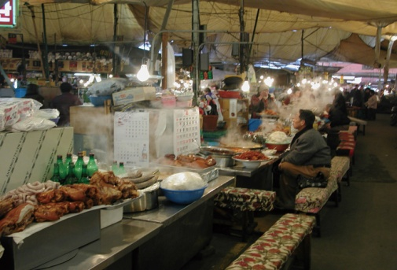
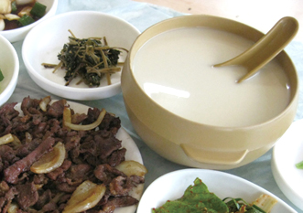  Drinking Etiquette  Aspects of Confucian culture still remain in Korean culture so there are many traditional customs that are observed when drinking or dining. It's always good to observe the customs of the country you're in, but don't worry about offending others if you're less than perfect in remember all of the social rules. Just remember that politeness and respect for your elders is of the utmost importance, as many of the rules reflect this.  ● Respect your elders  ● Always use both hands● Refilling glasses  ● Drinking rules for females  ● Binge drinking  Many people in Korea enjoy drinking and drinking culture. Unfortunately just like in any other country, there are those that enjoy their drink too much. This is partially due to a popular drink in Korea called poktanju, which literally translates to "bomb alcohol". This potent drink is a mixture of soju and beer. It's great to drink if you can handle your alcohol, but please drink responsibly.  ● Makgeolli  Makgeolli is a traditional Korean alcoholic beverage that has been a part of Korean drinking culture for many centuries. Made from a mixture of rice and wheat, rice farmers used to make it whenever they could spare the time. It has a soft, silky texture and goes down very easily, making it extremely easy to get very drunk very quickly if you're not careful. It has been said that makgeolli is very good for your skin and health (in moderation of course), making makgeolli a very popular drink among females.  ● Soju  When people think of Japan, they think of sake. France or Italy, people think of wine. As for Korea, the honor would indefinitely go to soju. There are two major types of soju; one type is made from diluted ethanol, while the other type is made from distilled starches like sweet potatoes or wheat. The majority of soju you'll find in Korea will be of the former. Korean soju is about 19 - 21% alcohol by volume and is usually consumed straight from a shot glass. But unlike the western concept of drinking shots, Koreans will usually sip from their shot glasses of soju.  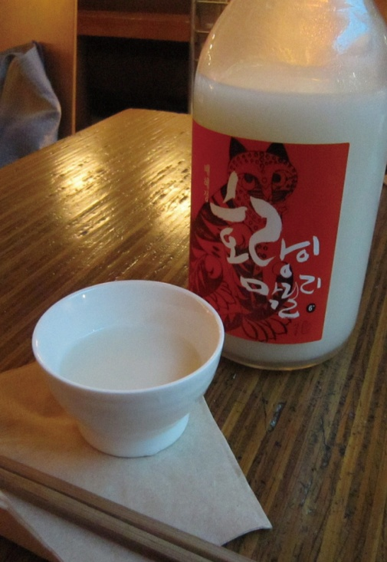  ● Beer  Beer is the world's most commonly consumed beverage, and can be found in Korea as well. The most common brands in Korea are Cass, Hite, OB and Max. Nearly every drinking establishment in Korea will serve one, if not all of these.  ● Wine, etc.  Wine has been gaining popularity in Korea in the last few years. Although there are several Korean-made wines, most of the wines you'll find on the menu in restaurants and bars will be of the imported variety. Japanese liquor has also been gaining popularity as of late. | 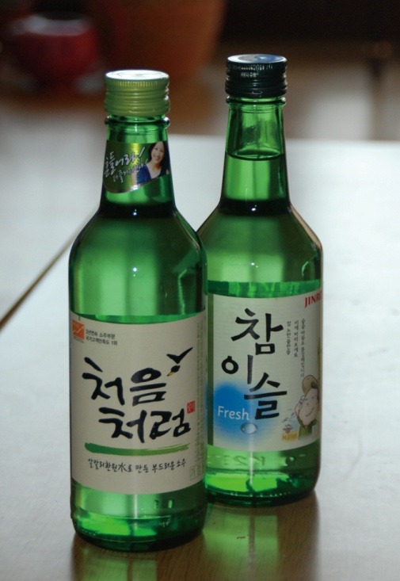 | 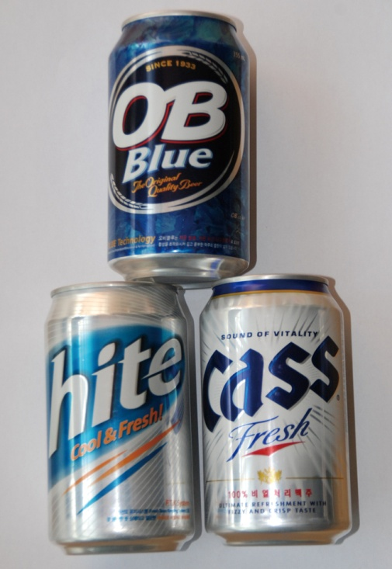

worksheet #2

Write the good and bad factors of drinking

Good Bad
- (1)
- (2)
- (3)
- (4)
- (5)

