Speaking Lesson Plan
96th WD Judy

Title: Introduce the winter Olympics.
Teacher | Student Level& Age | No of Students | Length
Judy | Intermediate & 15 ~ 17 | 20 students | 40 minutes

Materials:
- handout ( with picture of winter olympic items )
- White board, markers
- Projector & Laptop ( To show a video clip “last winter Olympic highlight” )

Aims:
- Ss will be able to enhance speaking skills talking about topic.
- Ss will be able to practice speaking by presenting about winter olympic items.

Language Skills:
Listening: Listening to teacher’s talking, other student’s opinion.
Speaking: Discussing with group members and presenting.
Reading: Reading handout.
Writing: Writing about winter olympic item.

Language Systems:
Phonology: Presenting.
Grammar: Using correct grammar when talking peers and presenting.
Discourse: Group discussion
Functions: Using appropriate words when talking peers and presenting.

Assumptions:

Anticipated Errors and Solutions:

References:
http://www.youtube.com

Notes:

Pre Task
Title:  Motivating by seeing about last winter Olympic highlight. |  | Aims:  -To make Ss to be interested in this lesson  -To make students be ready to discussing, presenting | Materials:  - handout, Laptop, Projector
Time | Set Up | Students | Teacher
7  mins | Whole class | - Introducing each other.  - Seeing the viedo. | - Play the video.

Notes:
The teacher can give a little tips about winter Olympics.

Task Preparation
Title:  Divide the 4 groups. |  | Aims:  -To make students choose 2 winter Olympic items and discuss , present. | Materials:  Laptop, Projector, handout
Time | Set Up | Students | Teacher
3  mins | Organize four team. | - Having seats with group peers | - Make 4 groups and Arrange the seats for 5 pairs of students.  - Give the handout.

Notes:

Task Realization and Practice
Title:  Disscuss and Present |  | Aims:  - To practice speaking by presenting about winter olympic items. | Materials:  Board, marker, handout  Laptop, Projector,
Time | Set Up | Students | Teacher
25  mins | 4 groups | - Listen to the teacher’s talking.  - In a group, Talk about how to present the 3 winter olympic items.  - Conversation with group peers. | - Explain the rule of presenting.  - Give them 5 minutes for presenting.

Notes: All group members participate in presenting.

Post Task
Title:  Review |  | Aims:  To confirm understanding about topic. | Materials:  Board, marker, Handout.  Laptop, Projector
Time | Set Up | Students | Teacher
5  mins | Whole class | - Answering questions | - Asking Questions about topic.

Notes:

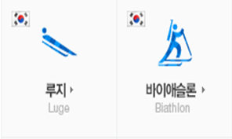
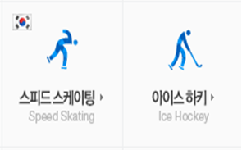
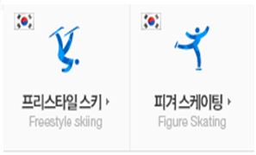

A B C D

