**NAME: DATE:**



**Your superhero NAME: DATE:**

**1) What is the name of your superhero?**

**2) Is your hero going to be male or a female?**

**3) What powers will the super hero have?**

**4) Are your hero’s superpowers weird or comical?**

**5) How did your hero get their super powers?**

**6) Does your hero have a secret identity?**

**7) Does your hero have a significant other?**

**8) Does your hero have any special psychological weaknesses?**

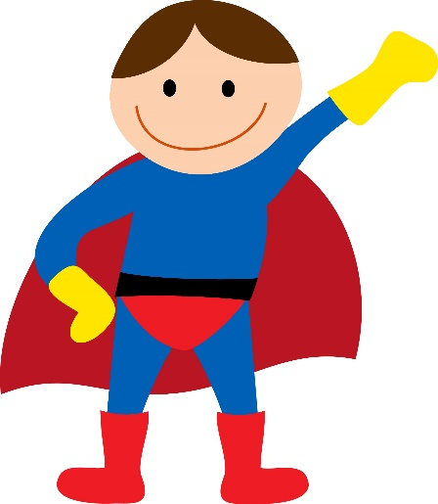**9) Does your hero have any special physical weaknesses?**

**10) Does your hero have any romance?**

