Reading Lesson Plan

Title: The Unsolved Mystery (The Bermuda Triangle)
96WD_Liz
Teacher | Student Level & Age | No of Students | Length
Mona Liza Secretaria (Liz) | Low Intermediate / 15 | 19 | 50 mins

Materials:
- Photos of the place Bermuda and The Bermuda Triangle
- Video clip
- Vocabulary Aids
- Comprehension Worksheets
- Vocabulary Worksheets
- Whiteboard, board markers and tape

Aims:
- The student will learn to value reading as a means of learning and enjoyment.
- To have practiced reading for a variety of purposes including to gather information, to follow directions, to give a response, to form an opinion, to understand information, to enjoy and appreciate
- Read texts from a variety of genres like documentary readings.

Language Skills:
Listening: Listening to the video, to their classmate reading and to the teacher.
Speaking: Giving answers orally during the activity.
Reading: Reading the article.
Writing: Completing the worksheet by writing the information.

Language Systems:
Phonology: Correct pronunciation of the words especially in the vocabulary activity.
Lexis: list of vocabulary in the article
Grammar: Present Tense stating a fact or general truth.
Discourse: The article stating the unsolved mystery.
Functions: Giving reasons, Stating facts, Asking for information

Assumptions:
The students can express themselves minimally to other people.
The students at this level have learned present tense.

Anticipated Errors and Solutions:
Students might have difficulties pronouncing some of the words.
  - * The teacher will teach pronunciation during vocabulary discussion.
  - The students might have problems with tenses when expressing facts or general truth.
  - * During the post task activity, the teacher will explain the tenses use in expressing facts or general truth.

References:
http://esllibrary.weebly.com/uploads/2/1/7/8/2178024/the_bermuda_triangle.pdf
http://olc.spsd.sk.ca/de/resources/6_9ela/GradeLevelObjectives/Reading.htm

Notes:

Pre Task or Warmer
Title: Documentary |  | Aims:  * To create interest and establish the theme.  *To create a relaxed and friendly learning environment. | Materials:  A photo of the Bermuda Triangle  5 minutes video clip of a documentary about the Bermuda Triangle’s mystery.
Time | Set Up | Students | Teacher
10 minutes | group works | *Greetings.  * Give ideas and opinion.  *Work in groups and share ideas about the video. | *Greetings.  *Show the picture and ask the student what they think about the photo.  *Show the 5 minutes video clip of a documentary about the Bermuda Triangle’s mystery.  *Explain to them that after watching, they are going to say something about the video.  *Work in Group for 3 minutes. The teacher monitors the student while they do the discussion.

Notes:

Task Preparation or Presentation
Title: Words |  | Aims: *To prepare the student for the activity.  *The student will be able to understand the vocabulary and expressions used in the reading activity. | Materials:  - Visual aids for the vocabulary.
Time | Set Up | Students | Teacher
5mins | whole class | *Do the vocabulary activity with the whole class. | *Elicit words from the students by asking a student to read the definition in front of everyone and the rest will guess the word.  Do the CCQ and ICQ.  *Explain that they are going to read an article during the main task and the words can be found in the article.

Notes:

Task Realization or Practice
Title: Reading the article. |  | Aims: *The students will have practiced reading an article.  *The students learned how to connect ideas from the information they’ve got. | Materials:  (19) copies of the article. Plus extra copies  (19) copies of worksheets for comprehension exercise. Plus extra copies.  (19) more vocabulary practice worksheet. Plus extra copies
Time | Set Up | Students | Teacher
30mins | Individual and Group work | *Write the information on their worksheet.  *Complete their worksheet | *Read and repeat. Then give them time to read it quietly then let them answer the questions in group. They have 20 minutes to do it.  *Monitor the whole class while they are doing the activity.  The teacher will ask the students regarding the answer.  And give another vocabulary activity. To be done in 5 minutes.  Do the CCQ and ICQ.
Notes:

Post Task or Production
Title: Lost |  | Aims:  Will be able to build understanding of the reading text. | Materials:  (19) Reasoning Worksheet plus extra copies
Time | Set Up | Students | Teacher
10mins | Pair work | *Work with a partner.  *Fill in the circles. | *Ask the students to write the many explanations for the disappearances in the Bermuda Triangle. Fill in each circle below with an explanation. Give 4 and in two boxes write their own idea.  * Do the CCQ and ICQ.  Do the wrap-up by acknowledging the students’ effort and participation.

Notes: If the activities finished earlier than expected, the student will be asked to share about strange things that had happened to them in any situations.

Worksheets, handouts and lesson materials
Material for Pre Task Activity

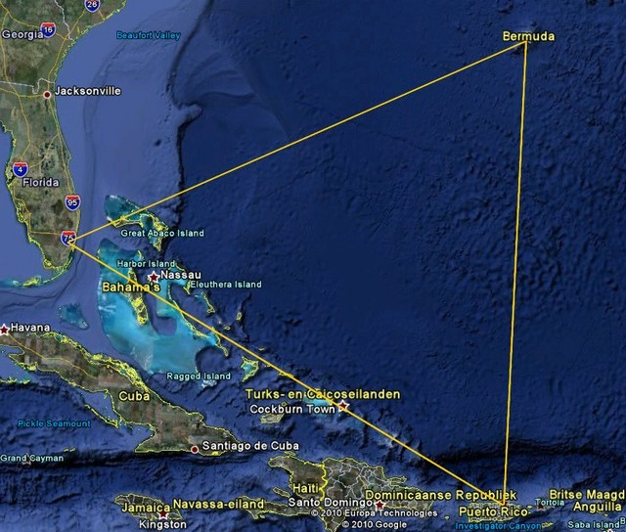

Documentary Of Bermuda Triangle’s Mystery
A Video Clip
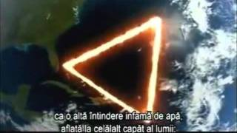

Material for Pre Task & Task- Realization activity
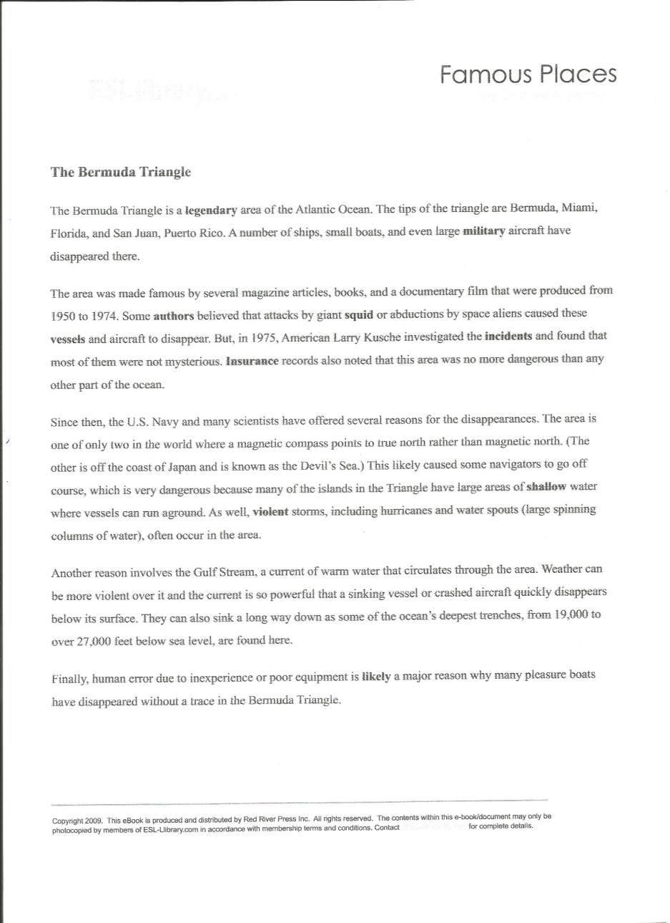
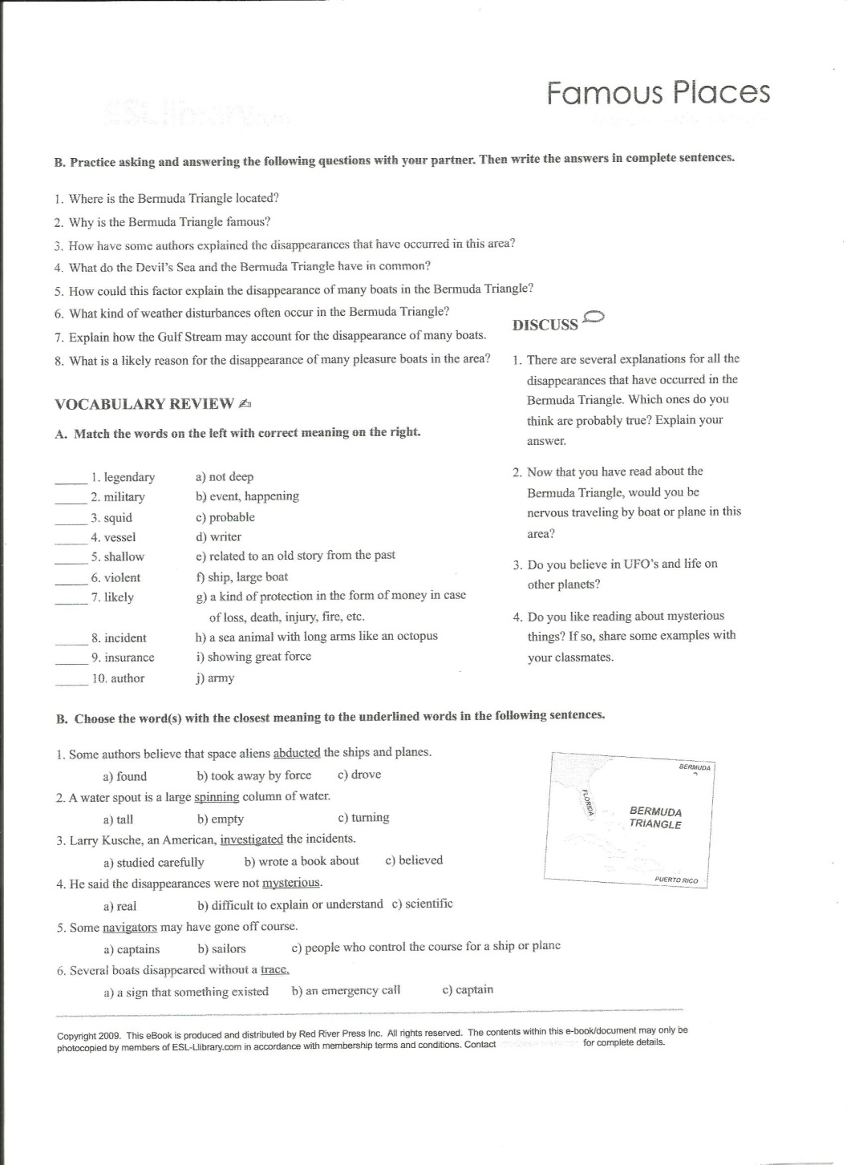

Material for Post Task activity

The Bermuda Triangle Mystery
There are many explanations for the disappearances in the Bermuda Triangle. Fill in each circle below with an explanation. Give 4 and in two boxes write your own idea.

Choose the words with the closest meaning to the underlined words in the following sentences.
- Some authors believe that space aliens abducted the ships and planes.
- found b. took away by force c. drove
- A water spout is a large spinning column of water.
- tall b. empty c. turning
- Larry Kusche, an American, investigated the incidents.
- Studied carefully b. wrote a book about c. believed
- He said the disappearances were not mysterious.
- real b. difficult to explain or understand c. scientific
- Some navigators may have gone off course.
- captains b. sailors c. people who control the course for a ship or plane
- Several boats disappeared without a trace.
- A sign that something existed b. an emergency call c. captain
Choose the words with the closest meaning to the underlined words in the following sentences.
- Some authors believe that space aliens abducted the ships and planes.
- found b. took away by force c. drove
- A water spout is a large spinning column of water.
- tall b. empty c. turning
- Larry Kusche, an American, investigated the incidents.
- Studied carefully b. wrote a book about c. believed
- He said the disappearances were not mysterious.
- real b. difficult to explain or understand c. scientific
- Some navigators may have gone off course.
- captains b. sailors c. people who control the course for a ship or plane
- Several boats disappeared without a trace.
- A sign that something existed b. an emergency call c. captain

Choose the words with the closest meaning to the underlined words in the following sentences.
- Some authors believe that space aliens abducted the ships and planes.
- found b. took away by force c. drove
- A water spout is a large spinning column of water.
- tall b. empty c. turning
- Larry Kusche, an American, investigated the incidents.
- Studied carefully b. wrote a book about c. believed
- He said the disappearances were not mysterious.
- real b. difficult to explain or understand c. scientific
- Some navigators may have gone off course.
- captains b. sailors c. people who control the course for a ship or plane
- Several boats disappeared without a trace.
- A sign that something existed b. an emergency call c. captain
Choose the words with the closest meaning to the underlined words in the following sentences.
- Some authors believe that space aliens abducted the ships and planes.
- found b. took away by force c. drove
- A water spout is a large spinning column of water.
- tall b. empty c. turning
- Larry Kusche, an American, investigated the incidents.
- Studied carefully b. wrote a book about c. believed
- He said the disappearances were not mysterious.
- real b. difficult to explain or understand c. scientific
- Some navigators may have gone off course.
- captains b. sailors c. people who control the course for a ship or plane
- Several boats disappeared without a trace.
- A sign that something existed b. an emergency call c. captain

Choose the words with the closest meaning to the underlined words in the following sentences.
- Some authors believe that space aliens abducted the ships and planes.
- found b. took away by force c. drove
- A water spout is a large spinning column of water.
- tall b. empty c. turning
- Larry Kusche, an American, investigated the incidents.
- Studied carefully b. wrote a book about c. believed
- He said the disappearances were not mysterious.
- real b. difficult to explain or understand c. scientific
- Some navigators may have gone off course.
- captains b. sailors c. people who control the course for a ship or plane
- Several boats disappeared without a trace.
- A sign that something existed b. an emergency call c. captain
Choose the words with the closest meaning to the underlined words in the following sentences.
- Some authors believe that space aliens abducted the ships and planes.
- found b. took away by force c. drove
- A water spout is a large spinning column of water.
- tall b. empty c. turning
- Larry Kusche, an American, investigated the incidents.
- Studied carefully b. wrote a book about c. believed
- He said the disappearances were not mysterious.
- real b. difficult to explain or understand c. scientific
- Some navigators may have gone off course.
- captains b. sailors c. people who control the course for a ship or plane
- Several boats disappeared without a trace.
- A sign that something existed b. an emergency call c. captain

Choose the words with the closest meaning to the underlined words in the following sentences.
- Some authors believe that space aliens abducted the ships and planes.
- found b. took away by force c. drove
- A water spout is a large spinning column of water.
- tall b. empty c. turning
- Larry Kusche, an American, investigated the incidents.
- Studied carefully b. wrote a book about c. believed
- He said the disappearances were not mysterious.
- real b. difficult to explain or understand c. scientific
- Some navigators may have gone off course.
- captains b. sailors c. people who control the course for a ship or plane
- Several boats disappeared without a trace.
- A sign that something existed b. an emergency call c. captain
Choose the words with the closest meaning to the underlined words in the following sentences.
- Some authors believe that space aliens abducted the ships and planes.
- found b. took away by force c. drove
- A water spout is a large spinning column of water.
- tall b. empty c. turning
- Larry Kusche, an American, investigated the incidents.
- Studied carefully b. wrote a book about c. believed
- He said the disappearances were not mysterious.
- real b. difficult to explain or understand c. scientific
- Some navigators may have gone off course.
- captains b. sailors c. people who control the course for a ship or plane
- Several boats disappeared without a trace.
- A sign that something existed b. an emergency call c. captain

Choose the words with the closest meaning to the underlined words in the following sentences.
- Some authors believe that space aliens abducted the ships and planes.
- found b. took away by force c. drove
- A water spout is a large spinning column of water.
- tall b. empty c. turning
- Larry Kusche, an American, investigated the incidents.
- Studied carefully b. wrote a book about c. believed
- He said the disappearances were not mysterious.
- real b. difficult to explain or understand c. scientific
- Some navigators may have gone off course.
- captains b. sailors c. people who control the course for a ship or plane
- Several boats disappeared without a trace.
- A sign that something existed b. an emergency call c. captain
Choose the words with the closest meaning to the underlined words in the following sentences.
- Some authors believe that space aliens abducted the ships and planes.
- found b. took away by force c. drove
- A water spout is a large spinning column of water.
- tall b. empty c. turning
- Larry Kusche, an American, investigated the incidents.
- Studied carefully b. wrote a book about c. believed
- He said the disappearances were not mysterious.
- real b. difficult to explain or understand c. scientific
- Some navigators may have gone off course.
- captains b. sailors c. people who control the course for a ship or plane
- Several boats disappeared without a trace.
- A sign that something existed b. an emergency call c. captain

Choose the wordsEEx with the closest meaning to the underlined words in the following sentences.
- Some authors believe that space aliens abducted the ships and planes.
- found b. took away by force c. drove
- A water spout is a large spinning column of water.
- tall b. empty c. turning
- Larry Kusche, an American, investigated the incidents.
- Studied carefully b. wrote a book about c. believed
- He said the disappearances were not mysterious.
- real b. difficult to explain or understand c. scientific
- Some navigators may have gone off course.
- captains b. sailors c. people who control the course for a ship or plane
- Several boats disappeared without a trace.
- A sign that something existed b. an emergency call c. captain
Choose the words with the closest meaning to the underlined words in the following sentences.
- Some authors believe that space aliens abducted the ships and planes.
- found b. took away by force c. drove
- A water spout is a large spinning column of water.
- tall b. empty c. turning
- Larry Kusche, an American, investigated the incidents.
- Studied carefully b. wrote a book about c. believed
- He said the disappearances were not mysterious.
- real b. difficult to explain or understand c. scientific
- Some navigators may have gone off course.
- captains b. sailors c. people who control the course for a ship or plane
- Several boats disappeared without a trace.
- A sign that something existed b. an emergency call c. captain

