Reading Lesson Plan

Title : Blood type in Korean culture
Teacher | Student Level & Age | No of Students | Length
96WD SUE | Intermediate Low | 20 (the age of 20s) | 50 mins

Materials:
White board, Board markers, Visual aids, Worksheet #1,2

Aims:
SS will know by reading in the text about blood type in Korea. And they will be interested about this topic by improving reading.
SS will read about other SS’ experienced by writing.
SS will spend good time by finding out own character

Language Skills:
Listening: They will hear other’s opinion carefully and then will be improving their listening skill.
Speaking: They will speak about their own experiences with peers.
Reading : After reading in a text, They will solve a vocabulary matter. By working they will improve a scanning skills.
Writing : They will write on their worksheet about their characteristics.

Language Systems:
Phonology: Practicing new vocabulary and their pronunciations.
Lexis : Understanding the way new words are used in sentences.
Grammar : Filling the handouts.
Discourse: Teacher-SS interaction, student-student interaction.
Functions: Getting the SS to discuss and question each other in groups.

Assumptions: SS will already know how the class is set up and run (there will be 20 SS and will work in pairs or groups)
SS will know some knowledge about blood type in Korean culture.
SS is in the age of 20s.

Anticipated Errors and Solutions:
- SS may not understand the teacher’s instructions clearly.
→ Give instructions as simple as possible. Check their understanding by asking specific concept questions.

References:
http://beyondhallyu.com/culture/its-in-your-blood-the-link-between-blood-types-and-personalities/

Notes:

Pre Task or Warmer
Title:  Eliciting topic |  | Aim: To let SS into the main topic and get them interested. | Materials: pictures, board marker, white board
Time | Set Up | Students | Teacher
10 mins | Whole class | Listen to the teacher and speak | <Greetings>  Warm up  Show them pictures about the topic.  And then asking eliciting question.  <Model>  I write on the board “blood type of Korean culture”

Notes:

Task Preparation or Presentation
Title:  Pre activity |  | Aims:  To prepare step before talking the main topic. | Materials: worksheet #1
Time | Set Up | Students | Teacher
20 mins | Whole class | By filling a blank in a worksheet. | Distributing a worksheet to the SS  <CCQ>  And then let them fill a blank by guessing and looking up a dictionary.  Let them solve the worksheet in a 5 minutes  <ICQ>  <Monitoring>  If they ask a question, answer it.  After checking the time, If they need more time, I’ll give more.  Checking the answer together.

Notes:

Task Realization or Practice
Title:  Sharing own experience |  | Aims:  To let the SS practice their reading comprehension skills and speaking skills. | Materials:  Worksheet #2,#3
Time | Set Up | Students | Teacher
20 mins | Whole class  Working in groups  Individually | Let them read, talk and w  Share their experience  Write the paper | Distributing worksheet #2 to the SS.  Give SS time to read the text in a 5 minutes.  <CCQ>  Asking questions about the text.  And then divide into 4 groups.  Let them talk about text.  <ICQ>  After finishing talking, I distribute worksheet #3 to the SS.  Let them write about that with experienced own story.  Give them time in a 5 minutes.

Notes:

Post Task or Production
Title:presentation |  | Aims:  To let the SS practice their speaking by conversing with other SS | Materials:
Time | Set Up | Students | Teacher
10  Mins | Whole class | Listen and ask the questions to the presenter | <Conclude>  I pick someone who will present about own story.  Let them do SS interaction by asking and answering.  Checking up simply about the topic.  Ending greetings.

Notes:

Worksheets, handouts and lesson materials
Blood Type A – The Farmers
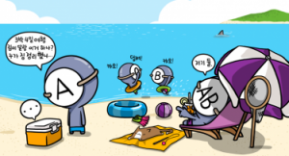Those with blood type A are often called ‘Farmers’ in South Korean culture. They can be secretive and reluctant to share their feelings due to their shy, reserved and introverted sensibilities. They can also be considerate to others, patient and are often punctual. They can be highly creative and can be perfectionists, which can cause them to become too focused on the details. They have been said to like to forget reality and hide in their own worlds due to a romantic nature. However, they can be self-conscious and can be unable to express their emotions well. They are said to be stubborn, cautious and tense and can be obsessive and uptight. They are also the blood group least likely to be able to hold their liquor. It is thought that blood type As do best with vegetarian diets.

Blood Type B – The Nomads
Blo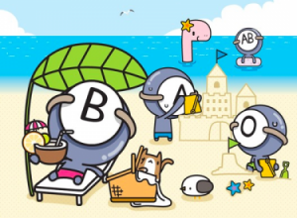od type Bs are said to enjoy life and are passionate, wild and active. They can be creative and optimistic and have a ‘let’s go’ attitude. They love animals and are passionate about the people and things that they hold dear. They can have an individual and independent nature and don’t care about what others think of them. They can laugh in failure’s face and have a bright and liberal way of living – however this can cause them to have enemies. They can be impatient and can give up easily. They have often been described as shallow and lazy, self-centred and irresponsible. Men with blood type B aren’t considered good ‘husband material’ as they can be ‘bad boys’ and ‘players’. This makes them desirable to women but only for the short term. Women with blood type B do not share this attribute. Those with blood type B are said to have a strong immune system and do well with dairy.

Blood Type AB – The Humanists
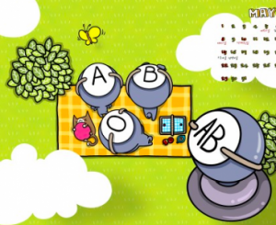Those with blood type AB are said to have a ‘can do anything’ attitude and have strong concentration. They are said to be interested in anything and can be highly intelligent. They are said to be controlled by their heads rather than their hearts and can be controlled, rational and critical. They can sometimes show an authoritative attitude. They can be shy, aloof and indecisive and can be distant from others. Some even go so far as to say that AB’s prefer to be alone. They are also said to have split personalities and can therefore be emotional and unpredictable. Some consider them to be untrustworthy and two-faced because of this. However, they are said to be good with money. They are also recommended to eat like the Farmers and Nomads do.

Blood Type O – The Warriors
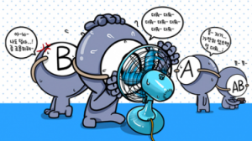Those with blood type O are said to be natural leaders – they are outgoing, energetic and optimistic. They speak their minds loud and clear whilst being friendly and easy going. They tend to be expressive and passionate with high self-confidence and are highly ambitious. They have a strong physical presence and are unlikely to be overlooked. They tend to be dramatic which might make others feel uncomfortable. They can be arrogant, insensitive, ruthless and vein. They can be obsessively preoccupied with success. However, they won’t leave someone who is in trouble by themselves and are said to be natural athletes. It is suggested that blood type O’s eat a high protein diet and exercise rigorously.

