[96th WD_Chloe] Reading Lesson Plan

Title : Shopping around the world
Teacher | Student Level & Age | No of Students | Length
Chloe(Seyeon, SHIM ) | Basic Intermediate | 11 | 50 mins

Materials:
- paper(5p) , handout(15 copies)
- article(15 copies)
- projector
- Board & Marker,
- music(It helps Ss feel comfortable when they discuss)

Aims:
- To learn new words
- To practice conversation skills through the discussion.
- To get information from the article.

Language Skills:
Listening: teacher’s instruction, discussion
Speaking: Discussion in pairs and in groups, Reading instructions, Answering questions
Reading: article
Writing: taking note, handout

Language Systems:
Phonology: Vocabularies
Lexis: Vocabulary used in the article. (new vocabulary)
Grammar: be verb, because
Discourse: Discussion
Functions: presentation, comparing

Assumptions:
- All the students are teenagers(Age 11 above)
- Students may understand the script without having problems.

Anticipated Errors and Solutions:
Before reading, students will learn new vocabularies in the article for understanding .

References:
TOUCHSTONE text book

Notes:

Pre Task or Warmer
Title:  Brain storming |  | Aims:  To Elicit what students already know (schema) | Materials:  Paper, pen, marker, whiteboard
Time | Set Up | Students | Teacher
10m | group | Ss discuss what they think about and then write down on the paper. Then, come to the white board and write it down. Share the words all together | Hand out paper  ICQ

Notes:

Task Preparation or Presentation
Title:  Let’s learn vocabulary |  | Aims:  To be able to learn words involved in shopping  To comprehend article well before reading article  ‘ | Materials:  Handout, ppt
Time | Set Up | Students | Teacher
10m | group  Whole class | Ss fill in the blank using the words with partners and share the answer all together.  Before reading, Ss can learn vocabularies related to the article | Give out handout and divide in to some groups  Have Ss fill in the blank and then share the answers with whole class(full sentence)  ICQ  Turn on the ppt , show the new vocabularies in the article.

Notes:

Task Realization or Practice
Title:  Shopping around the world |  | Aims:  To understand shopping place all over the world | Materials:  Article
Time | Set Up | Students | Teacher
20m | Individual  group | Each S read out each sentence in the article and divide into 4 groups in order to talk about discussion questions.  Let Ss present the results. | Get them read out clearly and loudly.  ICQ&CCQ  Get them divide into 4groups and discuss using the questions.

Notes:

Post Task or Production
Title:  My favorite store is… |  | Aims:  To be able to tell your own recommendations using the paragraph | Materials:  Handout, pen, note
Time | Set Up | Students | Teacher
10m | Individual  group | Ss make sentences using models and take turns reading what they make | Have Ss make sentences using model and help note in handout  ICQ  Have Ss take turns talking to partner their recommendations

Notes:

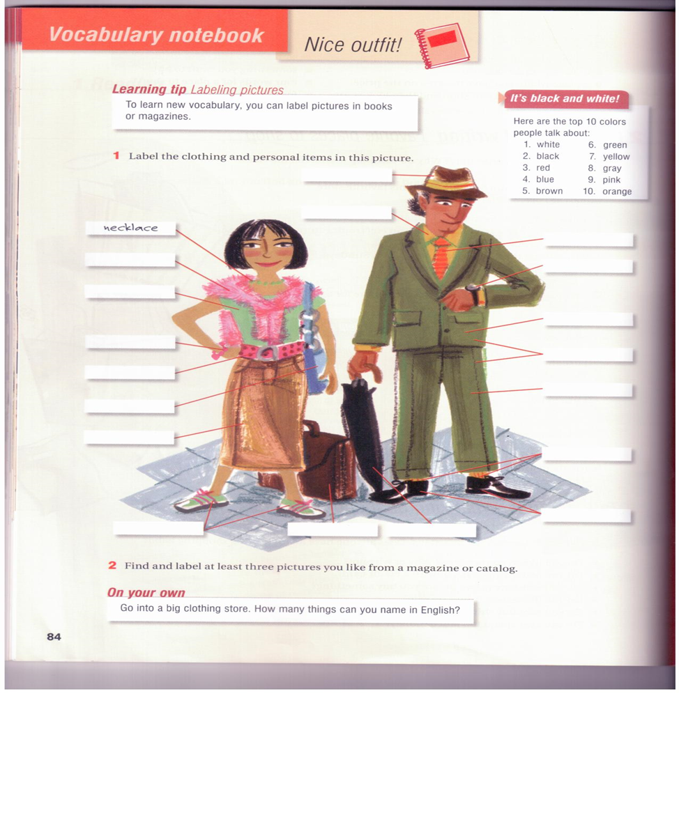

Fill in the blank using the words below hat/ bracelet/sweater/belt/Tshirt/tie/watch/ /suit/jacket/socks/shoes/briefcase/ pants /umbrella/bag/sneakers/ Yshirt/skirt

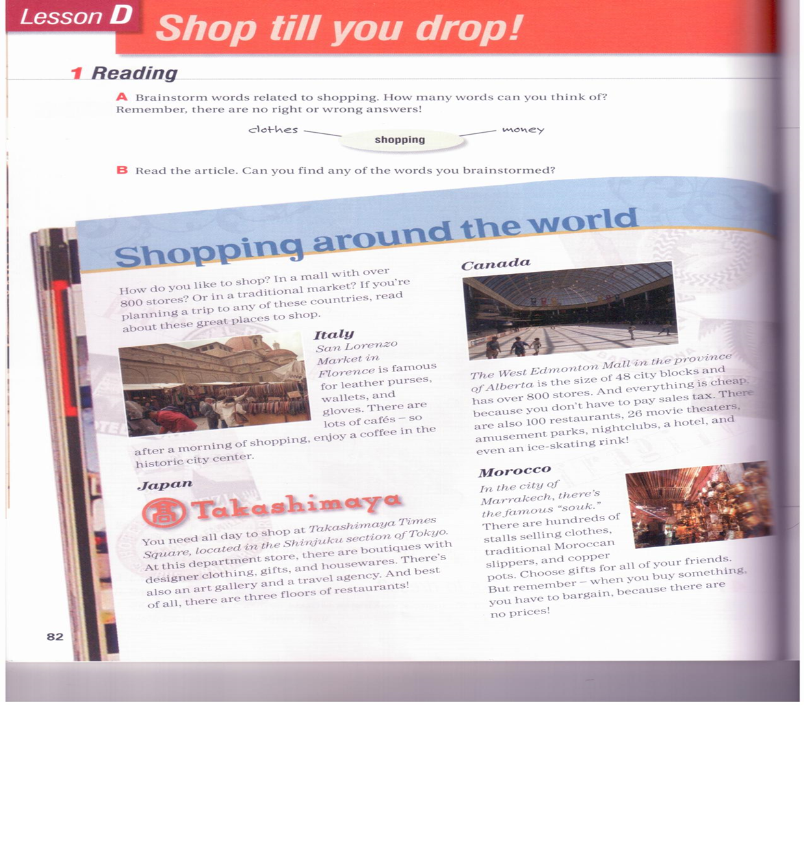
Article Questions

Look at the article. Find…
a good place to have coffee
a place where you can shop and then look art
a place with no sales tax
Somewhere you want to go
Something you want to buy

Write a paragraph about your favorite store for a shopper’s guide.Use the model below.
My favoritestore is…  I like it because…  I usually go there…  They sell…  They also have…  I like to buy… | Help note  Linking ideas with because to give reasons  My favorite store is Chang’s because it has great clothes  I like to shop there because it’s cheap.

Group work Take turns reading your recommendations. Do you learn about any new places to shop?

