Reading Lesson Plan

Title: Market shopping
Teacher | Student Level & Age | No of Students | Length
Kelly Nayoung Kang | Intermediate & high school | 11 | 50 mins

Materials:
-Notebook, Beam projector, Speaker and Board & Markers
-You Tube video
-Newspaper article(13)
-Worksheet (13)

Aims: To help students
-inspire patriotism, instill national consciousness. think about nation

-Know how to read and understand a newspaper-
-clarify their own opinion to others and persuade the opposition team

Language Skills:
Speaking: speak more fluently, clearly to express their opinion to persuade opposition
Listening: Listen and accept other classmates’ opinion.
Reading: read the article and worksheet
Writing: Write down and summary their opinion to debate

Language Systems:
Phonology: new vocabulary
Lexis: new vocabulary
Functions: debate
Grammar: speak and write down grammar sentences
Discourse: debate about the topic

Assumptions:
The class teaching method is based “The political Dimensions of language teaching and the participatory approach”

Anticipated Errors and Solutions
-Students maybe make an error by saying something
: Errors are corrected gently, not in a direct. Confrontational manner.

References:
Book: Learning Teaching written by Jim Scrivener/ Techniques & Principles in Language Teaching written by Diane Larsen-Freeman and Marti Anderson
Debate role: http://www.eastconn.org/tah/DebateRoles.pdf
You tube:
-Yuna Kim FS "Homage to Korea" - 2011 World Figure Skating Championships
(http://www.youtube.com/watch?v=9wEQL7ZcrKM)
-A great nation - with phenomenal visions and overflowing hearts - KOREA http://www.youtube.com/watch?v=8-3pC8aX1Wg
A newspaper’s article: The Korea Herald (http://www.koreaherald.com/view.php?ud=20140112000169)

Notes:
If time is lack of time, then assignment video introduction will be skipped.
Read title first, skim first ti very quickly. Then read.

Warmer
Title:  Greeting &  Watching a video |  | Aims to:  -inspire patriotism  -instill national consciousness  -think about nation | Materials:  Notebook, Beam projector, Speaker  Video: Yuna Kim FS "Homage to Korea" - 2011 World Figure Skating Championships  (http://www.youtube.com/watch?v=9wEQL7ZcrKM)
Time | Set Up | Students | Teacher
11 mins | Whole class | - Each students sits in a group.  - Watch the video.  - Give their opinion. | - Arrange the desks for making groups (A and B)  - Greet the students  - Play the video  - Ask students some question to elicit.

Notes:
Group A and B are for debating
Teacher’s questions are related to patriotism( Arirang, Yuna Kim, homage to Korea, Korea)

Task Preparation
Title:  Read the article |  | Aims:  -To know how to read and understand a newspaper  -To know why we should have interest in present situation  - To make them critical reading | Materials:  A newspaper’s article  (http://www.koreaherald.com/view.php?ud=20140112000169)
Time | Set Up | Students | Teacher
17  mins | Whole class | - Read and understand the article  - Are able to find a word that students don’t know in their dictionary.  - Are able to underline important things that they think | - Give the article to them  - **Explain how to read and understand  - Introduce today’s activity to the students  - Demo

Notes:
Teachers 2.**
1.Students are allowed to use their electronic dictionary or smart phone if they don’t know a word meaning.- (14. Emerging Uses of Technology in Language Teaching and Learning in Techniques & Principles in Language Teaching written by Diane Larsen-Freeman and Marti Anderson)
2 They are recommended to summary per paragraph to help understand whole article.

ICQ:
- How can we understand the article more effectively? (method-underline, summary per paragraph,)
- If we read a word that we don’t know, what should we do? (method- skip, find immediately, find later, ect)
- Think and make questions to help your understanding during reading it.
CCQ:
- Why do you think we read a newspaper? (Eliciting- answer would be to understand present situation, etc.)
- Let them tell the advantage and disadvantage for reading a newspaper.

Practice
Title:  debate |  | Aims to:  -clarify their own opinion to others  -accept others opinion  -persuade the opposition team | Materials:  -Worksheet
Time | Set Up | Students | Teacher
13 mins | Small groups  –A and B (groups of 5 and 6 students) | - Read worksheet  - Debate (group A and B- disagree vs. agree) | - **Take the coordinator role

Notes:
Coordinator role
- Announces team position (also Leadoff)
- Feeds helpful notes and suggestions to (Worksheet)
- Teammates during the debate
- Delivers attention grabbing opening
- argument, gives overview outline

Production& Post task
Title:  Give and get Feedback and give assignment |  | Aims:  -Check the result of the activity and get feedback  -Instill national consciousness  -think their dreams be related to nation to contribute. | Materials:  You Tube: A great nation - with phenomenal visions and overflowing hearts - KOREA http://www.youtube.com/watch?v=8-3pC8aX1Wg
Time | Set Up | Students | Teacher
9mins | Whole class | - Give and get feedback to/from the teacher  - Will write an essay- Topic: My dreams | - Give the assignment (read the script *demo)

Notes:
Feedback! Need to constantly notice and respond to feedback in order to adjust and redirect work moment by moment to make it as effective for each individual as possible.
Give the assignment (let them read the script, and show a little as demo)

Seating arrangements, Worksheets, handouts and lesson materials
- Seating arrangements

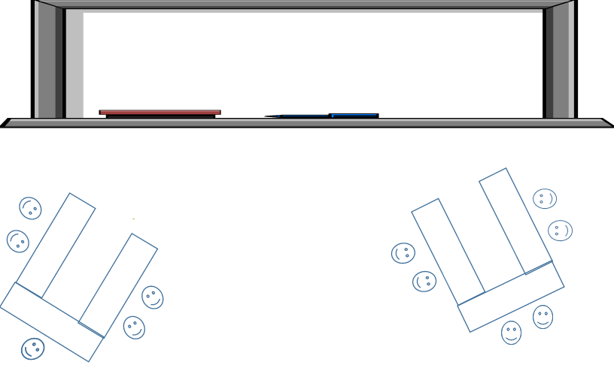

- Lesson material
  - Article of the Newspaper
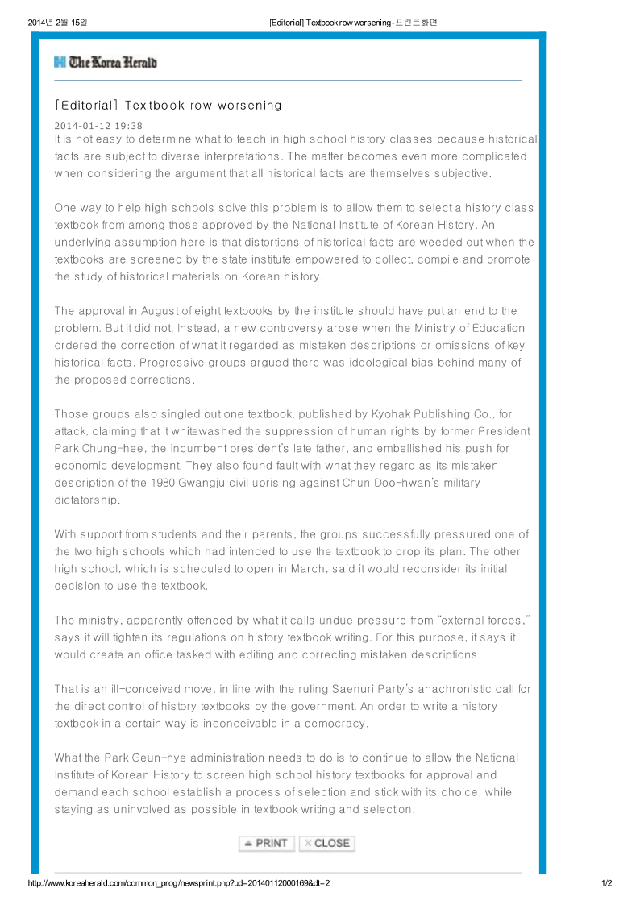
  - Worksheet

Think about After reading

1 | It is right to educate citizens with a single version of history authorized by the state. | Agree / disagree
2 | History should not sway to ideological reasoning | Agree / disagree
3 | History textbooks, at least, should convey the truth as it is, regardless of ideology | Agree / disagree
4 | It is right to educate citizens with various version to have diverse perspectives | Agree / disagree
5 | History is able to change wrongful outside pressure | Agree / disagree
6 | The state-designated system may not be the right direction | Agree / disagree
7 | A fair textbook verification become very important with the ministry’s decision. | Agree / disagree

Write down and summary your opinion to debate
  - Worksheet

Topic: My dreams
Name: ____________________________

________________________________________________________________________________________________________________________________________________________________________________________________________________________________________________________________________________________________________________________________________________________________________________________________________________________________________________________________________________________________________________________________________________________________________________________________________________________________________________________________________________________________________________________________________________________________________________________________________________________________________________________________________________________________________________________________________________________________________________________________________________________________________________________________________________________________________________________________________________________________________________________________________________________________________________________________________________________________________________________________________________________________________________________________________________________________________________________________________________________________

