Reading Lesson Plan

Title : A New Life for Trash
Teacher | Student Level & Age | No of Students | Length
Jessica Joo | Pre- Intermediate & Elementary Students  (12-15 year-old) | 12 students | 50 mins

Materials:
- White board & Markers
- Recycle PPT
- 15 copies of four different worksheets (worksheet1,1-2,2,3)

Aims:
- Ss will be able to understand vocabulary, context, and the usage of the expressions related to the reading and answering about the story.
- Ss will improve speaking and listening ability by sharing their thinking
- Teacher’s want to give students clear instruction and Teacher’s want to make Ss be able to practice speaking from presentation to the class by discussing their ideas.

Language Skills:
Reading: reading the text “A New Life for Trash”/ worksheets
Writing: answering questions and Complete the sentences/ graphic organizer.
Speaking: sharing ideas, discussing with a partner.
Listening: listening to the teacher’s presentation, instructions and other students’ opinions.

Language Systems:
Lexis: new vocabularies related to “A New Life for Trash” and idioms.
Functions: sharing and discussing one’s own ideas.
Discourse: Teacher-student interaction and student-student interaction through the activities.
Phonology: practicing pronunciation of vocabularies
Grammar: allowing the students to form their own sentences based on the new vocabulary & idioms related to the topic.

Assumptions:
- Ss may have heard the idioms used in passing conversations or in media, but do not know the exact definitions.

Anticipated Errors and Solutions:
- Students might have some difficulty understanding the words used in the main activity worksheet.

: Make sure that the students are familiar with the vocabulary by pre-teaching the words that are used in the passage.

References:
- READING JUICE for KIDS LEVEL3 Book & Workbook

Notes:
- If students finish their activities earlier than anticipated
:Assign the SOS Activity to the students

Pre-task
Title:  Greeting &  Get Ready to the topic |  | Aims:  To greet students and get them ready for the new lesson  - To lead the students into the main topic and get them interested.  - To elicit words. | Materials:  White board & markers  PPT
Time | Set Up | Students | Teacher
9mins | Whole class | - Listen and respond to the teacher  - talk to the classmates and share ideas  - Ss answer / questions | - Greeting  - Ask questions to students about recycle  asking questions  - Have you ever recycled?  - What is recycling?  - What do you think of this picture?  - Show PPT to Ss  -Eliciting the main word ‘recycle’  - Give a recycle present to students (PPT)  <Let distinguish what can not be assumed that it is possible to recycle.>  - Monitor and guide Ss

Notes:

Task Preparation
Title:  Recycle pre-task |  | Aims:  - To develop their vocabulary  - To make Ss learn the recycle and practice it by making sentences. | Materials:  White board & markers  Recycle worksheet 1,1-2  PPT
Time | Set Up | Students | Teacher
13min | Whole class→  Individually | - Listen and respond to the teacher  - Ss will guess meanings of vocabularies.  - Ss will learn about ‘recycle’  - Ss will make sentences using vocabularies they learned.  - Ss answer / questions | - Distribute worksheet 1,1-2  - Give instructions  - Instructions  - Let them fill out our part vocabularies form  - Write the correct definition of each word or phrase.  - If all the fill out our part vocabularies form,  - Complete the sentences with the correct words  - ICQ  - How much time do you have?  - Do you work alone?  - Can you write down the answers on the worksheet?  - CCQ  - What do you have to do?  - Can you guess why do we have this activity?  - Monitor and guide Ss  - Check the answers with Ss

Notes:

Task Realization
Title:  “A New Life for Trash” |  | Aims:  To develop Ss ability to read and understand the story, through answering some True/False questions and useful word search  To help Ss to improve their comprehension skills | Materials:  White board & markers  “A New Life for Trash” (15copies)  worksheet 2,3 (15 copies)  PPT
Time | Set Up | Students | Teacher
25min | Individually | - Listen and respond to the teacher  - Read the story “A New Life for Trash”  - Work on the worksheet and answer them  - Participate actively with the presenting their answers | - Distribute “A New Life for Trash” to all (15 copies) – give 10mins  - Give instructions  - Instructions  - -Read the “A New Life for Trash”.  - -I’ll give you the worksheet 2.  - -After reading, choose the correct answers, complete True/False (the first part of the worksheet)  - -I’ll give you 7mins  - -After complete worksheet, let answer the comprehension questions..  - CCQ  - What are we going to do?  - How much time do you have?  - Monitor and guide Ss  - After reading, distribute second worksheet 3  - (Complete the graphic organizer)  - I’ll give you 7mins  - Monitor and guide Ss  - After Ss are done with the worksheet, ask them for the answers

Notes:

Post Task
Title:  Write the passage summary of “A New Life for Trash” & closing |  | Aims:  To check whether Ss understood the lesson  - To improve Ss comprehension skill  To wrap up the class | Materials:  Board & marker  PPT  Worksheet 4 (15 copies)
Time | Set Up | Students | Teacher
11mins | Individually | - Listen and respond to the teacher  - Work on the worksheet individually  - Participate actively with the presenting their answers | - Give instructions  - Distribute the worksheet 4 to all (15 copies) – give 7mins  - (complete write the passage summary)  - Monitor and guide Ss  - After Ss are done with the worksheet, ask them for the answers – 4mins  - Give feedbacks  - Tell Ss what we are going to do for the next class

Notes:
- SOS activity : If time is running short, ask for a volunteer to read the answers for the worksheet

● What do you recycle?
clothes book toy cooking foil

vegetable water can plastic bottle

newspaper paper glass tooth brush

Worksheet 1.

●Vocabulary
-Write the correct definition of each word or phrase.

1. garbage _____________________ 6. Problem ____________________

2. recycle _____________________ 7. Wrong ____________________

3. break down _____________________ 8. Planet ____________________

4. useful _____________________ 9. Turn into ____________________

5. mark _____________________ 10. Throw away ____________________

Worksheet 1-2
● Complete the sentences.
-complete the sentences with the correct words.
Garbage problem break down planet recycle

mark throw away useful turn into wrong

1. Trash is buried and ___________________ underground.

2. Tom does not like to take out the yucky and smelly ___________________.

3. The ship was ________ with a red cross.

4. You can __________________ your toys lf you no longer play with them.

5. The spy gave a _________________________tip to the police.

6. It is _____________to steal other people’s things.

7. A caterpillar ___________________ a butterfly.

8. Do you know the closest ___________________ to the Earth?

9. Do not____________________ your garbage anywhere.

10. Try to face your _________________________instead of running away.

A New Life for Trash

The Earth is turning into a big garbage can. It is a big problem.

But we can help the Earth by recycling.

Recycling means taking something old and making it new. We can recycle paper. This means old paper becomes new

paper. We save trees and energy by recycling paper. We can also recycle glass.

People often throw away plastic. This is very wrong. It takes hundreds of years for plastic to break down. But if we recycle

plastic, it can become many things. It can become a piece of furniture. It can become signs on the roads. It can even
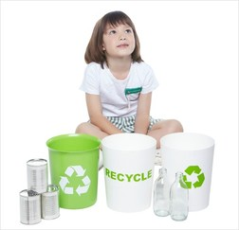
become garbage cans, paper, glass, and plastic- they are all useful.

Some things cannot be recycled. Look for this special mark on things.

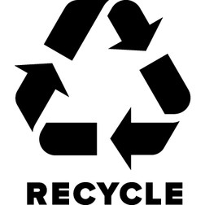
It means they can be recycled.

Next time, think before you throw something out, Recycling is easy to do.

You can help clean the planet!

Worksheet 2
● Choose the correct answers.

1. What is the passage mainly about?

ⓐImportance of recycling
ⓑImportance of saving garbage?
ⓒOut dirty planet.

2. Which can NOT be recycled?
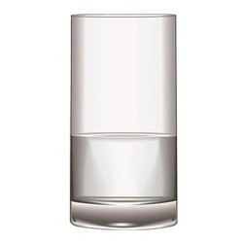
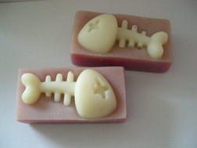

ⓐ glass ⓑ plastic ⓒ fish bone

3. According to the passage, which is true?

ⓐ It takes ten years to break down plastic.
ⓑ Not everything can be recycled.
ⓒ Glass can be recycled and become sings.

4. How can we save trees and energy?
ⓐ by recycling paper
ⓑ by collecting glass
ⓒ by making furniture

5. Which sentence best tells about recycling?

ⓐ It means not taking something new.
ⓑ It means giving something old getting something new.
ⓒ It means taking something old and making it new.

6. What does plastic NOT become after recycling?

ⓐ a piece of furniture
ⓑ signs on the roads
ⓒ trees

●Choose the correct answers (True/ False)
True False
By recycling, you can keep the Earth clean.

All the garbage could be recycled.

Recycled plastic can become garbage cans.

Glass cannot be recycled.

Workdsheet3
● Complete the graphic organizer.

Plastic Water Bottle

If you recycle

●Plastic________________________________________

●The Earth____________________________________

If you don’t recycle

●Plastic _____________________________________

●The Earth ___________________________

- turns into a big garbage can ★ become furniture or signs on the road

- needs a long time to rot away ★ become a clean planet
worksheet4
● Write the passage summary. You can refer to the graphic organizer.
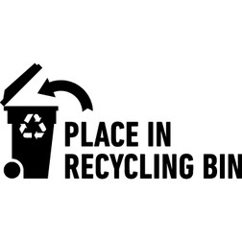
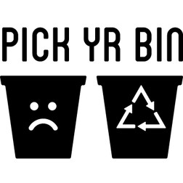
A New Life for Trash

You can help the Earth by recycling. If you don’t recycle

a plastic water bottle, plastic ___________________

_________________________________________________Than, the Earth

________________________________________________________________.

But if you recycle, plastic_____________________________________

_________________________________________. And the Earth ________________

_______________________________________________.

