Grammar Lesson Plan
96WD_SJ

Title : Temporary vs Permanent
Teacher | Student Level & Age | No of Students | Length
SJ | Low intermediate&17 years old | 19 | 50 mins

Materials:

Board, Pictures(I-Pad), Projector, Handouts

Aims:
To help Ss think learning Grammar is interesting, not tedious, by providing interesting activities.
To help Ss learn Present Continuous Tense and Simple Present Tense naturally by getting Ss to induce the rules for themselves.
To help Ss develop their abilities to think and induce rules by giving them opportunities to figure out.

Language Skills:
Reading: Questions in handouts, vocabulary written on the board
Speaking: discussion, questioning, answering
Listening: the teacher’s instructions and ICQ, discussion, questioning and answering
Writing: writing answers and sentences

Language Systems:
Grammar: uses of Present Continuous Tense and Simple Present Tense
Phonology: pronouncing new vocabulary and sentences
Lexis: learning new vocabulary
Discourse: discussing what rules can be induced from what are being learned in the class
Functions: explaining, describing actions, expressing movements, expressing temporariness and permanence, inducing

Assumptions:

Anticipated Errors and Solutions:
Some Ss may have difficulty in using the verb forms of the third person of Simple Present Tense
=>Teacher needs to propose many examples and also make examples with Ss to clarify the rule.

References:
Ramiro Garcia, James J.Asher. BaEsic contents house. 2008. ENGLISH ICE BREAK Intermediate: Watermelon : p 28, 42,46,48,92.(the pictures of actions, for Task Preparation activity)
http://cafe.daum.net/leeosan/mHBA/700?docid=1Ng8q|mHBA|700|20130611171841&srchid=IIMzUv5H600#A134D1A024C2591332FE3E7(the picture of the river, for Task Preparation activity)
http://cafe.daum.net/skymessage/HvY4/276?docid=1BFxY|HvY4|276|20100105182711&srchid=IIMo3QWS200#A1702E8234B31886275C6CD(the picture of the solar system, for Task Preparation activity)
Raymond Murphy. 2007. Grammar in use Intermediate: Cambridge : p 6~7 (the exercises, for Task realization activity)

Notes:

Pre Task
Title: Learning new words  explaining what words mean |  | Aims:  By this activity,  to help Ss think and find out for themselves  to help Ss get ready and motivated for the lesson | Materials:  Board
Time | Set Up | Students | Teacher
2mins  8mins | Whole class | Listening to instructions  Answering to ICQ  Thinking and finding out the meanings of the words  Explaining the meanings of the words | Giving Instructions  ICQ  Writing words on the board  Getting Ss to answer(‘in sentence. Synonym is not enough.’)  Positive reaction(“Good try” or “closely”, not “Wrong” or “No”)  Making example sentences for CCQ  Positive Feedback

Notes:

Task Preparation
Title: Feeling  describing pictures and thinking out the distinction |  | Aims:  To help Ss grow more interested and remind themselves about what they already learned by describing activities  To help Ss grow the senses of Present Continuous Tense and Simple Present Tense naturally by providing pictures  To give Ss the chances to share the ideas by group work | Materials:  Pictures(I-Pad), projector, board
Time | Set Up | Students | Teacher
5mins  5mins | Whole class  Group | Listening to instructions and answering to ICQ  Looking at the pictures and describing them  Listening to instructions and answering to ICQ  Discussing the distinction of the pictures  Answering | Giving instructions and ICQ  Showing pictures one by one  Giving instructions and ICQ  Monitoring  Questioning  Positive Feedback

Notes:
Forming 4 groups. Each group has 4~5 Ss.

Task Realization
Title: Experiencing  Doing exercises |  | Aims:  To help Ss experience the uses of Present Continuous Tense and Simple Present Tense by getting Ss to do exercises  To help Ss clarify the distinction between Present Continuous Tense and Simple Present Tense by discussion | Materials:  Handouts(‘Exercises’), board
Time | Set Up | Students | Teacher
2mins  18mins | Whole class  Group | Listening to instructions and answering to ICQ  Receiving handouts  Doing exercises  Answering | Instructions and ICQ  Distributing handouts  Monitoring  Questioning  Positive Feedback

Notes:

Post Task
Title: Inducing and Applying  -drawing out the conclusion |  | Aims:  To help Ss induce the rules of Present Continuous Tense and Simple Present Tense by discussion  To help Ss keep in mind by getting them to make sentences using what they have learned today. | Materials:  Board
Time | Set Up | Students | Teacher
2mins  8mins | Whole class | Explaining the rules  Listening to instructions and answering to ICQ  Discussing and making sentences  Writing sentences and drawing timeline on the board  Checking with teacher | Eliciting the rules from Ss  Instructions and ICQ  Monitoring  Monitoring  Checking with Ss  Positive Feedback  Finishing the lesson

Notes:

Today’s Vocabulary

Temporary: lasting for only a limited period of time
Ex) I’m looking for some temporary work.
→ synonym: momentary, transient, transitory etc
→ adv : temporarily
→ noun : temporariness

Permanent: lasting for a long time or for all time in the future; existing all the time
Ex) a permanent job
→ synonym: perpetual, eternal, lasting, everlasting etc
→ adv : permanently
→ noun : permanence

Pictures related to actions (for Pre task)

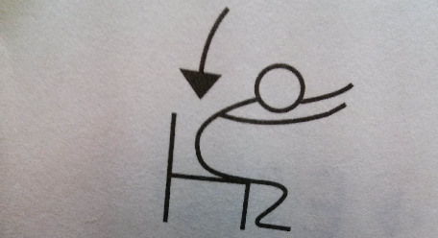

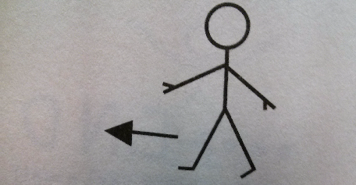

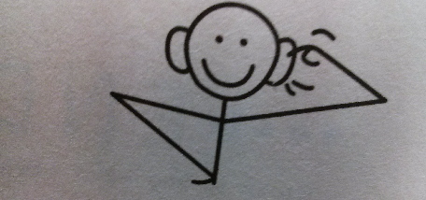

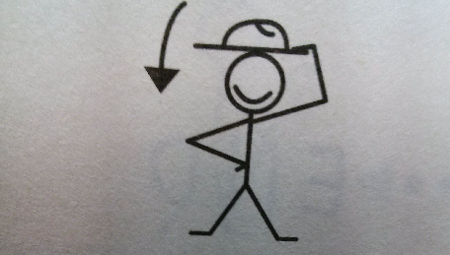

Materials related to movements etc (for Task Preparation)
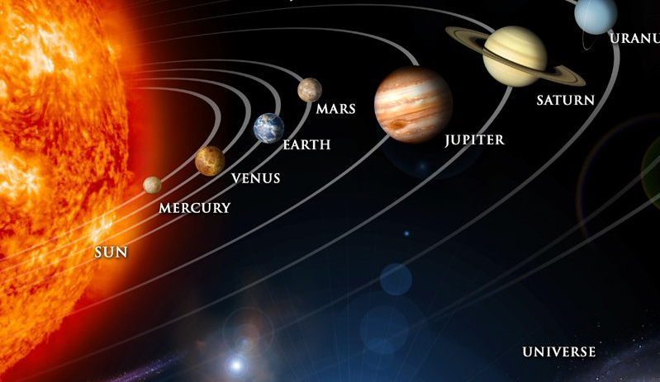
The earth moves round the sun.

The stream flows down.

Honesty is the best policy.

2+3 is 5.

A person is sitting on the chair. A boy is walking straight.
VS

The earth moves round the sun. The stream flows down.

Exercises

Q1. Are the underlined verbs right or wrong? Correct the verbs that are wrong.
Ex) The moon goes around the earth. → right
I usually go to work by car. → right
“You work hard today.” “Yes, I’ve got a lot to do.” → wrong; are working

1. Water boils at 100 degrees Celsius.
2. The water boils. Could you turn it off?
3. Look! That man tries to open the door of your car.
4. Can you hear those people? What do they talk about?
5. “What do you do?” “I’m studying now.”
6. “What are you doing?” “I’m a teacher.”

Q2. Put the verb in the correct form, present continuous or simple present.

Ex) My parents live (live) in Boston. They have lived there all their lives.
Matt is in San Francisco right now. He is staying (stay) at the Pelton Hotel. He always stays
(always/stay) there when he’s in San Francisco.

1. Hurry up! Everybody (wait) for you.
2. Julia is very good at languages. She (speak) four languages very well.
3. “ (you/listen) to the radio?” “No, you can turn it off.”
4. “ (you/listen) to the radio every day?” “No, just occasionally.”
5. The Han River (flow) into the West Sea.
6. The Han River (flow) very fast today-much faster than usual.

