[96th WD_Chloe] Reading Lesson Plan

Title : Shopping around the world
Teacher | Student Level & Age | No of Students | Length
Chloe(Seyeon, SHIM ) | High beginner | 11 | 50 mins

Materials:
- paper(5p) , handout(15 copies)
- article(15 copies)
- Board & Marker,
- music(It helps Ss feel comfortable when they discuss)

Aims:
- To learn new words
- To practice conversation skills through the discussion.
- To get information from the article.

Language Skills:
Listening: teacher’s instruction, discussion
Speaking: Discussion in pairs and in groups, Reading instructions, Answering questions
Reading: article
Writing: taking note, handout

Language Systems:
Phonology: Vocabularies
Lexis: Vocabulary used in the article. (new vocabulary)
Grammar: be verb, because
Discourse: Discussion
Functions: presentation, comparing

Assumptions:
- All the students are teenagers(Age 11 above)
- Students may understand the script without having problems.

Anticipated Errors and Solutions:
Before reading, students will learn new vocabularies in the article for understanding .

References:
TOUCHSTONE text book

Notes:

Pre Task or Warmer
Title:  Brain storming |  | Aims:  To Elicit what students already know (schema) | Materials:  Paper, pen, marker, whiteboard
Time | Set Up | Students | Teacher
10m | group | Ss discuss what they think about and then write down on the paper. Then, come to the white board and write it down. Share the words all together | Hand out paper  ICQ

Notes:

Task Preparation or Presentation
Title:  Let’s learn vocabulary |  | Aims:  To be able to learn words involved in shopping  To comprehend article well before reading article  ‘ | Materials:  Handout, white board , marker
Time | Set Up | Students | Teacher
10m | group  Whole class | Ss fill in the blank using the words with partners and share the answer all together.  Before reading, Ss can learn vocabularies related to the article | Give out handout and divide in to some groups  Have Ss fill in the blank and then share the answers with whole class(full sentence)  ICQ  Write down words on the white board in the article.

Notes:

Task Realization or Practice
Title:  Shopping around the world |  | Aims:  To understand shopping place all over the world | Materials:  Article
Time | Set Up | Students | Teacher
20m | Individual  group | Each S read out each sentence in the article and divide into 4 groups in order to talk about discussion questions.  Let Ss present the results. | Get them read out clearly and loudly.  ICQ&CCQ  Get them divide into 4groups and discuss using the questions.

Notes:

Post Task or Production
Title:  My favorite store is… |  | Aims:  To be able to tell your own recommendations using the paragraph | Materials:  Handout, pen, note
Time | Set Up | Students | Teacher
10m | Individual  group | Ss make sentences using models and take turns reading what they make | Have Ss make sentences using model and help note in handout  ICQ  Have Ss take turns talking to partner their recommendations

Notes:

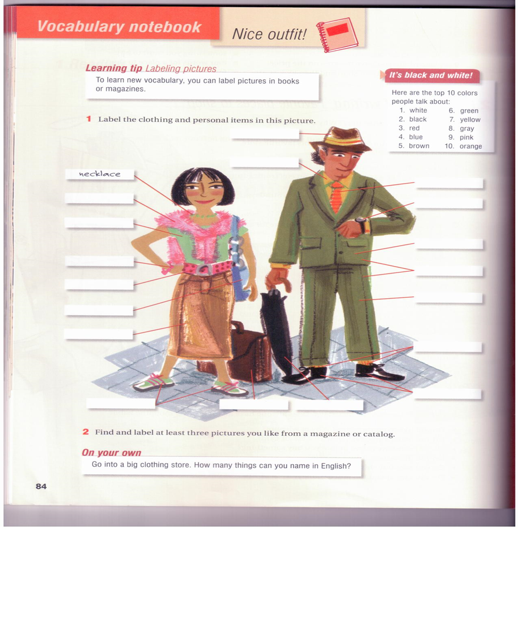

Fill in the blank using the words below hat/ bracelet/sweater/belt/Tshirt/tie/watch/ /suit/jacket/socks/shoes/briefcase/ pants /umbrella/bag/sneakers/ Yshirt/skirt

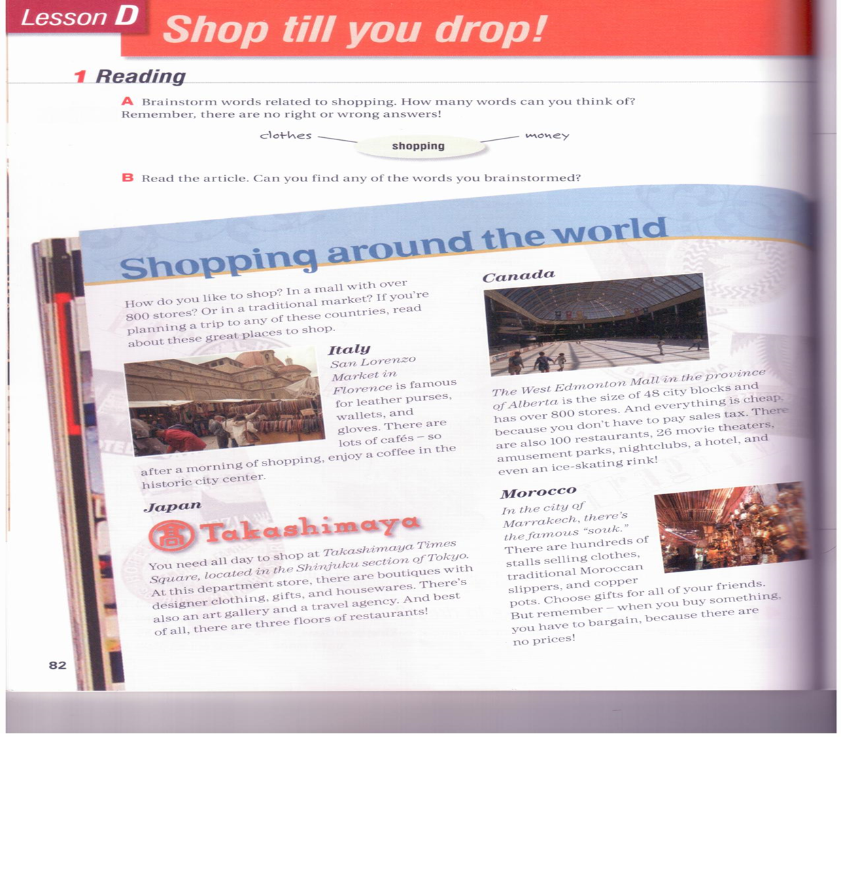
Article Questions

Look at the article. Find…
a good place to have coffee
a place where you can shop and then look art
a place with no sales tax
Somewhere you want to go
Something you want to buy

Write a paragraph about your favorite store for a shopper’s guide.Use the model below.
My favoritestore is…  I like it because…  I usually go there…  They sell…  They also have…  I like to buy… | Help note  Linking ideas with because to give reasons  My favorite store is Chang’s because it has great clothes  I like to shop there because it’s cheap.

Group work Take turns reading your recommendations. Do you learn about any new places to shop?

