Grammar Lesson Plan

Title: What are you going to have?

96WD_Liz
Teacher | Student Level & Age | No of Students | Length
Mona Liza Secretaria (Liz) | Beginner/ 9 | 19 | 50 mins

Materials:
- Photos of food
- Substitution Drill Chart
- Vocabulary Aids
- Sheets of paper with statement for the main activity
- Partitives worksheet
- Whiteboard, board markers and tape

Aims:
At the end of the lesson:
- The student will have practiced future tense “going to” in a sentence.
- The student will have practiced food and drinks partitives.

Language Skills:
Listening: Listening to the sound file
Speaking: Giving answers orally during the activity.
Reading: Reading the statement given by the teacher, the vocabulary and worksheet.
Writing: Completing the worksheet by writing the information on it and by writing on the board.

Language Systems:

Grammar: Future tense “going to” to state what to eat & using correct partitives of food and drinks.

Phonology: Correct pronunciation of the words especially in the vocabulary activity.
Lexis: list of vocabulary in the grammar exercise
Discourse: The grammar statement that indicates something they want to eat.
Functions: Asking and stating wants.

Assumptions:
The students can express themselves especially when choosing something to eat.
The students at this level have learned some food vocabulary.
The students know how to ask simple questions.

Anticipated Errors and Solutions:
Students might have difficulties pronouncing some of the words.
  - * The teacher will teach pronunciation during vocabulary discussion.
  - The students might be confused with partitives. They might be overwhelmed with the information.
  - * The teacher will teach partitives into parts then let student get used to the first 4 and then introduce another 4, and so on. Until the teacher covers all of it.

References:
http://www.grammar-quizzes.com/agree2b.html
http://www.esltower.com/GRAMMARSHEETS/partitives/foodpartitivessearch.pdf
English Time 5 Textbook by Susan Rivers

Notes:

Pre Task
Title: Eating |  | Aims:  * To create interest and establish the theme.  *To create a relaxed and friendly learning environment. | Materials:  Listening file  Photos of chosen food to be discussed.
Time | Set Up | Students | Teacher
5minutes | Whole class | *Greetings.  * Give ideas and opinion about the listening file.  *Name the pictures on the board. | *Greetings.  *Let the students listen to the sound and let them guess where the place is and what the people are doing.  *Elicit as much information as possible.  *Show them the pictures. Let them name the pictures.

Notes:

Task Preparation
Title: Words |  | Aims:  *To learn the grammar without creating pressure to the student.  * The student will have practiced the target grammar. | Materials:  - Visual aids for the vocabulary and grammar.  - ball
Time | Set Up | Students | Teacher
15mins | whole class | *Do as the teacher say, which is to listen and repeat.  *Volunteer to go in front and pass the ball to anyone who they want to ask with this question: “What are you going to have?”  *The chosen student will answer: “I’m going to have_________.”  *The rest of the students will answer” She’s/He’s going to have_____________________” | *The teacher will introduce partitives and future tense.  *Ask the students to listen and repeat.  *Elicit students’ ideas while doing the activity.  *Ask 4 students to come in front and pass a ball to anyone who they want to ask with the question: “What are you going to have?”  *Inform the students that if they fail to catch the ball they have to say the answer 5 times.  *Introduce the additional examples.  Using third person singular. He/She  *Ask the student to listen and repeat.  *Ask two students to come in front. Male and female.  *Ask the student, ”What are you going to have?”  Once the student answers, ask the rest of the students, “What’s she going to have?”  Do the CCQ and ICQ.  *

Notes:

Task Realization
Title: Pass the word |  | Aims:  * The student will have improvement on listening to the details related to partitives.  *The student will have practiced writing accurately after listening. | Materials:  Sheets of paper stating the statements to be relayed. In 3 categories: Easy, Medium, Difficult  Markers and whiteboard
Time | Set Up | Students | Teacher
20mins | Group work | * Form in two teams,  *the last student in each team read the statements,  *pass the word to the person right in front by whispering,  *will pass the word to the person in front, and so on  * when the statement reaches the front, the person at the front has to write the statement on the board.  *The students have to be keen in listening and accurate in writing. | * Line up the students in two teams and have the last student in each team read the statement and pass the word to the person right in front of him/her by whispering. Then that student will pass the word to the person in front of him/her, and so on. When the statement reaches the front, the person at the front has to write the statement on the board.  The team who writes the correct order on the board and the fastest will get a point.  *The team who earns most of the points is the winner.  *Ask the student to create the name of their group.  Do the CCQ and ICQ.
Notes:

Post Task
Title: |  | Aims: *The student will be able to group words that they could eat and drink, as well as the container use and the adjectives. | Materials:  Substitution Drill on the board.  (19) copies of worksheet; plus extra copies
Time | Set Up | Students | Teacher
10mins | Group work | *Work with the group in arranging the words on the board.  *Listen and repeat as the teacher gives instructions.  *Fill in the worksheet with correct answer. Listen as the teacher gives the instructions on how to do it. | *Ask the student to arrange in order and in correct categories all the words on the board.  *Introduce the additional examples.  Like bottle, bunch, carton, jar  *Ask the student to listen and repeat.  *Ask the student to fill in the worksheet.  *Give instruction how to do the worksheet activity.

Notes:

Worksheets, handouts and lesson materials
Material for Pre Task Activity

Listening File ( Eating)
Photos of the food and Drinks

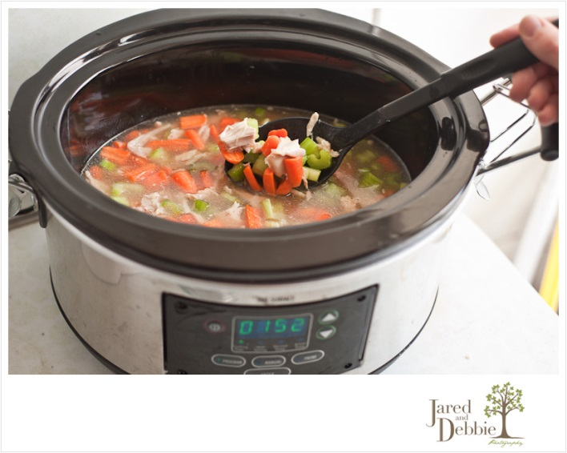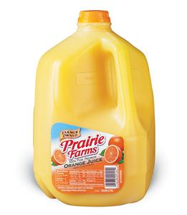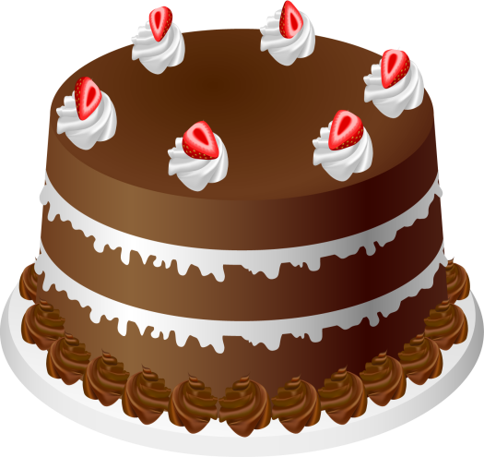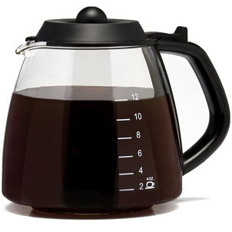

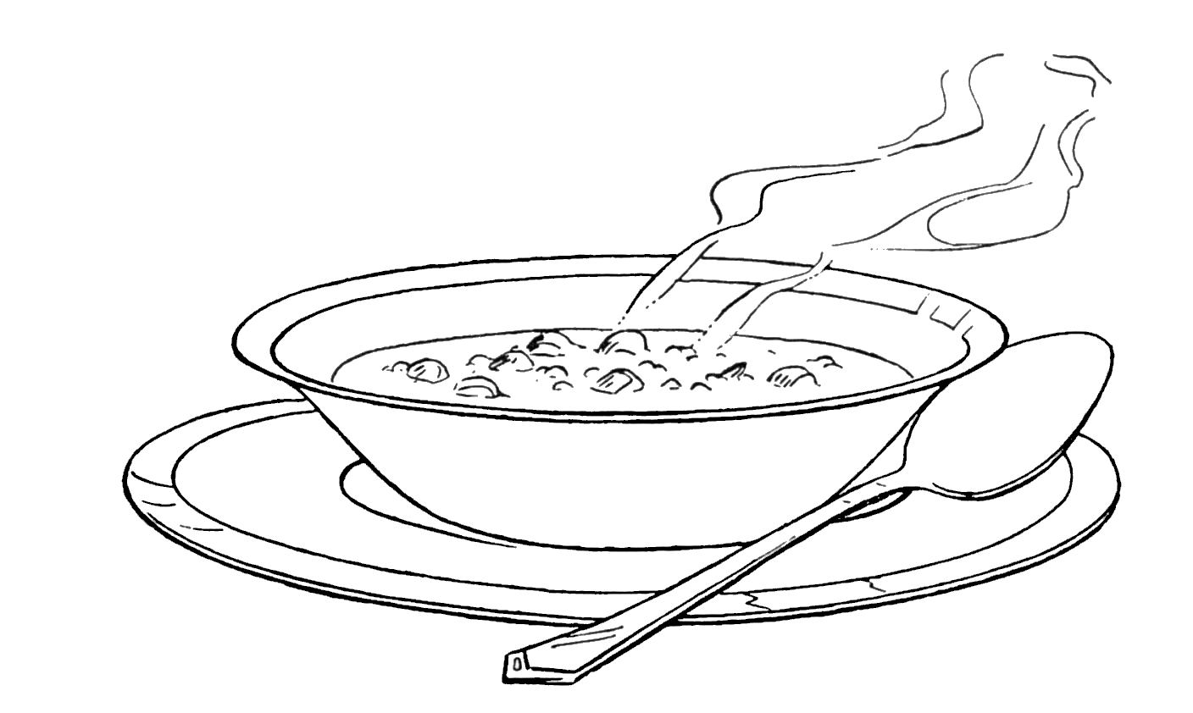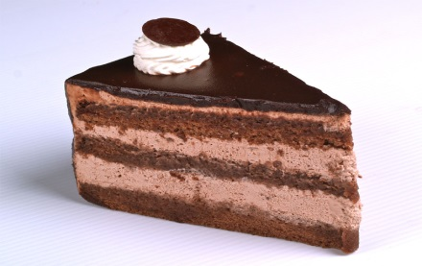

Material for Pre Task & Task- Realization activity
Vocabulary and grammar Aids. ( to be posted on the board)
A ball
Easy, Medium, Difficult Statement Categories

Materials for post task Activity
Substitution Chart (Sample)

a bowl of soup
fruit
I’m going to have | a slice of | cake  bread ham
a glass of milk
water
cola

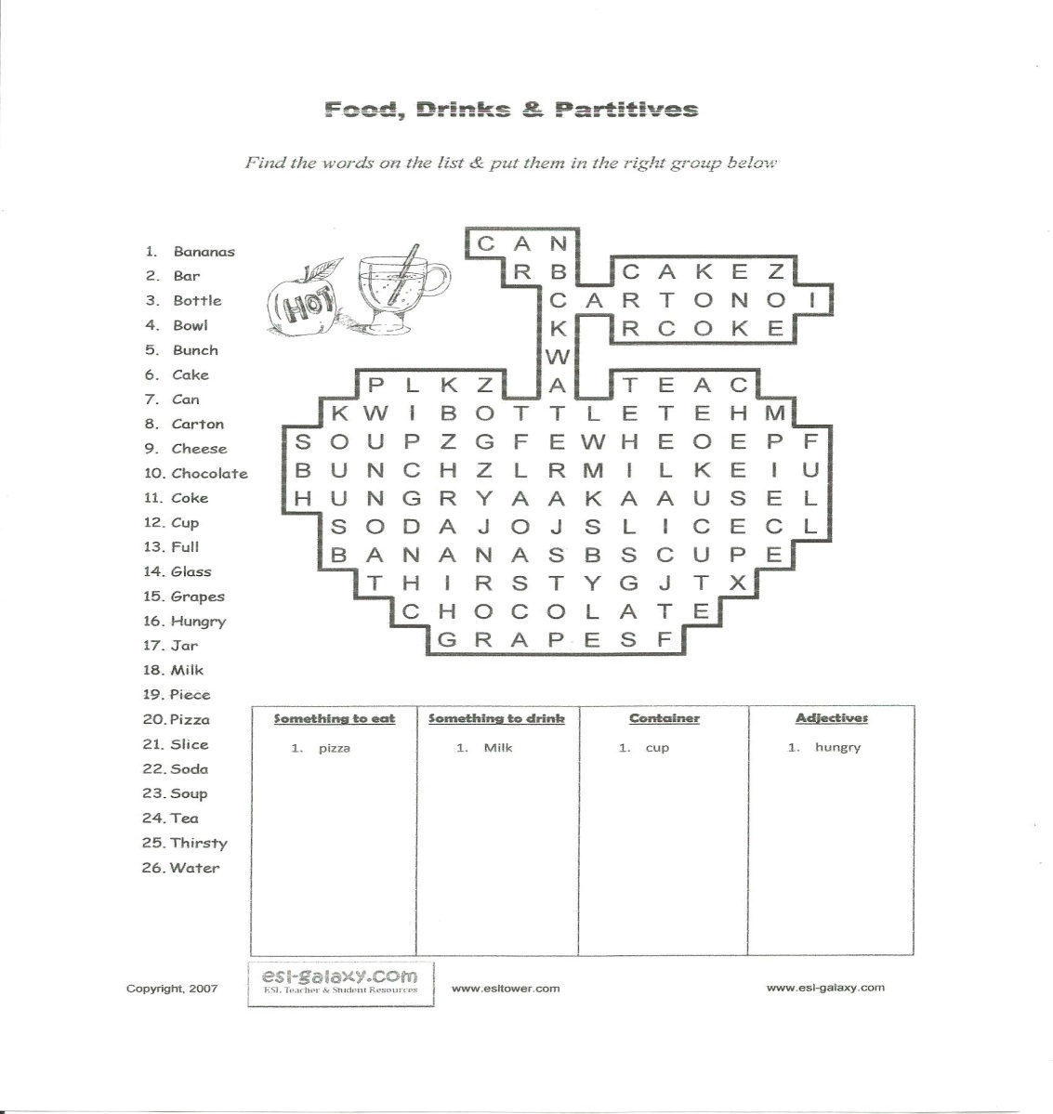
Easy Level

I’m going to have a glass of juice.
I’m going to have a cup of coffee.

Medium

She’s going to have a slice of cake and a cup of coffee.
He’s going to have a bowl of soup and a glass of juice.

Difficult

I have a slice of cake, a cup of coffee and a bowl of soup in my pocket.
I have a bowl of soup, a glass of juice and a slice of cake in my bag.

