Grammar Lesson Plan

Title : Where’s the cat?
Teacher | Student Level & Age | No of Students | Length
Jessica Yoo | False-beginner & Elementary Students | 12 students | 50 mins

Materials:
- White board & Markers
- 15 copies of Cat worksheet
- 15 copies of Grammar club book
- 15 copies of Where’s monster worksheet
- Computer & TV (or speakers)
- Scissors & Glue sticks

Aims:
- To be able to get the main idea by working on the worksheets and the book.
- To learn or be familiar with key vocabulary relating to the topic.
- To improve grammar skill by completing the worksheets.

Language Skills:
Reading: reading the text from the worksheets
Writing: answering questions and working on the projects.
Speaking: sharing ideas or discussing with a partner.
Listening: listening to the teacher’s presentation, instructions and other students’ opinions.

Language Systems:
Grammar: from the text and worksheets, Ss get to learn how to use preposition.
Lexis: new words and idioms used in the text.
Phonology: pronunciation of the key vocabularies.
Functions: talking with the usage of preposition and presenting one’s answer for the worksheet.
Discourse: teacher-student interaction and student-student interaction through the activities.

Assumptions:
- Some students might know the song I’ve prepared
- Some students might know the vocabularies that I have prepared

Anticipated Errors and Solutions:

References:
http://www.youtube.com/watch?v=hx8i-Wq_jtc
http://kizclub.com/Phonics/word/position.pdf
A book, Grammar Club 1by Gillian Flaherty and James Bean

Notes:
- If students finish their tasks earlier than anticipated
☞ SOS activities (play a game or worksheets)

Pre-task
Title:  Greeting & song |  | Aims:  To greet students and get them ready for the new lesson  - To help the students to think and speak only in English  - To get Ss interested in the topic | Materials:  White board & markers  Computer & TV  Cat worksheet
Time | Set Up | Students | Teacher
5mins | Whole class | - Listen and respond to the teacher  - Learn the song and sing out loud | - Greet students kindly and enthusiastically  - Play a song through youTube  - Sing out loud

Notes:

Task Preparation
Title:  Cat worksheet |  | Aims:  - To develop their vocabulary  - To encourage Ss to learn the topic  - To help students to understand the main task easily | Materials:  Cat worksheet  Scissors & Glue sticks
Time | Set Up | Students | Teacher
11mins | individually | - Listen and respond to the teacher  - Individually work on the worksheet (cut and paste) | - Distribute worksheets to everyone (Cat worksheet)  - Give instructions  - Ask them to complete the worksheet– give mins  - Ask ICQ:  +How much time do you have?  + What do you need to use?  Ask CCQ: Why do you think you’re doing this?  - Monitor and guide Ss

Notes:

Task Realization
Title:  Grammar club |  | Aims:  To develop Ss ability to read and understand the grammar, through answering some questions  To help Ss to improve their grammar skills | Materials:  White board & markers  Grammar club book (15copies)
Time | Set Up | Students | Teacher
24mins | Individually | - Listen and respond to the teacher  - Work on the copies of the book and answer them  - Participate actively with the presenting their answers | - Distribute Grammar club book to all (15 copies) – give 20mins  - Give instructions  - Ask ICQ:  + What are we going to do?  + How much time do you have?  - Monitor and guide Ss  - After Ss are done with the worksheet, ask them for the answers – give 4mins

Notes:

Post Task
Title:  Where’s the monster & closing |  | Aims:  To check whether Ss fully understood the lesson  - To improve Ss comprehension skill  To wrap up the class | Materials:  Board & marker  Where’s the monster (15 copies)
Time | Set Up | Students | Teacher
10mins | Individually | - Listen and respond to the teacher  - Work on where’s the monster worksheet individually  - Participate actively with the presenting their answers | - Give instructions  - Distribute Where’s the monster worksheet to all (15 copies) – give 7mins  - Monitor and guide Ss  - After Ss are done with the worksheet, ask them for the answers – 3mins  - Give feedbacks  - Tell Ss what we are going to do for the next class

Notes:
- If time is running short, ask for a volunteer to answer
- After all the work is finished but still got some time left, play a game on the white board (hang man, etc.) or SOS activity (worksheet)

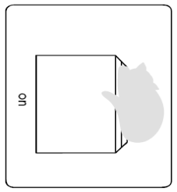
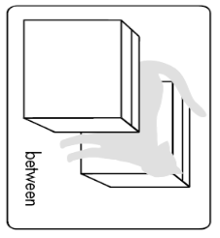
Worksheets, handouts and lesson materials

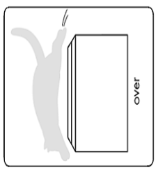
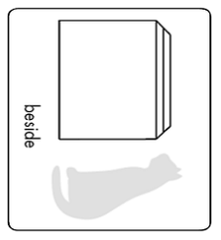

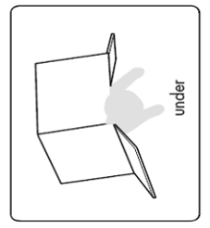
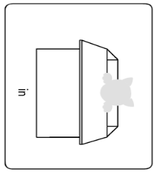

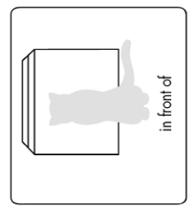
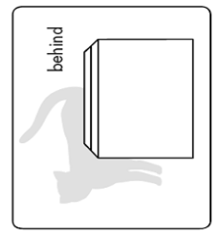

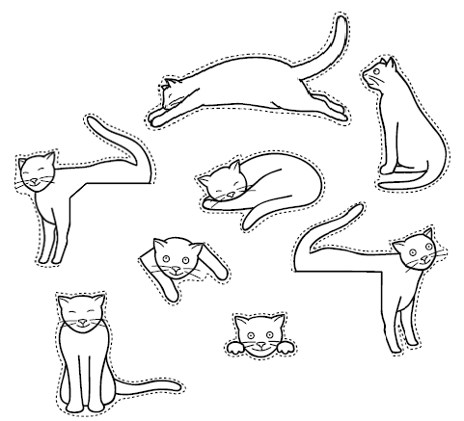

Where is the Monster?
Match the sentence the right picture.

He is:
- In the chair

- On the chair

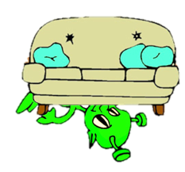
- Over the chair

- Under the chair

- In front of the chair

- Behind the chair

- Between the two chairs

