Grammar Lesson Plan

Title: Prepositions
Teacher | Student Level& Age | No of Students | Length
Jessica JO | High-beginner &  Elementary Students | 12 students | 50 mins

Materials:
- White board & Markers
- Computer, projector
- Prepositions PPT
- 15 copies of two different worksheets (worksheet#1,2)
- SOS worksheet

Aims:
- Ss will understand correct use of prepositions of time by completing the activities of this lesson.
- Ss will practice use prepositions by speaking in correct sentences using prepositions learned.
- Ss will be able to differentiate use by repeating the drills.
- Ss practice cooperative learning and speaking by discussing the answers of the grammar exercises in pairs and presenting the answers in after class.
- Ss will know the meaning and the use of each prepositions by listening to the explanation and internalized them.

Language Skills:
Listening: Ss will listen teacher’s instruction and other students’ speaking
Speaking: Ss will have a time to speak the class and during activities
Reading: Reading the worksheet’s question.
Writing : Completing their worksheets and writing prepositions sentence

Language Systems:
Phonology: Practicing new vocabulary and pronunciation.
Lexis: Meaning of each prepositions.
Grammar: Let the Ss use their own sentences based on the rules of prepositions.
Discourse: Asking to T or other Ss to make full sentences.
Functions: Questioning, answering, presenting, making a sentence.

Assumptions:
- Ss have a abundant ability to understand about teacher’s explanation and perform the activities.
- Ss will know about prepositions.

Anticipated Errors and Solutions:
- Ss may not understand the teacher’s instructions clearly
: I will give instructions again as simple as possible.
- During the activity, monitor them and give them a helpful feedback.

References:

Notes:
- If students finish their activities earlier than anticipated
: Assign the SOS Activity to the students

Pre Task
Title:  To warm up about today’s topic |  | Aims:  To elicit what students already know (schema)  To speak students’ opinion  To learn prepositions | Materials:  - White board & Markers  - Computer, projector  - Prepositions PPT
Time | Set Up | Students | Teacher
11mins | Whole class | - They will listen and answer teacher’s questions.  Ex) We are in the classroom.  There is a mobile phone on my desk.  - Ss will guess what the teacher’s question.  - Students will see the PPT.  - Ss will understand to hear a description of the preposition. | <Greeting>  Before starting the class, T asks questions.  <Eliciting and Prediction>  ex) Lynn, Where are we now?  Who is sitting next to you?  What is on your desk?  Who is sitting between Jessica and Eunice?  What is behind you?  (Ask all the Ss the questions, so that they may answer using the preposition)  CCQ  - Can you guess what you will learn today?  -Turn the PPT and show students  -Explain about the rules of prepositions

Notes:

Task Preparation
Title:  Prepositions of Place Matching Activity |  | Aims:  To let them know the rules of the Prepositions  To encourage Ss to learn the topic  To help students to understand the main task easily | Materials:  - White board & Markers  - Computer, projector  - Prepositions PPT  - Worksheet #1,2
Time | Set Up | Students | Teacher
15mins | Whole class  Individually  Whole class | - Listen to the instructions for teacher.  - Do individually the worksheet  - Ss will guess what the teacher’s question.  - Ss check the answers  - Teacher is to nominate students, read the text  Ex) T : Jessica, can you read the question number 1?  Ss: The lion is …………the rhino and the buffalo.  T : What is the answer?  Ss: c. between | - Handout worksheets  - Give instructions.  - Worksheet #1  Let's look at the worksheet #1  Look at the picture let us write the numbers in a different  view by searching the statement number of prepositions,  respectively.  - Worksheet #2  Let's look at the worksheet #2  Please fill in the blanks.  (Using prepositions AT, BEHIND, BETWEEN, BY, IN, IN FRONT OF, NEXT TO, ON, TO)  ICQ  - How much time do you have?  - What are you going to do?  CCQ  - Can you think about why we do the this activity?  - Monitor and guide Ss  - Check the answer and read the answer one by one.

Notes:

Task Realization
Title:  Play game! |  | Aims:  - To Ss can give an interest and understanding of the preposition easy and fun through the game.  To Ss improve the fluency of the prepositions sentences. | Materials:  - White board & Markers  - Computer, projector  - Prepositions PPT
Time | Set Up | Students | Teacher
20mins | Whole class  In Group  Whole class | - Ss sit nicely  - Ss listen to T's explanation about how to do game.  - Divide the group.  - If you have questions occurred, ask the teacher.  Ex) Ss: Going to find that two of the paper?  T: yes, one of the matching game.  - Do it the activity  - During the game, the question occurs ask the teacher  - Answer to the T's ICQ, CCQ | <Procedure>  Now, We are going to do fun game!  - Give instructions  <Instructions>  Let’s play the treasure hunt now.  First, divide into three groups.(Grouping)  There is various text hidden in our classroom.  However, this document is not perfect.  Let's put it on the board preposition corresponding to the paper  that says each statement, the text that is written in the paper  even if the search together.  Let's make the perfect sentence.  Most, find early team win.  I'll give a small gift to the winning team.  <Demonstration>  If I've found paper "The lion is ............ the rhino and  the buffalo" you look for prepositions that corresponds to this  sentence to "between" and put it on the board subsequently to  complete the sentence.  After the game was over, we try to say the completed sentence,  Together.  ICQ  - How much time do you have?  - When you see two paper, what will you make?  - - What kinds of sentence?  - If your team is winner, what do you want?  CCQ  - What do you need to do next?  - Who are you working with?  - Monitor discreetly  - Give them time (3minute/1:30 seconds)  - After the game, Make each student to read the answer out loud.  - Go to next stage if they finished earlier

Notes:

Post Task
Title:  Review of today’s lesson |  | Aims:  To let SS review what they learned  - To improve Ss prepositions skill | Materials:  - White board & Markers  - Computer, projector  - Prepositions PPT
Time | Set Up | Students | Teacher
10mins | In Group  Whole class | - Listen to the instructions for teacher.  - Do it the activity  - During the game, the question occurs ask the teacher  - Answering and questioning  - Ss will hear to the teacher’s summary | <Procedure>  Free Production  <Instruction>  Finally, we will groups on each other make a statement to the preposition. write three example sentences using each prepositions.  And try to connect the sentences to make a story.  After everyone has finished, all of you together read the story out loud  I will give you handouts but they are only for your references.  I’ll give you 5 minutes.  <Demonstrate>  For example, Lynn may start with " Next to me,  Jessica is sitting." then  Eunice keeps the story line saying" There are many sweets on top of her desk."  And everyone takes turn until everybody writes down 3 sentences.  <Feedback>  - Was the activity meaningful to you?  - You guys did a great job today  - Was it fun?  Eliciting again about grammar point  <Ending Greeting>  Great job for today and I will see you next week.

Notes:

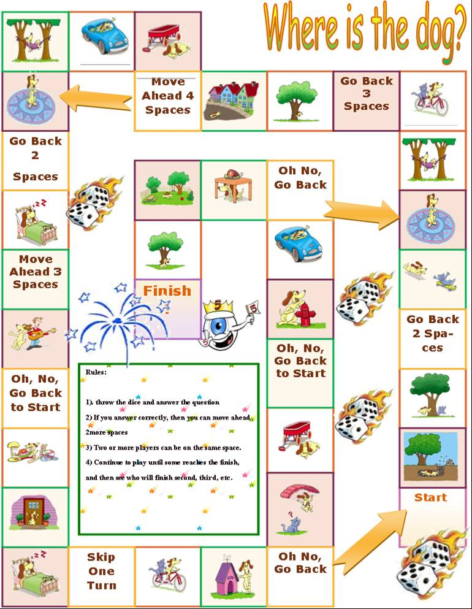
SOS Activity

