Dictionary Game with Julie and Julia

Instructor:  Jane (Jiyoung Oh) | Level:  Upper-Intermediate | Students:  9 | Length:  50 Minutes

Materials (refer to the end of the pages)
- Board and board marker
- An extract from a book ‘Julie and Julia’ (students / teacher)
- A short scene from a movie ‘Julie and Julia’
- A jeopardy game

Aims
- Students will learn new vocabularies through reading an extract of a book, guessing the meanings of the vocabularies from the context, watching a movie ‘Julie and Julia’, discussing with groups and a dictionary game activity.

Language Skills
- Reading: Reading a passage during warm-up activity, and an extract from a book during main activity
- Listening: Listening to the teacher and classmates’ talk
- Speaking: Group discussion of figuring out the meaning of vocabularies, and speaking during activity
- Writing: Writing the meaning of vocabularies during group discussion

Language Systems
- Phonology: Sound of new vocabularies
- Lexis: Words used in the extract and game (lulling, droned, dawn, nasty, alignment, fate , decreed, lugging, tingled, pricked, crinkle, claw, venturing)
- Grammar: N/A
- Function: Expressing opinion and daily conversation
- Discourse: Expressing opinion and any conversation that students have during activity and group discussion

Assumptions
- Students are adults (Ages from 20 to 45)

Anticipated Errors and Solutions
- If students are having difficulties with guessing the new vocabularies
Give them a hint when they are having group discussion.

References
- Jeopardy game template (www.edtechnetwork.com/powerpoint.html‎)
- A book, Julia and Julia, Julie Powell, 2009 (page 172-173)
- Julia and Julia movie script (http://www.script-o-rama.com/movie_scripts/j/julie-and-julia-script-transcript.html)

Pre-Task
Materials:
Time | Set Up | Teacher | Students
1 min  3 min |  | 1. Hand out an extract from the book  2. Let students read the extract | Students will read the extract

Task Preparation
Materials: Reading, movie clip, word and meaning cards,
Time | Set Up | Teacher | Students
5 min  3 min  5 min | Whole class  2 Groups | 1. Play the movie ‘Julie and Julia’ which contains same story from a book  Introduction  2. Let students guess the meaning of the vocabularies  3. Hand out cards written with meanings and let students match the word and the meanings - 5min  Demonstration  Show students matching word cards and meaning cards  I.C.Q  How much time do we have?  (Give time warning: 1 minute left) | Students will watch ‘Julie and Julia’ and have more clue on the meaning of vocabularies  Students will guess the meaning of the vocabularies highlighted on the passage  5 minutes  Students will make 2 groups  Students will match the meaning card and word card together

Task Realization
Materials: Jeopardy game
Time | Set Up | Teacher | Students
20 min | 2 Groups | Open jeopardy power point  Ask students when the movie was first released  Introduction  1. Each group will make their group name (short and easy) with an action  2. When students know the answer for the question, group members will shout their group name  Demonstration  Show demonstration  Practice shouting each group name with an action  ICQ  What do you do if you know the answer?  3. Start with jeopardy game  4. Keep the points of each team on the board | A group which gets right answer (in 2009) first will have a chance to go first in jeopardy game  Students will practice shouting their group name with an action  Shout my group name with an action  Students will read the meanings and find the answer (word)  Students who gets the right answer will get the points

Post Task
Materials:
Time | Set Up | Teacher and students
8 min | Whole class | Error correction and feedback  1. Students will discuss any errors made during the class.  2. Students will check the correct meaning of vocabularies they have learnt if there’s something they do not understood.

Materials
- An extract from a book ‘Julie and Julia’ (students ver.)

Student’s Name ________________

Julie and Julia

Julie Powell reclaims her life by cooking every single recipe in Julia Child’s legendary Mastering the Art of French Cooking in the span of one year.

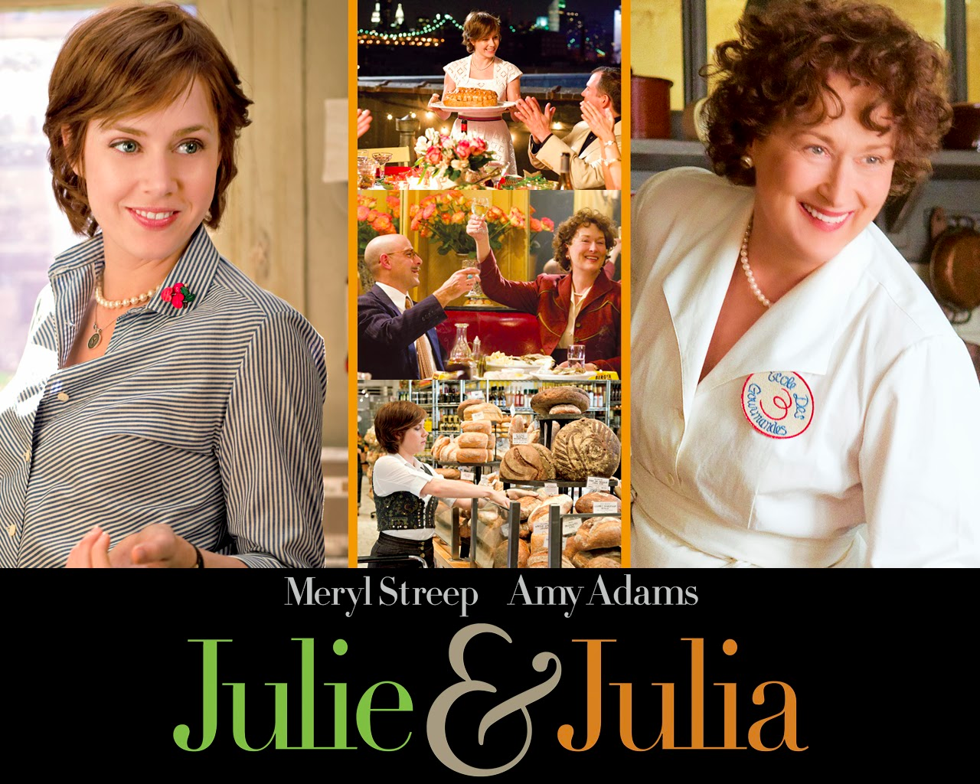

I am going to have to murder and dismember a crustacean. How will I ever do this? Last night our sleep machine, the one we have by our bed to drown out the noise of freight trucks rumbling past our apartment, was speaking to me. And it was saying, “Lobster Killer, lobster killer, lobster killer….”

I was awake by dawn, worrying. It was Sunday morning in Long Island City with my husband, Eric. The fish market did not smell fishy, and they had lobsters in a nasty-looking cloudy tank. I bought three. The stars fell into alignment, for fate had decreed these three lobsters must die. I had been imagining lugging the lobsters home in a bucket, but the guy just stuck them in a plastic bag. On the drive home the back of my neck tingled and my ears stayed pricked for the sneaking crinkle of a lobster claw venturing out of a plastic bag- but the lobsters just sat there.

- An extract from a book ‘Julie and Julia’ (teacher ver.)

Julie Powell reclaims her life by cooking every single recipe in Julia Child’s legendary Mastering the Art of French Cooking in the span of one year.

I am going to have to murder and dismember a crustacean. How will I ever do this? Last night our sleep machine, the one we have by our bed to drown out the noise of freight trucks rumbling past our apartment, was speaking to me. And it was saying, “Lobster Killer, lobster killer, lobster killer….”

I was awake by dawn, worrying. It was Sunday morning in Long Island City with my husband, Eric. The fish market did not smell fishy, and they had lobsters in a nasty-looking cloudy tank. I bought three. The stars fell into alignment, for fate had decreed these three lobsters must die. I had been imagining lugging the lobsters home in a bucket, but the guy just stuck them in a plastic bag. On the drive home the back of my neck tingled and my ears stayed pricked for the sneaking crinkle of a lobster claw venturing out of a plastic bag- but the lobsters just sat there.

・reclaim – v. to bring back, as from error, to a right or proper course
・crustacean – any aquatic arthropod of the class Crustacea, typically having the body covered with a hard shell of crust, including the shrimps, lobsters, and crabs
・drown – to destroy or get rid of by immersion
・freight – to load with goods for transportation
・rumbling – making a low heavy rolling sound
・dawn – n. the time that marks the beginning of the twilight before sunrises
・nasty – a. very unpleasant to see, smell, taste, etc
・alignment – n. the proper positioning or state of adjustment of parts in relation to each other
・fate – n. a power that is believed to control what happens in the future
・decreed (decree) – v. to order or decide something in an official way
・lugging – v. pulling or carrying (something) with great effort
・tingled (tingle) – v. to have a feeling like the feeling of many small sharp points pressing into your skin
・pricked (prick) – v. to cause a sharp, painful feeling on or in part of your body
・crinkle – n. a small, thin line that appears on a surface
・claw – n. a sharp curved part on the toe of an animal (such as a cat or bird)
・venturing – v. going somewhere that is unknown, dangerous, etc

- Word and meaning cards (print for each group)

reclaim crustacean
drown
freight
rumbling
dawn
nasty
alignment
fate
decreed
lugging
tingled
pricked
crinkle
claw
venturing
to bring back, as from error, to a right or proper course

any aquatic arthropod of the class Crustacea, typically having the body covered with a hard shell of crust, including the shrimps, lobsters, and crabs

to destroy or get rid of by immersion

to load with goods for transportation

making a low heavy rolling sound

the time that marks the beginning of the twilight before sunrises

very unpleasant to see, smell, taste, etc

the proper positioning or state of adjustment of parts in relation to each other

a power that is believed to control what happens in the future

to order or decide something in an official way

pulling or carrying something with great effort

to have a feeling like the feeling of many small sharp points pressing into your skin
to cause a sharp, painful feeling on or in part of your body

a small, thin line that appears on a surface

a sharp curved part on the toe of an animal (such as a cat or bird)

going somewhere that is unknown, dangerous, etc

