Phrases with Gerund

Instructor:  Jane (Jiyoung Oh) | Level:  High-Intermediate | Students:  9 | Length:  50 Minutes

Materials (refer to the end of the pages)
- Board and board marker
- [1/3] An e-mail contents work sheet
- [2/3] Printed 7 phrases
- [3/3] Worksheet with pictures

Aims
- Students will learn 7 phrases with gerund through guessing and discussing the meanings of the phrases, and making a conversation using the phrases that they learnt.

Language Skills
- Reading: Reading a written e-mail
- Listening: Listening to the teacher and classmates’ talk
- Speaking: Group discussion of finding errors from the sample e-mail and
presentation of their group work
- Writing: Writing the answers on the worksheet

Language Systems
- Phonology: Sound of [worth] and [busy]
- Lexis: Words used in e-mail
(Yours sincerely, Best regards, Cheers)
- Grammar: Phrases using gerund
(look forward to, be used to, cannot help, it’s no use, feel like, be worth, be busy)
- Function: Expressing opinion
- Discourse: Expressing opinion and any conversation that students make using the phrases
they learn.

Assumptions
- Students are adults (Ages from 20 to 45)

Anticipated Errors and Solutions
- If students are having difficulties with writing an e-mail
= Give them a little bit of guide.
ex.) What about (this…)?

- Students might have difficulties with guessing the meaning of a phrase ‘cannot help’
=Go over the meaning with teacher in case they guess wrongly.

References
N/A

Pre-Task
Materials: An e-mail contents work sheet
Time | Set Up | Teacher | Students
2 min  2 min | Whole class  Pair | Ask students if they have written an e-mail in English before.  Hand out an e-mail contents work sheet. | Students will make a pair with a person next to them.  Students will get an e-mail contents work sheet and find some phrases that are wrong. (2 min)

Task Preparation
Materials: Board, marker, printed 7 phrases, worksheet with pictures
Time | Set Up | Teacher | Students
2 min  3 min  3 min  5 min | Pair  Whole class  Groups | Elicit 5 wrong phrases  Check the answers.  Put 7 phrases on the board vertically and write ‘verb+ing’ next to the 7 phrases, indicating that all the phrases go with gerund.  Ask students if they know the meanings of each phrase.  Introduction  5 minutes for  1. guessing and discussing the meaning of the phrases  2. matching the phrases to the pictures  3. making a sentence for each picture using a phrase  4. writing the answers on the board  Three groups of three  Demonstration  Teacher will give a demonstration.  ICQ  - Do we know the meaning of the phrases?  - How much time do you have for presentation?  - What do you after finishing the discussion?  (Give time warning: 1 minute left) | Students will present 5 wrong phrases they have found.  Students will correct the answer and go over what the e-mail wants to say.  Students will make three groups of three.  Look at the worksheet together.  - No, we are guessing the meaning of the phrases.  - 5 minutes  -Write the answers on the board  Students will work together and write the answers on the board

Task Realization
Materials: Same as task preparation
Time | Set Up | Teacher | Students
6 min  2 min  5 min  10 min | Groups | Go over the answers students wrote on the board and check the answers.  Introduction  5 minutes for making a short conversation using at least 5 phrases.  ICQ  How many phrases are you going to use?  (Give time warning: 1 minute left) | Correct the answers if there were anything went wrong.  Students will make a short conversation using at least 5 phrases that they learnt during class for 5 minutes.  - At least 5 phrases  Students will make a conversation for 5 minutes.  Each team will come out in front and present their conversation.

Post Task
Materials: Board and board marker
Time | Set Up | Teacher and students
10 min | Whole class | Error correction and feedback  Teacher will elicit difficulties and solutions from students.  Students will discuss any errors made during the class.

Materials
- [1/3] An e-mail contents work sheet

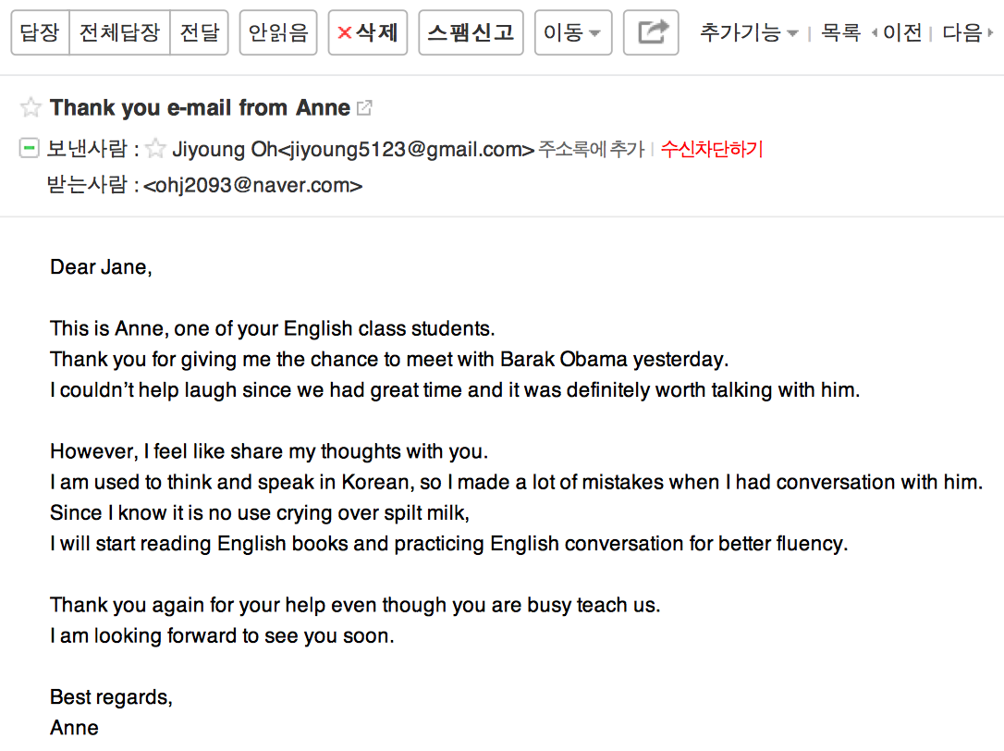

- [3/3] Worksheet with pictures

Using the phrases below, make a sentence for each picture.

look forward to be used to cannot help it’s no use feel like be worth
be busy

1. 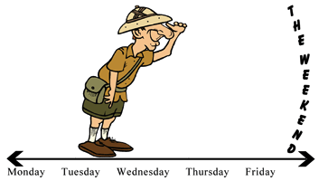

Answer: I look forward to going on a picnic this weekend.

2. 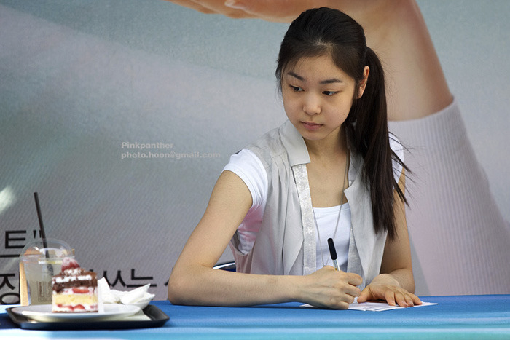
Answer: Yuna feels like eating the cake.

3.
Answer: He is busy working in his office.

4.
Answer: They are worth buying at Best Buy.

5. 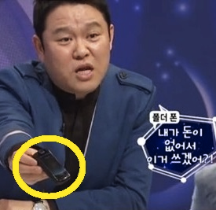
Answer: Kim Gura is used to using 2G cell phone.

6.
Answer: He cannot help loving Suji.

7.
Answer: It’s no use crying over spilt milk
- [2/3] Printed 7 phrases (font size 150, make sure every student can see the words on the board)

look forward to
be used to
cannot help
It’s no use
feel like
be worth
be busy

V+ing

