Listening Speaking Reading Grammar Writing

Topic: Relative pronoun

Instructor:  Jin Lee &  Lauren Son | Level:  Intermediate(Adult) | Students:  12students | Length:  30 Minutes

Materials:
- two play dough (for magic show)
- worksheet #1,#2, #3(12copies)
- jeopardy game (ppt file), Computer and projector

Aims:
- Main aim: Ss will be able to improve their grammar skills by playing a game
- Secondary aim : Ss will be able to learn new grammar and vocabulary by playing a game and doing worksheet
- Personal aim : we want to be able to reduce commentaries and give more STT and improve eliciting

Language Skills:
- Reading : Ss will read the sentences in worksheets and a game
- Listening : Ss will listen to speaking of teacher and classmates
- Speaking : Ss will speak their own sentence playing the game
- Writing : Ss will write several sentences for their post activity

Language Systems:
- Phonology : /r/, /l/
- Lexis : New vocabulary and idioms
- Function: explain, inform
- Grammar: Relative pronoun –who, which, that, whom
- Discourse: discussion and conversation

Assumptions:
- Ss already know that how the class set up and run.
- Ss will learn how to add two clause together using relative pronouns.
- Ss understand the contents easily through games and activities

Anticipated Errors and Solutions:
- Ss may not be able to understand the contents properly.
->ICQ and CCQ
- Activity takes longer than expected
-> Instructors will cut the post activity speaking time
- Ss may need more time to work on the main activity
-> Give Ss little more time to finish
- If Ss finish their task earlier than anticipated
-> Ask students about the main ideas of relationship and SOS activity

References:
- http://etc.sfsu.edu/sites/sites7.sfsu.edu.etc/files/worksheets/relative_pronouns.pdf
- http://www.englishwsheets.com/relative-clauses-1.html
- http://speakspeak.com/english-grammar-exercises/intermediate
- http://batxillerat2.wikispaces.com/5+Unit+5+Relatives

Lead-In
Materials: play dough

Time | Set Up | Student Activity | Teacher Talk
1min | Whole class |  | Good morning, everyone. How was last week? Everyone seems tired, right?  We prepared a magic show for you! And I’ll also teach you the trick at the end and you can surprise your friends.  See these two play dough? It’ll magically become one. Open up your eyes and look closely! (add two pieces together)

Pre-Activity
Materials: worksheet #1
Time | Set Up | Student Activity | Teacher Talk
2min  4min  2min | Whole  class  Pair  Whole class | Answers elicited questions  Students work on their worksheets  Students check answers | Procedure:  - Brainstorming  Elicit  Have you found out the trick?  Great! As we showed our magic with play dough and you can also use sentences to do this magic trick.  Model  Write the subject “Relative pronoun” on the board and read it out  Write “Thank you very much for your peer evaluations. These are very touching.  How can you make them into one beautiful sentence?  What word can you use as a magic power?  Yes! “Which” is correct answer!  Erase period and ‘these’ and write ‘which’ in between sentences.  CCQ  “Can you add two sentences together?”  “What do you need to make that happen?  - Pre-activity  Instruction  I will pass out the worksheet #1. We will practice relative pronouns. With your partner, you will fill in the blanks with “who, which, whose, whom” and complete the sentence for last six questions. I’ll give you four minutes.  (Distribute worksheet #1)  Let’s look at Q1 together….  Let’s look at Q18 together….  Now, you may begin.  ICQ  Are you working alone?  How much time do you have?  Monitoring  Monitor discretely. Answer for any questions if needed.  Give time warning: 2 minutes; 1 minute left.  “Ok, times up.”  Check Answers  Let’s go over the answers together.  Go over one by one. Have each student read the sentence and guess the correct answer.  “Great job everyone”

Main Activity
Materials: ppt file, computer, projector
Time | Set Up | Student Activity | Teacher Talk
2min  12min | groups | Ss play the game | - Instruction  “Now, we are going to play a jeopardy game. You will work with your group. (divide in 3 groups) Let’s see the screen. Each team will choose one box and solve the problem in 5seconds. If you cannot answer in time, you will lose your chance and other teams may get the chance to answer.  Let’s see one question as an example…  ICQ  Do you work with your group?  How much time do you have for one question?  “Let’s start the game”  Monitoring  Monitor students as the game proceed and answer for any questions if needed.  Time Warning  Count 5 seconds and if the team can’t answer in 5 seconds, give the chance to the other teams.  Finishing the game, sum the score and give the winner candies.

Post Activity
Materials: worksheet #2

Time | Set Up | Student Activity | Teacher Talk
4min  2min  1min | Group  Whole class | Students work on their worksheets  . | - Post Activity  Instruction  We will do one more worksheet before we finish today. With your partner, I want you to read the sentence and complete them.  (distribute worksheet #2)  ICQ  Do you work with group?  How much time do you have?  “Start it now”  Monitoring  Monitor discreetly. Answer students if they ask questions.  Feedback  “Let’s check the answers. Go over answers together.  - conclude lesson  Elicit today’s subject and do any error correction about grammar and pronunciation that students often made mistakes.  “You all did really good work today. Please try to remember new grammars we learnt today. Thank you for your participation and great attention. See you tomorrow!”

SOS Activity
Materials: worksheet #3

Time | Set Up | Student Activity | Teacher Talk
5min  2min | Individually  Whole class | worksheet #3 | - Listening and fill in the gaps  Instruction  “Now, we are going to practice what we learned today. You will complete the sentence with relative pronoun and match the sentences with the pictures. You will work with your group and I will give you 5mins”  (Distribute the worksheet #3)  ICQ  Is this group work?  How much time do you have?  Check answer  “Check the answers together. Please read aloud each sentences slowly and correctly by all students in rotation.”  Teacher tells students correct answer as soon as they tell answer.

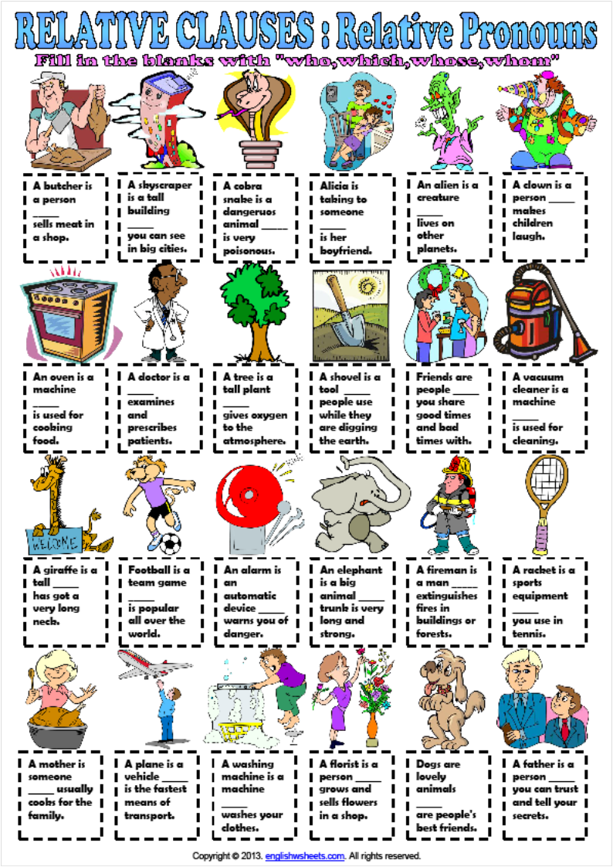
Worksheet #1
Worksheet #1_Answer
Worksheet #2
- This is the lady about whom _____________________________________
- We visited a country that _________________________________________
- I don't like the people whom ______________________________________
- Where's the basket in which ______________________________________?
- Peter laughed at the story that _____________________________________
- My aunt met the writer whom _____________________________________about.
- Sammie spoke with the teacher whose _______________________________
- I met the manager whom _________________________________________for.
- She hates the blouse that __________________________________________
- Tell me about the tourists whose ____________________________________
- What did you do with the money which ____________________________________
- That’s Brad, the guy ____________________________________

Worksheet #2_Answers will vary
- This is the lady about whom _____________________________________
- We visited a country that _________________________________________
- I don't like the people whom ______________________________________
- Where's the basket in which ______________________________________?
- Peter laughed at the story that _____________________________________
- My aunt met the writer whom _____________________________________about.
- Sammie spoke with the teacher whose _______________________________
- I met the manager whom _________________________________________for.
- She hates the blouse that __________________________________________
- Tell me about the tourists whose ____________________________________
- What did you do with the money which ____________________________________
- That’s Brad, the guy ____________________________________

Worksheet #3
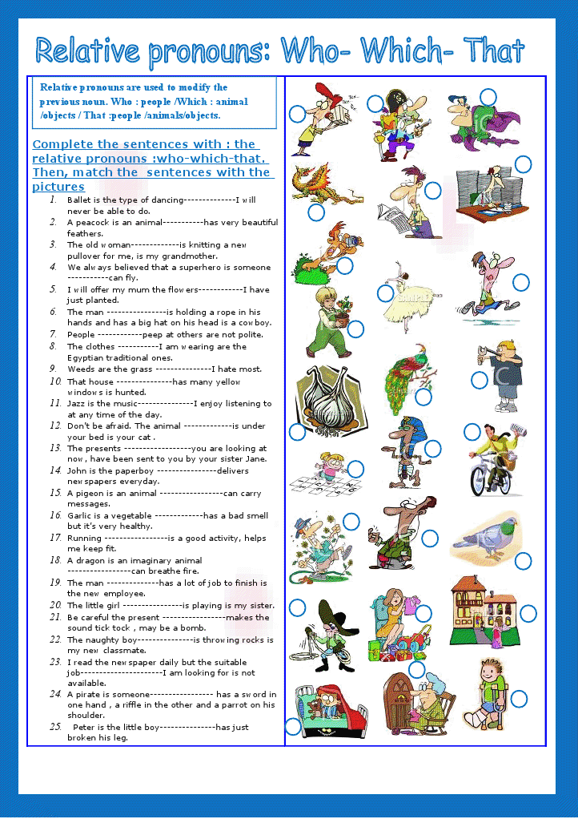
Worksheet #3_Answer

