□ Listening □ Speaking ■ Reading □ Grammar □ Writing

Topic: Personalities by blood type

Instructor:  Jung, Dasom(Som), Penny Yun | Level:  Intermediate(Adults) | Students:  12 students | Length:  30 minutes

Materials:
- Realia - some pictures of personalities by blood type
- White board and board markers
- Meaning match worksheet (12 copies)
- Fill in the blanks worksheet (12 copies)
- A piece of paper and a pen, poster(for each group and pairs)

Aims:
- Main aim: Ss will be able to improve their language skills by reading and
understanding topic at the same time.
- Secondary aim: Ss will be able to learn vocabulary by doing activities.
(Meaning match, discussion, fill in the blanks)
- Personal aim: I want them to be more confident in using the English language
and be able to speak fluently.

Language Skills:
- Reading: Ss will read worksheets.
- Listening: Ss will listen to the speaker’s short speech about their opinion.
- Speaking: Ss will speak about their prediction for pictures and practice by talking about their experiences.
- Writing: Ss will write their comments on the topic.

Language Systems:
- Phonology: /r/, /l/ and /f/, /p/
- Lexis: New vocabulary used in the dialogue:
(uptight, mercurial, rational, mediators, robust)
- Function: Presenting the topic
- Grammar: Preposition + noun
- Discourse: Discussion

Assumptions:
Students already know:
- They know how many classmates they have in the class.
- All students know some examples of personalities by blood type.
- They have an opinion about concept of blood type.

Anticipated Errors and Solutions:
- If students don’t understand the meaning of the vocabulary such as uptight, mercurial, rational, mediators, robust etc.
→ Students will learn new vocabulary before activity.
- If students can’t complete the matching activity at the first time.
→ Teacher will guide and give some tips to the students.
- If students discuss loudly.
→ Ask them to keep their voice down.

References:
- Visual aid - pictures of personalities by blood type(https://www.google.co.kr)
- Main and post activity – http://korea4expats.com/article-blood-types.html
- Synonym - http://www.thesaurus.net/traits
- Picture of celebrities : http://blog.naver.com/fantasticje?Redirect=Log&logNo=40178891481

Lead-In
Materials: None
Time | Set Up | Student Activity | Teacher Talk
1min | Whole  class | Answering teacher’s questions | Hello everyone!  How was your weekend?

Pre-Activity
Materials: Board, board markers, visual aid, poster
Time | Set Up | Student Activity | Teacher Talk
3min  3min  2min | Whole  class  Group  Whole  class | Answers elicited questions  Students check answers and learn the vocabulary | Procedure :  1. Brainstorming  Elicit  (Show the students visual aid-picture from google without telling the name.)  When you think about teacher and doctor what kinds of personalities do they have?  How do you know?  Model  Write the name “Personalities by blood type” on the board.  CCQ  Do you determine someone by their blood type?  Most Japanese and Korean know their blood types?  2. Idioms  Instruction  “I’ll give a poster of synonym.  By the way, what is synonym? Firstly, read the meaning of the words and match the meaning on the poster. Work in groups. I’ll give you 3minutes to finish.”  (Distribute the worksheet #1)  “Guys, please don’t start yet.”  Demonstration  Look at #1… “Yes, that's right, it means… ”  ICQ  Do you work alone or in groups?  How much time do you need?  “Let’s begin.”  Monitoring  Monitor discreetly. Answers students if they ask questions.  Give time warning :  2minutes; 1minute left.  (Be flexible with time. Give 1 more minute if they need it.)  “Time is up.”  Check answers  Let’s check the answers together.  (Call out two teams put their answer on the board.) Go through the sentences one by one.  Explain the meaning and teach pronunciation if necessary.  “All right, well done, guys.”

Main Activity
Materials: Board, board marker, poster, a pen
Time | Set Up | Student Activity | Teacher Talk
2min  6min  4min | Group  Group  Whole  class | Students start discussing about positive and negative traits of blood type.  Students think about their opinion | 1. Prediction  Today’s topic is personalities by blood type.  (Write the topic on the board.)  Instruction  “We’re going to predict in four groups. Each group will guess and write about the personalities by blood type. After the discussion, in each group, one person will report to the class. I will give you 6minutes to discuss.”  ICQ  Do you need to write about your  group’s opinion on the poster?  Do you choose one person to report to  the class?  “Let’s discuss.  Monitoring  Monitor discreetly. Answers students if they ask questions.  Give time warning :  2minutes; 1minute left.  (Be flexible with time. Give 1 more minute if they need it.)  “Time is over.”  Feedback  “It’s time to listen to each group’s  opinion. Please come to the front  and report your results. Speak loudly  and clearly. Other students must pay  attention to the reporter.”

Post Activity
Materials: Pictures, a piece of paper, a pen, board, tape, worksheet
Time | Set Up | Student Activity | Teacher Talk
2min  5min  2min | Individually  Individually  Whole  class | Answers elicited questions of today’s lesson | 1. Free production  Instruction  “I’ll give you the blank of blood type worksheet and you have to read the information first, write it down the proper blood type and match with the right picture. Work alone. I’ll give you 5minutes to finish.  (Distribute a piece of worksheet# 1)  ICQ  Are you working alone or in group?  How many minutes do you have?  “Let’s start.”  Monitoring  Monitor discreetly. Answers students if they ask questions.  Feedback  “Let’s match the right blood type  together.”  (Call out the students)  2. Conclude Lesson  Elicit today’s vocabulary for  students and make corrections  about mispronounced words such as  ‘introverted, robust, aloof, reluctant  and incorrect grammar that students  often make.  “Today, we’ve talked about the personalities by blood type.  In Korea, when we meet someone first, we tend to ask blood type and prejudge the personalities of the person by that.  Sometimes it’s good to understand others’ by blood type.  However there is no scientific evidence to back this up.  Believe wisely. Thank you for your attention. You guys did a great job today. See you tomorrow.”

SOS Activity
Materials: Worksheet #2 Role play
Time | Set Up | Student Activity | Teacher Talk
3min  5min | Pairs  pairs | Role-play  Students do the role-play | 1. Role-play  Instruction  “I’ll give you some situation cards. You  have to figure it out the personality with  the situation and you’ll do the role-play  with your partner. Work in pairs. I’ll give  you 2minutes to prepare. I’ll show you  how to do.”  (Distribute the role-play card.)  ICQ  Do you work with your partner or not?  How many minute do you have?  Let’s start!  Check answers  “Let’s do the role-play.”

Visual aid for eliciting

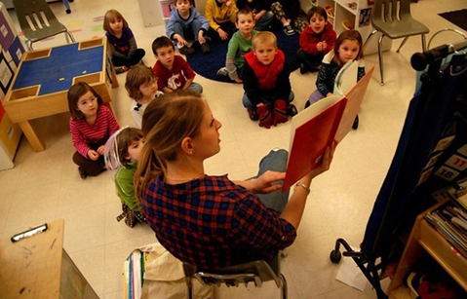

Matching the meaning for pre activity (poster)

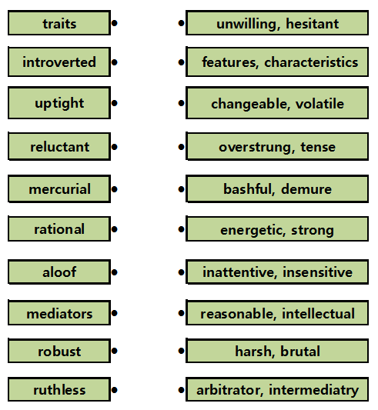
Worksheet #1
Q. Write the proper blood type.

Blood Type : ___
Best Traits: Ambitious, athletic, robust and self-confident.
Worst Traits: Arrogant, insensitive, ruthless and vain.
Referred to as ‘warriors’, they are viewed as natural leaders and are often, also, natural athletes. They tend to be outgoing, expressive and passionate, but can also bore others to death with their obsessive drive for success coupled with their absolute convictions that they are winners. This certainty that they will always win explains why they aren’t afraid to take risks or gamble. They have a strong physical presence and are unlikely to ever be overlooked.

Blood Type : ___

Best Traits: Cool, controlled, empathic, introverted and rational.
Worst Traits: Aloof, critical, indecisive and unforgiving.
Referred to as ‘humanists’, they are said to be controlled more by their heads, than by their hearts. They are rational, good with money, but unpredictable. Although inclined to be distant, they prefer harmony and as such, work well with mediators. Some consider them two-faced, and therefore untrustworthy.
Blood Type : ___

Best Traits: Animal-loving, creative, flexible, individualistic, optimistic and passionate.
Worst Traits: Forgetful, irresponsible and self-centered.
Referred to as ‘hunters’, they have very independent natures and tend not to be concerned about what other people think of them. Although often described as shallow and lazy, they can be quite passionate about the things they hold dear. Patience is not their strong suit either.
Type B men have acquired a very negative reputation in Korea and are not considered by many to be good husband material. Often described as ‘players’, they are perceived as being selfish and mercurial, quick to anger and not terribly reliable. That said, their bad boy image makes them very attractive to women, but not for the long term. (Type B women do not share in this bad rep, for some unexplained reason).
Blood Type : ___

Positive Traits: Conservative, introverted, reserved, patient, punctual and inclined to be perfectionists.
Worst Traits: Obsessive, stubborn, self conscious and uptight.
Referred as ‘farmers’ in some descriptions, they are said to be considerate of others and loyal to a fault. They can also be secretive and reluctant to share their feelings. Apparently they don’t hold their liquor well, either.

Worksheet #1-1
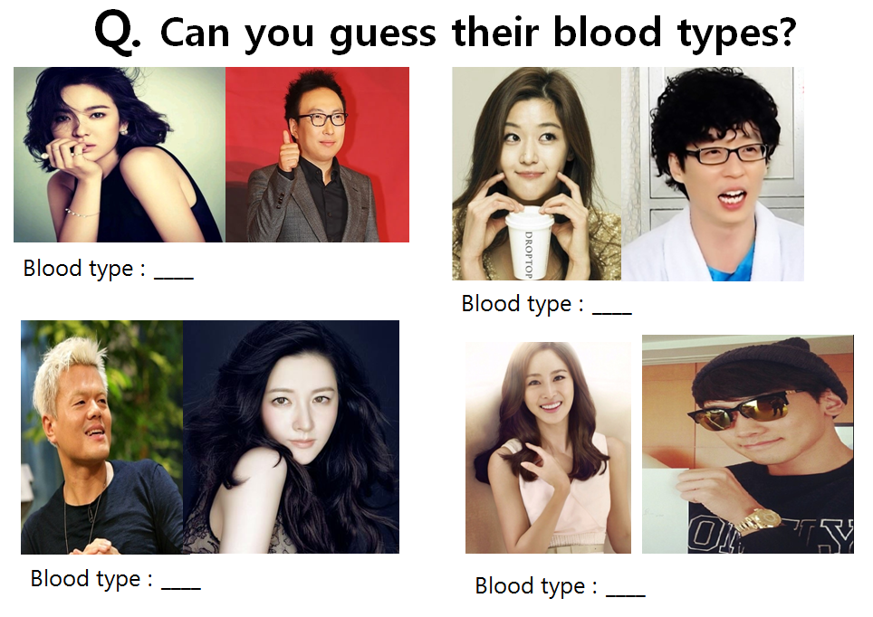

Worksheet #2

◈ Read the situation, and prepare the role play.
One couple; dating spot; fighting; reconciliation

1. Woman - Blood type A
Man - Blood type A

2. Woman - Blood type B
Man - Blood type B

3. Woman - Blood type O
Man - Blood type O

4. Woman - Blood type A
Man - Blood type O

5. Woman - Blood type AB
Man - Blood type A

6. Woman - Blood type A
Man - Blood type B

