□ Listening □ Speaking □Reading ■ Grammar □ Writing

Topic: Grammar - Passive Voice

Instructor:  Angela, Jung | Level:  Intermediate(Adults) | Students:  10 students | Length:  50 minutes

Materials:
- News article from koreaherald - Look for passive sentences (10 copies)
- Worksheet #1 - Exercises on passive voice (10 copies)
- Worksheet #2 - Writing including passive voice(5 copies for group activity)
- White board and board markers

Aims:
- Ss will be able to improve their understanding of passive voice.
- Ss will be able to apply passive voice to their speaking and writing.

Language Skills:
- Listening : teacher’s elicitation; other Ss’s opinion during discussion ;
Ss’s presentation ; teacher’s explanation of grammar
- Reading : reading news article.
- Speaking : answering the teacher’s elicitation; discussion
- Writing : Writing news article including passive sentences.

Language Systems:
- Phonology: /p/, and /f/ sound
- Lexis: new vocabularies on the news article.
- Function: narration and explanation
- Grammar: passive voice
- Discourse: discussion for writing news articles.

Assumptions:
Students already know :
- Ss are interested in news.
- Ss follow teacher’s instruction well.

Anticipated Problems and Solutions:
- If Ss have a problem about writing news articles.
→ Ss will get some hints of appropriate vocabularies and grammar during activity.
- If Ss doesn’t finish when time is up.
→ Ss will get 1~2 minutes more.

References: News article is extracted from http://www.koreaherald.com/view.php?ud=20140408001343,

Lead-in
Materials: Board, Board markers

Time | Set Up | Description of activites
3min | Whole  class | Greeting  Hello everyone !  How are you doing ?  I hope you feel good today.  Eliciting  We’re going to study grammar ‘passive voice.’  I think you have heard about active voice and passive voice.  Is there anyone who can explain active voice or passive voice?  (After listening to what Ss said, start explaining passive voice comparing to active voice.)

Presentation
Materials: Board, Board markers

Time | Set Up | Procedure
8min | Whole  class | Teacher Clarification  Now, I’ll explain active voice and passive voice.  For example,  “Tom loves Jane.”  This sentence is active voice. In this sentence, Tom is the subject, and the subject is doing the action. Jane is the object of the sentence.  But, Instead of saying, "Tom loves Jane," I would say,  "Jane is loved by Tom."  In this sentence, Jane is the subject, but she isn't doing anything. She is just the recipient of Tom's love. We call this voice as passive voice.  Then, I’ll explain how to make passive voice. When we make passive voice sentence, we can use this rule.  Be + V-pp + (by N)  In informal expression, get + V-pp can be used.  For example,  “She got caught. “  “They are getting married next month. ”  Sometimes, not “ by” but other preposition can be used.  For example,  “ You might be interested in my proposal.”  “They are not satisfied with the result.”  Then, can you make a passive voice sentence ?  Would you write a sentence on the board ?  CCQ  Do you know how to make passive voice ?  Does the subject of passive voice do the action ?

Practice
Materials: Board, Board Marker, News article, Worksheet#1

Time | Set Up | Procedure
7min  5min  5 min | Individually  Individually  Whole  Class | Restricted Output  - Look for passive voice from news article  Now, We’ll practice passive voice.  have you heard about Ta-Yo Bus ?  Ta-Yo is a famous bus character of TV animation.  So, the Seoul city made real Ta-Yo buses. They run around the Seoul City. People can take a Ta-Yo bus in Seoul.  I ’ll give you this Ta-Yo article for practicing passive voice.  Find and mark passive voice sentences in Ta-Yo news article.  I’ll give you 5 minutes.  Work individually.  (Go around and check the answers while they do activity. When Ss miss the answer, let them know.)  I checked your answer, all the Ss did very well.  So, we’ll go on to next practice.  - Exercises on passive voice(worksheet #1)  In this time, we’ll practice passive voice of various tenses.  I’ll hand out worksheet #1.  When you get the worksheet, change active voice to passive voice.  I’ll give you 5 minutes.  Do individually.  ICQ  How much time do you have ?  Who do you work with ?  (Monitor and answer the questions when Ss ask questions)  Are you done?  If you are done, let’s check the answers together.  Who wants to answer the no(1) ?  (From no (1) to no.(10), check the answers with Ss.  If another explanation is needed, explain more. )  If Ss doesn’t understand them very well, explain again using substitution table.  Good job.

Production
Materials: Board, Board Marker, Worksheet #2

Time | Set Up | Procedure
20min  2 min | Group  Whole  Class | Authentic Output  - Writing including passive voice(worksheet #2)  You practiced various passive voice today.  So, you can apply to speaking and writing when you need.  Now, we’ll write short articles including passive voice sentences that we learned today.  There is an example. Refer to the example, make news article.  We’ll do this as a pair work.  (Let Ss know their partner.)  You’ll do just one picture.  So, choose one picture a group.  Which group wants to do no.1 picture ?  (Decide which picture they will do)  You all chose the picture.  Then, discuss with your partner what contents you will write.  After discussion, write the article on your worksheet and then write it on the board.  I’ll give you 10minutes.  ICQ  How much time do you have ?  After you finish writing on your worksheet, what do you have to do?  2 minutes are left.  1 minute is left.  (If there is a group that doesn’t write on the board, let the group write on the board.)  Time’s up.  (Check the news articles on the board with Ss. If there are some errors, ask Ss who can correct errors. When Ss cannot correct errors, teacher make Ss know the answers.)  Your article is very interesting. I think you learned passive voice very well. You are also good at applying this grammar to your speaking and writing  Wrap-up  Did you enjoy today’s lesson?  We’ll talk about another grammar rule.  Have a nice day.

[News article] Animated character buses smash hit with kids
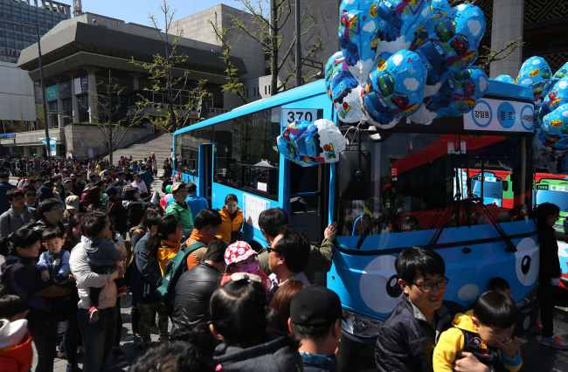
Buses covered in animated characters are growing so popular in Seoul City that policymakers are considering introducing additional character-covered public transportation.
.
.
.
In response to the high demand, Park recently answered on his page that the city would consider making “Pororo buses,” a character from Korean computer-generated animated cartoon series “Pororo the Little Penguin.” Pororo is often called the children’s president as many preschool kids are huge fans. “The Pororo bus is being pushed but nothing has been finalized for now,” an SBA official said. The animated character project may not only be limited to buses but expand to other public transportation, Seoul City officials said Monday. The mayor wrote on his Facebook that the city had requested the capital’s subway operator Seoul Metro operate trains designed as Larva, another famous animated series. “Larva,” a Korean slapstick animated comedy, has attracted a large number of elementary school student fans with its two characters, Red and Yellow. Receiving the top award from the Korean Contents Award, Larva has been exported to more than 90 countries. The final decision for the Larva subway will be made soon, a Seoul Metro official said. By Lee Hyun-jeong
http://www.koreaherald.com/view.php?ud=20140408001343 
Worksheet #1 – Various exercises on passive voice

- Simple Present
1 ) He opens the door. ⇒ ____________________________________________
- Simple Past
2) We stopped the bus. ⇒ _____________________________________________
- Present Perfect
3) I have eaten a hamburger. ⇒________________________________________
- Future
4) Jane will buy a new computer. ⇒ _____________________________________
- Present Progressive
5) My father is washing the car.. ⇒ _____________________________________
- Past Progressive
6) He was playing the guitar. ⇒ ________________________________________
- Past Perfect
7) Joe had cleaned the tables. ⇒ _______________________________________
- Exercise with Auxiliary Verbs
8) She would carry the box. ⇒__________________________________________

Worksheet #2 –Writing including passive voice
Make news articles including passive voice sentences.
Example>
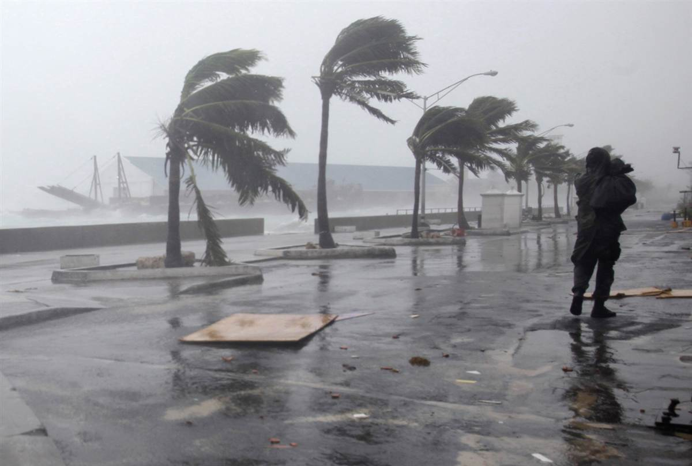 | The island of Puerto Rico was hit by Hurricane Calvin late this morning. Electric power was temporarily disrupted throughout the island and many homes were damaged by heavy rains and strong wind.

Exercise>
- 1 ) Thunderstorms

- 2) Tornado

- 3) Wildfires in Australia

- 4) Earthquake
- 

