Listening Speaking █ Reading Grammar Writing

Topic: Obituary
Instructor:  Gina Lee | Level:  Intermediate | Students:  10 students | Length:  50 minutes

Materials:
- Visual aids for the key vocabulary
- Comprehension quiz and vocabulary (worksheet #1 – 10 copies)
- Sample obituaries of Bickerstaff, Kroeker, White and Jobs (Appendix 1 – 10 copies)
- Sample Korean obituaries (Appendix 2 – 10 copies)
- Tim Bullamore Poster (Appendix3 – 10 copies)
- Extra article “Want a long obituary? …….” (Appendix 4 – 10 copies)
- A piece of paper and a pen
- White board and a board marker

Aims:
- Students are able to read wide range of obituaries and an article about the topic.
- Students can build schematic knowledge in order to interpret texts meaningfully.
- Students can understand cultural difference by comparing American with Korean obituary.

Language Skills:
- Reading: reading text “Want a long obituary? …..” and sample obituaries
- Listening: listening to teacher’s presentation, instruction, and classmates’ ideas
- Speaking: talking about personal experience and sharing ideas in a group
- Writing: answering comprehension questions and writing students’ own obituary

Language Systems:
- Phonology: to learn about silent letters such as succumb
- Lexis: to learn the meaning of new vocabulary
- Function: to understand the specific expression in obituary (Survived by, a.k.a. (also known as) and etc.)
- Grammar: The + set (groups) : groups (e.g. the deceased)
- Discourse: to discuss the cultural difference between American and Korean obituary with groups

Assumptions:
- Students are exposed to the obituary in the English and Korean newspaper.

Anticipated Problems and Solutions:
- If one specific student dominates talking, try to diffuse domination by asking question to other student.
- There may not be enough time to complete the lesson → Assign the post activity writing tasks as a homework assignment.

References:
- An article “Want a long obituary? …………………” from
http://publiceditor.blogs.nytimes.com/2013/01/03/want-a-long-obituary-be-president-pope-or-publisher/
- Sample obituary from www.google.com/image/obituary
- Visual aids from http://blog.naver.com/soultrain59/159005824

Lead-In
Materials: none

Time | Set Up | Student Activity | Teacher Talk
5 min | Whole class | Some of the students talk about their week | Greeting  - Hello everyone?  - How have you been during the week?  (Wait a little while, bring up a personal story)

Pre-Reading Activity
Materials: Board and board markers. Visual aids

Time | Set Up | Student Activity | Teacher Talk
5 min  3 min | Whole class  Group  Whole class | Students answer for the elicit questions  Students talk about their own experience in group  Students answer for the ICQ | Procedure:  Introduction  Today’s topic is obituary.  Eliciting  - What is an obituary?  - Where do you find one?  - Who writes one?  - Why someone writes one?  - Which information should be in?  (Collect and write what students say on the board.)  Brainstorming  Let’s share your story related to an obituary with your group if you don’t mind. I will give you 3 minutes.  ICQ  - What do you do?  - How much time do you have?  - Who do you talk to?

While-Reading Activity
Materials: Board and board markers. Appendix 1-2

Time | Set Up | Student Activity | Teacher Talk
5 min  3 min  5 min  3 min  7 min  7 min | Whole class  Individually  Pair  Whole class  Individually  Whole class | Students answer for the CCQ  Students skim the appendix 1 and 2.  Students discuss about the difference and similarity.  Students talk about what they discussed.  Students read the appendix 3 and 4 again.  Students answer for the questions and guess the meaning of new vocabulary. | Procedure:  CCQ by showing visual aids  - Is obituary a cultural thing?  Why? Or Why not?  - Does it related to funeral rites?  - Are the funeral rites different from different cultures?  - How do you think it is different from American funeral and Korean one?  (give out appendix 1 and 2 to the students)  What I just give you out is the sample of American and Korean obituaries, which you may easily find on the newspaper.  Skimming  What is skimming?  Do not concentrate on the details. What I want you to do first is,  Just to skim the sample obituaries and try to find the difference between American and Korean one.  I will give you 3 minutes to skim the reading material and 5 minutes to discuss about the difference and similarity with a partner next to you.  ICQ  - What should you do?  - How much time for skimming and discussion do you have?  - Do you work alone?  Pair discussion  (Monitor students)  Prediction  Let’s share what you have just found.  From group 1, what did you find?  (Write the difference on the board.)  Scanning  Now we are going to scan. That means you need to be more careful with the details. I will give you another 7 minutes so that you can read through each obituary and answer to comprehension questions. Please do it by yourself.  ICQ  - How much time do you have?  - What do you do this time?  - Do you work alone?  (Monitor students if they have questions)  Comprehension questions  Let’s find out the answers.  How can you guess the meaning of new vocabulary?

Post-Reading Activity
Materials: Appendix 3

Time | Set Up | Student Activity | Teacher Talk
2 min  4 min  1 min | Whole class  Pair  Whole class | Students answer the elicit questions.  Students discuss how they would write their own obituaries.  Students answer for ICQ | Procedure  Eliciting  (give out the appendix 2)  - What is it for?  - Who is Tim Bullamore?  - What did Bullamore talked about?  - According to the advertisement, whom has he been writing obituaries for?  Task  If you were a famous obituary writer like Tim Bullamore, how would he write your obituary? Let’s discuss about it. You have 3 minutes with your partner next to you.  Closing  It’s time to wrap up. Based on what we learned today, please write an obituary of your own until next class. It would be no more than one third of A4 paper.  ICQ  What do you do?  How long would it be?  When is your writing due?  GREAT!  Bye and see you next time.
SOS Activities
Materials: Appendix 4

Time | Set Up | Student Activity |  | Teacher Talk
 | Groups | Students skim an extra article to get a main idea |  | Let’s skim the extra article on the appendix 4, trying to find where the main idea is by groups

WORKSHEET #1

Comprehension Questions

- Who died of disease?

- Do they hold a funeral in that hospital where they have been receiving medical treatment?

- Where will be funeral held or was it held?

- Can we see the dead on the day of funeral?

- Do visitors bring money?

- Who is also known as Heisenberg which means White Mountain in German?

- What does Mr. White’s family want for condolers/mourners to do instead of flowers?

- After the funeral, where does Mr. Bickerstaff’s body go?

- What is funeral home and who is funeral director?

- What does funeral director do with the dead?

Related Vocabulary

- Succumb

- The deceased

- a. k. a.

- Funeral home
Funeral director

- The memorial
A private memorial
A funeral service

- Casket

- In the lieu of

- Donations to charity

- Surviving
Survived by

- Cremation vs Burial

- Grave vs Cemetery

- Embalming

- Mourners/condolers

- Hearse vs Limousine

- Trapped by dogma

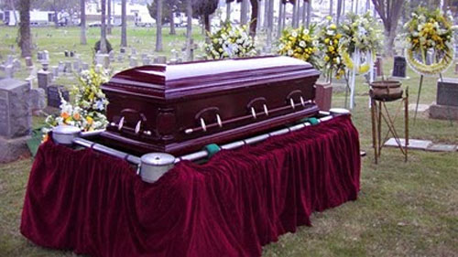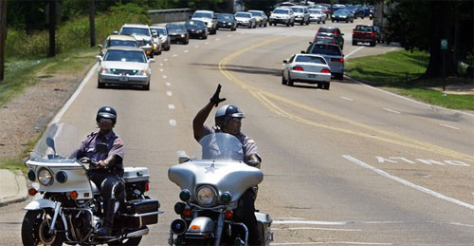
Visual Aids

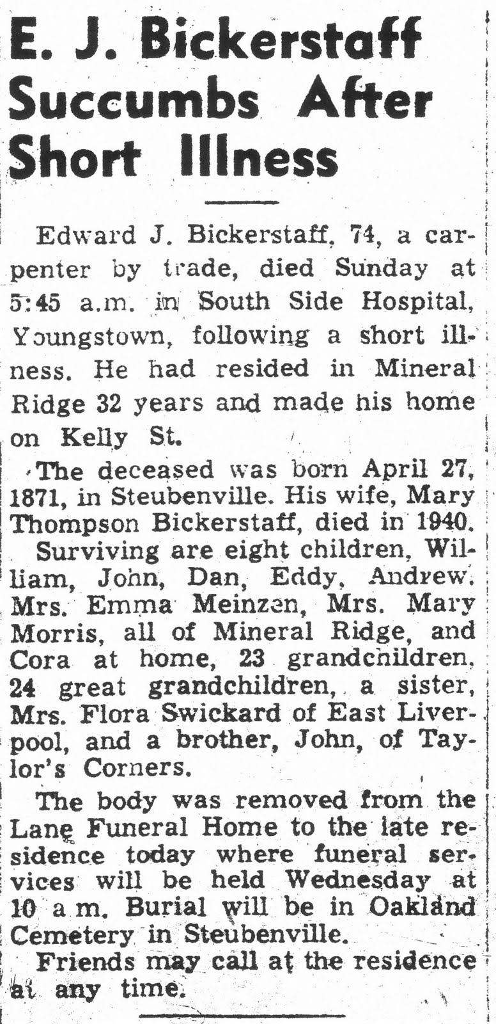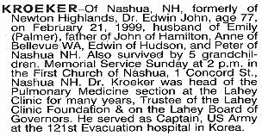

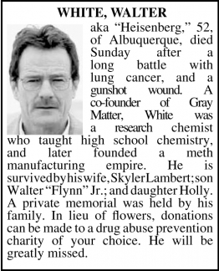

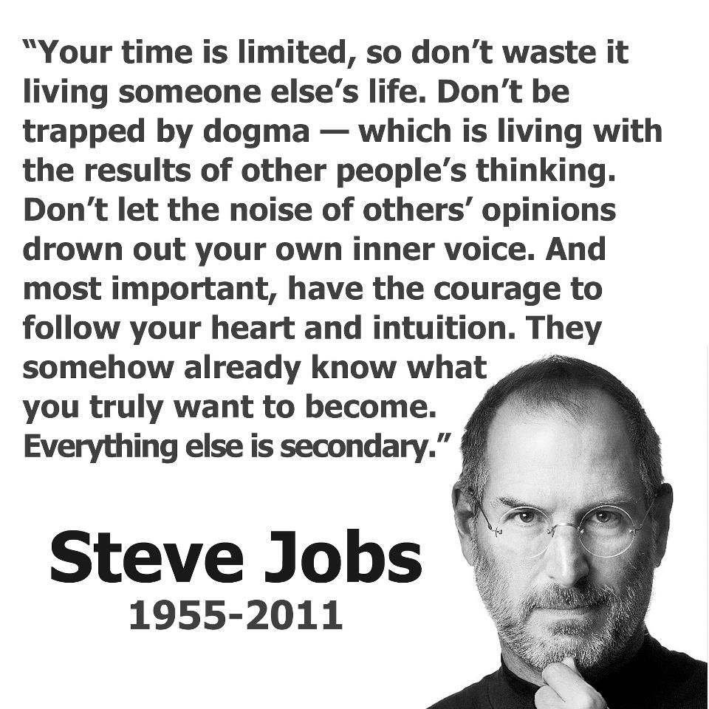

Korean Obituary
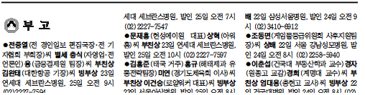

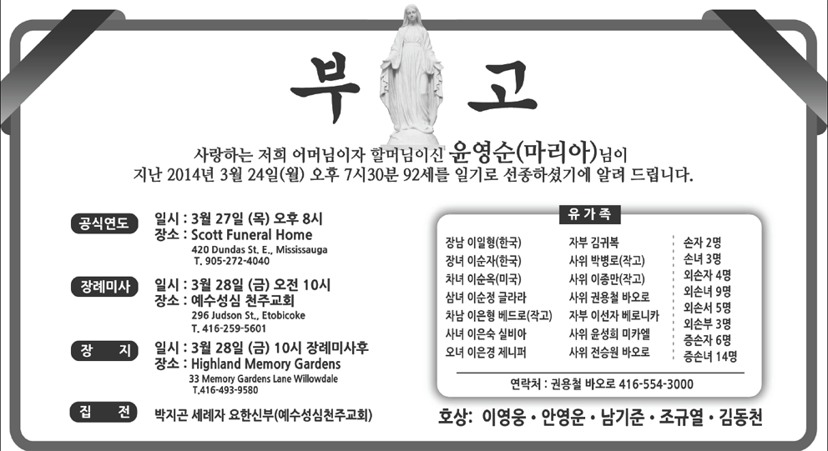

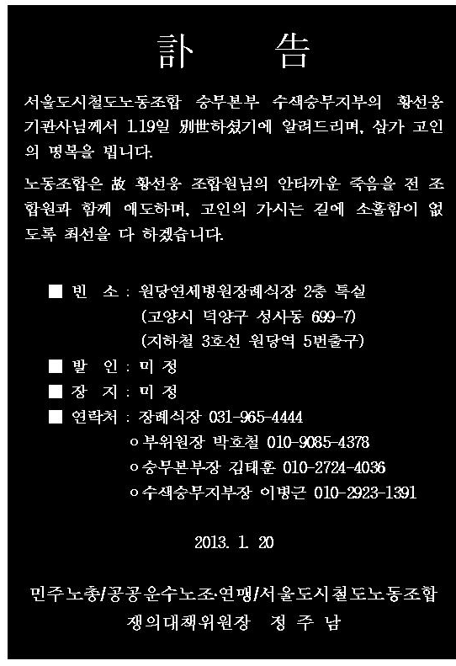

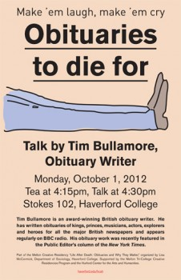

Want a Long Obituary? Be President, Pope or Publisher
By MARGARET SULLIVAN
January 3, 2013, 4:30 pm 26 Comments
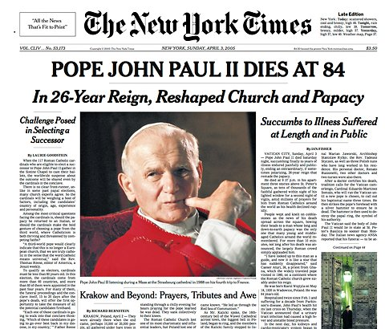
The longest obituary of the past 30 years did not appear on the front page.
Combining my last two posts – one on long stories, one on front-page obituaries – here are a few more numbers to ponder.
Last year’s obituary for the former Times publisher Arthur O. Sulzberger was the fourth-longest obituary in the last 30 years.
Over those three decades, only 10 obituaries have been longer than 6,000 words. The longest was for Pope John Paul II at 13,870 words. (Incidentally, the obituary itself did not appear on A1; news stories and analysis on the pope’s death took precedence.) Next was the obituary for former President Richard M. Nixon at 13,155, followed by the one for former President Ronald Reagan at 11,411.
Then Mr. Sulzberger’s at 7,725. And the last of the longest five was yet another former president, Gerald R. Ford, at 7,674.
Moral of the story: If you want a long obituary, consider becoming president or pope. Failing that, it’s best to be the former publisher of the newspaper publishing the obituary.

