Listening/Speaking Reading X Grammar Writing
Topic: My Personality
Instructor:  Rachel | Competency Level  Pre-Intermediate | Number of Students:  8 | Lesson Length:  50
Materials:
Personality Cards
- Gentle
- Lazy
- Gregarious
- Selfish
- Outgoing
- Greedy
- Neat
- Irresolute

Photos
-5 peoples
Video Clip “Personality Test”
Game paper
Blank paper
Laptop
Board

Drilling Wall Chart 1 – subject + Be verb + adjective + and + adjective.
Drilling Wall Chart 2 – subject + Be verb + adjective + but + adjective.

Aims: (What students will be able to achieve by participating in the activities of the lesson.)
Improve Ss listening skills by listening to T’s story, Ss talk.
Improve Ss speaking skills by answering T, Ss presentations.
Improve Ss grammar skills about conjunction by drilling, writing, and talk with group.

Language Skills: (Lists what language skills students will be using by participating in the activities of the lesson.)
- Reading: drilling wall chart
- Listening: teacher talk, Ss talk
- Speaking: sharing Ss stories about their personality, answering T
- Writing: Writing 3 sentences about own personality in activities.

Language Systems: (Lists what language systems students will be using by participating in the activities of the lesson.)
- Phonology: drilling, T and Ss talk
- Function: writing and description
- Lexis: conjunction
- Grammar syntax: subject + Be verb + adjective + and/but + adjective
- Discourse: responding the teacher

Assumptions: (What students must already be able to do and what concepts must already be mastered before the lesson in order to achieve the aims of the lesson.)
All Ss Know about Be verb
All Ss can talk about own personality through writing
All Ss know how to use and/but when they talk
All Ss now some worlds about personality

Anticipated Errors and Solutions: (What things might go wrong in the lesson and what the solution will be)
If Ss don’t know about personality cards -> tell Ss more explain.
If Ss don’t know about personality -> teach Ss or search the worls together.
If Ss don’t understand about game -> explain to Ss more and show Ss example first

References:
http://www.youtube.com/watch?v=BLZAlp0if3M
(Personality Test)

Lead-In (10 min)
Materials:
Personality Cards
- Gentle
- Lazy
- Gregarious
- Selfish
- Outgoing
- Greedy
- Neat
- Irresolute

Board

Time | Set Up | Student Activity and Goals | Teacher Talk – Instructions an Procedures
1 min  5 min  2 min  2 min | Whole  Whole  Whole  Whole | Greet T.  Listen to T.  Listen to T.  Listen to T. | Greet Ss  Showing the cards and ask to Ss how do they look like and tell them which is positive and negative.  Tell to Ss about T’s personality by using conjunction.  T put all of the cards on board.

Pre-Activity (18 min)
Materials:
Blank Paper
Board
Drilling wall Chart 1 – subject + Be verb + adjective + and + adjective.
Drilling wall Chart 2 – subject + Be verb + adjective + but + adjective.

Time | Set Up | Student Activity and Goals | Teacher Talk – Instructions an Procedures
2 min  8 min  3 min  5 min | Group  Group  Ss  Whole/  Ss | Ss receive the paper.  Ss start with group activity.  Ss present.  Follow the drilling | Make a group and hand out blank paper.  Give them some pictures and discuss and guess the personality and make 1 sentence.  Ask Ss to present.  Put drilling wall chart on the board.  Do drilling with student  subject + Be verb + adjective + and/but + adjective.

Main Activity (17 min)
Materials:
Game Paper

Time | Set Up | Student Activity and Goals | Teacher Talk – Instructions an Procedures
2 min  5 min  5 min  5 min | Group  Group  Group  Whole | Listen T.  Activity with partner and make 2 sentences.  Ss Present  Game | Tell Ss about T’s story and make 2 sentences by using conjunction.  Tell Ss that talk with your partner about childhood and make 2 sentences about their personality.  Ask Ss to present.  Explain a game: Is this “and” or “but”?

Post Activity (5 min)
Materials:
Lap top
Video Clip “Personality Test”

Time | Set Up | Student Activity and Goals | Teacher Talk – Instructions an Procedures
4 min  1 min | Whole  Whole | Ss watch the video clip.  Ss listen and say bye to T. | Show Ss the video clip and explain.  Closing and their accomplishment and improvement and thanking Ss.

Drilling Wall Chart 1

I am positive and outgoing.
She is pretty and smart.

Drilling Wall Chart 2

I am gentle but cowardly.
He is tough but moody.

-Photos-
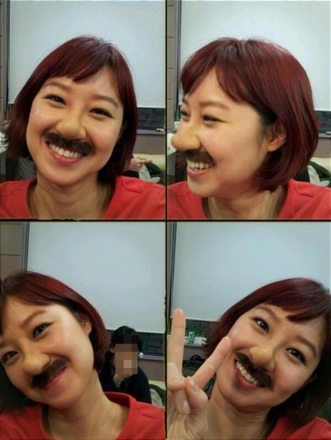

-Personality Cards -
- Gentle
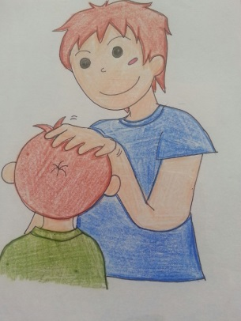
- Lazy
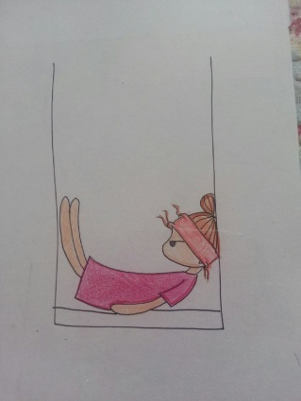
- Gregarious
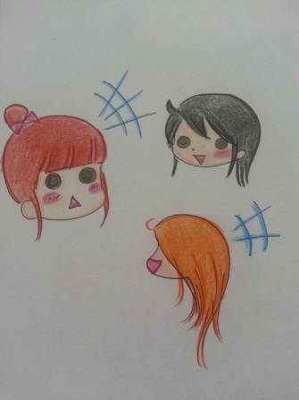
- Selfish
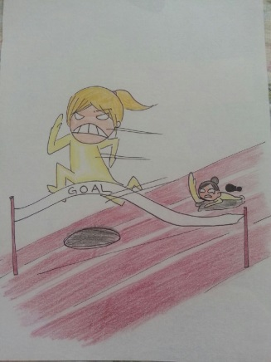

- Outgoing
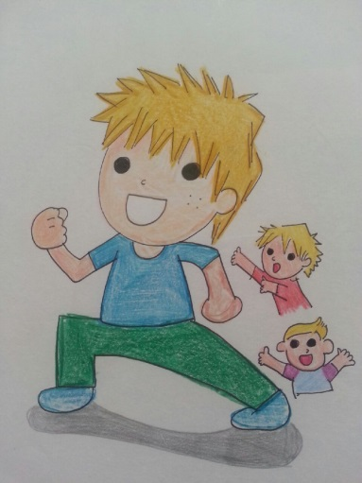
- Greedy
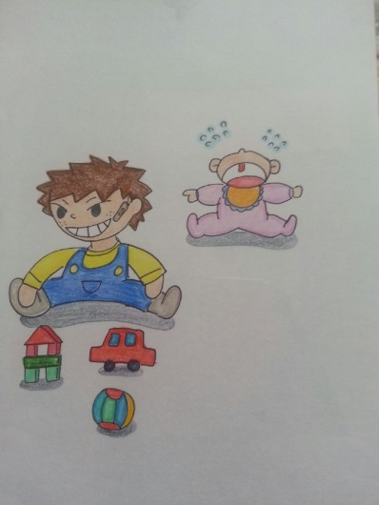
- Neat
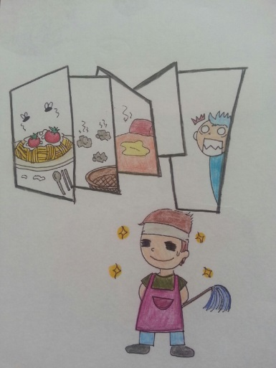
- Irresolute
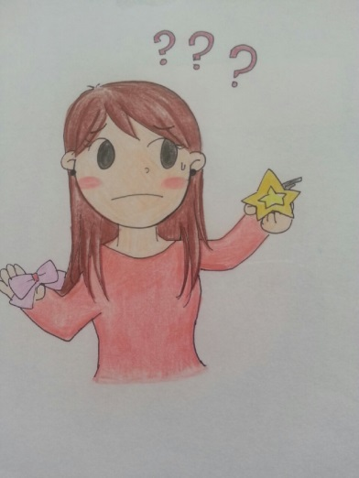
-Game Paper-
She is smart ___ gentle.

I cooked lunch ___ I made a cake.

Can he read ___ write?

Do it slow ___ carefully.

Give me a knife ___ fork.

I love my father ___ mother.

Make a better place for you ___ for me.

Love is understanding ___ forgiveness.

This place is safe ___ warm.

This cake is sweet ___ delicious.

I am lazy ___ neat.

I want nobody ___ you.

This is red ___ that’s not.

I am hungry ___ he is not that hungry.

That song is sad ___ beautiful.

I’m so sorry ___ I love you..

Nothing is here ___ love.

I’ll forgive ___ not forget.

I love her ___ she loves someone else.

You don’t love me ___ I love you.

Everything back ___ you.

I am pretty ___ lonely.

