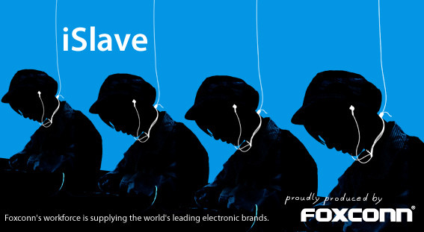Working Condition
Customer Service
Read the article excerpts in the left column and fill in the blank in the right column using appropriate comparatives or superlatives.
- Costco pays nearly all of its employees a decent living (well in excess of the minimum wage) while Wal-Mart continues to pay its workers as if their employees don’t actually need to eat more than once a week, live in an enclosed space and, on occasion, take their kids to see a doctor | - The average employee wage at Costco is higher than Wall –mart.
- Amazon's user-friendly website, along with low prices, one-click shopping, no-hassle returns, free-shipping options and even the sense of community it fosters, has welcomed some 180 million happy buyers into the fold. Combined, those contented clickers buy an average of 9.6 million items a day. "Amazon has always been very good at being simple, and simple is not easy," said Shep Hyken, a customer-service consultant. | - One of the companies with the best customer service reputation is Amazon.
- One common path to success for many small businesses is establishing themselves in a niche market. Because no matter how hard they try, no large retailer can be all things to all people, there are always going to be segments of the population whose needs for particular products and/or services are going unmet – leaving room for the small business to succeed by meeting those needs. | - Niche market refers to smaller and more specialized but profitable market
- More than 90 percent of Apple’s products – including the iPhone, iPad and Mac computer — are assembled in China. Labor practices and working and living conditions at factory-owned dorms came under scrutiny after more than a dozen workers committed suicide starting in 2010. The New York Times wrote an in-depth series about working conditions at Apple’s partner sites, and Change.org last year delivered a petition signed by hundreds of thousands of consumers asked Apple to take a more forceful stance with suppliers in China. | - One of the Apple’s Chinese suppliers is most famous for substandard working condition.
- A generic drug is a chemically equivalent, lower-cost version of a brand-name drug, costing 30-80% less! A brand-name drug and its generic version must have the same active ingredient, dosage, safety, strength, usage directions, quality, performance and intended use. | - A price of a genetic drug is less expensive than a brand –name drug.
- IKEA uses a lot of lumber to make its affordably priced furniture. However, the company uses sustainable forestry techniques, which means that the minimalist yet stylish nightstand you just bought didn’t cost the planet a piece of a rainforest. The company is also investing in solar and wind energy to an unprecedented degree. The company plans to double its already strong investments in renewable energy and hit 100% clean energy by 2020. It also leads the way in selling cleaner, greener products. | - IKEA trys to be more eco –conscious company by using sustainable forestry production.

