Listening Speaking Reading Grammar Writing
Topic: Pet animals

Instructor:  Young | Level:  Intermediate | Students:  14 | Length:  30 Minutes

Materials:
- Pictures of pets
- Vocabulary worksheet(14 copies),
- Vocabulary answer wallchart
- Article worksheets(14 copies)
- Picture of cover of Charlotte’s Web
- Reading activity wallchart
- Papers for reading activity(4 copies)
- Pictures of different pets(4 copies)
- Reading worksheet for writing(14 copies)
- Crossword puzzle worksheet(14 copies)
- Crossword puzzle answer wallchart
- White board, board markers & tape
- Chairs & desks for activities

Aims:
- Main Aim: To enable Ss to improve their reading skills by having Ss read, talk and write about pet animals.

- Secondary Aim: Ss will read an article about pets by having Ss fill in the blanks about vocabularies related to pets, engaged in presentation of pros and cons, and write their own stories based on the article and their imagination.

- Personal Aim: I want to improve on teacher’s pace and on my demonstrations.

Language Skills:

- Speaking: Ss will talk about pros and cons of raising different pets.

- Writing: Ss will be engaged in writing their own stories based on the article and their imagination.

- Listening: Ss will listen to each other’s ideas in an effort to share them.

- Reading: Ss will read the article, worksheets, and the words in wallcharts.

Language Systems:

- Lexis: ax, runt, carton, pitcher, wobble, sopping.
- Phonology: None to discuss.
- Grammatical: Subjunctive ‘if’.
- Function: Giving opinions.
- Discourse: None to discuss.

Assumptions:

- All Ss know how the class is set up and run (there will be groups of each desk).
- Ss have had positive as well as negative experiences with raising pets.
- Ss already know the basic concept of listing pros and cons.
- All Ss have done a presentation activity before.

Anticipated Problems and Solutions:

Problems | Solutions
Due to time management, Ss must learn the meanings of some vocabularies in the pre-activity and they might have many questions about vocabularies for me to answer. | I will follow the one-third rule when Ss present and give the rest of the answers on a wall chart. If they still have questions, I will answer the questions during break time or after school.
Ss might speak too slowly for the presentation about pros and cons activity which may affect time management. | I will follow the one-half rule for the main activity that we will only get half the Ss to present.
Understanding the article might be difficult. | I will use CCQ more clearly for better understanding.
I might need more time to complete my 30 minute microteaching since some class members could be absent or running late. | I will do SOS activity that gets Ss to do a crossword puzzle related to the article Ss read and share their correct answers with one another.

References:
- California State University TESOL Program Reading Module

Lead-In
Materials: None
Time | Set Up | Student Activity | Teacher Talk
2min | T-WC | 2 students will give answers. | Greeting  Hello, everyone! How was your weekend?  2 guiding questions  - What do you usually do in your spare time?  - What is your favorite novel?

Pre-Activity
Materials: Pictures, Vocabulary worksheet(14 copies), Vocabulary answer wallchart, A board and board markers, Tape
Time | Set Up | Student Activity | Teacher Talk
2min  3min  2min | Whole  Class  Pair work | Seat arrangement (7 pairs)  Ss work in pairs.  3 students present their answers. | Quiz Activity: Vocabulary  Tells Ss about the definition of pets, and helps Ss to guess and say ‘pets’.  Eliciting:  -Okay, Ss. What is this? Can you guess the name? It is an animal that you keep in your home to give you company and pleasure.  It starts with P. P..Pe.. Right! It’s called a ‘pet’.  CCQ:  Shows Ss a picture of pet bottles and tape it on the board.  -Is this a pet? (No)  Shows Ss a picture of pets and tape it on the board.  -Is this a pet? (Yes)  Now, Grace, you say pet. Ustina, you say animals. Okay. One more time. Great.  T gets Ss to say “pet”, “animals” one by one so that T can make new pairs.  Demonstrations/Instructions:  I’m going to give you a vocabulary quiz paper. Here, I have one. All you have to do is to match these words to the right pictures here and fill in the blanks with your partner for 3 minutes.  T shows how to do it briefly.  ICQ:  -What are you going to do? (matching the words to the pictures and filling the blanks)  -How much time do you have? (3minutes)  -Are you working individually? (No)  -Are you working in pairs? (Yes)  I don’t want you to start until I say begin.  ICQ:  -Are you going to start when I give you a paper? (No)  -Are you going to start when I say begin? (Yes)  T gives Ss quiz papers and a time warning.1 minutes, 30 seconds, 10 seconds.Time’s up!  T gets Ss to present their answers and put an answer wallchart on the board so that Ss can see it clearly.  If you have any question about this quiz paper, come and ask me during break time. I’ll be glad to answer your question.

Main Activity
Materials: Article worksheets(14 copies), Picture of cover of Charlotte’s Web, Reading activity wallchart, Papers for reading activity(4 copies), Pictures of different pets(4 copies), White board, Board markers & tape
Time | Set Up | Student Activity | Teacher Talk
7min  6min | Individually  Pair work  Group work | Each S gets one paper and read it for 3 minutes.  Ss make a title in pairs.  3 Ss present their own titles and share the reason with others.  Each group gets one picture and one paper and lists the pros and cons of raising the animal they have as a pet.  3-4 Ss present their pros and cons lists. | Reading activity: Making a title  Instructions:  I’m going to give each of you an article. It’s a pet related story. I want you to read this article for 3 minutes, individually.  ICQ:  -What are you going to do? (reading~)  -Are you going to work in pairs? (No)  -Are you going to work individually? (Yes)  -How much time do you have? (3minutes)  I don’t want you to touch the paper until I say begin.  ICQ:  -Are you going to touch the paper when I give it to you? (No~)  -Are you going to touch the paper when I say begin? (Yes~)  T hands out papers to Ss and gives Ss time warning.  1 minute, 30 seconds, 10 seconds,  Time’s up!  Instructions:  The story you’ve just read is chapter 1 in Charlotte’s Web written by E.B. White.  Show Ss a picture of cover of Charlotte’s Web and tape it on the board.  Now, in pairs, you make a suitable title for this chapter 1 for 2 minutes and share the reason with other classmates.  ICQ:  -What are you going to do? (making a title~)  -Are you going to work individually? (No)  -Are you going to work in pairs? (Yes)  -How much time do you have? (2minutes)  Let’s begin!  T gives Ss time warning.  1 minute, 30 seconds, 10 seconds,  Time’s up!  T gets Ss to present their own titles and share the reason with other classmates.  Reading activity: Pros and Cons  T makes 4 groups and tapes a pros and cons activity wallchart on the board.  Demonstrations/Instructions:  Now, I’m going to pick one picture here. It’s a snake. Then, I’m going to present the pros and cons of raising a snake as a pet.  T shows Ss how to do the pros and cons activity.  You’re going to do just like this as a group. Each group makes a pros and cons list of raising the animal you have as a pet. You try to list as many as possible in 4 minutes.  ICQ:  -What are you going to do? (listing pros and cons~)  -Are you going to work individually? (No)  -Are you going to work in groups? (Yes)  -How much time do you have? (4minutes)  I’m going to give each group one picture and one paper. I don’t want you to touch them until I say begin.  ICQ:  -Are you going to touch the paper and picture when I give it to you? (No~)  -Are you going to touch the paper and picture when I say begin? (Yes~)  Let’s begin.  T gets Ss to work in groups for 4 minutes and gives Ss time warning.  2 minutes, 1 minute, 30 seconds, 10 seconds, Time’s up!  T gets Ss to present their pros and cons.  Good job, everyone.

Post Activity
Materials: Reading worksheet for writing(14 copies), A board and board markers, Tape
Time | Set Up | Student Activity | Teacher Talk
8min | Individually  Individually  Whole class | Each S gets a paper.  Ss write the ideas for what is going to happen in chapter 2.  1 Ss present her idea for chapter 2. | Reading Activity: If I were the author !  Instructions:  Now, I’m going to give you a paper. I don’t want you to touch it until I say begin.  ICQ:  -Are you going to touch the paper when I give it to you? (No)  -Are you going to touch the paper when I say begin? (Yes)  T gives a paper to each S.  Demonstrations/Instructions:  Here, I have a paper just like you. Imagine I’m the author of Charlotte’s Web, and all you have to do is to think for a while and write sentences that describe what’s going to happen in chapter 2.  T shows how to do it briefly.  I’ll give you 4 minutes. You do this individually  ICQ:  -What are you going to do? (writing the ideas for chapter 2)  -How much time do you have? (4minutes)  -Are you working in pairs? (No)  -Are you working individually? (Yes)  Let’s begin.  T gets Ss to write their ideas for chapter 2 on the paper.  T gives Ss time warning.  3 minutes, 2 minutes, 1 minutes, 30 seconds, 10 seconds.  Time’s up.  T gets Ss to share their ideas with other classmates.  Error Correction:  Do you have any questions?  Teacher answers to Ss’ questions.  No error correction today.  T gets Ss to unscramble the word ‘pet animals’.  Good job, everyone.  See you tomorrow~
SOS Activities
Materials: Crossword puzzle worksheet(14 copies), Crossword puzzle answer wallchart, A board and board makers
Time | Set Up | Student Activity | Teacher Talk
5min | Individually | Ss do a crossword puzzle individually.  Ss present their answers. | Reading Activity: Crossword puzzle  Instructions:  You are going to do crossword puzzle related to the story you read today. All you have to do is to complete the crossword on the paper I’m going to give you.  Work individually.  I’ll give you 4 minutes.  ICQ:  -What are you going to do? (completing a crossword)  -How much time do you have? (4minutes)  -Are you working in groups? (No)  -Are you working individually? (Yes)  T gets Ss to complete the crossword and gives Ss time warning.  2 minutes, 1 minutes, 30 seceonds, 10 seconds, Time’s up!  T helps Ss to get the correct answers and put an answer wallchart on the board.  Error Correction:  Do you have any questions?  Teacher answers to Ss’ questions.  No error correction today. Good job, everyone. See you tomorrow~

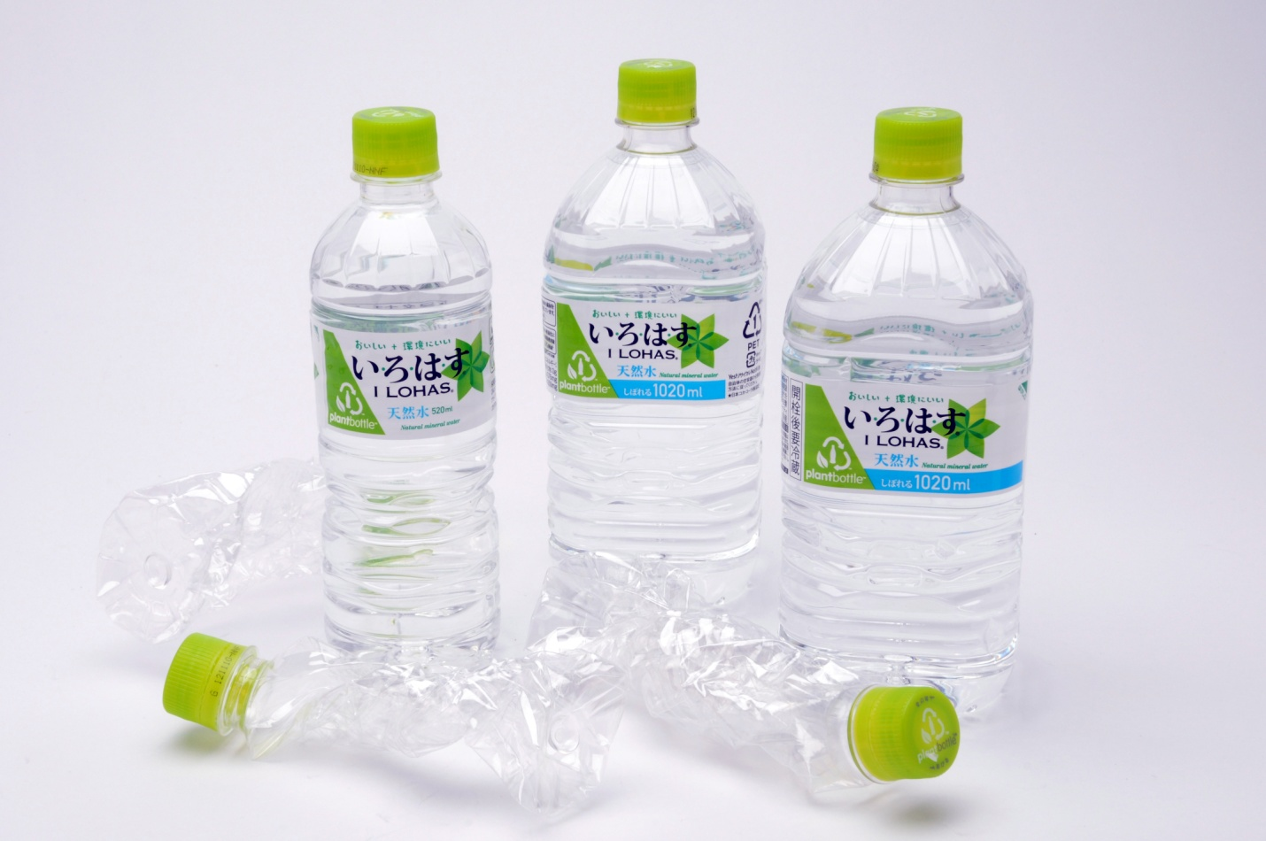

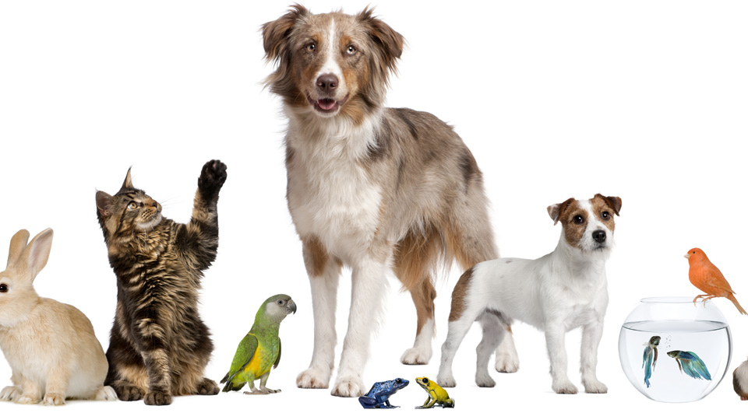

Vocabulary Worksheet
Charlotte's Web
-Chapter 1, Vocabulary Quiz-

1. sopping 2. runt 3. carton 4. ax 5. pitcher 6. wobble

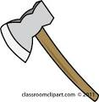
A B C D E F
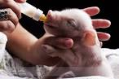

MEANING | VOCABULARY | ALPHABET
a tool that has a heavy metal blade and a long handle
a member which is smaller or weaker than the others
container for liquid
extremely wet
a plastic or cardboard container
to move or rotate with an uneven or rocking motion

Vocabulary Answer Sheet

MEANING | VOCABULARY | ALPHABET
a tool that has a heavy metal blade and a long handle | ax | B
a member which is smaller or weaker than the others | runt | A
container for liquid | pitcher | E
extremely wet | sopping | F
a plastic or cardboard container | carton | C
to move or rotate with an uneven or rocking motion | wobble | D

Article Worksheet

Chapter 1, Charlotte’s Web

“Where’s Papa going with that ax?” said Fern to her mother as they were setting the table for breakfast.
“Out to the hoghouse,” replied Mrs. Arable. “Some pigs were born last night.”
“I don’t see why he needs an ax,” continued Fern, who was only eight.
“Well,” said her mother, “one of the pigs is a runt. It’s very small and weak, and it will never amount to anything. So your father has decided to do away with it.”
“Do away with it?” shrieked Fern. “You will kill it? Just it’s smaller than the others?”
Mrs. Arable put a pitcher of cream on the table. “Don’t yell, Fern!” she said. “Your father is right. The pig would probably die anyway.”
Fern pushed a chair out of the way and ran outdoors. The grass was wet and the earth smelled of springtime. Fern’s sneakers were sopping by the time she caught up with her father.
“Please don’t kill it!” she sobbed. “It’s unfair.”
Mr. Arable stopped walking.
“Fern,” he said gently, “you will have to learn to control yourself.”
“Control myself?” yelled Fern. “This is a matter of life and death, and you talk about controlling myself.” Tears ran down her cheeks and she took hold of the ax and tried to pull it out of her father’s hand.
“Fern,” said Mr. Arable, “I know more about raising a litter of pigs than you do. A weakling makes trouble. Now run along!”
“But, it’s unfair,” cried Fern. “The pig couldn’t help being born small, could it? If I had been very small at birth, would you have killed me?”
Mr. Arable smiled. “Certainly not,” he said, looking down at his daughter with love. “But this is different. A little girl is one thing, a little runty pig is another.”
“I see no difference,” replied Fern, still hanging on to the ax. “This is the most terrible case of injustice I ever heard of.”
A queer look came over John Arable’s face. He seemed almost ready to cry himself.
“All right,” he said. “You go back to the house and I will bring the runt when I come in. I’ll let you start it on a bottle, like a baby. Then you’ll see what trouble a pig can be.”
When Mr. Arable returned to the house half an hour later, he carried a carton under his arm. Fern was upstairs changing her sneakers. The kitchen table was set for breakfast, and the room smelled of coffee, bacon, damp plaster, and wood smoke from the stove.
“Put it on her chair!” said Mrs. Arable. Mr. Arable set the carton down at Fern’s place. Then he walked to the sink and washed his hands and dried them on the roller towel. Fern came slowly down the stairs. Her eyes were red from crying. As she approached her chair, the carton wobbled, and there was a scratching noise. Fern looked at her father. Then she lifted the lid of the carton. There, inside, looking up at her, was the newborn pig. It was a white one. The morning light shone through its ears, turning them pink.
“He’s yours,” said Mr. Arable. “Saved from an untimely death. And may the good Lord forgive me for this foolishness.”
Fern couldn’t take her eyes off the tiny pig. “Oh,” she whispered. “Oh, look at him! He’s absolutely perfect.”

Reading Wallchart
Owning a Pet Snake

Advantages(Pros) Disadvantages(Cons)

• Only eat and • Hard to cuddle
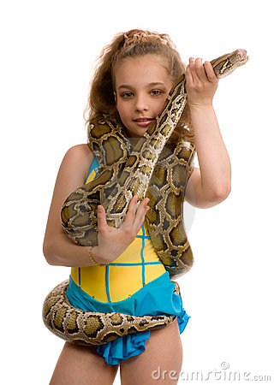
poop once a week

• Easily adaptable • Easily find ways to
to humans escape

• Hardly bite • Eat mice (gross..;;)

• Don't get hair
anywhere • No affection

• Never bark, • Uncharacteristically
very quiet aggressive

• Cooler in Summer • Expensive for a basic set up
A hedgehog
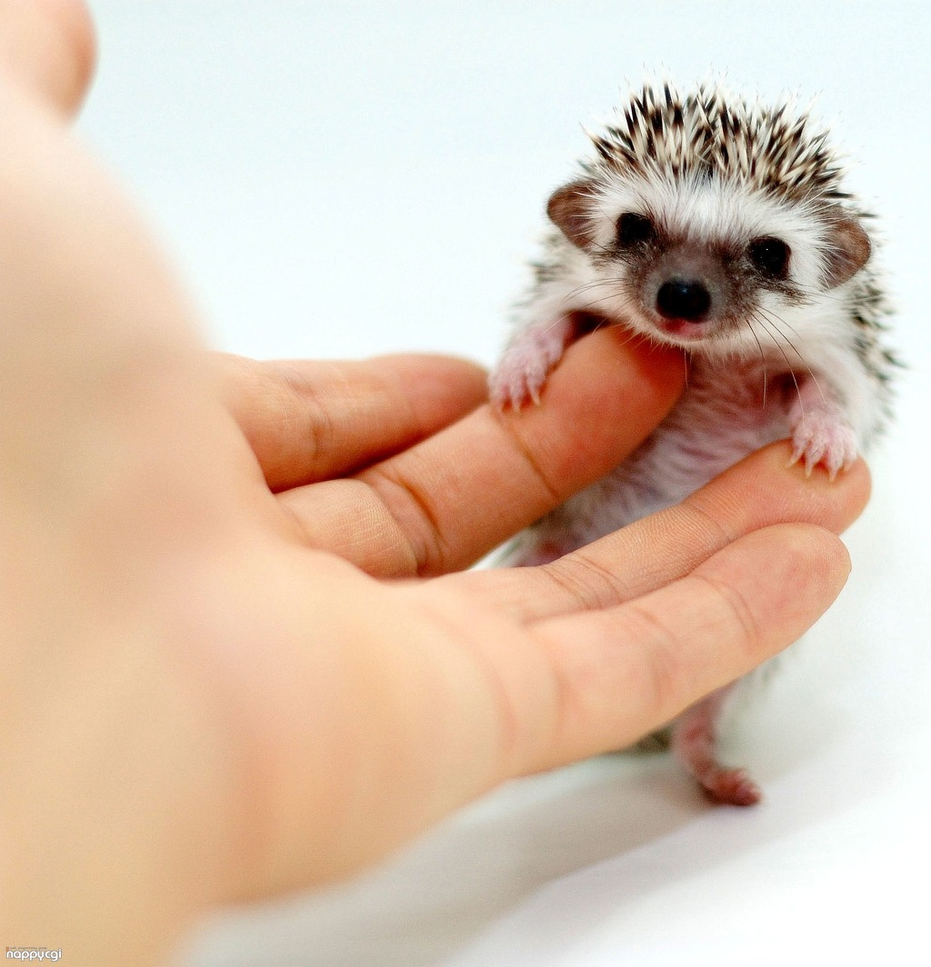

A lion
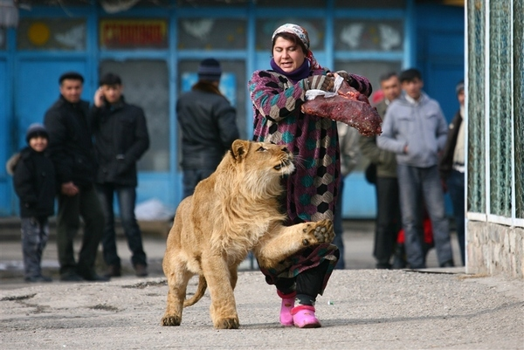

A parrot
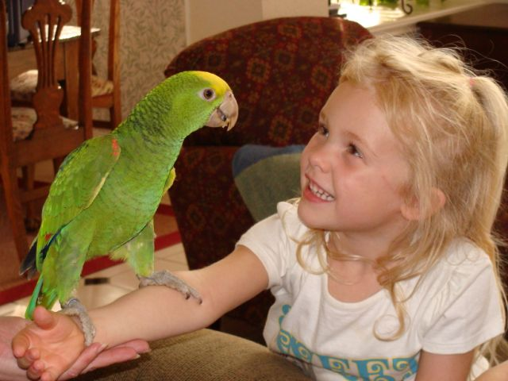

A monkey
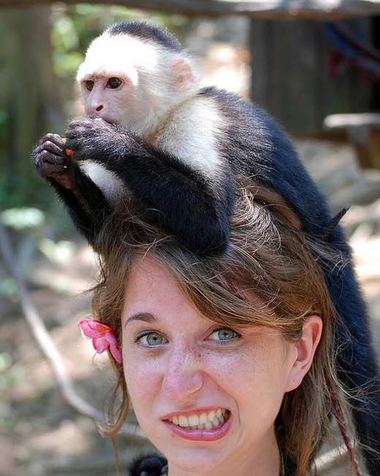

Reading Worksheet for Writing
"If I were the author.."

You've just read the chapter 1 of this story.
Now, imagine you are the author of this story.
What would 'chapter 2' be like?

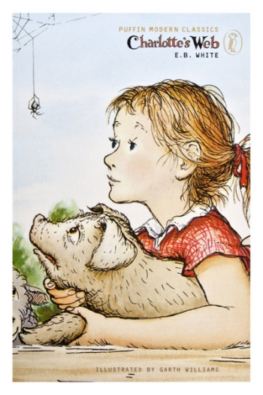
Write sentences that describe what's going to happen in chapter 2 based on your imagination.

Sos crossword puzzle worksheet

Charlotte's Web

Complete the crossword below

 |  | 1
 |  |  |  |  |  |  | 2
 | 3
4 |  |  | 5 |  | 6
 |  |  |  |  |  |  | 7

Across  1. The age of the young girl  3. Mrs. Arable wanted to put the box on here  4. The family was going to have this  7. The thing Mr. Arable carried when he returned to the house | Down  1. The author of Charlotte's Web  2. 'This is the most terrible case of ______ I ever heard of.'  5. The thing that Mr. Arable was going to use to kill a runt  6. The young girl who didn't want to kill a runt

Sos crossword puzzle answer sheet

Charlotte's Web

Complete the crossword below

 |  | 1  e | i | g | h | t
 |  | .
 |  | b
 |  | .
 |  | w |  |  |  |  | 2  i
 | 3  c | h | a | i | r |  | n
 |  | i |  |  |  |  | j
 |  | t |  |  |  |  | u
4  b | r | e | 5  a | k | 6  f | a | s | t
 |  |  | x |  | e |  | t
 |  |  |  |  | r |  | i
 |  |  |  |  | n |  | 7  c | a | r | t | o | n
 |  |  |  |  |  |  | e

Across  1. The age of the young girl  3. Mrs. Arable wanted to put the box on here  4. The family was going to have this  7. The thing Mr. Arable carried when he returned to the house | Down  1. The author of Charlotte's Web  2. 'This is the most terrible case of ______ I ever heard of.'  5. The thing that Mr. Arable was going to use to kill a runt  6. The young girl who didn't want to kill a runt

