Listening
Topic: The Phobia

Instructor:  HyongWon Kim(Chloe)  Seung-A Cho (Maurin) | Level:  Intermediate (Adult) | Students:  6 people | Length:  50 Minutes

Materials:*Video clips ( youtube)
*Computer ( with internet) hooked up to a projector
*A copy of the cloze worksheets for each student
*Key Vocabulary
*Pictures and name card ( List of phobia)

Aims:

- Students will be able to know about so many different phobias exist in the world.
- Students will be able to learn more about new vocabulary
- Student will be able to aware they might have one of phobias

Language Skills:
Listening: Ss will listen to a video clip about phobia, the types and the symptoms.
Reading: Ss will categorize the script of the video clip.
Speaking: Ss will talk about their own experiences and ideas.
Writing: Ss will write down their own sentences of word definitions.

Language Systems:
Phonology: /f/ (ph sound from phobia) while learning various phobias.
Lexis: irrational fear, get queasy, become housebound, single out.
Grammar: some/others/still others, the most + adjective.
Function: categorizing and enumerating definitions, symptoms and fears.
Discourse: briefing(listening) and discussion(students’ talk)

Assumptions:
* Students may not familiar with ~phobia words
(phobia words based on Greek lnguage)
* Some students may have some kind of phobia

Anticipated Errors and Solutions:
* Student can make some mistakes of pronunciation of many phobia words.
Let them know how to pronounce and repeat listen and speak
* It might be a little bit hard to understand the Doctor's speacking

References:
List of phobias - http://phobialist.com/
The most common 10 phobias - http://psychology.about.com/od/phobias/p/commonphobias.htm
Video clip (Pre-Activity) - http://youtu.be/JDvDCqLCdEE (00:00:12~00:00:45)
Video clip (Main-Activity) - http://youtu.be/4tEIh_fJ_9g (~)

Lead-In
Materials:
A picture and a video clip
Time | Set Up | Procedure
5min | Whole class  Whole class | Lead in by asking the students if they have fear for something. See if they have similar experiences to phobias.  Greetings  Hi, Guys! How are you today?  Guiding Questions  Show a frightened person’s picture) How does he look?  When do you get scared? Have you felt scared on a tall building or in front of a needle?  Motivate  Let’s watch a short video clip. You’ll see why we asked the questions.  (Watch a video clip for 45 seconds)  Elicit  What does he look? What is his fear? Yes, He is scared of a dog and trying to run away from it. He said his heart is ~. Did you hear what the people told him to soothe him? Have you had a similar experience?  It can be not only a dog but also insects, a knife or anything.  Can you guess the name of such irrational fears? It’s PHOBIA!  Today’s topic is phobia.
,
Pre-Activity
Materials:
PPT and board writing.
Time | Set Up | Procedure
3min | Whole class | Warm up – show pictures & let students guess what the fear is.  There are many different kinds of phobias and each phobia has a name. For example, I have , meaning I have fear for . Let’s learn some of their names.  This is “ (name of a phobia), the fear of .”  (With a PPT: Arachnophobia-spiders, Ophidiophobia-snakes, Acrophobia-heights, Agoraphobia-crowded area, Cynophobia-dogs, Trypanophobia-needles. )  Pre-teach  By writing the four words on the board and sho demonstration for new words (Guess what game)  1, irrational fear  2.get queasy  3.singled out  4. housebound  Instructions  Let’s make two groups of three people. I will give the definitions of two expressions to each group. While one group is acting out the expressions, the other group will guess what it is and describe it with a full sentence. You can have five minutes to make up two scenes. You cannot say the words while acting. And after watching the other team’s acting, you can talk with your members and write your definition on the board but do not shout or laugh at others’ work. When both teams are done, one person comes out and writes the original definitions, Okay? And as always, use English when you talk!  Elicit  Show acts for 1 2,3,4, What is this, guess what?x4 times  Have you any experience get quesy when you speak in front of mant people?  How do you feel when teacher singled you out?  CCQ  There is someone has fear of so many things so she does not want to go outside and want to stay at her room everyday, what is this?  Run the Activity  (Give each group what to act (two expressions each))
7min | In group

Main Activity
Materials:
computer and projector and screen.
Cloze sheets (6) Full script (6)
Time | Set Up | Procedure
5min | Pairs | 1.Prediction  I will give you a cloze sheet before listening.  With your partner, guess what words are supposed to be there.  ( You do not have to fill it now, just guess)  ICQ: Are you working in pairs?  Do you need to fill the blanks right now?  2.Listening the main media ( Doctor's speaking) x2  Instruction  Listen and try to fill in the blanks. The speaker's speacking is little bit fast but I believe you guys can do it.  The words in the blanks will be the answer of the question of your cloze sheet questions  ICQ: Do you need to take a note while listening?  Do you work in pairs or indivisually?  Comprehension Questions (Literal)  Q1. What is the definition of a phobia? Q2. What are the symptoms of a phobia? Q3. What are the three categories of phobia? Q4. What is the most common social phobia?  Check the answer  Give a full script to each student and check the answers.
7min  5min | Individual

Post Activity
Materials:
A discussion sheet and seating arrangement.
Time | Set Up | Procedure
15min | In group | Motivation  Well done, guys. We’ve listened to the explanation and I believe you  all understand well enough to talk about your own ideas and exeriences. (hand out the discussion sheet)  We learned what phobia is and many different kind of phbias.  Now, we can talk more about our experiences.  This is our activity sheet. Take a look at the questions  - What do you think your phobias are? How did you know that?  - Have you had a dangerous/embarrassing/fun/brave moment related to your phobias? Share your experience!  - Have you heard of/ experienced other people's phobias?  - What do you think the worst phobia ia among the most common phobias? Why?  - Is there any other phobias that you've heard of but is not in the list?  Close  Thank you for your participation and hope you had much fun

Warm-up pictures

Arachnophobia / Ophidiophobia
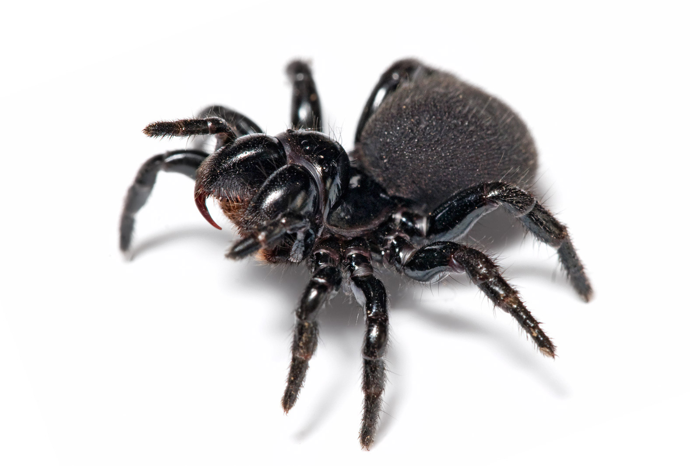
Acrophobia / Agoraphobia

Cynophobia / Trypanophobia


New expressions
Irrational fear :
Irrational (not based on clear logical thought) + fear (the bad feeling that you have when you are in danger, when something bad might happen or when a particular thing frightens you)
Get queasy :
To feel sick; wanting to vomit / slightly nervous or worried about something
Become housebound :
To become unable to leave your house because you cannot walk very far as a result of being ill, sick or old.
Single out :
To choose somebody or something from a group for special attention.

Q & A sheet

Q1. What is the definition of a phobia?

Q2. What are the symptoms of a phobia?

Q3. What are the three categories of phobia?

Q4. What is the most common social phobia?

Cloze workhsheet

Fill the blanks~~~~~

affect millions of Americalns of all ages and walks of life. But what

exactly is a phobia and what impact does it have on a person's life?

(Doctor) A phobia is a type of and is defined as an intense

extreme emotional and physical reactions when encoutering their

particular fear.

Nearly everyone fears something. Some people become anxious during

thundersrorms. Others on tall buildings, still others find themselves

jumping on to a chair at the site of a tiny mouse but there's a big diffrence between

that is experienced ocassionally and the often crippling

uncontrollable fear that can resultin in a person goint to great length to avoid their

phobia even if it means missing a job interview, vacation or school play.

When people with phbias can't avoid what they're afraid of, they may experience

various symtoms, such as , , shortness of

, tenmbling or weakness. Most people with phobias realize

their fear is excessive and irrational. But they typically aare unable to overcome

their feelings of dread and the often desperate need to escape the subject to their

phobia. Ultimately this may intefere with the ability to function in daily life.

The American Psychiatic Association divedes phobias into three main categories

including , , also known as social anxiety disorder

and . specific phobia, also known as simple phobis, are the

irratioanal fear of very specific situation, place, animal or object.
The most common specific phobia is fear of animals such as dogs-Cynophobia,

cats- Ailurophobia, mice- Musophobia, snake- Ophidiophobia, or spiders-

Arachnophbia, and that's only the tip of the iceberg. The phobias list identifies

more than 500 specific phobias ranging from the fear of garlic, dust, clocks,comets

to dancing, snow string and puppet. A person with social phobia may be intensely

fearful of being , talking stranger,ridicule, eating and showing

embarrassment in social situations. The most common social phobia is fear of

public speaking.

Agoraphobia is a fear of any situation where it may be difficult to escape or et help

if needed. People with Agoraphobia often feel unsafe any public place and may

become so disabled by their fear that they become

Q1. What are the three categories of phobia?

Q2. What are the symptoms of phobia?

Full Script (MAIN ACTIVITY)

Phobia affect millions of Americalns of all ages and walks of life. But what

exactly is a phobia and what impact does it have on a person's life?

(Doctor) A phobia is a type of anxiety disorder and is defined as an intense

irrational fear of an extreme emotional and physical reactions when encoutering their

particular fear.

Nearly everyone fears something. Some people become anxious during

thundersrorms. Others get queasy on tall buildings, still others find themselves

jumping on to a chair at the site of a tiny mouse but there's a big diffrence between

temporary anxiety that is experienced ocassionally and the often crippling

uncontrollable fear that can resultin in a person goint to great length to avoid their

phobia even if it means missing a job interview, vacation or school play.

When people with phbias can't avoid what they're afraid of, they may experience

various symtoms, such as a rapid heartbeat , dizziness , shortness of breath

excessive sweating , tenmbling or weakness. Most people with phobias realize

their fear is excessive and irrational. But they typically aare unable to overcome

their feelings of dread and the often desperate need to escape the subject to their

phobia. Ultimately this may intefere with the ability to function in daily life.

The American Psychiatic Association divedes phobias into three main categories

including specific phobia , social phobia , also known as social anxiety disorder

and agoraphobia . specific phobia, also known as simple phobis, are the

irratioanal fear of very specific situation, place, animal or object.

The most common specific phobia is fear of animals such as dogs-Cynophobia,

cats- Ailurophobia, mice- Musophobia, snake- Ophidiophobia, or spiders-

Arachnophbia, and that's only the tip of the iceberg. The phobias list identifies

more than 500 specific phobias ranging from the fear of garlic, dust, clocks,comets

to dancing, snow string and puppet. A person with social phobia may be intensely

fearful of being singled out , talking stranger,ridicule, eating and showing

embarrassment in social situations. The most common social phobia is fear of

public speaking.

Agoraphobia is a fear of any situation where it may be difficult to escape or et help

if needed. People with Agoraphobia often feel unsafe any public place and may

become so disabled by their fear that they become housebound

Discussion Questions (Post-Activity)

We learned what phobia is and different kind of phobias. Now, we can talk more about our experiences. This is our activity sheet. Take a look at the questions.

- What do you think your phobias are? How did you know that?

- Have you had a dangerous/embarrassing/fun/brave moment related to your phobias? Share your experience!

- Have you heard of/experienced other people’s phobias?

- What do you think the worst phobia is among the most common phobias? Why?

- Is there any other phobias that you’ve heard of but is not in the list?

Keep these in mind!
- We have 15 minutes to have a group talk. And then we will pick some of us to share their answers.
- You can listen and talk about your friends’ experiences if you do not feel like to talk about your phobia.
- Do not force someone to talk and do not make fun of other people’s phobias.

Most Common 10 Phobias
1. Arachnophobia: The fear of spiders.
2. Ophidiophobia: The fear of snakes.
3. Acrophobia: The fear of heights.
4. Agoraphobia: The fear of situations in which escape is difficult.
5. Cynophobia: The fear of dogs.
6. Astraphobia: The fear of thunder and lightening.
7. Trypanophobia: The fear of injections.
8. Social Phobias: The fear of social situations.
9. Pteromerhanophobia: The fear of flying.
10. Mysophobia: The fear of germs or dirt.

